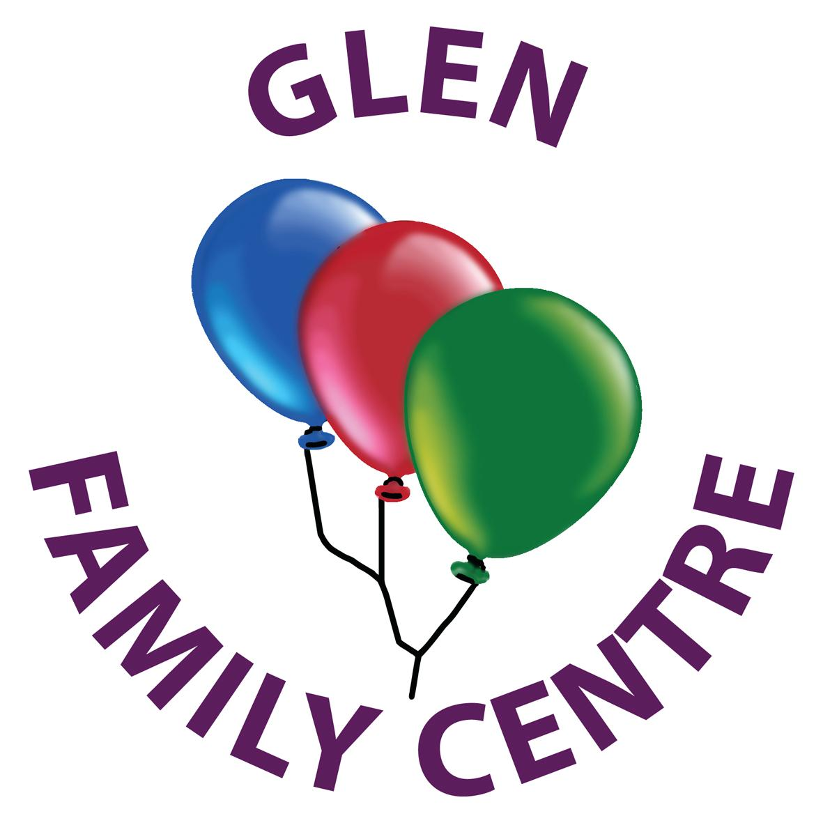

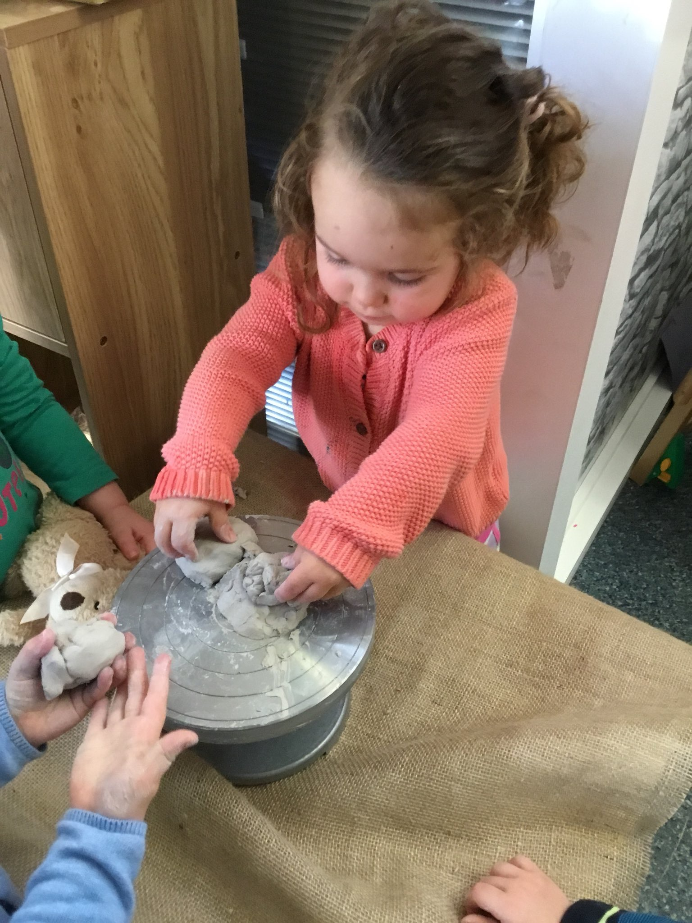

Glen
Family
Centre
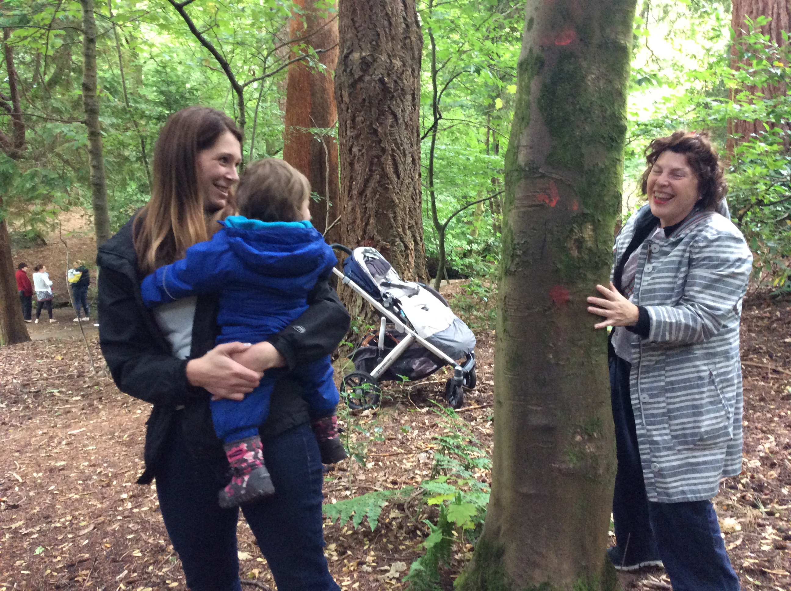
Handbook

Glen Family Centre
Woodfarm Road
Thornliebank
G46 7JJ

0141 570 7510

Where getting it right for
every child is our priority!
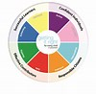

CONTENTS

Welcome

Section 1- General Information
Page 4

Our Vision, Values and Aims
The Staff Team
Link Staff
The Extended Team
Allocation of places
Nursery Hours
Wraparound care
Attendance
Centre Holidays/ Closures
Emergency Closure Arrangements

Section 2- Starting Nursery
Page 9

Enrolment
Visiting the Centre
Settling In
What does my child need to bring?
What should my child wear?

Section 3- While I’m at Nursery
Page 11

Safety & Security
Personal Care & Toilet Training
Keeping us up to date
Food & Drink
Can I…?
Medical Information
Accidents and Illness
Staged Intervention

Section 4- Curriculum and Pedagogy
Page 17

Curriculum and Pedagogy
Pre Birth – 3: Positive Outcomes for Scotland’s Children
Building the Ambition: National Guidance on Early Learning and Childcare
The Role of Planning in our nursery
Measuring and Reporting Progress
Our Wider Community

Section 5- Transitions & Moving On
Page 22

Internal Transitions
Moving On

Section 6- Parental Participation
Page 23

Stay & Play
Play Visits
Groups for Parents
Other ways to get involved
Communication

Section 7- Further Information
Page 26

Centre Improvement
Our Policies
Child Protection Policy & Procedures
Equalities
Data Protection
Complaints
Contact Information
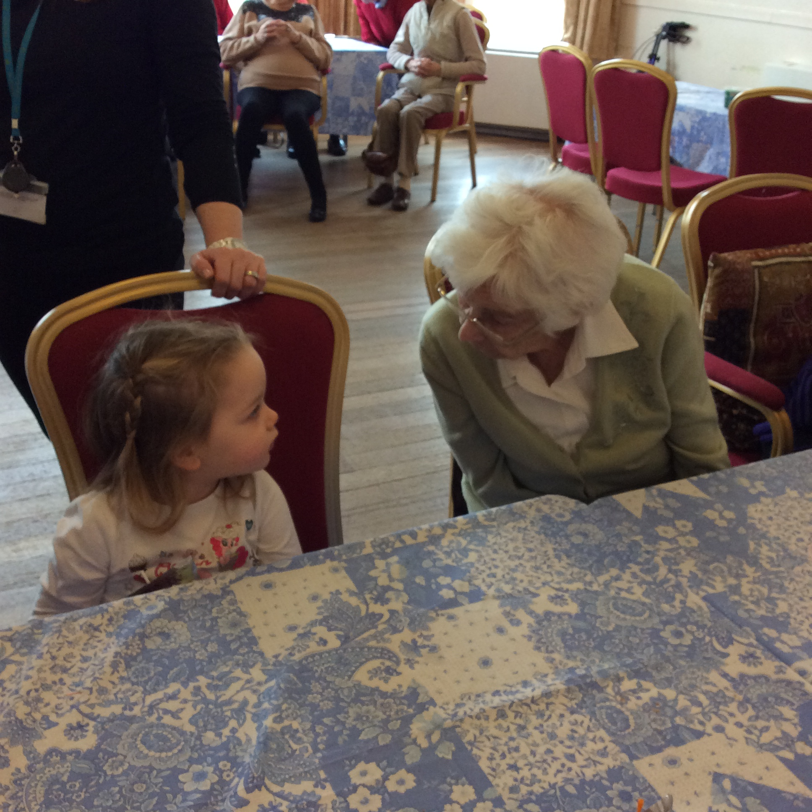
Useful Links

Welcome to Glen Family Centre

Early years experiences are the most important we will have in our lives. Positive early experiences promote positive future life chances. They shape how we grow in all areas of development both now and in the future.

At Glen Family Centre we understand this and ensuring your children have the best start in life is as important to us as it is to you. When your child is allocated a place at the centre we will work with you to get to know both your child and family. This ensures we provide care and early education based on individual needs as well as supporting you in the most challenging job of all...being a parent.

Glen Family Centre is non-denominational. We welcome and respect children and families of all religions, faiths and beliefs.

This Handbook provides information on the services we offer for children from birth to 3 years and their families and should tell you what you need to know about the Centre; however please feel free to speak to a member of the management team or your allocated key worker if you have any questions.

Thank you for allowing Glen Family Centre team to be part of this precious stage in the journey of your child’s life.

Margaret Harper-Abdullah
Head of Centre

“There can be no keener revelation of a society’s soul than the way it treats its children.”
Nelson Mandela

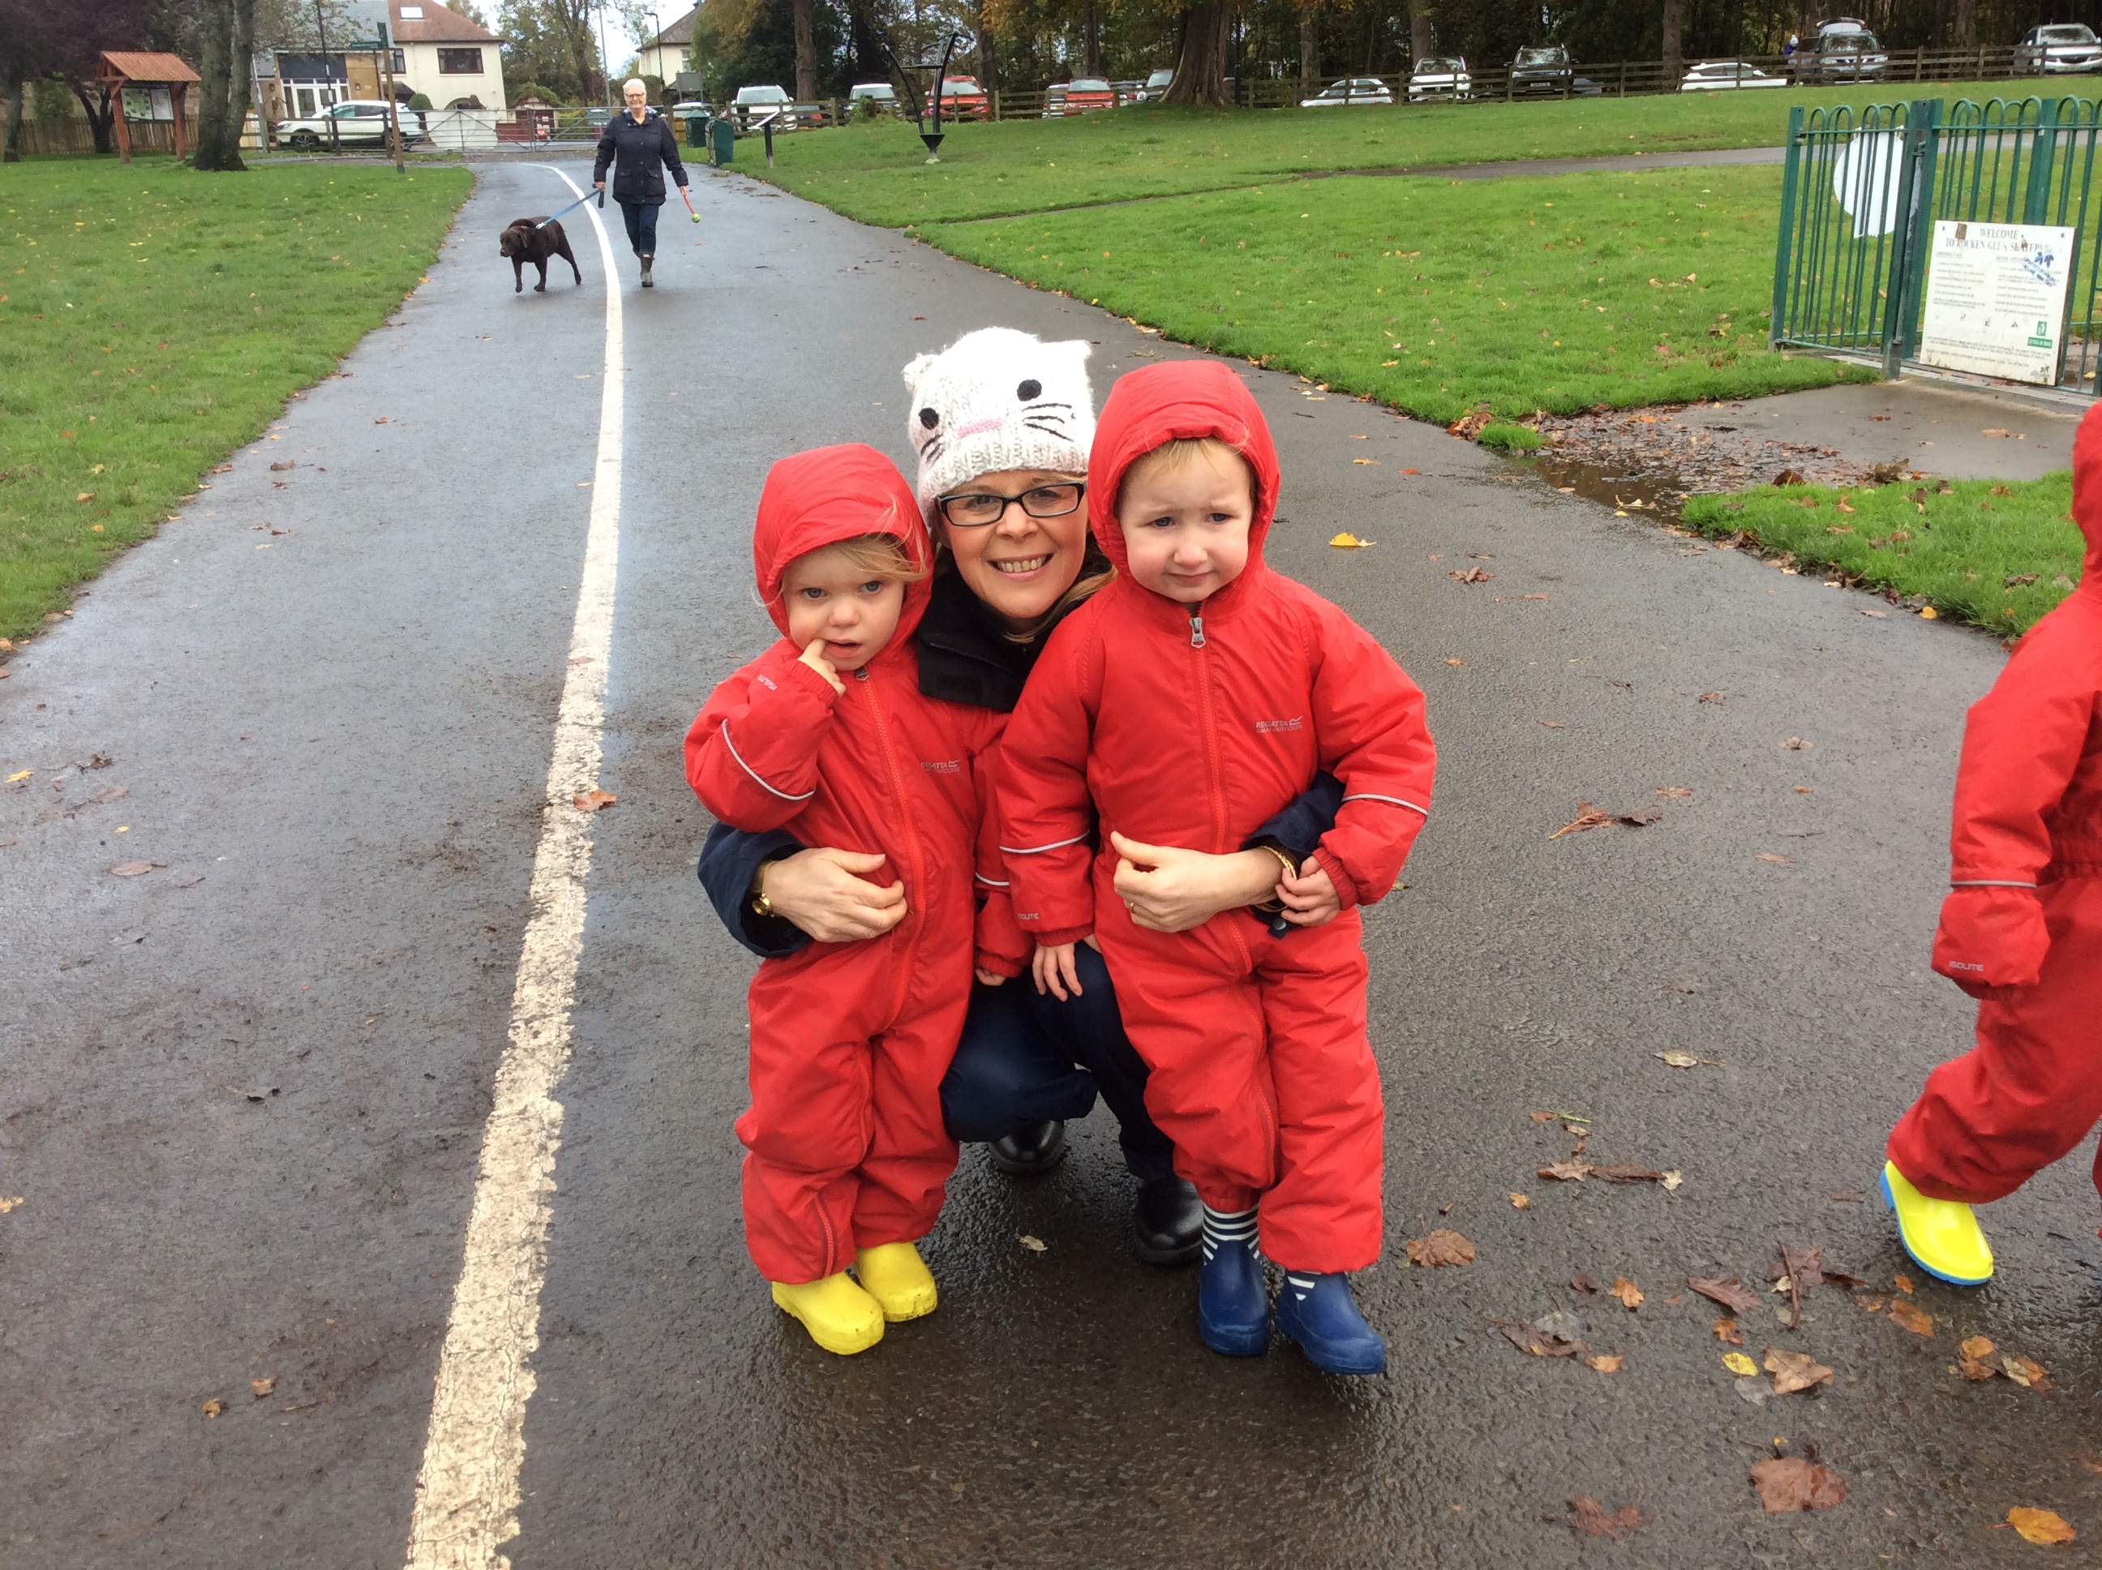

Section 1- General Information

Our Vision
Children and families achieve their full potential through meaningful involvement in a nurturing and safe environment where they feel respected as individuals and have a positive sense of responsibility for themselves and others.

Our Values
Respect Equality Inclusion Achievement
Nurture Reflection Innovation

Our Aims

At Glen Family Centre we aim to:

Provide a welcoming, safe, secure and healthy environment for everyone involved in the life of the Centre.

Provide a range of opportunities for children and families to learn, develop and achieve together in safe and nurturing environments.

Promote children’s learning and development through active play and exploration by providing a challenging and dynamic curriculum which meets the needs of individual children.

Provide services which

o are responsive to the needs of children and families,
o respect their individuality,
o recognise the importance of relationships and
o have a focus on the rights of the child.

Encourage success by celebrating the achievements of children, parents and staff.

Maintain an ethos that recognises, promotes and celebrates diversity, ensuring all members of our learning community feel safe, valued, included, respected and fairly treated.

Engage with agencies in the local community and work in partnership with them to support the needs of children and families.

Ensure our provision is continuously improving and evolving to meet the needs of children and families as we strive to become a Centre of Excellence.
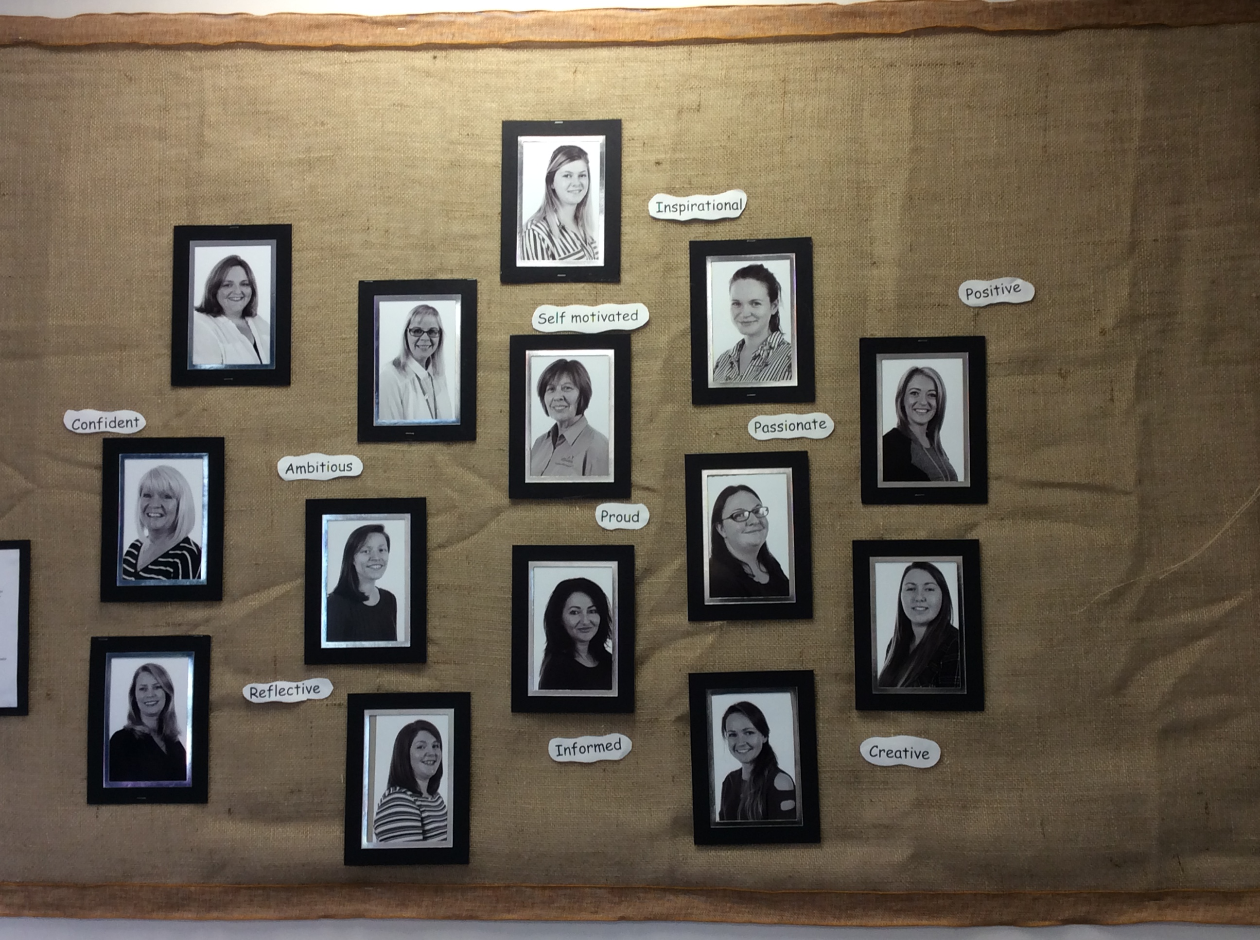
The Staff Team

Core Staff
The Core staff team consists of:
• The Management Team
• Child Development Officers
• Ancillary Support Team including
• Admin assistant
• Catering Assistant
• Janitor/Cleaner

A full staff list will be provided with the handbook and can be viewed on our notice board at the main entrance.

Link Staff
To support the work we do in the Centre we have some core link staff who regularly work with our staff team, children and families. These include
• Senior Educational Psychologist
• Speech & Language Therapist
• Health Visitor
• Social Worker
• Family First Worker
• Early Learning Literacy Team

Again, the details of these staff will be provided with this handbook.

Extended Team
As well as our link staff detailed above, many other professionals visit the Centre to work with our children and families. These include physiotherapists, occupational therapists, teacher’s specialising in visual/ hearing impairment, health visitors, play therapists and many more.

We support people training to work in Early Learning and Child Care environments and, at any time, may have Modern Apprentices, Teaching and/or Childcare students working in the Centre.

All staff working with professional bodies/ organisations are members of the Protection of Vulnerable Groups scheme or have an Enhanced Disclosure check to allow them to work with children.
All permanent staff are also registered with the appropriate Registration Body for their profession e.g. Scottish Social Services Council (SSSC), General Teaching Council Scotland (GTCS).
Allocation of Places

Places at Glen FC for children 0-3 years are allocated by one of the following routes-
1. The authority’s PRG (Pre 5 Resource Group).The PRG is a multi-agency group which meets monthly to consider referrals received from professionals e.g. health visitors, social workers, family support worker. If your child is under 3 years and you feel a nursery place is needed you should speak to any of the professionals involved with your family. These places can be ‘term time’ or ’full year’ depending on individual circumstances.
2. The authority’s LAP (Local Admissions Panel). The LAP allocates places for 2 year old who live in households where parents are claiming specific benefits. Application to the LAP can be made directly by parents who can get an application form from the Centre or ERC’s Pre 5 Admissions Team.

Children are routinely offered either a morning or afternoon placement. If you feel there is a need for any additional time or an alternative placement a referral should be made to the PRG by a professional involved in your child’s care. All places are reviewed periodically by the Head of Centre and/or Joint Support Team and can be reallocated at the discretion of the Head of Centre/ JST.

3. Purchasing a place. Parents can buy a place in Glen Family Centre if there are places available. If a suitable place is available, parents enter into a contract with ERC which last for a term before being reviewed. If a place remains available, a new contract for another term can be agreed and so on. Details of the current charges are included with this handbook.

At Glen our Care Inspectorate registration allows placement for the following numbers of children -

0-2 years 19 children
2-3 years 31 children

Places at ERC Nurseries / Family Centres for children aged 2-5 years are allocated in accordance with East Renfrewshire Council’s Admission Policy by the Pre 5 Admissions Team within the Education Department. These placements can be term-time or extended year provision.
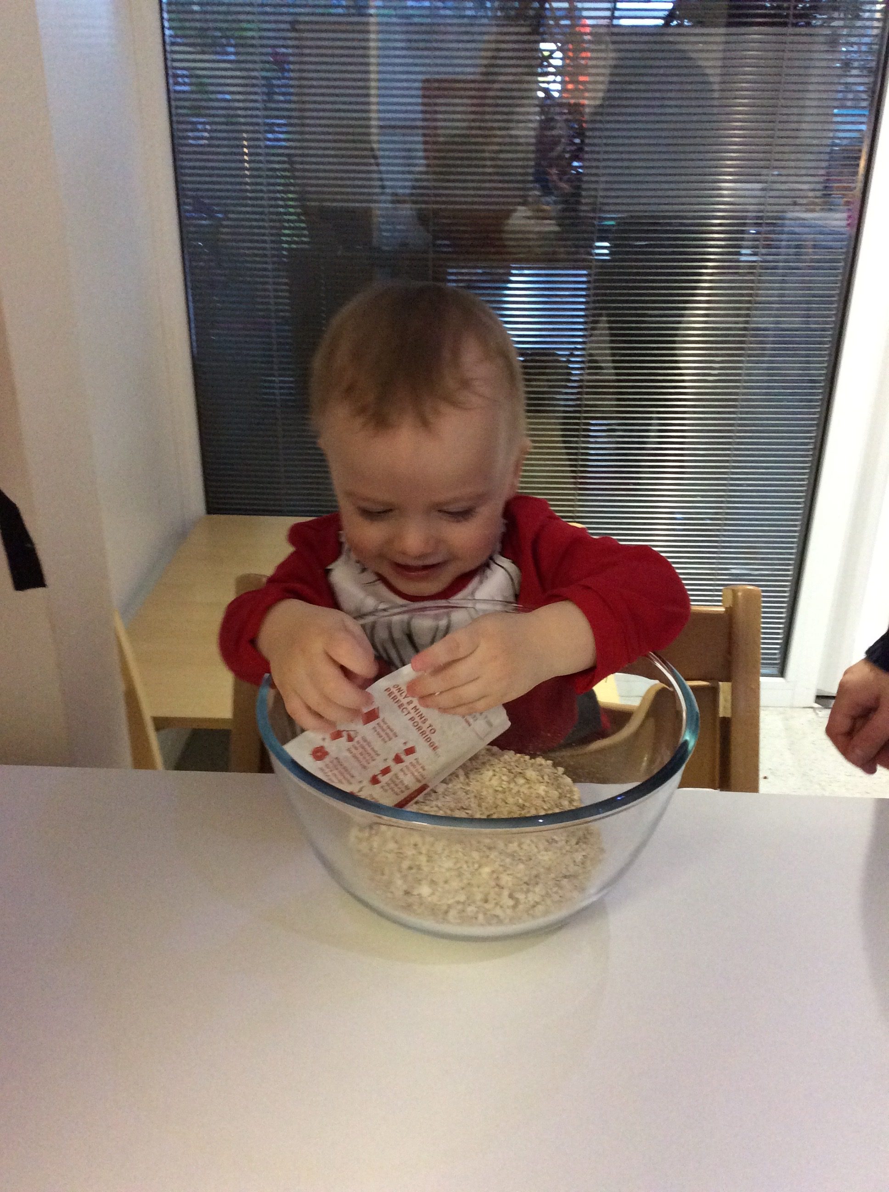

Nursery Hours

The morning session 09:00 until 12:00.
The afternoon session 13:00 until 16:00.

To ensure your child gains maximum benefit from their placement we would ask that they attend the full 3 hour session whenever possible. There are opportunities for parents to participate with their children during sessions and on-going stay and play sessions. More information can be found later in this handbook.

We can offer parents a ‘wraparound’ service where extra hours of childcare can be purchased. Current costs can be found on our website.

Wraparound Care

To support parents with meeting the demands of their work and living patterns East Renfrewshire Council operate a ‘Wraparound Care’ programme. This facility means that a child who has a place in Glen Family Centre can attend for extra hours over and above his/her allocated session. These additional hours within the nursery day and lunchtime provision can be bought provided there are places available. Children can be cared for during extended hours, from 8:00 in the morning and until 6:00 in the evening. Each hour will be charged at a standard rate. Parents will choose a regular care package and the charges will be invoiced four weekly in advance. An Account will be sent to you from East Renfrewshire Council and not directly from the family centre.

If you are interested in using this service you should speak to Catherine in the office.

Wraparound times:

Early Morning- 08:00 – 09:00
Lunchtime- 12:00 – 13:00 (separate charge for food is payable
or parents can provide a healthy packed lunch)
Afternoon- 16:00 – 17:00
Or 16:00 – 18:00

Attendance

If your child is unable to attend nursery please let us know either in advance or by telephone on the day of absence. If we do not have prior notification a member of the management team or your key worker will contact you by telephone to confirm the absence.
If you are planning a holiday and your child will be absent, please let your key worker or the office staff know. This will then be recorded on the register and we will not need to telephone you while you are relaxing.
Attendance is monitored to ensure best use of places allocated.

Centre Holidays / Closures

Glen Family Centre is opened all year round with a few exceptions. We close over the Christmas holiday period, for designated public holidays and ERC Education Department ‘In Service’ days.
As detailed in the ‘Allocation of Places’ section, children who have a ‘term time’ placement do not attend during school holiday periods even though the Centre is open. Details of school holidays for the current session are displayed in the Centre and on the leaflet accompanying this handbook

Emergency Closure Arrangements

Establishments may be affected by unforeseeable events, such as, severe weather, power failures or difficulties with heating. If this happens we will do our best to let you know about the details of the closure either by telephone, text, Twitter, in the press or on local radio. Updates will also be on East Renfrewshire Council’s website - www.eastrenfrewshire.gov.uk

Should we have to evacuate the centre and not be able to re-enter for any reason, staff and children will walk to Glenwood Nursery School which is further down Woodfarm Road. Parents will be notified as above.

Section 2- Starting Nursery

Enrolment

When your child has been allocated a place with us, a member of Glen FC management team will contact you and arrange to visit you and your child at home. Your key worker will also come along on the visit.

During this visit we will chat with you about your child and your family, and try to get to know you a little. This also means your child gets to meet his/her key worker in their home environment and will then have a familiar face when they attend the centre for the first time.

We will take this opportunity to discuss any referrals and complete all necessary forms. You will need to have the following documents – your child’s birth certificate, and one of the following- mortgage statement/ rental agreement, current council tax notice, child benefit letter or utility bill.
Your key worker will bring along some toys from the centre and will use this time to play, bond, engage and form a relationship with your child. During the visit we will arrange a suitable day and time for your child to start nursery.

Visiting the Centre

Before your child starts nursery you are encouraged to come and visit the Centre and have a look around. We have ‘Book Bug’ sessions every fortnight which you are welcome to attend with your child. This is a great way for you both to become familiar with the environment and some of the staff as well as an opportunity to meet some of the other children and parents.
Please ask staff for details.

Settling In

During the first week you should make yourself available to support your child to settle into the nursery environment. We ask that you stay with your child in the playroom for an hour on their first day. The time will be built up gradually until your child is confident staying with us for the full session.

As every child is unique we treat everyone individually with the care and attention they deserve. Some may take a little longer to settle than other; don’t worry and be guided by your key worker. The settling process is very important and ensures your child is happy and secure in making the transition from home to the Centre.

What does my child need to bring?

Your child will have a nursery bag/box which is kept on their own peg in the cloakroom or playroom. Your child should be dressed appropriately for the weather conditions. A change of clothes – pants, socks, t-shirt and skirt/trousers. We have a limited stock of clothes for changing children so it is important that you supply fresh items after use.

- Nappy box in changing area to be kept replenished.

A supply of nappies and wipes should also be put in the bag/box. Remember to top these up as required.
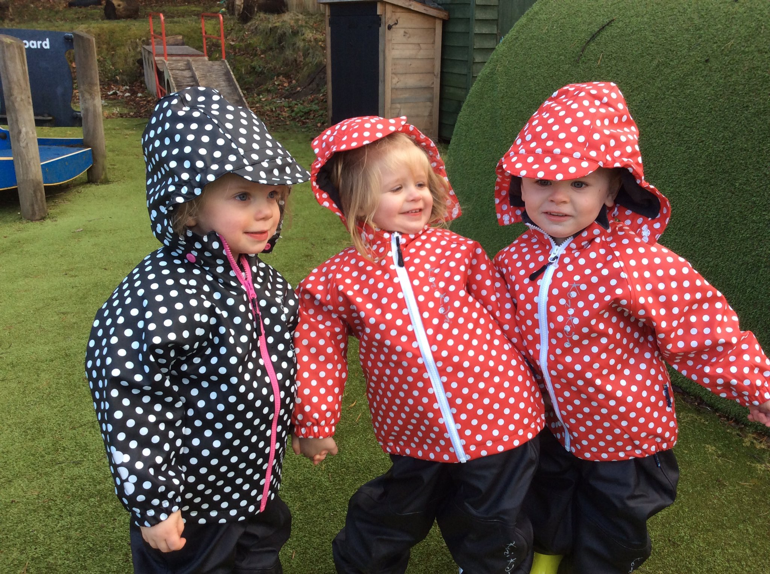

Outdoor learning is an important part of our curriculum. The children play outdoors daily and must have suitable clothes for the weather.

What should my child wear?

Early education is about exploring, discovering, creating and experimenting. This often means messy play and messy clothes. Please bring your child to the centre in ‘play’ clothes which you won’t mind being covered in paint, mud, glue and much more. Clothes which have sleeves that roll up easily and trousers which allow independence are also beneficial.

On cold days children should have a warm jacket, gloves and a hat. Even if you come by car, remember we spend part of the session outdoors in all weathers.

On warm sunny days children should:
have a sun hat in their bag

be wearing factor 50 sun screen

Parents/Carers should ensure the first application of sun screen is applied to their child when arriving at nursery regardless of your childs skin tone. This information should be shared with your child’s key worker.

Please supply sun screen for your child for top ups throughout the day

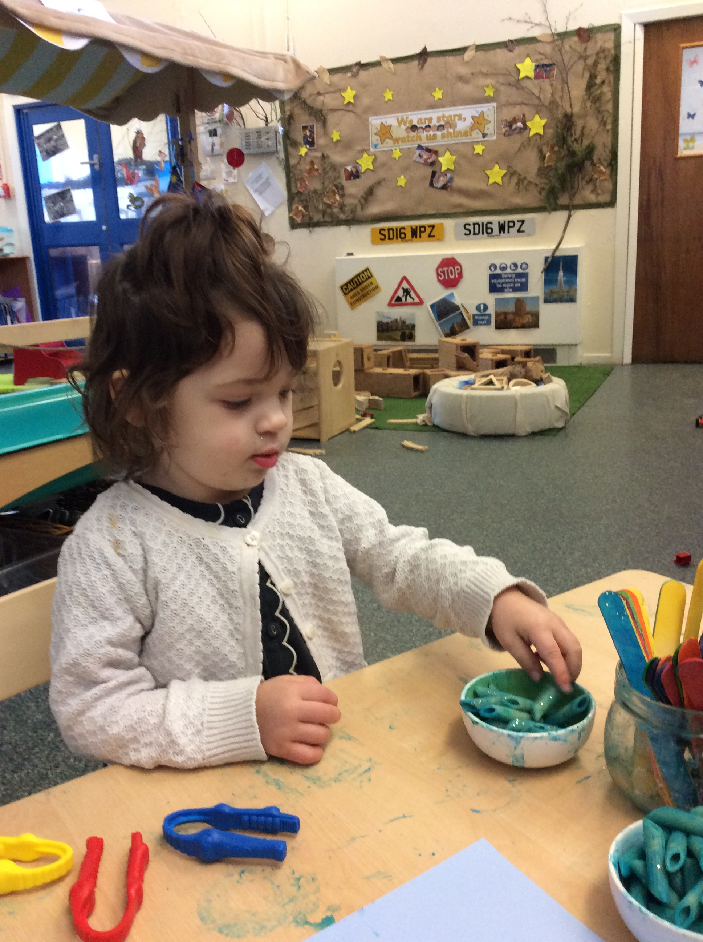
Section 3- While I’m at nursery

Safety & Security

The safety and security of our children, families and staff is of paramount importance. Our security entry systems allow us to be sure we are in control of who is in the Centre and aware of why they are here. If you are leaving the building and someone is waiting
to enter, please get a member of staff. Please do not open the doors to anyone, even if you think you recognise them.

To ensure your child’s safety out with the Centre, we will only let them leave with those adults, over 16 years, whom you have nominated during enrolment. If you need to make a change to these arrangements please speak to your key worker or office staff. Should you need someone different to collect your child at short notice or in an emergency situation, you will be asked to provide us and that person with a password to enable us to verify their identity.

Welcome Time and Home Time

When you bring your child to nursery you should make them comfortable by removing their outdoor clothes and changing shoes in the cloakroom before bringing them to the playroom.

Personal Care and Toilet Training

Your child’s personal care needs will be met with respect and dignity. Our changing stations and toilets ensure privacy is maintained while allowing staff to appropriately supervise and support children. Parents should NOT enter the children’s toilet. If your child needs to use the toilet while you are with them in the centre, please speak to a member of staff if they cannot manage on their own and need help.

When you think your child is displaying signs that he/she is ready for toilet training please speak with your key worker who will explain the methods we use to support you and your child.
Toilet training will not be started in nursery without it being discussed and agreed with you.

It is important that children have enough spare clothes in nursery to manage any accidents.

Keeping us up to date

To allow us to provide effective support for your child and family it is important that we are kept up to date with any changes. Obviously having the correct emergency contact information is crucial should we need to get in touch quickly; however it is just as important to let us know about other things that might be changing to ensure we can help your child manage changes in their circumstances. Things it might be good for us to know include-

change of phone numbers, moving house
illness of close family, new babies, change of sleep pattern,
bereavement, hospital admissions, separation

Food and Drink

Snacks
A healthy snack is offered to children during both morning and afternoon sessions. Glen is a health promoting nursery and all snacks are in line with National Nutritional Guidelines. We offer milk and water to drink and provide a selection of snacks which include a variety of fresh fruit, toast, cereal, raisin, crudities and dips. On special occasions, including birthday and end of term parties, snacks may vary to include some treats such as a small piece of cake or some crisps. You will be notified of these special occasions in the newsletter. Water is available throughout the session from our water cooler in the playroom. To enable our team to continue to support the children to eat healthy, we ask that parents contribute £2.50 per week to our nursery snack through parent pay. This is in addition to any hot meals that parents purchase for their child’s lunch.

Lunchtime
If your child attends over lunchtime you can choose to either provide a healthy packed lunch or pay for lunch to be provided by our catering staff.

The lunch menu has been developed using National Nutritional Guidelines. It is rotated every three weeks and offers two courses which will include options for children with specific dietary requirements e.g. food allergies, vegetarian. A copy of the menu is available from the office and is on the website.

If you prefer to provide a packed lunch for your child we would ask that it is a healthy lunch avoiding sweets, chocolate and fizzy drinks. Lunch boxes are kept in the nursery fridge to keep them cool. Please do not provide anything that needs to be reheated as we are unable to do this due to heath and safety procedures.

If your child has any allergies or is on a special diet, please alert the management team who will inform the staff and the cook.

Breastfeeding Friendly

Breastfeeding is widely recognised as the most favourable means of infant feeding with considerable benefits for both mum and baby. Glen Family Centre is a ‘Breastfeeding Friendly’ establishment where staff are specially trained to promote an environment where breastfeeding is seen as the normal way to feed babies and infants.

At Glen Family Centre the staff team will support breastfeeding and parent: infant relationships as well as raising awareness in children to improve acceptance and standards of care within today’s society.

Staff promote, protect and support any mother who chooses to breastfeed and welcome this within any public or private area of our nursery where both mum and baby feel relaxed and comfortable during this special time. We also promote the awareness in children of breastfeeding as a normal activity through books and resources in the nursery.
A full policy with more detail is available on our website or at the office.

Can I…?

As part of everyday nursery life children will participate in many different events and opportunities. During enrolment you will be asked to consent (or not) to a variety of activities including environmental walks in the local area exploring concepts of nature, numbers, print and healthy living or taking your child to nearby parks or areas of interest. When excursions further afield are planned, you will be informed in advance and asked to complete an additional consent form giving your permissions for your child’s participation. Only children whose parents/carers have given the necessary consent will be able to take part in outings.

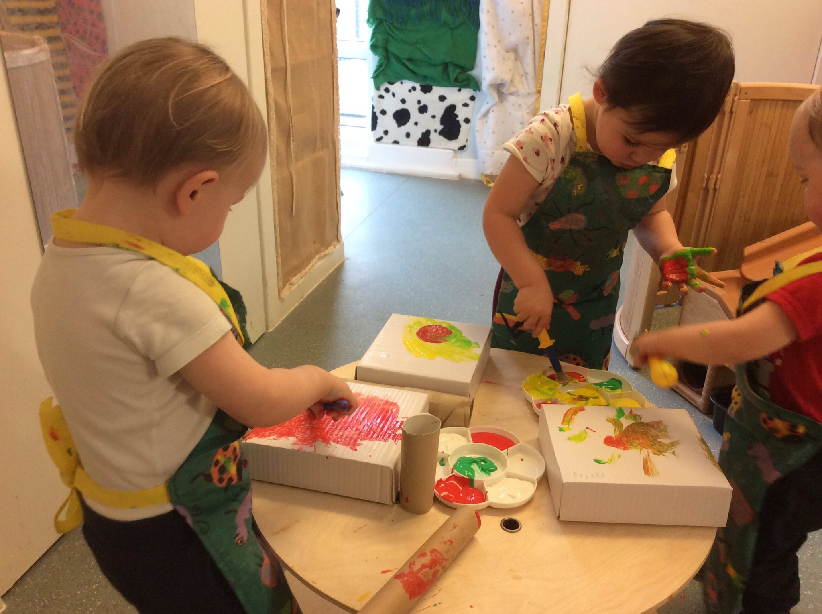
Staff also like to take photographs and video recordings of the children during these events as well as during every day nursery sessions. This helps to provide a record of your child’s learning and development for both you and them to enjoy and recognise their achievements. Photographs and recordings may also be used for displays in the Centre, for our website or staff training. Your child’s images will only be use with your permission.

We will also ask you for consent regarding some health promoting and screening programmes which are detailed below.

Tooth-brushing Programme

Childsmile is a national programme designed to improve the oral health of children in Scotland and reduce inequalities both in dental health and access to dental services. Good oral health in childhood means healthy teeth and gums throughout life. Childsmile is working to ensure all children, regardless of income or background, have the best possible start in life. Young children need help with tooth brushing on a daily basis, with research showing us we need to brush at least twice a day with fluoride toothpaste.
For more information: www.child-smile.org
At Glen Family Centre we have a ‘Smile Too’ award and understand the importance of tooth brushing in young children. Our tooth-brushing programme is part of our daily nursery routine and is a fun and educational experience for your child. Your child will be allocated a toothbrush with a picture on it that will be stored in an individual container.
Containers are washed regularly with hot soapy water and the toothbrushes are replaced on a regular basis. Someone from ‘Smile Too’ visits the centre regularly.

Medical Information & Illness

To ensure your child receives the appropriate care while they are at nursery it is important for us to be aware of any medical needs he/she has. You have the opportunity to inform us of any conditions/allergies during enrolment; however you must remember to keep us up to date with any changes or if your child develops a medical condition after enrolment.

If your child requires to be given medication during the nursery session you should discuss this with your key worker. We can only administer drugs which have been prescribed for your child and cannot give cough bottles or pain relief such as ‘Calpol’ on an ‘ad hoc’ basis. You need to complete a form which authorises nursery staff to administer the medication. This is called the ‘Administration of Medication’ form and is available from the office or our website. You should read the ‘Medication- Guidance for Parents’ information which is also available from the office or on the website.

If your child suffers from asthma or allergies and requires medication when they are having an attack or reaction, you will need to complete a ‘Symptoms’ form. Again this is available from the office or on the website. We cannot accept medication that says ‘as required’ without details of the circumstance when the medicine would need to be given.

Accidents and illness

All minor accidents or injuries are recorded in our Accident Log. If your child has an accident, you will be asked to sign an accident form. A copy will be held in office files and another will be given to you.

If your child becomes ill while attending the Family Centre we will contact you immediately. If you cannot be reached we will use the information you have provided to contact the named emergency contact person. Please remember to keep contact details up to date. Your child will be given immediate attention as necessary in order to make him/her comfortable until a parent or carer arrives to collect them.

If your child is suffering from a virus or any kind of contagious illness, we ask that you keep them at home where they will be most comfortable and to avoid infecting other children. PLEASE NOTE Public Health Authority guidelines stipulate that children should be absent from nursery for 48 hours following a bout of sickness or diarrhoea.

If your child has an accident which needs further attention, we will follow the same procedures to contact you as above; however, should there be the need for emergency treatment, we will call an ambulance first and a member of staff will accompany your child to hospital and meet you there. Any incident resulting in a child needing hospital treatment will be logged on ERC’s electronic system and the Care Inspectorate will be notified.

Wellbeing

Many children need a little extra support from time to time for a variety of reasons. This may be because they have an identified learning need or medical difficulty or there is something going on in their life such as the death of a grandparent, breakdown of parents’ relationship or perhaps they have moved house and are struggling to adjust. Whatever the reason, it is important for children to receive any additional support they need to ensure they can access all opportunities available to them and meet their full potential.

Sometimes this support can be provided by staff within the centre; however we work with a range of other professionals to ensure the right people with the appropriate
knowledge and skills are available should they be needed. Some of these specialists are mentioned in the ‘Link Staff’ and ‘Extended Team’ sections above.

If we feel your child could benefit from some additional support we will always speak to you first. Nobody will work with your child without your knowledge. If you feel your child needs extra support please speak to your key worker or our Additional Support Needs Coordinator.

When it is agreed a child should be consider for additional support we may discuss their needs at our Joint Support Team meeting.

Our JST is chaired by the Head of Centre and the other members include:

Depute Head of Centre- ASN Coordinator
Educational Psychologist
Link Social Worker
Link Health Visitor
Link Speech and Language Therapist

While your child is receiving additional support we will use ERC’s Staged Intervention procedures to ensure this support is monitored, reviewed and evaluated. You will be invited to attend a meeting every term to participate in setting and reviewing targets for your child.

Section 4 – Curriculum and Pedagogy

Curriculum and Pedagogy…very fancy words which really mean what we do and how we do it.

At Glen Family Centre the key workers are all qualified and registered as Childcare Practitioners. In addition the staff team have received specific training in ‘Nurturing & Child Led Play Approaches’ which is the method, or pedagogy, embraced in our centre.

Research has highlighted how vital early experiences are in shaping and developing a young child’s brain and how future development and learning are impacted by those earliest experiences. In recognising this we understand the importance of a child’s emotional wellbeing and social competence in enabling them to reach their full potential. Providing play and learning experiences using nurturing and child led approaches ensures we are supporting children emotionally and socially which, in turn, enables them to engage fully and meaningfully with all learning opportunities.

Play lies at the heart of the curriculum and makes a major contribution to your child's development. Children learn as they play and as they share experiences with other children and adults. Through play, children practice and develop many skills they need in life. Using a 'Child Led' approach in implementing the curriculum through play means that your child has the opportunity to learn through the experiences they enjoy most.

The Wellbeing wheel details the indicators we consider in all aspects of our work as we aim to get it right for every child.

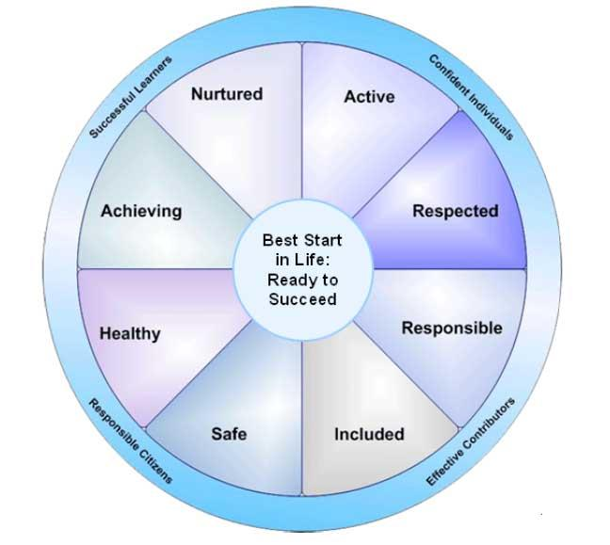
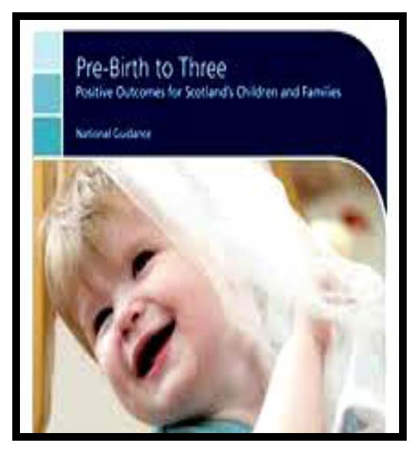
Pre birth – 3: Positive Outcomes for Scotland’s Children

At Glen Family Centre we believe that our children are unique individuals and active participants within the world around them showing particular interests, preferences and capabilities in all that they say and do.

Our children’s views and attitudes are shaped from a very early age and being part of a family and community helps to determine individual values and beliefs. We value, respect and respond to parents’ knowledge of their child and this information is imperative to ensuring effective practice within our centre.

When planning for our children’s learning we focus on each individual child while using the ‘Pre-Birth to Three’ document as a valuable tool to support the ‘Rights of the Child’, ‘Relationships’, ‘Responsive Care’ and ‘Respect’ which in turn supports the celebration of the skills and achievements of all our children.
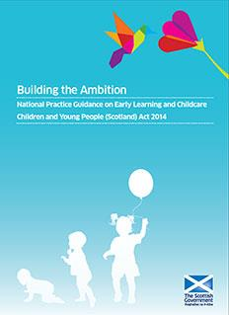

Building the Ambition: National Practice Guidance on Early Learning and Childcare.
Building the Ambition is the most recent national guidance document to be published. Just like the Pre birth – 3 document above, Building the Ambition places a focus on children’s earliest years and sets the context for high quality early learning and childcare.
When planning and providing a variety of opportunities for your children, we use Building the Ambition to ensure we fully consider what children need at different times in terms of the experiences offered, what high quality adult interaction should be like and what their environment should contain.

Building the Ambition is closely linked with Curriculum for Excellence but written in a meaningful, practical way for babies, toddlers and young children.

While following all national guidance, we strongly believe that, for young children to develop both cognitively and physically, we must support them in their emotional well being and social competence in an environment where they feel safe, secure and nurtured.

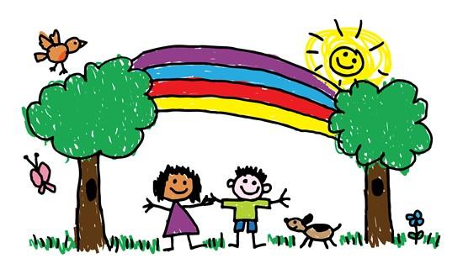

Outdoor play is a very important part of a young child’s learning journey and, at Glen, we extend the playroom to the outdoor environment by ensuring children have access to outdoor learning every day. Children will have choice to move freely between indoors / outdoors throughout their session.

Our aspiration for all children and for every young person is that they should be successful learners, confident individuals, responsible citizens and effective contributors to society and at work. By providing structure, support and direction to young people’s learning, the curriculum should enable them to develop these four capacities. The curriculum should complement the important contributions of families and communities.
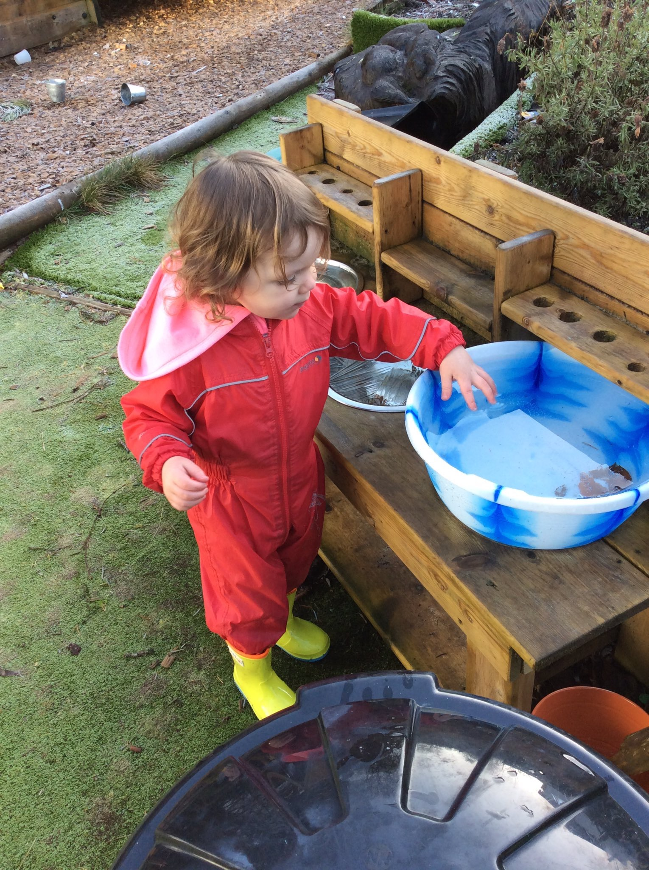
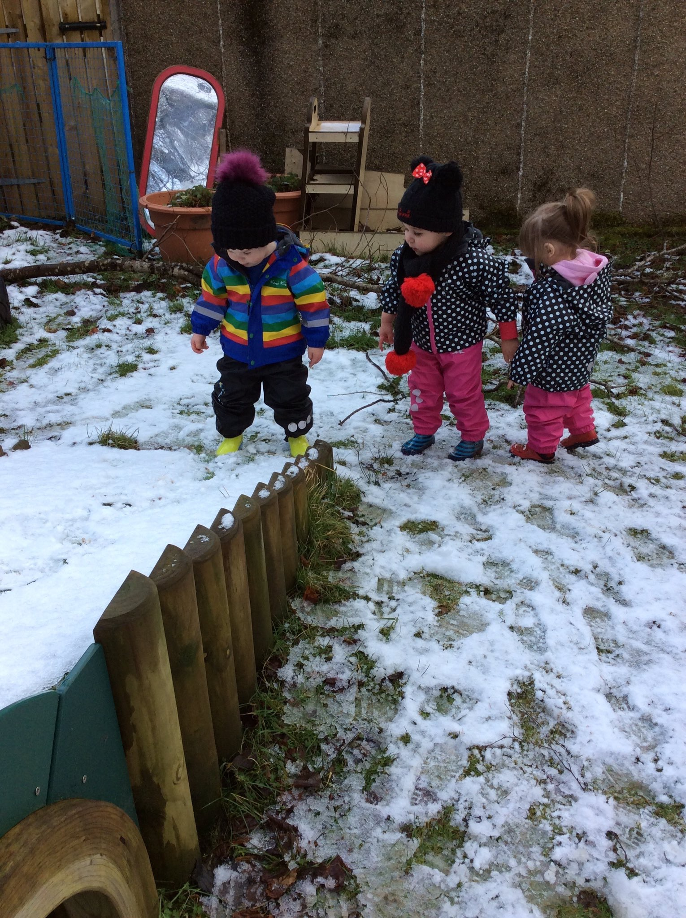

The role of planning in our nursery

In order to support learning and development through play we create a high quality curriculum for young children which:-

• provides opportunities to play alone, in pairs, in small groups and large groups depending on the child’s stage of development
• supports independence, interdependence, making choices and decisions
• is content, rich and relevant
• values and extends children’s ways of thinking reasoning and understanding
• helps children to acquire the tools for thinking, learning and playing which enables them to become successful learners
• is culturally diverse and reflects the customs, culture and lifestyles of different ethnic groups
• involves parents in the processes of playing and learning

With children, staff prepare plans for each playroom which are displayed on our learning walls. We also encourage you to become involved in planning by reviewing and commenting on your child’s learning story regularly.

At the end of each playroom plan, staff observations of children, their interests, reactions and their experiences will form the basis of an evaluation of the plan. This evaluation will help to indicate the content of the next playroom plan. Observations of the children will also help to record each child’s progress and achievement.

Useful information available at http://www.educationscotland.gov.uk/parentzone/

Measuring and Reporting Progress
In Glen Family Centre we know that children will achieve in a variety of ways.
We assess their developmental progress so that we can use this information to develop an appropriate curriculum for each child.

Your child’s key worker monitors the progress of each child in collaboration with other child development officers. Using observations of your child during free-play, a Learning Journal will be built up showing you child’s learning and achievements.
Your child’s progress in nursery will be reported to you:
• Informally through discussions on an on-going basis
• At the end of the Winter & Summer terms your child’s Learning Journal will be sent home for you to look at with your child and for you to add your comment and let us know of any achievement you child has made at home However, your child’s journal is available to take home and add to at any time throughout the course of the term.
• Formally at parent consultations

Children are encouraged to be involved in the compilation of their own Learning Journals according to their stage of development. As children participate in opportunities in the playrooms, they are encouraged to reflect upon their efforts and perhaps to make some comment about it or, for younger children, staff will take note of their response to particular opportunities and interactions.

Our Wider Community
Glen FC is located within a vibrant community and we are keen to promote positive partnership with it and use it to the benefit of our children and families. We use many of our community resources in the course of our everyday work and encourage staff, parents and children to do so too. We also welcome members of the community into the centre to strengthen links and widen the experiences on offer.
Much of our work with our wider community partners is detailed elsewhere in this handbook- Link Staff, Extended Team, Can I...?, Staged Intervention and Transitions (below). In addition we also engage with Parks & Recreation, Library services and many more.

You will often find us out and about in our local community enjoying opportunities such as:
• Book Bug sessions at Thornliebank library. We also borrow books to enjoy in the nursery.

• Walks in Eastwood Park where we love exploring the woodland and the stream

• Outings to Rouken Glen Park where we love to stretch our legs and enjoy the play park or the Ramblers group.

• Visiting the cafe and chatting with the workers in Eastwood Theatre.

As stated above, we also invite members of organisations in the community to the centre to talk about their role in the area. This can include;
• The emergency services to talk about their work and support children in keeping themselves safe and well.

• Charities and voluntary sector organisation

• School Crossing Patrol Person

• Park rangers

Supporting others in our Community

We welcome students from a range of learning establishments to the centre to support the development of skills required to enter the wider workforce. This can include pupils from our local Secondary Schools on work experience, students from colleges studying courses related to early learning and childcare, and Modern Apprentices undertaking training with ERC to become Child Development Officers. Students attend the centre in varying patterns depending on their needs and course, and will work with children under close supervision of staff.

Section 5-Transitions & Moving on

Children experience many transition in their lives such as starting nursery, moving to a new room or key worker or moving on to a different nursery or school. While these are normal changes that occur, it is important for us as adult to realise these can be daunting experiences for children. Think about how you felt when you started your first job, had a change of manager or a trusted advisor/friend moved away. Yes, these were events that we can expect in our lives, but they can still cause us anxiety. This is just the same for children when they make transitions and it is important that we help them to adjust and reduce the worry as much as possible by planning effective transition periods.

Internal Transitions
This sounds much scarier than it is. Internal transitions are simply moves and changes your child will experience within the Centre. If your child joins us when they are just a baby, you can expect them to change room, and possibly key worker, at least once if not more. We will work closely with you and your child to plan any changes and these will always be made gradually whenever possible.

Moving on
Children will leave Glen FC when they are around 3 years old to move onto their local nursery. When your child turns 2 years of age we will support you in completing a ‘First Steps’ application form. If you do not complete and return the form to the Pre 5 Admission Team at ERC, your child may not be allocated a place in your local nursery.
We work closely with all of our local nurseries to ensure continuity in children’s learning and development, and aim to ensure the receiving nursery has a good picture of your child’s strengths and needs before they move. Some of the ways we do this include-
• Introducing the idea of moving on through our everyday work in the Centre
• Information regarding your child’s achievements and stage of development will be shared prior to transfer.
• Arranging visits to the new nursery with your child.
• Informing you of induction events and visits at the new nursery.

Should your child experience any difficulties in settling into the new environment every effort will be made to arrange for his/her key worker to attend and support.

Our main catchment nurseries are:
Braidbar Nursery Class Crookfur Nursery Class
Glenwood Family Centre Giffnock Nursery Class Isobel Mair Family Centre Mearns Nursery School Thornliebank Nursery Class Hazeldean Family Centre

Section 6- Parental Participation & Involvement
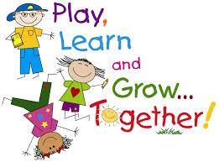

At Glen FC we recognise parents as the primary educators of their children. We are continually developing a range of creative and interesting ways to address the needs of children and families. Underpinning all we do are the principles of a nurturing, supportive and family friendly approach which will enhance family wellbeing and support the whole family to reach their full potential. Below are details of some of the ways you can get involved and some of the opportunities you can participate in.

Stay & Play
Nursery isn’t just for your child. You can stay and play too and learn more about what your child gets up to during the session. You can also learn some new ways to play from working alongside your key worker with your child. This can be particularly useful in your child’s earliest months when it may seem that all they can do is eat, sleep and cry! Your toddler / older child will love showing you around and getting you involved in their play.

Play Visits
We can offer play visits at home to families who may be more comfortable in their own environment. The visit will be informal and fun and taken at the child’s pace. There is no need for any preparation or expense as a key worker will bring a bag of resources to use. This visit is likely to involve a story, a short activity and some songs and rhymes. We would hope that the play visits develop your child’s interests and give you some ideas for things you can do together at home. We also hope the visits help you and your child build relationships with staff and make you feel more confident about playing with your child and accessing community resources.

Groups for Parents
There are a range of groups run throughout the year at Glen for you to get involved in. Groups usually meet weekly for around 1.5 – 2 hours and last between 4 -8 weeks depending on the topic. Some groups are ongoing and continue to meet every week. Groups are led by a variety of people including those in our own staff team and we also have the help of others who may have specialist knowledge or skill including the Family & Adult Learning Team, educational psychologist, Social Work Service, health visitors, voluntary organisations, other parents and many more. Below are some of the topics we cover. If you have a suggestion or idea for a group you would like to see us offer, please speak to Claire Smith, Senior CDO, or pop your comment in our suggestions box.

Baby Massage
Spend some quality time with your baby learning simple baby massage techniques. This can help you both relax, supports sleep and can help with things like colic.

Gardening Group
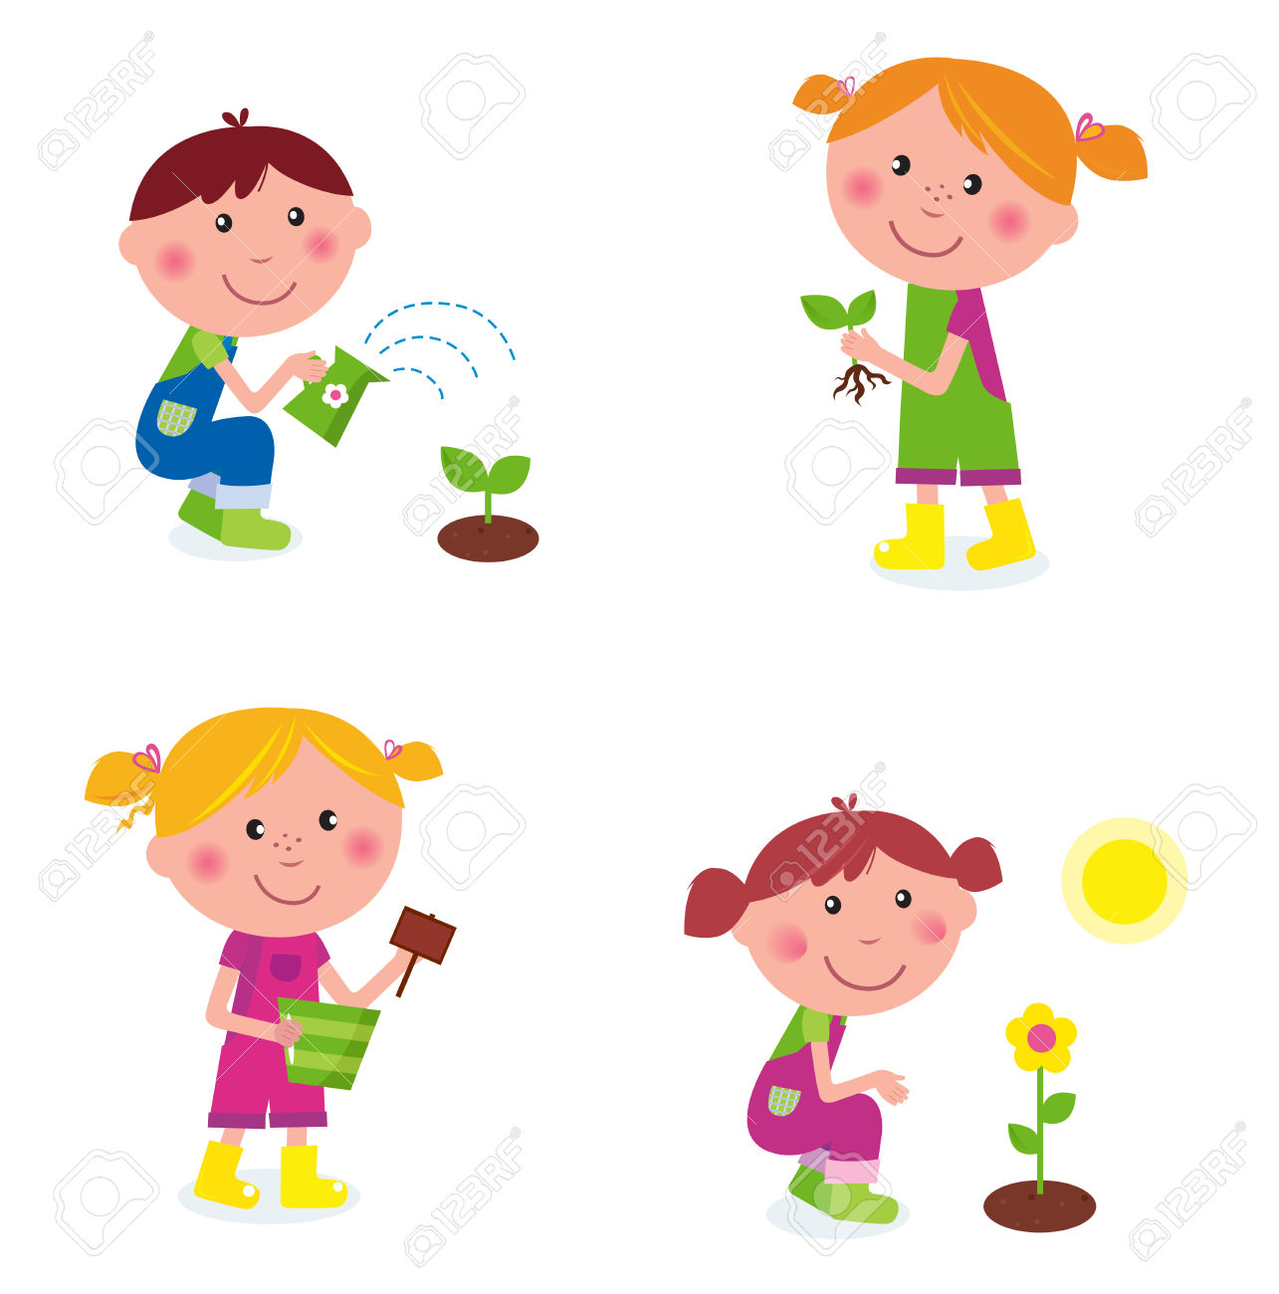
Does exactly what it says... takes care of the gardens and outdoor areas of the centre.
You don’t have to be a skilled gardener; you just have to be fit enough to get stuck in with other parents and children and help keep Glen FC looking good.

POPP
The Positive Parent Programme explores our relationships with our children in the context of helping us to positively manage behaviours. Most parents who take part say the best thing is realising ‘it’s not just me!’

Drop In

Come along for a coffee and chat. The ‘Drop In’ group has no fixed agenda; it’s just another opportunity to meet other parents and relax. However, the group have taken on some tasks within the centre when the need has arisen. They have spruced up our entrance foyer, took on some fundraising for Christmas and decorated Santa’s Grotto.

Other ways to get involved.

Individual Support
As well as a range of groups, we can also offer support on an individual bases. The staff team are skilled and knowledgeable in many areas including baby feeding and weaning, toilet training and more. Speak to your key worker or a member of the management team if you interested.

Parents’ Committee

The Parents’ Committee represent parents in many aspects of the work of the Centre including:
• Supporting self-evaluation and improvement
• Overseeing fundraising efforts
• Engaging with staff in the development and review of policies
• Promoting community involvement in the life of the centre
• Joint Policy Review

If you are interested in joining the Parents’ Committee please speak to your key worker, a member of the management team or Parents’ Committee members.

Fundraising
Parents are encouraged to make a small weekly donation of £2 to the Centre’s Nursery Fund. These funds are used to help pay for baking ingredients, outings & trips, special events & parties, additional resources and specialist to work with your children e.g. Dance teacher/ football coaches.

In addition we have larger fund raising events throughout the year. We need your support to make these as successful as possible.

Nursery Fund Committee
Funds raised through Nursery Fund donations and other activities are overseen by the Nursery Fund Committee. Membership of the Committee includes staff and parent representatives and is chaired by the Head of Centre. The current membership can be seen on the Centre’s website.

The Nursery Fund Committee has an agreed formal constitution. Accounts are kept for all monies collected and are available for inspection at any time. The accounts are audited by an external, independent auditor annually.

Giving your views and suggestions
The easiest way to get involved in the life of the centre is to talk to us and tell us what we do well and what we could do better. There are many ways you can do this throughout the year including completing questionnaires, taking part in consultation events, commenting on your child’s profile, completing a comment/suggestion form or talking to us directly. We’re always happy to hear your views and will keep you informed as to how we use them.

Communication
We publish a regular newsletter to keep you informed about life in the nursery. Notices will also be placed on the notices boards in the foyer and playrooms. Please make time to have a look when you drop off or collect your child. The Centre has a website/ twitter feed which has up to date information and useful links to other interesting sites.
If English is not your first language and you would prefer information in an alternative language please let us know.

Section 7- Further Information

Centre Improvement
We are continually striving to be the best we can be for you and your children. We carry out self-evaluation and monitoring activities throughout the year using a variety of methods and measures including national policy and guidance documents such as Getting it Right for Every Child, How Good is Our Early Learning and Childcare? and the national Health and Social Care Standards . We gather information from everyone involved in the work of the centre including parents, children, the community and other professional.

Using this information we identify what we have done well and what we need to develop. We put our evaluation together in a document called the ‘Quality and Standards Report’ and use the information about things we need to develop to produce a ‘Centre Improvement Plan’. Both of these documents can be found on our website or you can ask for a paper copy from the office.

Our Policies
Glen Family Centre has policies in place to ensure that staff, parents and visitors to our centre are clear on our work practices and standards. Our policies are written in line with local and national guidelines including Getting it Right for Every Child, Pre Birth- 3, Health and Social Care Standards and How Good is Our Early Learning and Childcare?. These documents are also used to plan, monitor and evaluate our work. The policies are available in the main entrance, the Parents’ Room and on our website. Policies are monitored and reviewed regularly reflecting our commitment to continuous improvement.
In addition, as part of ERC’s Education Department, Glen FC also uses the wider policies of ERC to guide and influence our work with children and families. ERC policies can be found on the ERC website.

Child Protection Policy and Procedures

At Glen Family Centre We Work Hard to Keep Our Children Safe

At Glen Family Centre we take the care, welfare and protection of our children very seriously. We believe all children have a right to feel safe within nursery, home and community.

Within our nursery we strive to provide a safe, secure and nurturing environment for our pupils, which promotes inclusion and achievement. All Education staff have a statutory and professional responsibility to take action if we have reason to believe a child is suffering or is at risk of abuse.

Our child protection policy and procedure sets out what we will do if we have reason to believe a child is being abused or is at risk of abuse, either within the home or the community. These policies are designed to ensure that children get the help they need when they need it.

Every staff member undergoes a minimum of one child protection training activity every session. Many of our staff are more extensively trained in specific areas of child protection to support and identify potential child protection concerns.

All schools in East Renfrewshire have comprehensive Pupil Support systems in place and we work closely with our partners in Social Work, Health and the Police. The nursery operates a multi-agency Joint Support Team to ensure that the best possible supports are available to children when they need them.

The Child Protection Co-ordinator for the nursery is Margaret Harper-Abdullah, Head of Centre. If you wish any further information or a copy of the nursery policy, please contact the office. If you wish to discuss this important matter further, please make an appointment to speak with Margaret .

If you are worried or know of a child who could be at risk of abuse or neglect please speak to the Child Protection Coordinator, Depute Head of Centre or to a member of staff on of the following numbers:-
Clarkston Social Work Office 0141 577 4000
Barrhead Social Work Office 0141 577 8300
Strathclyde Police Family Protection Unit 0141 532 4900
Standby Social Work Out of Hours 0800 811 505

Equalities
East Renfrewshire Council Education Department is committed to ensuring equality and fairness for all.
In accordance with the requirements set out by the Equalities and Human Rights Commission, we seek to –
• Eliminate unlawful discrimination, harassment and victimisation and other conduct that is prohibited by the Equality Act 2012
• Advance equality of opportunity between people who share a relevant protected characteristic and those who do not
• Foster good relations between people who share a protected characteristic and those who do not.

Glen Family Centre has clear guidelines and procedures for dealing with incidents of inequality, as advised by the Education Department.
We encourage that any concerns be raised with us. Our Equalities Coordinator is Margaret Harper-Abdullah and can be contacted by email or by telephoning the centre.

Data Protection
Data Protection Act 1998
Information on children, parents and guardians is stored on a computer system and may be used for teaching, registration, assessment and other administrative duties. The information is protected by the Data Protection Act 1998 and may only be disclosed in accordance with the Codes of Practice. For further information please contact the centre.

Complaints

We hope that you will always be happy with the service we provide you and your family; however, if this is not the case, please speak to a member of the management team and we will do our very best to work through and resolve any difficulties. We follow East Renfrewshire Council’s Complaints Procedure which encourages complaints to be made directly to the service involved but if you are still unhappy, you can contact ERC directly:

Mrs Mhairi Shaw, Director of Education
East Renfrewshire Council Education Department
211 Main Street
Barrhead
G78 1SY
0141 577 3000

If you feel your concern has not been managed effectively or are not satisfied with the outcome, you can contact the following for further support and guidance:

The Care Inspectorate
4th Floor 1 Smithhills Street Paisley PA1 1EB
0141 843 6840
The Care Inspectorate has produced a leaflet to support those who wish to complain about a care service. It can be accessed on their website or from the link below.

http://www.scswis.com/index.php?option=com_content&view=article&id=7569&Itemid=369

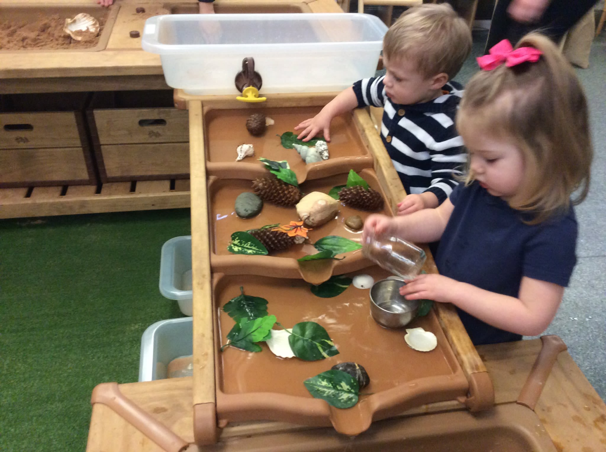

Contacts Information

Director of Education Mhairi Shaw 577 3481

Head of Service Janice Collins 577 3204

Quality Improvement Officer Pre 5 Rosamund Rodriguez 577 3222

Quality Improvement Officer
(Woodfarm Cluster) Charlie Johnstone 577 8346

Psychological Services Eilidh Lanzani 577 8510

Pre 5 Admissions Jennifer Ross 577 3288

East Renfrewshire Council General Enquiries 577 3000

Useful Links
Glen Family Centre:

Website: https://blogs.glowscotland.org.uk/er/Glen/

Twitter: https://twitter.com/Glen_FC

East Renfrewshire Council Policies and Links

Sending your child to Nursery (3-5years): http://www.eastrenfrewshire.gov.uk/article/1820/Sending-your-child-to-nursery

Complaints: http://www.eastrenfrewshire.gov.uk/index.aspx?articleid=1573

Child Protection: http://www.eastrenfrewshire.gov.uk/index.aspx?articleid=1923

Pre Birth to 3: http://www.educationscotland.gov.uk/earlyyears/prebirthtothree/

Building the Ambition: http://blogs.glowscotland.org.uk/er/curriculinks/

Curriculum for Excellence: http://www.educationscotland.gov.uk/thecurriculum/whatiscurriculumforexcellence/

Curriculum Links: http://blogs.glowscotland.org.uk/er/curriculinks/

Dyslexia: http://www.addressingdyslexia.org/

Emergency Closure of Schools and Establishments – Severe Weather Conditions: http://intranet.erc.insider/CHttpHandler.ashx?id=4193&p=0

ENABLE – ASN Support: http://www.enable.org.uk

ENQUIRE - ASN Support : http://enquire.org.uk/

ERC Website – general enquiries: http://www.eastrenfrewshire.gov.uk/index.aspx?articleid=1489

Inclusion: http://www.ea.e-renfrew.sch.uk/curriculinks/Links/Teachers/inclusion.htm

Internet Safety : http://www.ea.e-renfrew.sch.uk/curriculinks/Links/Parents/Parental%20Leaflets/Internet%20leaflet.pdf

Local improvement plan: http://www.eastrenfrewshire.gov.uk/local-development-plan

Psychological Services: https://blogs.glowscotland.org.uk/er/PsychologicalService/

Safe Use of ICT: http://www.ea.e-renfrew.sch.uk/curriculinks/Links/Parents/Parental%20Leaflets/Internet%20leaflet.pdf

School Holidays Dates:

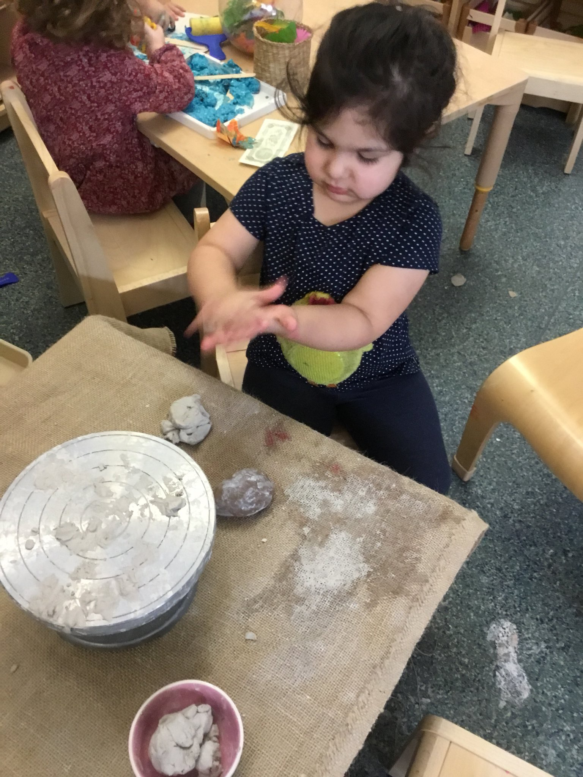
Twitter – East Renfrewshire: http://www.twitter.com/EastRenCouncil

Privacy notice – Education

Who will process your information?
The personal information you give to us through any of our forms relating to Education and any other pupil administrative information we hold about you in this context will be processed by East Renfrewshire Council, Eastwood Park Giffnock, G46 6UG for the administration of Education and any additional support you or your child may require.

Why do we process your information?
Your information is processed to help us administer education provision and related functions within East Renfrewshire. Your information may be shared with other departments within the council and other organisations for the same purposes and also to check the information we have is accurate; prevent and/or detect crime; and protect public funds. Other organisations may include bodies responsible for auditing or administering public funds, other councils, public sector agencies, government departments, exam bodies and other private companies or partners we use to process information and distribution services for the issue of correspondence.

What is the legal basis for us to process your information?
The council processes your information in order to perform a task carried out in the public interest and also to fulfil its legal obligations to ensure proper administration of the council’s financial affairs in terms of the Local Government (Scotland) Act 1973.

The law gives certain types of information special significance because of its sensitivity eg health information. If we process this type of information about you in relation to Education we do so on the basis that it is necessary for reasons of substantial public interest.

Do you have to provide your information?
Education needs your information to allow us to carry out public tasks in the public interest that is set out in law such as teaching in primary and secondary schools. It allows us to organise and administer classes, lunches, exams etc.

How do we collect information about you?
Most of the information the council holds about you will come from you as an individual and it provided at your first encounter with education whether it is applying for a place in an early learning and childcare establishment, support in the early years or applying for a place in one of our schools.

Such information includes:-
Child’s Forename
Child’s Surname
Child’s gender
School Stage
Details of child’s medical condition
Any other name child is known by
Child’s date of birth
Address including postcode
Mother’s/Carer’s Name
Father’s/Carer’s Name
Mother’s/Carer’s address including postcode
Father’s/Carer’s address including postcode
Mother’s/Carer’s telephone number
Father’s/Carer’s telephone number
Mother’s/Carer’s email address
Father’s/Carer’s email address
Single Parent/Carer family
Name of Brother/Sister
Date of Birth of Brother/Sister
School stage of Brother/Sister
Additional Information Support Application
School applying for
Preferred Alternative School
Early Learning and Childcare place applied for
Council Tax Evidence
Mortgage Statement
Rental Agreement
Rental Agreement End Date
Landlord Registration Number
Birth Certificate
Baptism Certificate
Date of Baptism
Name of Church venue
Child Benefit Statement
Utility Statements
Other Catchment Evidence

How long will we keep your information?
The council will hold your information from when your child first has contact with one of our services through to five year beyond them leaving school.

Who is your information shared with?
Your information will be accessed by council staff who need to do so to administer education and the many services that run alongside it. If such administration is provided on the council’s behalf by an external agency, that agency will also have access to your information. The information will be shared with SEEMiS, CRB, ParentPay, the Diocese of Paisley (in Roman Catholic schools), Scottish Government including their Analytical Services, Education Scotland, Glow (Scotland’s national education network), SQA, 2Cqr, BAM FM (Carlibar Primary, Barrhead Mearns Castle, Williamwood, Woodfarm High Schools), Bellrock FM (Mearns Primary and St Ninian’s High), Skills Development Scotland, Scholar (Heriot Watt University) and East Renfrewshire Culture and Leisure Trust.

The council also needs to ensure proper administration of its funds so details will be checked internally for fraud prevention and verification purposes. Information is also analysed internally in order to provide management information and inform future service delivery. Your information may also be shared with other departments within the Council. The council also generally complies with requests for specific information from other regulatory and law enforcement bodies where this is necessary and appropriate.

Do we transfer your information outside the UK?
In general we do not transfer personal information outside the UK but on the rare occasions we do we will inform you. We will only transfer information outside the UK when we are satisfied that the party that will handle the data and the country it is being processed in have adequate safeguards for personal privacy comparable to those which are in place in the UK.

Profiling and automated decision-making
The Education Department does not use profiling or automated decision-making for administration.

Your rights

You have the right to be informed of the council’s use of your information. This notice is intended to give you relevant information to meet this right.

Access personal data held about you

You have the right to access personal information the council holds about you by making what is known as a subject access request. You can receive a copy of your personal data held by the council, details on why it is being held, who it has been or will be shared with, how long it will be held for , the source of the information and if the council uses computer systems to profile or take decisions about you.

- Request rectification of your personal data

You have the right to request that the council corrects any personal data held about you that is inaccurate.

- Request that the council restricts processing of your personal data

You have the right to request that the council restricts processing your personal data if you think the personal data is inaccurate, the processing is unlawful, the council no longer need the personal data but you may need it for a legal purpose or you object to the council processing for the performance of a public interest task.

- To object to the processing of your data

You have the right to object to the council’s use of your personal data. The council will have to demonstrate why it is appropriate to continue to use your data.

Complaints
If you have an issue with the way the council handles your information or wish to exercise any of the above rights in respect of your information you can contact the council’s data protection officer by post at:

The Data Protection Officer
East Renfrewshire Council
Council headquarters
Eastwood Park
Giffnock
G46 6UG

or by email at DPO@eastrenfrewshire.gov.uk

You have the right to complain directly to the Information Commissioner’s office (ICO).
The address of their head office is:

Wycliffe House, Water Lane, Wilmslow, Cheshire, SK9 5EF
Telephone: 0303 123 1113

Alternatively, you can report a concern via their website at www.ico.org.uk
The ICO also have a regional office at:

45 Melville Street, Edinburgh EH3 7HI
Telephone: 0303 123 1115 e-mail: scotland@ico.org.uk

While you can go directly to the ICO, the council would welcome an opportunity to address any issues you have in the first instance.

