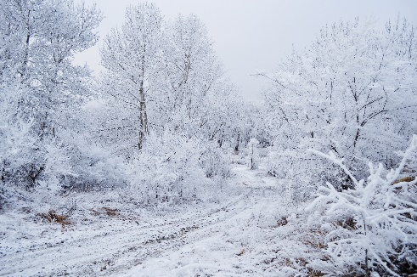 SEVERE WEATHER

On very rare occasions severe weather can lead to the emergency closure of the family centre.   The length of closure may vary from an early closure on an isolated occasion to full closure for one or more consecutive days.

It is the Education Department’s aim to maintain as full an education service as possible in times of emergencies but the health and wellbeing of children and staff will be the first consideration to put in place procedures for dealing with severe weather.

Unfortunately there may be occasions when emergencies make it necessary for children to be collected prematurely.  It is therefore important that Emergency Contact information is kept up-to-date, to enable the safe dismissal of children. For those who live some distance away it would be beneficial, where possible, to have a contact close to the family centre for situations such as heavy snowfall.

The [Council website](http://www.eastrenfrewshire.gov.uk/index.aspx?articleid=3831) will provide updates on the impact of adverse weather on Council services as will the Council’s [Facebook page](https://www.facebook.com/eastrenfrewshirecouncil)and [Twitter](https://twitter.com/EastRenCouncil) feed. The Local Radio will also provide regular updates.