How can we make it better?

Who was affected?

What were you feeling?

What happened?

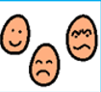

Talking time