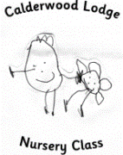 | Forest Schools  May 2016

Mon. | Tue. | Wed. | Thu. | Fri. | Sat. | Sun.
 |  |  |  |  |  | 1
2 | 3 | 4 | 5 | 6 | 7 | 8
 | AM: Group 1  PM: Group 6 |  | AM: Group 3  PM: Group 5
9 | 10 | 11 | 12 | 13 | 14 | 15
AM: Group 2

PM: Group 4
16 | 17 | 18 | 19 | 20 | 21 | 22
PM: Group 6 | AM: Group 1 |  | AM: Group 3  PM: Group 5
23 | 24 | 25 | 26 | 27 | 28 | 29
AM: Group 2
PM: Group 4

30 | 31  AM: Group 1  PM: Group 6
LL
notes

