Build Your Own Sandwich
14th March 2017

Starter

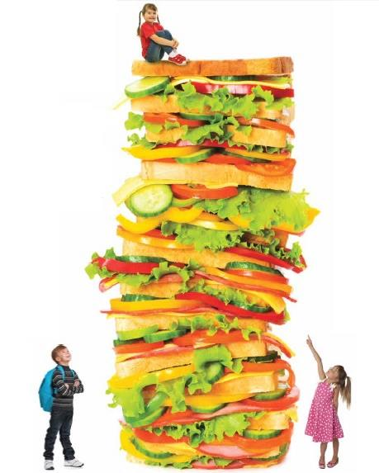
Sliced Melon

Select from the following range of breads

Flat Bread
Harvester
Wrap
Sliced bloomer

Pick your filling to build your sandwich

Chicken Tikka Mayonnaise
Grated cheese
Tuna mayonnaise
Sliced ham
Egg Mayonnaise
Sliced Turkey

Choose as much as you can eat
salad bowls

Diced peppers
Baton carrots
Sweetcorn
Tomato / Lettuce / Cucumber

Dessert Selection

Bite Size Shortbread & Tiffin
Fresh Fruit Platter

Assorted Drinks

