Education Department
Linda Fenn
Williamwood High School
Eaglesham Road
Clarkston
G76 8RF

Dear Parent/Carer

P3 SINGING GAMES AND RHYMES

Applications are now invited for all current P2 pupils wishing a place on the Singing Games and Rhymes programme starting in September 2017, at the Saturday Music Centre in Williamwood High School.

The course consists of three blocks of classes; two terms of 10 weeks and 1 term of 6 weeks, each weekly session lasting 30 minutes, and is designed to help develop throughout the year, a variety of skills through Kodaly based musicianship training, singing and musical games. If you would like your child to be considered for a place please complete the application form and return to Linda Fenn, no later than Monday 19 June 2017.

The cost for each term of 10 weeks is £40.00 and £24.00 for the 6 week term, with the first term starting on Saturday, 9th September 2017 – Saturday, 2nd December 2017 inclusive. The centre will be closed on Saturday 23rd September, 14th and 21st October 2017, for the school holidays. N.B. No monies should be included with your application form, as an invoice will be issued on confirmation of place.

Singing Games and Rhymes classes can take place at any time between 8.45am and 12.15pm. If you have a part of the morning that would be more suitable please indicate this on your application form and I will try to accommodate your request if at all possible.

Once all applications have been received a timetable of classes will be compiled and you will receive details of the time allocated to your child.

If you would like more information please do not hesitate to contact me on 0141 577 2568.

Yours faithfully

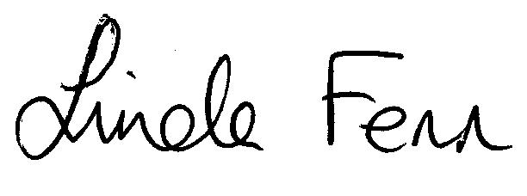
Linda Fenn
Co-ordinator -Saturday Music Centre & Instrumental Music Service

