Travelling Book

The Beautiful Butterfly And The Scary Spider

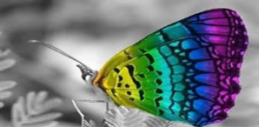
(N) Once upon a time there was a beautiful butterfly called Lyla. She had rainbow wings, a pink body with yellow spots and a red face. Lyla was flying to her house in a large apple forest when suddenly……………
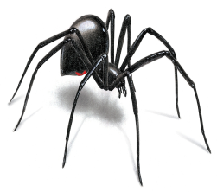
(P1) Peeking out behind a leaf was the most horrible, red-eyed, hairy, scary spider. The spider crept up the tree onto another leaf and spun a huge, big, sticky web. It was trying to catch the beautiful butterfly. Luckily the butterfly spotted the web and she managed to fly away from it BUT she had not seen the other webs her enemy spider had already spun on the other leaves……..
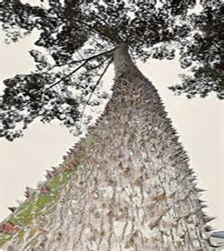
(P2) Poor Lyla was soon stuck in the group of sticky spider webs! This was a disaster! Just then, her friend Spot the Ladybird swooped down and knocked her out of the path of danger and the wriggly legs of the evil spider! The hairy monster then decided to quickly spin a super strength web to catch both Lyla and Spot. What were the two friends going to do?
(P3)As they were flying they were so busy talking about what to do next that they crashed into a hard, spiky tree. Suddenly they started to fall and went through a massive, dark hole in a green leaf. As they landed, they sighed in relief to be free of the scary spider. When they tried to get up they realised they were trapped! They found themselves stuck in a hairy, soft, sticky and strange-smelling web. Lyla and Spot started to struggle and fight the web but it seemed to be indestructible and invincible. Just then a group of red-eyed spiders approached…
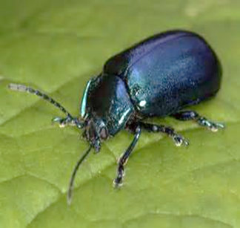
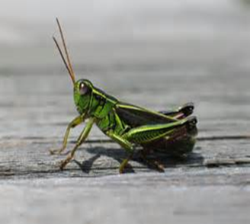
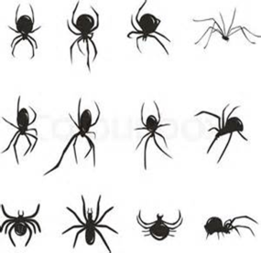
(P4)They were snarling and cackling like a bunch of mean old witches. The spiders nearly caught Lyla and Spot but they just managed to break free of the web in time. They then fell into another a web but luckily a grasshopper, Jeff, and beetle, Bob, were able to save them by catching them. However, Jeff and Bob had other plans for Lyla and Spot…
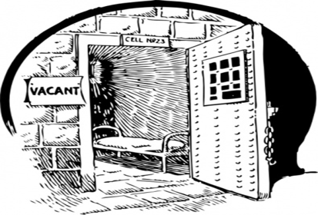
(P5a) Jeff and Bob put poor Lyla and Spot in silk handcuffs and marched them towards their secret insect prison. The secret insect prison was under the tallest tree in the forest. It was as dark as the night sky and smelt as bad as a skunk. Lyla and Spot saw lots of other bugs looking miserable and confused. Guards surrounded the prison and Lyla and Spot recognised the same red eyes that they had seen earlier in the day ……
(P5b) But, before the guards had a chance to lock Lyla and Spot in the secret insect prison, they froze in fear as they saw and heard the biggest army of ants they had ever seen swooping down and round about them, like a howling, swirling and suffocating wind. After untying the silk handcuffs and setting free Lyla and Spot, the ants swiftly made a magic bed with their bodies. ‘All aboard!’ cried General Antsome, the scariest and biggest ant they had ever seen. Lyla, Spot and all the other prisoners quickly jumped onto the magic carpet shouting cries of happiness. They were all so relieved to have escaped the horrors that lay before them that none of them heard the thunderous buzzing noise from the wasps’ nest that they had disturbed as they made their way through the trees. The angry buzzing grew louder and louder and angrier and angrier until….
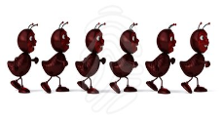
(P6) Stomp! Stomp! Stomp!
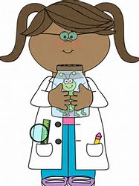
A herd of wild children from Braidbar Primary came bounding down the hill with a glass jar and a net. Inside the glass jar were lots of other insects.
The children scooped up the fleeing insects like scooping up ice-cream and took them carefully into the boiling classroom. They bounced around like hailstones on concrete as they were poured into a glass tank filled with sticks and leaves and other insects.
After a while, the terrified insects looked around their new environment. Gigantic colourful pencil cases, a massive white board and a large, hairy teacher with a booming voice like a ship’s horn.
“Time for Lunch! Line Up!” roared Mr McSnotters.
The children formed a line and filed out of the classroom. The class was empty, apart from the tankful of insects.
“We need to get out of here”, said Lyla.
“Here is my plan”
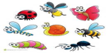
(P7) “One of us pretends to be dead…” After many whispers and agreements they came up with a plan. Lyla dropped to the floor and lay lifeless, her delicate wings pressing against the twigs and the dirt. The plan had begun.
As everyone was outside, two naughty boys crept into the classroom and stared into the tank. They spotted Lyla lying seemingly dead, opened the tank lid and gave her a fierce prod with a stick. As soon as the lid was open a large, thick cloud of insects swarmed out in anger, with Lyla leading the group to safety. All of a sudden one of the naughty boys closed the door. Then the other boy switched the lights on. Everyone was entranced by the bright lights, and the insects flew towards the blinding lights. Out of the blue one of the boys heard patting on the window. THE SPIDERS WERE BACK!!! As the boys took a short glance at the large hairy spider, their hair stood on end and they fled in terror, leaving all the insects to fly away.

