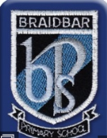
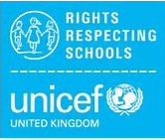
Rights Respecting Committee
Logo Competition
Winter 2016/17
Thank you for your fantastic, creative and varied responses to our design brief. It has been difficult to choose a winner. Listed below are some of the entries that really impressed us. Well done!

Highly Commended
P1: Finlay, Rhys, Nathan, and Iris
P2: Isla, Rayyan, Isobel, Andrew and Jack
P3:, Jacob and Robbie
P4: Matilda, Isla, Euan, Katie and Heather
P5a: Lucas, Arwaa, Harris and Ibrahim
P5b: Rayyan, Yasmin and Jack
P6: Catherine, Reeha, Hannan and Nathan
P7: Sadie, Hamza, Nathan H and Calum H
Runners Up
Kirstie (P7), Salihah (P3), Alex (P7), Ayman and Jack (P6), Stella (P3),
Tyler (P1), James (P1) and Mohammed (P3)
Overall Winners
Joint entry: Samuel and Ethan – P6

The winning entry!
