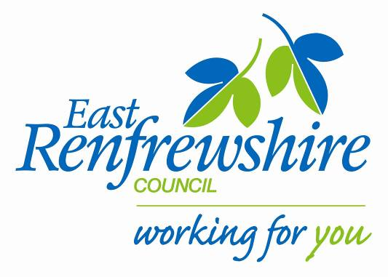
Education

Director: Mhairi Shaw, DCE
Council Headquarters,
211 Main Street,
Barrhead,
East Renfrewshire G78 1SY

Dear Parent/Carer

PLAY club: Primary 1/2s- February 2017.

As part of our NEW YEAR’S Active Schools after school programme running at Braidbar we are starting up a NEW PLAY CLUB for Primary 1 & 2. The club will start on Tuesday 7th February 2017.
See below for details:

Where: Braidbar Primary school (Gym Hall)
When: Tuesday Time 3.15-4.15pm
Dates: 7th, 21st, 28th Feb. 7th, 14th and 21st March 2017.
Bring: Gym kit, water bottle.

The club will consist of fun games that develop fundamental movement skills and physical activity levels. Our P7 Young Leaders will also be there and help lead the club as part of their course.

If your child is interested in attending, please complete the tear off slip below and return to the school office before Tuesday 1st February 2017.

There are only 16 places available so if there is a huge demand we will randomly select the pupils that can attend. Once we receive all the returns we will confirm with you if your child has been given a place at the club.
Yours sincerely,

Marie Baxter
Active School Co-ordinator (Woodfarm Cluster)

P1/2 PLAY CLUB-February 2017

My child is interested in attending the P1/2 PLAY club.

Name ……………………………………………. Class……………………………………………

