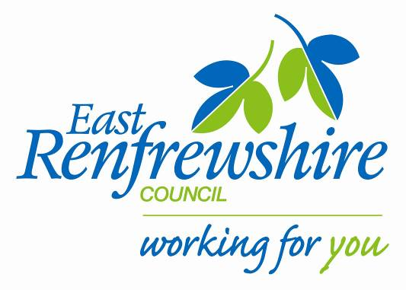
Education

Director: Mhairi Shaw, DCE
Council Headquarters,
211 Main Street,
Barrhead,
East Renfrewshire G78 1SY

Dear Parent/Carer

Girl’s Football club: Primary 4 & 5.

As part of our New Year’s Active Schools after school programme running at Braidbar primary we are starting up a NEW GIRLS Football club for Primary 4 and 5. Mrs Brown will be taking the club.
The club will start on Monday 16th January 2017.
See below for details:

Where: Braidbar Primary school (gym hall)
When: Monday Time: 3.15-4.15pm
Dates: 16th, 23rd & 30th January 2017. 6th February 2017.
Bring: Gym kit, water bottle.

If your child is interested in attending, please complete the tear off slip below and return to the school office before Monday 9th January 2017.

There are only 16 places available so if there is a huge demand we will randomly select the pupils to attend. Once we receive all the returns we will confirm with you if your child has been given a place at the club.
Yours sincerely,

Marie Baxter
Active School Co-ordinator (Woodfarm Cluster)

After school GIRLS Football Club: January 2017.

My child is interested in attending the P4/5 GIRLS Football club.

Name ……………………………………………. Class……………………………………………

