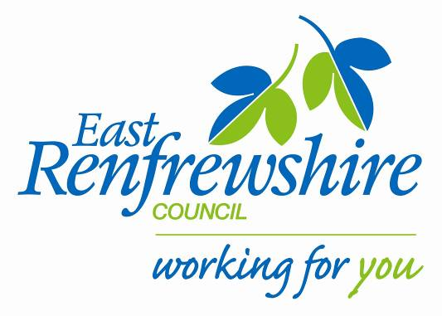
Education

Director: Mhairi Shaw, DCE
Council Headquarters,
211 Main Street,
Barrhead,
East Renfrewshire G78 1SY

Dear Parent/Carer

Braidbar Fitness club: Primary 4/5.

As part of our NEW YEAR’S Active Schools after school programme running at Braidbar we are starting up a NEW Fitness club for P4/5s. The club will be delivered by Mr Gordon. The club will start on Tuesday 10th January 2017.
See below for details:

Where: Braidbar Primary school (gym hall)
When: Tuesday Time: 3.15-4.15pm
Dates: 10th, 17th, 24th 31st January 2017.
Bring: Gym kit, water bottle.

If your child is interested in attending, please complete the tear off slip below and return to the school office before Friday 6th January 2017.

There are only 20 places available so if there is a huge demand we will randomly select the pupils to attend. Once we receive all the returns we will confirm with you if your child has been given a place at the club. Please do not bring any money in at this stage.
Yours sincerely,

Marie Baxter
Active School Co-ordinator (Woodfarm Cluster)

After school Fitness club JANUARY 2017- P4/5

My child is interested in attending the P4/5 Fitness club.

Name ……………………………………………. Class……………………………………………

