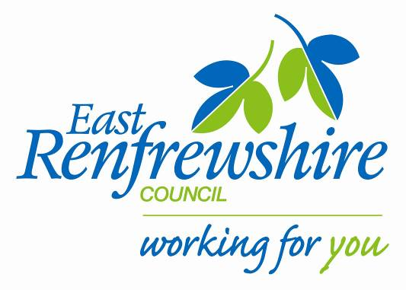
Education

Director: Mhairi Shaw, DCE
Council Headquarters,
211 Main Street,
Barrhead,
East Renfrewshire G78 1SY

Dear Parent/Carer

Woodfarm Primary Cricket club: Primary 5, 6 / 7

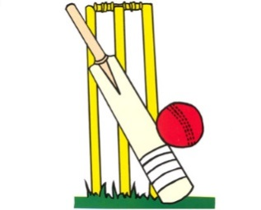
As part of our Active Schools after school programme running across the Woodfarm cluster we are starting up the cluster Cricket Club this term for P5,6/7 pupils. The club will be delivered by coaches from East Renfrewshire Cricket Club and will be held at Woodfarm High school. The club will start on Thursday 2nd February 2017.
See below for details:

Where: Woodfarm High School (outside cages across from school)
When: Thursday Time: 5-6pm
Dates: 2nd, 9th, 16th, 23rd February 2017. 2nd & 9th March 2017.
Bring: Gym kit, water bottle.

If your child is interested in attending, please complete the tear off slip below and return to the school office before Friday 20th January 2017. The cost is £12.00 for the block.

There are limited places available so if there is a huge demand we will randomly select the pupils to attend and aim to ensure those who have not attended a club to be given priority. Once we receive all the returns we will confirm with you if your child has been given a place at the club with a confirmation letter.
Yours sincerely,

Marie Baxter
Active School Co-ordinator (Woodfarm Cluster)
07800620690
Baxterm1@ea.e-renfrew.sch.uk

Woodfarm Cricket Club- P5 ,6 /7: February 2017.

My child is interested in attending the P5, 6/7 cricket club.

Name ……………………………………………. Class……………………………………………

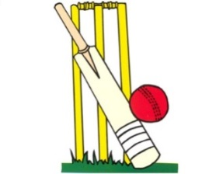
School…………………………………….

