1 | Explain what sustainability means  Rainforests
2 | Analyses possible implications for people and the world if deforestation continues at the same rate
3 | Explains how the control of important raw materials such as deforestation can affect the international power and influence of countries such as Brazil
4 | Explain the impact of Fair-trade in a chosen area and beyond.
5 | In relation to fair-trade, explain the interdependence of countries and areas of the world and assesses the impact on providers, consumers and the environment.
6 | Evaluate the sustainability of rainforests and analyse possible implications for human activity if they are destroyed
7 | Explain the process of shifting cultivation
8 | Explain the term subsistence farming
9 | Discuss strategies used to overcome deforestation and comment on their sustainability
10 | Explain the relationship between the rainforest and its climate

Gold questions – 1 point
Green questions - 2 points

1 | Name the 4 layers of the rainforest | 16 | Explain 2 impacts of deforestation on people  Rainforests
2 | Name an animal you’d find in the forest floor and say why it’s found here. | 17 | Explain 2 impacts of deforestation on the landscape
3 | Name an animal you’d find in the canopy and say why it’s found here. | 18 | Give any 2 facts you have learnt about the rainforest
4 | Name an animal you’d find in the emergent layer and say why it’s found here. | 19 | Explain 2 ways we can conserve the rainforests
5 | Name 2 continents where you would find tropical rainforests | 20 | What is fair-trade?
6 | Name the country and continent you would find the Amazon rainforest | 21 | Explain 2 impacts of deforestation on the landscape
7 | Describe the weather in Tropical rainforests | 22 | Describe 2 benefits of fair-trade on the people and environment
8 | How do tribes in the rainforest hunt? | 23 | What does conservation mean?
9 | How do tribes in the rainforest farm? | 24 | Give 3 reasons why rainforests are so hot.
10 | What is deforestation? | 25 | Describe slash and burn
11 | What is cattle ranching and how does it lead to deforestation? | 26 | Describe the weather in Tropical rainforests
12 | What is palm oil and how does it lead to deforestation? | 27 | Give any 2 facts you have learnt about the rainforest
13 | What is mining and how do it lead to deforestation? | 28 | Explain 2 ways we can conserve the rainforests
14 | What are dams and how do they lead to deforestation? | 29 | Give 3 reasons why rainforests are so hot.
15 | Explain 2 impacts of deforestation on animals | 30 | Explain 2 impacts of deforestation on the landscape

1 | Describe how plates move at destructive plate margins
2 | Describe how plates move at constructive plate margins  Environmental Hazards
3 | Describe how plates move at conservative plate margins
4 | What is the role of convection currents?
5 | Describe the conditions at the 4 layers of earth
6 | Look at map 1; describe the distribution of volcanoes and earthquakes. Mention 4 points
7 | How can the role of aid reduce the impact of an earthquake? Mention 4 points
8 | Explain in detail the difference between long term and short term aid
9 | Describe 3 ways to predict an earthquake
10 | For an earthquake you have studied, explain the impact of the earthquake on the people and landscape affected. You should include facts/statistics in your answer. Mention 6 points

Gold questions – 1 point
Green questions - 2 points

1 | Describe 3 ways the Japan earthquake and Tsunami affected people in the country
2 | Describe 3 ways the Japan earthquake and Tsunami affected the environment in the country
3 | Describe 3 ways the Japan earthquake and Tsunami affected the economy in the country  Environmental Hazards
4 | Give 2 examples of short term aid
5 | Give 2 examples of long term aid
6 | Suggest 3 ways more developed countries such as Japan can prepare for earthquakes
7 | Look at the map 1. Name two countries where you would find tectonic activity.
8 | Look at map 1, which coast of North and south America would you find more volcanoes and earthquakes?
9 | Look at map 2, name 2 different tectonic plates
10 | Look at map 2, name 2 a volcano in South America
11 | Look at map 2, name 2 a volcano in North America
12 | Look at map 2, name 2 a volcano in South East Asia
13 | Approx 300m years ago all the continents joined together to form one super continent. What was this called?
14 | Which ocean would you find the ring of fire surrounding?
15 | True or false: The ring of fire is home to 80% of all the world’s volcanoes.

Map 1

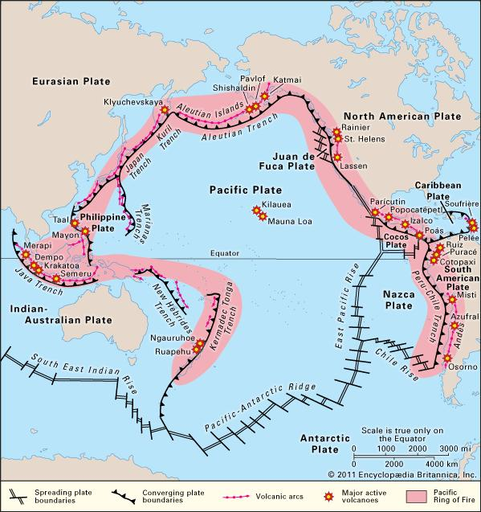
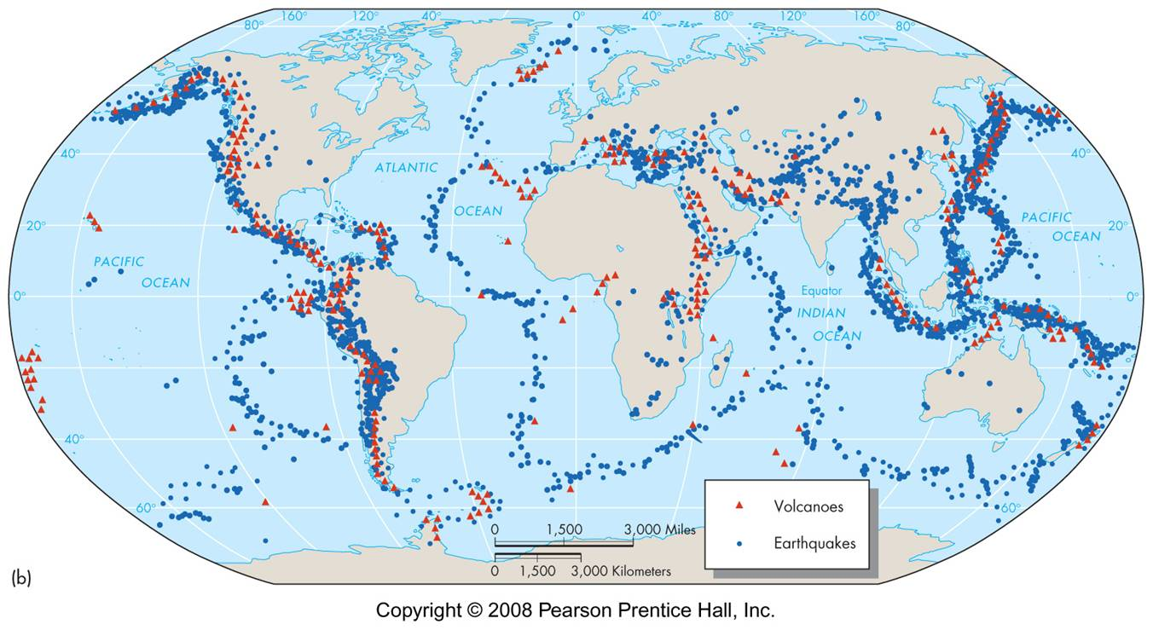

Map 2

