|  |  |  |
| --- | --- | --- |
| **1** | **What is the name of a river in India** | **Define the term irrigation** |
| **2** | **Name a country that borders India** | **What does infant mortality rate mean?** |
| **3** | **Name a sea that surround India** | **What possible 3 problems might the population of India face in 2050?** |
| **4** | **Name 2 cities in India** | **What possible 3 problems might the population of UK face in 2050?** |
| **5** | **What continent is India found in?** | **Explain, in detail, the formation of the Monsoon** |
| **6** | **Name 2 cities in Scotland** | **Give 3 reasons why people tend to living longer in Developed countries** |
| **7** | **Name a sea that surround Scotland** | **Give 2 ways farming can become more sustainable in the UK** |
| **8** | **What continent is Scotland found in?** | **Explain 2 impacts of shanty towns for the people of Dharavi** |
| **9** | **Name a 2 rivers in Scotland** | **Compare and contrast the population structures for India 2014 and UK 2010** |
| **10** | **Name an Island in Scotland** | **Explain links between weather and air pressure** |

Red Questions – 1 point

Gold questions – 2 points

Green questions - 3 points

|  |  |  |  |
| --- | --- | --- | --- |
| **1** | **Give 3 reasons why Indian families are larger than Scottish families** | **16** | **Name country A** |
| **2** | **Describe 3 things about the population pyramid for India in 2014** | **17** | **Name country B** |
| **3** | **Describe 3 things about the population pyramid for India in 2010** | **18** | **Name country C** |
| **4** | **Give 2 reasons why a country might have a high birth rate** | **19** | **Name city 1** |
| **5** | **Give 2 reasons why a country might have a low birth rate** | **20** | **Name city 2** |
| **6** | **Give 2 reasons why a country might have a high death rate** | **21** | **Name mountain range 3** |
| **7** | **Give 2 reasons why a country might have a low birth rate** | **22** | **Name sea E** |
| **8** | **Describe 2 characteristics of the monsoon** | **23** | **Name sea F** |
| **9** | **Identify 3 impacts of accessing poor quality water in developing countries** | **24** | **Name country D** |
| **10** | **Describe 4 problems of living in a shanty town** | **25** | **What does literacy rate show?** |
| **11** | **Describe 3 solutions to overcome the problems of living in a shanty town** | **26** | **Identify 3 reasons why Scotland is more developed than India** |
| **12** | **Describe 3 characteristics of a farm landscape in India** | **27** | **What does the birth rate show?** |
| **13** | **Describe 3 characteristics of a farm landscape in the UK** | **28** | **What is the difference between Weather and Climate?** |
| **14** | **Identify 4 ways people use the river Ganges** | **29** | **Describe one strategy used to overcome water related issues in developing countries** |
| **15** | **Define the term life expectancy** | **30** | **What does a line graph and a bar graph show on a climate graph?** |

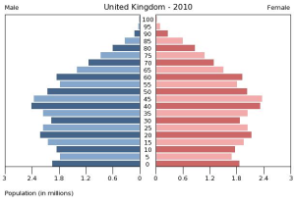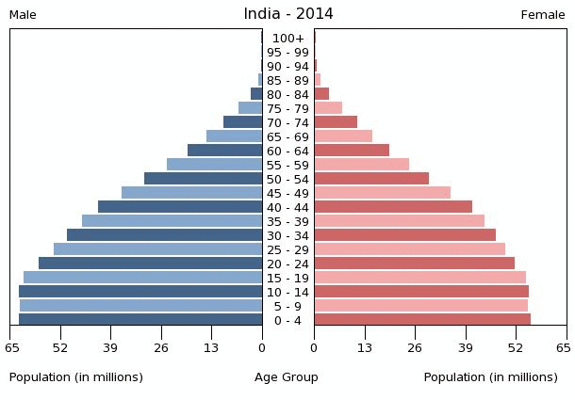

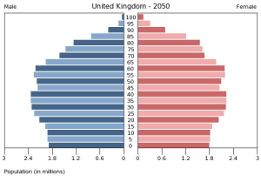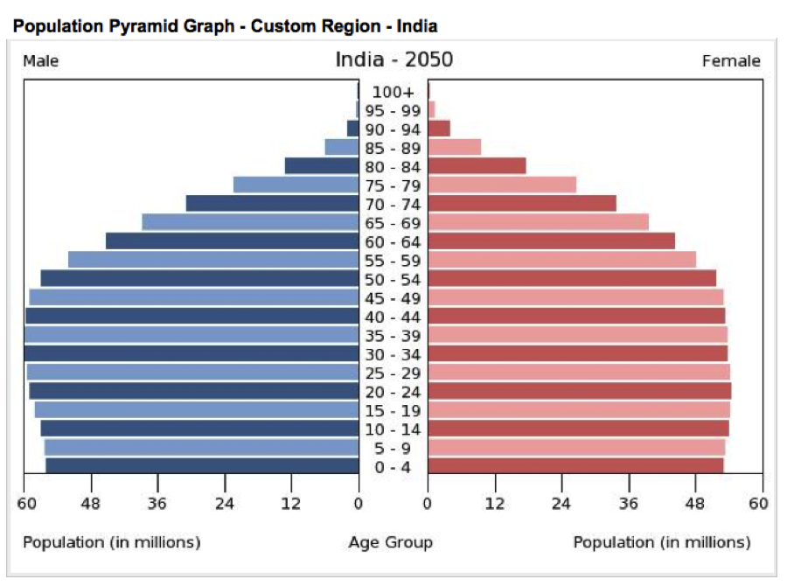

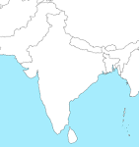

**3**

**2**

**1**

**F**

**E**

**D**

**C**

**B**

**A**

|  |  |  |
| --- | --- | --- |
| **1** | **What does a blue duck show on the map?** | **Which site would you choose to build a new out of town shopping centre? A,B,C,D (Give 3 reasons for your choice)** |
| **2** | **Give the 2 four figure grid references for the word bishopbriggs** | **Give a 6 figure grid reference for a station** |
| **3** | **What do the red lines show on a map?** | **Give a 6 figure grid reference for parking** |
| **4** | **What are the names of the lines used to show height on a map?** | **Give a 6 figure grid reference for a Loch** |
| **5** | **Give a 4 figure grid reference for a golf course** | **What would you find in GR 662705?** |
| **6** | **Give a 4 figure grid reference for a station** | **What would you find in GR 616725?** |
| **7** | **Give a 4 figure grid reference for Stepps** | **Would it be a good idea to build new houses at 595712? Give 2 reasons for your answer.** |
| **8** | **Give a 4 figure grid reference for your house** | **Use the scale line to calculate the distance in km from A to D** |
| **9** | **Give a 4 figure grid reference for the school** | **Use the scale line to calculate the distance in km from B to C** |
| **10** | **What direction would you be going if you walked from A to B** | **Give a 6 figure grid reference for a school** |
| **11** | **What direction would you be going if you walked from B to C** | **What would you find in GR 583679?** |
| **12** | **What direction would you be going if you walked from D to A** | **Give a 6 figure grid reference for a hospital** |
| **13** | **What evidence is there of a medieval past in GR 6172?** | **Give a 6 figure grid reference for a cathedral** |
| **14** | **What is the name of the farm in GR 5772** | **Give a 6 figure grid reference for a cemetery** |
| **15** | **What is the name of the motorway in 6468?** | **Give a 4 figure grid reference for the forth and Clyde canal** |



**D**

**C**

**B**

**A**