Nationals Geography

Personal learning Plan

Name _______________
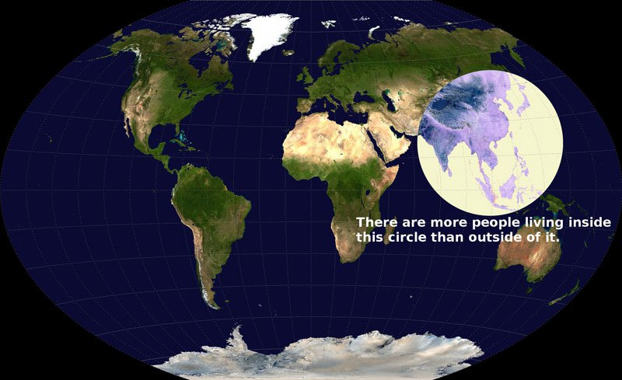
Checklist | I am good at... | I’m not sure about... | Skills Developed
Describe and explain the characteristics of each urban zone. (3 zones)
E.g. In the CBD you would find high order comparison shops. This is because there is a high footfall in the CBD so lots of customers are passing

Explain the changes in the CBD in the past 30 years

Explain the changes in the inner city in the past 30 years (How have authorities attracted people back to the inner city.)

Describe the threats to the greenbelt, impacts of building here and ways to protect this area

Describe location factors of shopping centres and their adv/diadv

Describe causes AND solutions to traffic congestion in GLASGOW

Describe the characteristics of a shanty town and the problems they causes AND identify solutions to help improve shanty towns in Rio

I have developed my literacy skills in this topic by.....

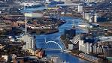
Urban Topic
Human Topics
Parent Comment

Teacher Comment

Rural Topic
Human Topics
Checklist | I’m good at …….. | I’m not sure about……. | Skill development
- Describe the location, land use pattern and main characteristics of extensive commercial farming (CASE STUDY: East Anglia)

- Describe new technology and methods used on farms, diversification & government influence in the East Anglia

- Explain why these changes were necessary

- Describe the location, land use pattern and main characteristics of intensive peasant farming (CASE STUDY: SE ASIA)

- Describe new technology and methods used on farms in SE Asia

- Explain why these changes were necessary
- Outline the advantages and disadvantages on the Green Revolution

Pupil Comment
Teaching Methods I enjoy are......

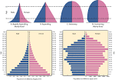
Parent Comment

Teacher Comment

Population Topic
Human Topics
Checklist | I’m good at …….. | I’m not sure about……. | Skill development
- Explain how social and economic indicators of development illustrate a country’s level of development.

- Physical and Human factors influencing global population distribution

- Explain factors influencing reasons for High and low birth rates AND high and low death rates

- Interpret population models such as Demographic Transition Model AND Describe and Explain population pyramids

I have developed my numeracy skills by..........

Parent Comment

Teacher Comment

2 things I can work on after my assessment are...

2 things I did well in my assessment are...

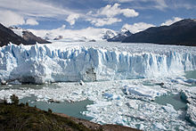
Glaciation Topic
Physical Topics

Outcome | I’m good at …….. | I’m not sure about……. | Notes
Identifying features on O.S maps

Describe and explain formation of features using diagrams

Explain why land uses are suited to Loch Lomond

Explain conflicts between land users in Loch Lomond

Explain solutions adopted to deal with identified land use conflicts

I am good at………………
1.
2.
3.
I can improve by ……..
1.
2.
Parent Comment

Teacher Comment

Coasts Topic
Physical Topics

Outcome | I’m good at …….. | I’m not sure about……. | Notes
Identifying features on O.S maps

Define types of erosion
Describe and explain formation of EROSIONAL features using diagrams (headland and bay, cave to stack, wave cut platform)

Explain process of longshore drift

Describe and explain formation of DEPOSITIONAL features (Spit, bar, tombol0)

Preparing for exam:
What should i focus on to prepare for a coasts question in the final exam?

Teacher Comment

Parent Comment

Physical Topics
Weather Topic
What do I need to know? | Completed | I’m not sure about… | Skill Development
Use climate information to construct a climate graph
-Choosing suitable scale
-Plotting graphs for Precipitation and temperature
Weather circles
Identify 5 weather characteristics from a weather circle, Understand symbols, Use written information to draw a weather circle
Factors affecting weather
-Latitude (Albedo, curvature of earth, depth of atmosphere)
-Relief/altitude (height of land)
-Distance from sea
-Aspect north or south facing
-Ocean currents/distance to the sea
Air masses
- 5 types of air mass

Depressions (low pressure)
- Temperature, cloud, rainfall at each of the 5 stages of a depression
Anticyclone (high pressure)
- Weather characteristics associated with anticyclone in winter and summer
Pupil Comment

Parent Comment

Teacher Comment

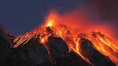
Environmental Hazards
Volcanoes | Completed | I’m not sure about | Am good at
Explain the formation of Volcanoes
- Constructive Plates
- Destructive plates
Describe the worldwide distribution of Volcanoes
Mt St Helens
- Prediction methods
- Effectiveness of prediction methods
Effect of eruption on
- People
- Environment
- Economy
Examples and effectiveness of
- Short term aid
- Long term aid
Earthquakes | Completed | I’m not sure about | I now understand
Explain the formation of earthquakes
- Conservative (sliding plates)
Describe the worldwide distribution of earthquakes
Haiti
- Prediction methods
- Effectiveness of prediction methods
Effect of eruption on
- People
- Environment
- Economy
Examples and effectiveness of
- Short term aid
- Long term aid

Global Issues
Tropical Storms | Completed | I’m not sure about | I now understand
Explain the formation of Tropical Storms
- Sea temp
- Hot humid surface water
- Air pressure
- Earth rotation
- Direction of movement
- Dies out
Describe the worldwide distribution of tropical storms
Hurricane Katrina
- Prediction methods
- Effectiveness of prediction methods
- Impact on people and environment
- Short and long term aid required and their effectiveness

Global Issues
Health

What do I need to know? | Completed | I’m not sure about… | I am good at
You will study 4 different Health case studies:
- Aids in a developing area – Africa
- Aids in a developed area –
- Developing countries disease – Malaria
- Developed country disease – Heart Disease
For each of the 4 case studies listed above you will need to know
- Causes of the disease (what factors contribute to it spreading)
- Effects of the disease on people (social) and economy (money)
- Strategies adopted to manage the disease (how can the disease be overcome) and the effectiveness of these measures

Course Evaluation
What teaching methods did you find most useful?

Do you feel past paper questions reinforced your learning? Please explain……

What areas were the most challenging?

What would you like to see more or less of?

Do you feel you were provided with enough revision material and time to revise during this topic? Give reasons for your answer

