1 | Describe how latitude affects Britain’s weather? | Explain the three processes of glacial erosion. | Explain the four processes of coastal erosion.
2 | Name the five air masses and associated weather. | Draw a diagram for the formation of a corrie. | Look at map 2. Give a 6 figure grid reference for a stack
3 | Explain the impacts of a prolong spell of tropical continental and arctic maritime air masses | Draw a diagram for the formation of a U-shaped valley | Look at map 2. Give a 6 figure grid reference for a headland and bay
4 | How does altitude affect the weather in the UK? | Draw a diagram for a pyramidal peak | Explain the formation of a stump.
5 | How does distance from sea influence the weather in the UK? | What is the name of the case study for a glaciated landscape? | Explain the formation of a bay.
6 | Outline the five stages of a depression. | Why is hill sheep farming suited to a glaciated landscape? | Explain the formation of a cliff.
7 | In which direction do the winds blow in a depression and an anticyclone? | Explain why tourism and recreation are suited to a glaciated landscape? | Explain the formation of a beach.
8 | Draw the symbols for a warm front, cold front and an occluded front. | Outline how two land users may be in conflict in a glaciated landscape. | Explain the formation of a spit.
9 | Describe and explain the weather in the warm sector. | Describe strategies that are used to manage conflicts in glaciated areas | Draw the diagrams for the formation of a stump.
10 | Compare the weather at the cold front and the warm front. | Explain in detail the formation of a corrie. | Draw the diagrams for the formation of a headland.
11 | Describe the weather associated with an anticyclone in winter and in summer. | Explain in detail the formation of a u-shaped valley. | Draw the diagrams for long shore drift.
12 | Draw a weather station circle for today’s weather. | Look at the map 1 on the back. Give a 6 figure grid reference for a corrie. | Why is hill sheep farming suited to a glaciated landscape?
13 | What do isobars tell you about the weather? | Look at the map 1 on the back. Give a 6 figure grid reference for a U shaped valley | Explain why tourism and recreation are suited to a glaciated landscape?
14 | What weather patterns are associated with high and low pressure? | Look at the map 1 on the back. Give a 6 figure grid reference for a ribbon lake | Outline how two land users may be in conflict in a glaciated landscape.
15 | Explain the changes that happen as a depression passes over the UK. | Look at the map 1 on the back. Give a 6 figure grid reference for a hanging valley | Describe strategies that are used to manage conflicts in glaciated areas

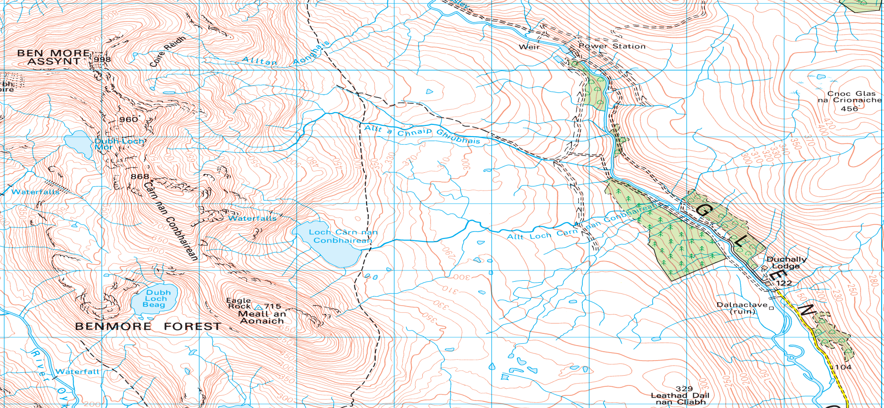
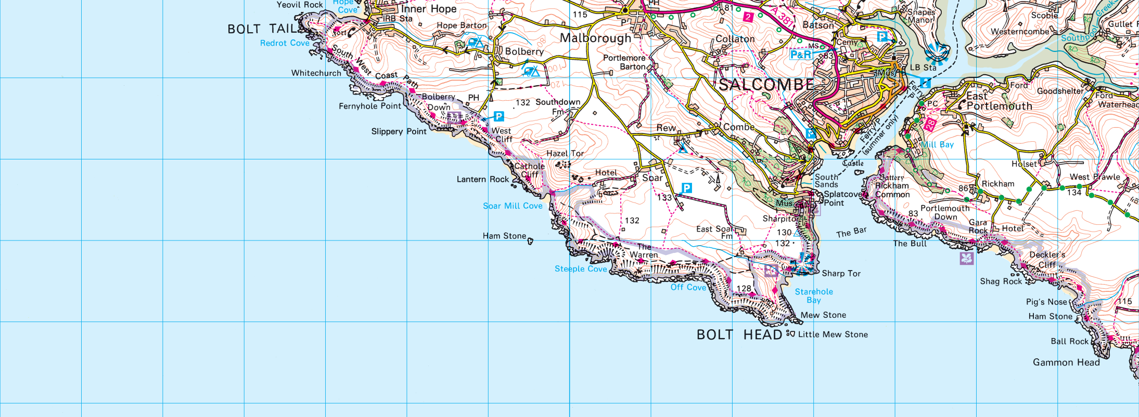
Map 2
Map 1
[Type a quote from the document or the summary of an interesting point. You can position the text box anywhere in the document. Use the Text Box Tools tab to change the formatting of the pull quote text box.]
[Type a quote from the document or the summary of an interesting point. You can position the text box anywhere in the document. Use the Text Box Tools tab to change the formatting of the pull quote text box.]
[Type a quote from the document or the summary of an interesting point. You can position the text box anywhere in the document. Use the Text Box Tools tab to change the formatting of the pull quote text box.]

# | Red urban | Yellow rural | Green population
1 | Explain 2 advantages and 2 disadvantages of out of town shopping centres | Describe the 4 characteristics of a rice farming landscape | Give 3 reasons why country would have a low birth rate
2 | Describe and explain 2 features of the CBD | Name 2 advantages of HYV seeds | Give 3 reasons why country would have a high birth rate
3 | Describe and explain 2 features of the inner city | Give 2 disadvantages of HYV seeds | Give 3 reasons why country would have a low death rate
4 | Describe and explain 2 features of the suburbs | Give 2 disadvantages of increased technology in rice farming | Give 3 reasons why country would have a high birth rate
5 | Explain 3 ways the rural-urban fringe can be protected | Give 2 advantages of increased technology in rice farming | Explain 2 physical factors that leads to an area being sparsely populated
6 | Explain 3 changes in the CBD | Give 2 advantages and 2 disadvantages of increased tourism in rural regions | Explain 2 physical factors that leads to an area being densely populated
7 | Explain 3 changes in the inner city | Discuss the impacts of Bio fuels in rural regions in developing countries | Explain 2 human factors that leads to an area being sparsely populated
8 | Describe 3 ways the rural – urban fringe is under threat | Discuss the impacts of fertilisers and pesticides in rural regions in developing countries | Explain 2 human factors that leads to an area being sparsely populated
9 | Describe 4 problems found of living in shanty towns | Explain the impacts of increased field size in East Anglia. | Describe 2 economic indicators of development
10 | Explain 4 solutions to the problems in shanty towns | Give 2 reasons why a farmer would diversify | Describe 2 social indicators of development
11 | What is the Urban Developed country case study? What is the Urban Developing country case study? | How has increased technology changed farming in East Anglia? Give 2 reasons. | Give reasons for the differences in population structure between Japan and India
12 | Describe 4 solutions to traffic congestion in Glasgow | How has Government Policies influenced farming in East Anglia? Give 2 reasons. | Describe and explain the population pyramid of India
13 | Describe 3 location factors required for an out of town shopping centre | Give 2 reasons of organic farming | Describe and explain population pyramid of Japan
14 | Describe 4 causes of traffic congestion in Glasgow | Explain why a farmer would use GM seeds in East Anglia | Look at the DTM, explain the changes in either the Birth or death rate
15 | What impact does urban sprawl have on rural areas. | What is a subsidy? | Choose one stage of the DTM. Describe and explain this stage

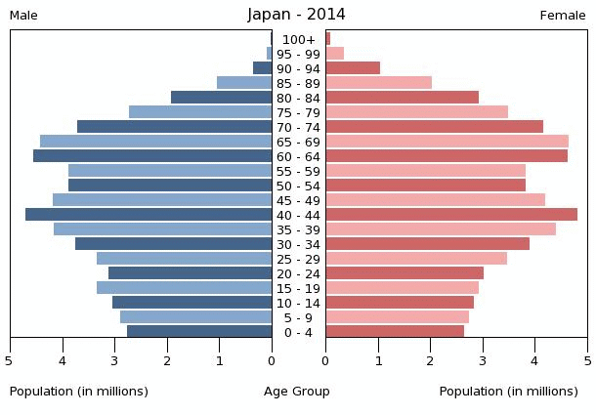
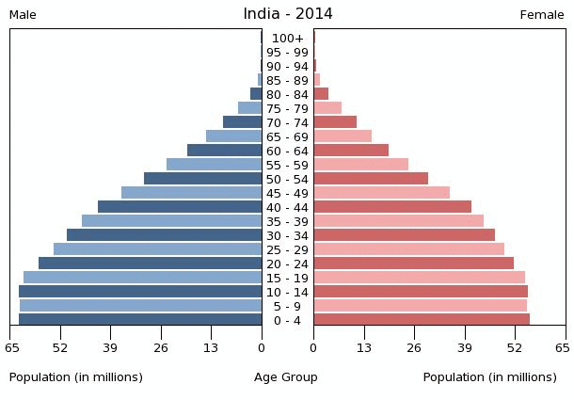

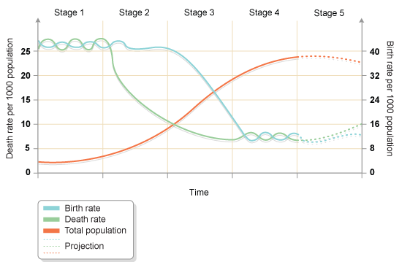
# | Red Hazards | Green Health
1 | Explain the formation of volcanoes | Describe the distribution of worldwide AIDS rates
2 | Explain the formation of earthquakes | Describe the distribution of worldwide infant mortality rates
3 | Explain the formation of tropical storms | Explain 4 causes of Heart Disease
4 | Describe the distribution of tectonic activity on the map | Explain 4 ways Malaria is transmitted
5 | Describe the distribution of tropical storms on the map | Explain 4 ways Aids is transmitted
6 | Describe 3 methods to predict a volcanic eruption | Describe 4 ways Heart Disease impacts the people and economy of a country
7 | Describe 3 methods to predict a tropical storm | Describe 4 ways Malaria impacts the people and economy of a country
8 | For Mt St Helens, give 5 ways the eruption impacted the people and the landscape. | Describe 4 ways Aids impacts the people and economy of a country
9 | Explain 3 types of aid required after any hazard | Explain 4 strategies used to reduce Heart Disease
10 | For Haiti Earthquake, give 5 ways the eruption impacted the people and the landscape. | Explain 4 strategies used to reduce Aids
11 | For Hurricane Katrina, give 5 ways the eruption impacted the people and the landscape. | Explain 4 strategies used to reduce Malaria
12 | Was the aid given after Mt St Helens effective? | Comment on the effectiveness of 3 methods used to reduce Heart Disease
13 | Was the aid given after Katrina effective? | Comment on the effectiveness of 3 methods used to reduce Malaria
14 | Was the aid given after Haiti quake effective? | Comment on the effectiveness of 3 methods used to reduce Aids
15 | Give 3 positive effects a volcanic eruption can have | Describe 3 physical and 3 human causes that result in disease being spread

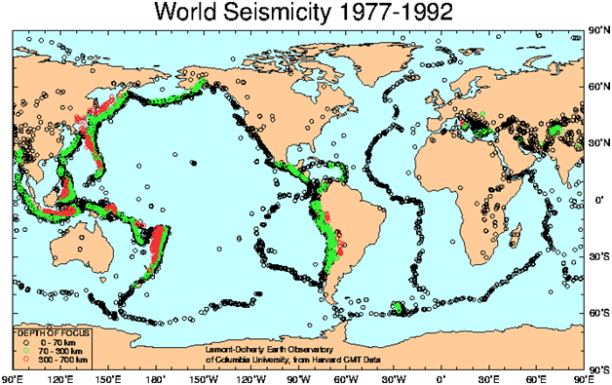
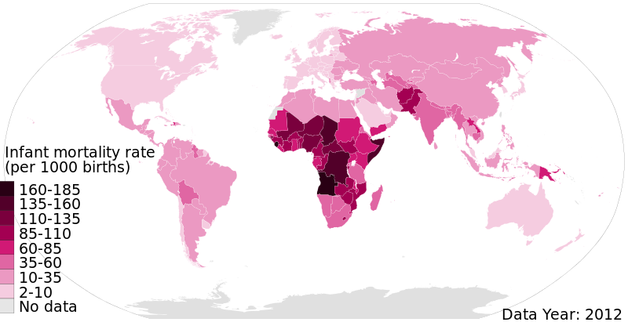
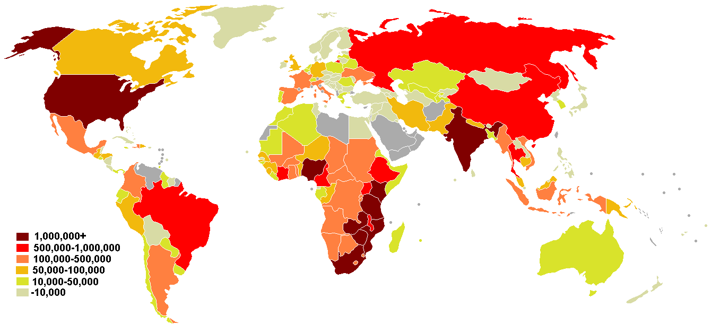
Volcano and earthquake Distribution
Aids Distribution

