|  |  |  |  |
| --- | --- | --- | --- |
| **1** | **Explain why the earth only receives 50% of solar energy** | **Explain the three processes of glacial erosion.** | **Explain the four processes of coastal erosion.** |
| **2** | **Explain the movement of energy by the Hadley cell** | **Draw a diagram and explain formation of a corrie.** | **Look at map 2. Give a 6 figure grid reference for a stack** |
| **3** | **Explain the movement of energy by the polar cell** | **Draw a diagram and explain formation of a U-shaped valley** | **Look at map 2. Give a 6 figure grid reference for a headland and bay** |
| **4** | **Explain the movement of energy by the ferrel cell** | **Define the term leaching** | **Explain the formation of a stump.** |
| **5** | **Give 4 reasons to explain how ocean currents redistribute energy around the world.** | **Define the term capillary rise** | **Draw an annotated diagram of a brown earth soil** |
| **6** | **Why is there a surplus of energy at the equator and deficit at the poles** | **Explain 4 characteristics of a brown earth soil** | **Explain the formation of a cliff.** |
| **7** | **In relation to the ITCZ describe 3 characteristics of tropical maritime air mass** | **Draw an annotated diagram of a gley soil** | **Explain the formation of a bar.** |
| **8** | **In relation to the ITCZ describe 3 characteristics of tropical continental air mass** | **Outline how two land users may be in conflict in a glaciated landscape.** | **Explain the formation of a spit.** |
| **9** | **Explain the impact of the ITCZ on the countries affected** | **Describe strategies that are used to manage conflicts in glaciated areas** | **Draw an annotated diagram of a podzol** |
| **10** | **Draw an annotated diagram of the hydrological cycle** | **Explain in detail the formation of eskers** | **Explain the process of longshore drift** |
| **11** | **Explain the movement of water through a drainage basin mention inputs, outputs, storage and transfers** | **Explain in detail the formation of terminal moraine** | **Explain the formation of a tombolo.** |
| **12** | **Explain the impact human activities can have on the hydrological cycle** | **Look at the map 1 on the back. Give a 6 figure GR for a corrie and U Shaped Valley** | **How can tourists be in conflict with other land users in coastal areas?** |
| **13** | **Explain 3 factors that would influence a hydrograph in a rural area** | **Explain 4 characteristics of a podzol soil** | **Explain 4 characteristics of a gley soil** |
| **14** | **Explain 3 factors that would influence a hydrograph in an urban area** | **Look at the map 1 on the back. Give a 6 figure grid reference for a ribbon lake** | **Outline how two land users may be in conflict in a coastal landscape.** |
| **15** | **Define 3 key terms from a hydrograph** | **Look at the map 1 on the back. Give a 6 figure grid reference for a hanging valley** | **Describe 3 strategies that are used to manage conflicts in coastal areas** |

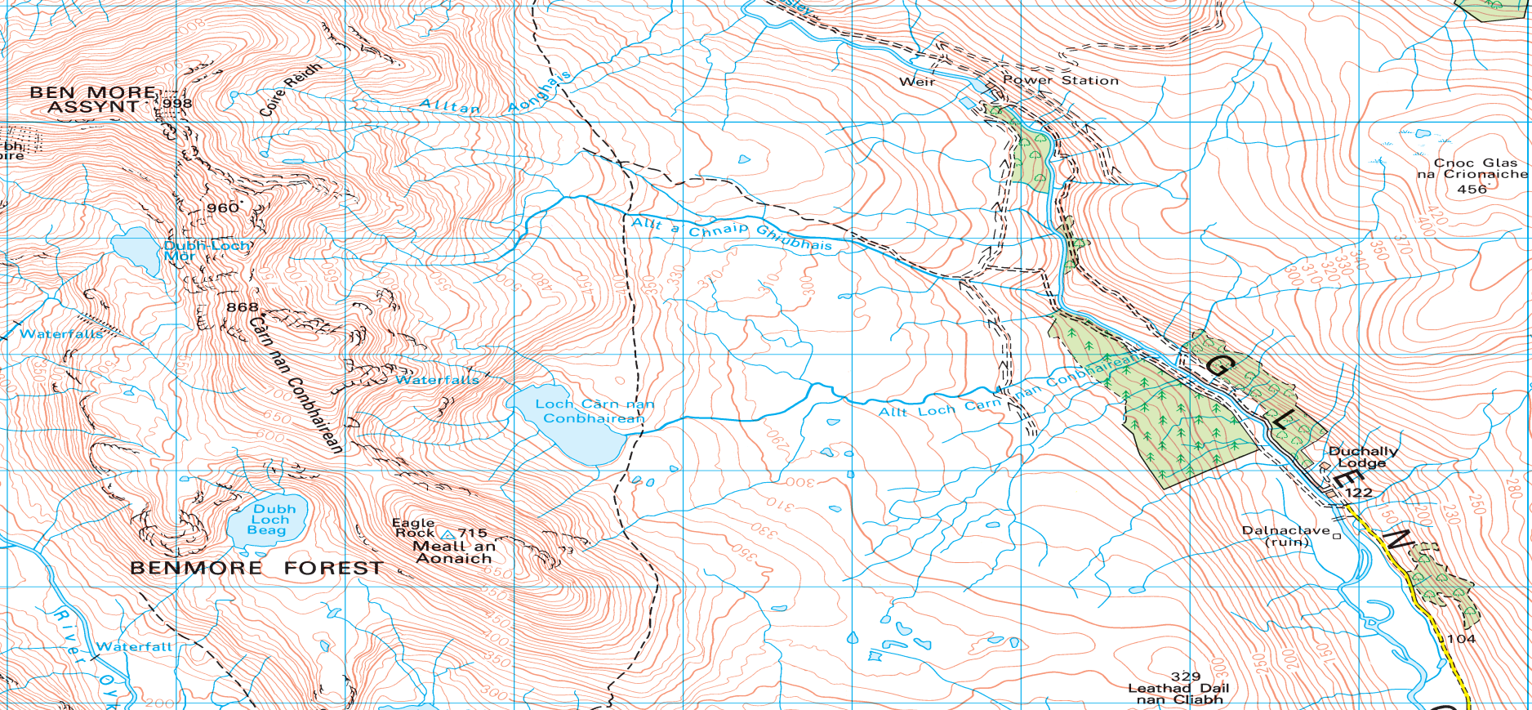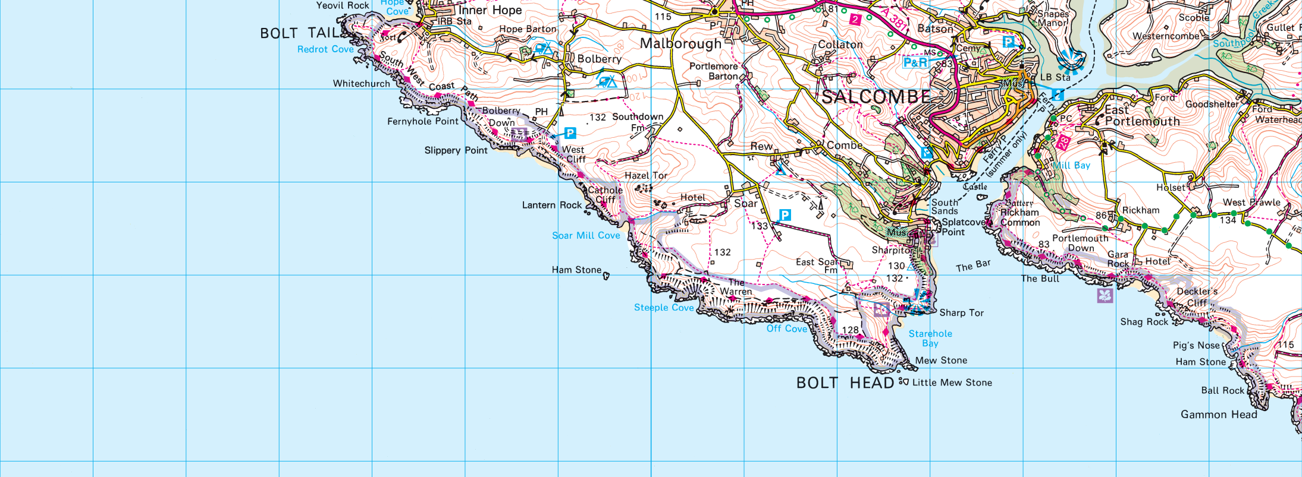

Map 2

Map 1

[Type a quote from the document or the summary of an interesting point. You can position the text box anywhere in the document. Use the Text Box Tools tab to change the formatting of the pull quote text box.]

[Type a quote from the document or the summary of an interesting point. You can position the text box anywhere in the document. Use the Text Box Tools tab to change the formatting of the pull quote text box.]

[Type a quote from the document or the summary of an interesting point. You can position the text box anywhere in the document. Use the Text Box Tools tab to change the formatting of the pull quote text box.]

|  |  |  |  |
| --- | --- | --- | --- |
| **#** | **Red urban** | **Yellow rural** | **Green population** |
| **1** | **Explain 4 reasons why housing changes had to be implemented in Glasgow** | **Define the term sheet wash** | **Give 3 reasons why country would have a low birth rate** |
| **2** | **Explain 4 reasons why housing changes had to be implemented in Mumbai** | **Define the term irrigation** | **Give 3 reasons why country would have a high birth rate** |
| **3** | **Explain 4 reasons why traffic changes had to be implemented in Glasgow** | **Explain 2 physical causes of rural land degradation in the Sahel** | **Give 3 reasons why country would have a low death rate** |
| **4** | **Explain 4 reasons why traffic changes had to be implemented in Mumbai** | **Explain 2 human causes of rural land degradation in the Sahel** | **Give 3 reasons why country would have a high birth rate** |
| **5** | **Outline 4 strategies used to overcome housing issues in Glasgow** | **Explain 2 impacts of RLD to the populations of countries in the Sahel** | **Outline 3 push factors for a forced migration case study** |
| **6** | **Outline 4 strategies used to overcome housing issues in Mumbai** | **Explain 2 impacts of RLD to the environment of countries in the Sahel** | **Outline 3 pull factors for a forced migration case study** |
| **7** | **Outline 4 strategies used to overcome traffic issues in Glasgow** | **Explain 2 impacts of RLD to the economy of countries in the Sahel** | **Explain 3 impacts of migration on the donor country for a forced migration case study** |
| **8** | **Outline 4 strategies used to overcome traffic issues in Mumbai** | **Explain 4 solutions to overcome RLD in the Sahel region** | **Explain 3 impacts of migration on the host country for a forced migration case study** |
| **9** | **Comment on the effectiveness of 3 strategies used to overcome housing issues in Glasgow** | **Explain 4 solutions to overcome RLD in the Sahel region** | **Outline 3 push factors for a voluntary migration case study** |
| **10** | **Comment on the effectiveness of 3 strategies used to overcome housing issues in Mumbai** | **Comment on the effectiveness of 3 strategies used to overcome RLD in the Sahel** | **Outline 3 pull factors for a voluntary migration case study** |
| **11** | **Comment on the effectiveness of 3 strategies used to overcome traffic issues in Glasgow** | **Comment on the effectiveness of 3 strategies used to overcome RLD in the Sahel** | **Give 4 reasons for the differences in population structure between Japan and India** |
| **12** | **Comment on the effectiveness of 3 strategies used to overcome traffic issues in Mumbai** | **Explain the implications for developing countries such as India for their projected population in 2050** | **Explain the population pyramid of India in 2014 (4)** |
| **13** | **Explain 5 problems of collecting population data in developing countries** | **Explain the implications for developing countries such as Japan for their projected population in 2050 (5)** | **Explain population pyramid of Japan 2014 (4)** |
| **14** | **Explain 3 methods developed countries use to keep an accurate record of their population between census** | **Outline 4 ways population data can be gathered in developed countries (5)** | **Explain 3 impacts of migration on the donor country for a voluntary migration case study** |
| **15** | **Explain 5 problems of collecting population data in developing countries** | **Explain 5 problems of collecting population data in developing countries** | **Explain 3 impacts of migration on the host country for a voluntary migration case study** |

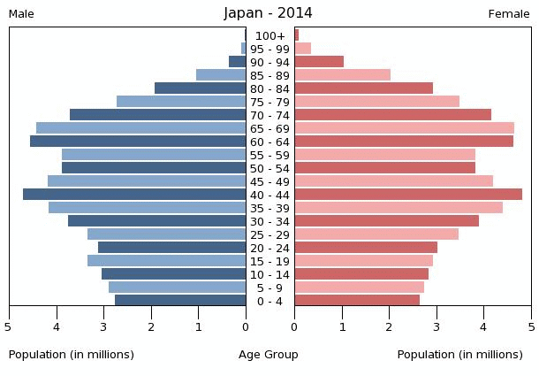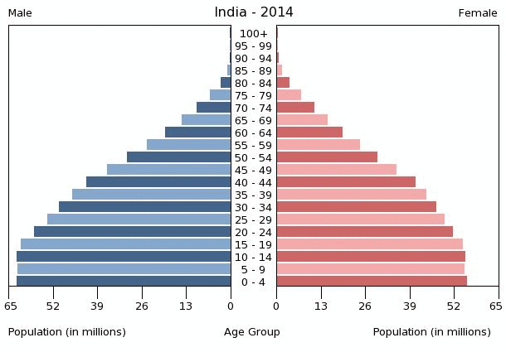

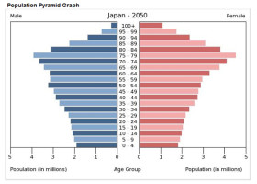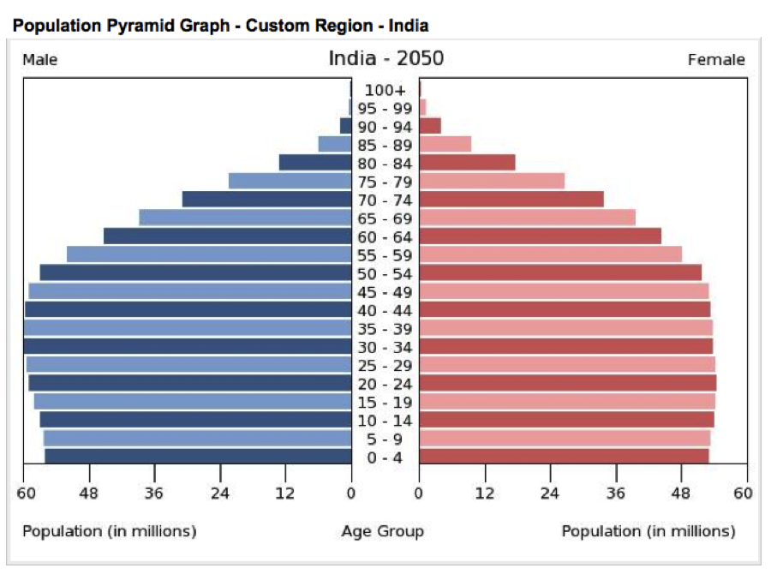

|  |  |  |
| --- | --- | --- |
| **#** | **Red RBM** | **Green Development and Health** |
| **1** | **Outline 4 physical characteristics of the Colorado river basin** | **Define 2 economic indicators of development** |
| **2** | **Explain 4 reasons why there is a need for water management in the Karnafuli river basin** | **Define 2 social indicators of development** |
| **3** | **Explain 4 reasons why there is a need for water management in the Karnafuli river basin** | **What are the disadvantages (3) of only using a single indicator to measure development?** |
| **4** | **Explain 4 physical factors that need to be considered when selecting a site for a dam** | **Why are combined indicators e.g HDI more accurate to measure development than single indicators. (4)** |
| **5** | **Explain 4 human factors that need to be considered when selecting a site for a dam** | **Explain 3 reasons to account for the differences in development between developing countries – use country examples** |
| **6** | **For the Hoover dam explain 3 economic advantages of the dam** | **Explain 3 reasons to account for the differences in development between developing countries – use country examples** |
| **7** | **For the Hoover dam explain 3 economic disadvantages of the dam** | **Explain 4 physical causes of malaria** |
| **8** | **For the Hoover dam explain 3 social advantages of the dam** | **Explain 4 human causes of malaria** |
| **9** | **For the Hoover dam explain 3 social disadvantages of the dam** | **Explain 4 impacts to country if they eradicate malaria** |
| **10** | **For the Hoover dam explain 3 environmental disadvantages of the dam** | **Explain 4 methods used to overcome malaria** |
| **11** | **For the Hoover dam explain 3 environmental advantages of the dam** | **Explain 4 methods used to overcome malaria** |
| **12** | **For the Hoover dam explain 2 political advantages of the dam** | **Comment on the effectiveness of 4 strategies used to reduce malaria** |
| **13** | **For the Hoover dam explain 2 political disadvantages of the dam** | **Explain 4 Primary health care strategies used in developing countries** |
| **14** | **Outline 4 physical characteristics of the Colorado river basin** | **Comment on the effectiveness of 4 primary health care strategies used in developing countries** |
| **15** | **Outline 2 physical and 2 human factors that need to be considered when selecting a site to build a dam** | **Comment on the effectiveness of 4 strategies used to reduce malaria** |



