Geography Homework

This booklet contains some examples of the type of question which you may be asked in your Higher Geography Question Paper.
Throughout the year, your teacher(s) will select questions from this as homework exercises. You should use the other questions as an aid to your revision. We will mark any questions you attempt.

In addition to these questions you will be expected to:
- Read over any notes in preparation for the next lesson – including recapping previous learning
- Make revision notes for your unit and course assessment
- Check Glow regularly for links to useful news articles
- Complete fieldwork required for your assignment
- Undertake personal reading research for you assignment.

Unit 1: Physical Environments
Subtopic: Lithosphere

- Choose one of the following features of glacial erosion. Explain the processes and stages in its formation
a) corrie
b) arête
c) u-shaped valley
d) ribbon lake
4

- Choose one of the following features of glacial deposition. Explain its formation;
- drumlin
- terminal moraine
- esker
4

- Explain, with the aid of annotated diagrams, the formation of the main features of glaciation in the Cairngorms National Park or any other glaciated upland area you have studied.

10

- Choose one of the following features of coastal erosion. Explain the processes and stages in its formation;
a) stack
b) headland/bay
c) wave cut platform
4

- Choose one of the following features of coastal deposition. Explain its formation;
- spit
- bar/lagoon
- tombolo
4

- Referring to named examples within the Cairngorms or any other upland or coastal area you have studied:
(i) explain the environmental conflicts that have occurred;
(ii) evaluate solutions to these environmental conflicts
11

- With the aid of annotated diagrams, explain the formation of the physical features associated with coastal landscapes. You should refer to both erosional and depositional features in your answer.
11
For any named upland or coastal area you have studied:
(i) explain the environmental conflicts that may be caused by large numbers of people visiting the area for tourism and recreation;
(ii) suggest measures taken to resolve these environmental conflicts and comment on their effectiveness.
10
- Study Diagram Q9.
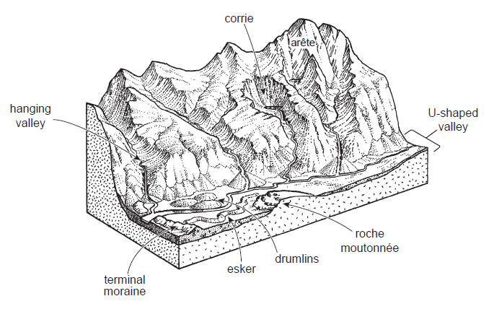
Select one erosional landform and one depositional landform from Diagram Q9.
With the aid of annotated diagrams, explain the formation of each feature.
10

Diagram Q9: A Glaciated Landscape
Subtopic: Hydrosphere

- Explain, with the aid of an annotated diagram, the basin hydrological cycle.
4

- “A drainage basin is an open system with four elements – inputs, storage, transfers and outputs.”
Explain the movement of water within a drainage basin.
4
- Look at diagram Q12.
Explain the impact of human activities on the hydrological cycle.

Diagram Q12: Human activities affecting the hydrological cycle
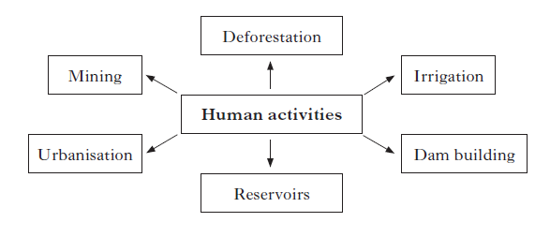

- Look at diagram Q13.
Explain the changing river levels on the River Nene at Northampton from 29th to 30th April 2012.
4

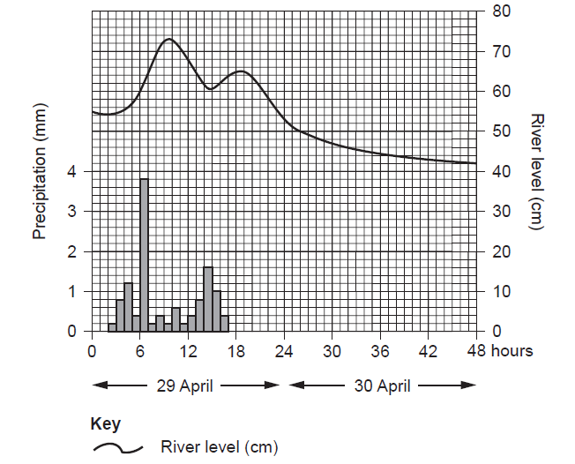
Diagram Q13: Flood Hydrograph for the River Nene in Northampton
Subtopic: Biosphere

- Look at diagram Q14
Explain the conditions and processes which lead to the formation of the podzol soil.
5
- Look at diagram Q15.
Explain the conditions and processes which lead to the formation of the brown earth soil.
Diagram Q15: Brown Earth Soil

5
- Look at diagram Q16.
Explain the conditions and processes which lead to the formation of the gley soil.

5
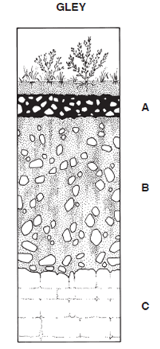
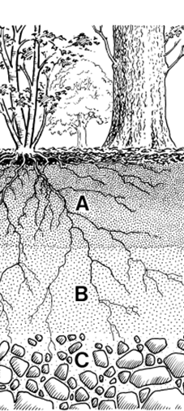
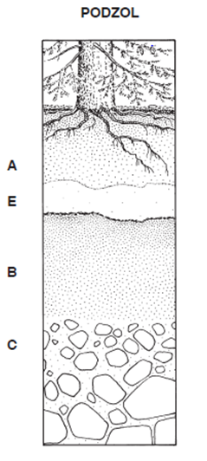
Diagram Q14: Podzol Diagram Q15: Brown Earth Diagram Q16: Gley
Sub-topic: Atmosphere
- Explain why the Earth’s surface absorbs only 50% of the solar energy received at the edge of the atmosphere. You should refer to both conditions in the Earth’s atmosphere and at the Earth’s surface.
3
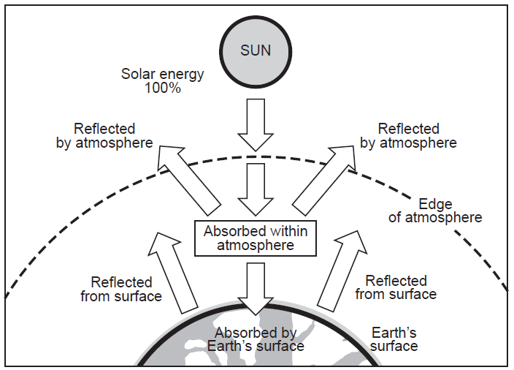
Diagram Q1: Earth/Atmosphere Energy Exchange

- With the aid of an annotated diagram or diagrams, explain why there is a surplus of solar energy in the tropical latitudes and a deficit of solar energy towards the poles.
4

- Explain how atmospheric cells and their associated surface winds help to redistribute energy around the globe.
5

- Study Map Q4.
Explain how the ocean currents help to redistribute energy around the globe.
4

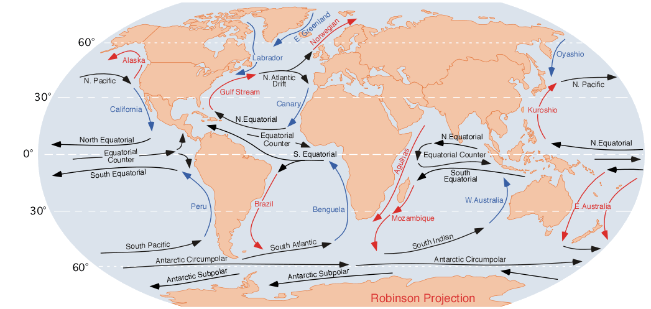
Map Q4: Ocean Currents

- Study Diagram Q5A and diagram Q5B.
Referring to the position of the ITCZ, explain the changing rainfall pattern as you move inland from Abidjan to Nioro.
5

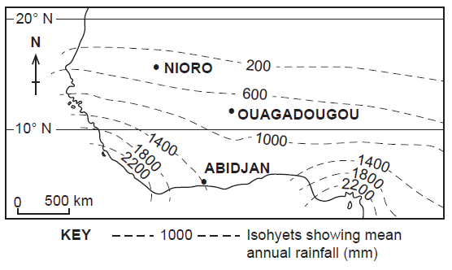
Map Q5: West Africa

Diagram Q5B: West Africa — selected rainfall graphs
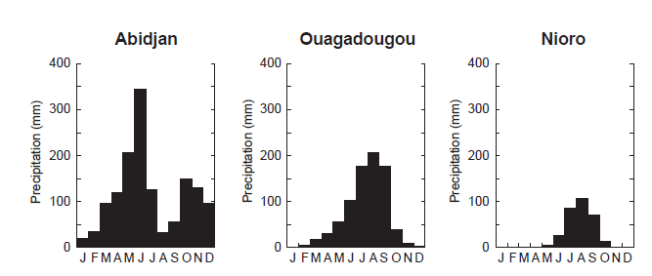

Unit 2: Human Environments
Sub-topic: Urban

- With reference to a named city that you have studied in the Developing World:
(i) explain the social, economic and environmental problems found in shanty town areas;
12
(ii) explain the methods the residents and local authorities have used to tackle these problems.
6

- Look at Map Q2
For Glasgow, or any named developed world city you have studied, explain schemes which have been introduced to reduce problems of traffic management in the Central Business District.
5
Map Q2: Inner-ring road plan to reduce traffic congestion in Glasgow’s Central Business District
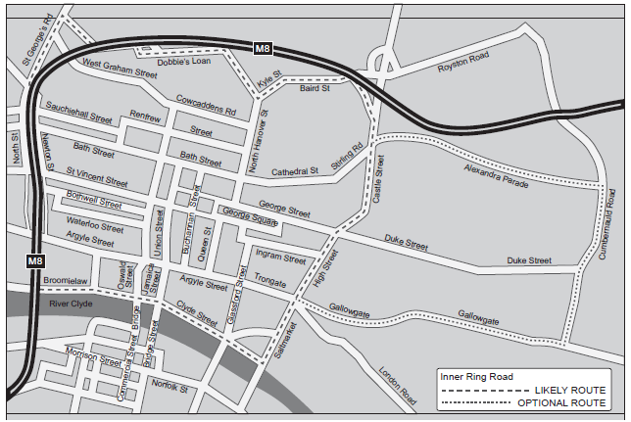

- Look at Map Q3.There are over 600 shanty towns (favelas) within Rio de Janeiro.
With reference to Rio de Janeiro, or any named city that you have studied in a Developing Country, discuss the social, economic and environmental problems of favelas.
6

- Look at Map Q3.
Rio de Janeiro hosted the 2014 World Cup and will host 2016 Olympic Games. The favelas nearest to the Olympic and World Cup venues have been targeted for improvement.

Referring to Rio de Janeiro, or any named city that you have studied in a Developing Country, evaluate the methods used to tackle problems in shanty towns.
5

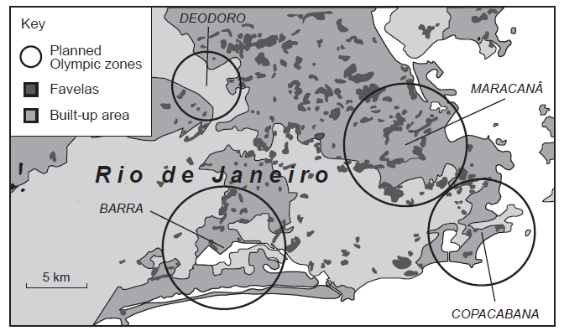
Map Q3: Location of favelas, World Cup and Olympic venues in Rio de Janeiro

- “Lagos is one of the world’s mega-cities — a crime-ridden, seething mass of some 15 million people crammed into the steamy lagoons of Southwest Nigeria. Two out of three Lagos residents live in a slum. The government estimates that Lagos will have expanded to 25 million residents by 2015 to be the third largest city in the world.”

For Lagos or any named city you have studied in a Developing Country:
- explain why your chosen city has grown so rapidly;
5
- explain the socio-economic and environmental problems which have resulted from such rapid growth.
6
Sub-topic: Population
Nigeria conducted a population census in 2006. However, the chairperson of the National Population Commission stated in 2012 that ‘Nigeria has no data.
People can’t really tell you precisely what the population is’. Another census will be conducted in 2016.

Explain the problems of collecting accurate population data in developing countries.
6

- With reference to an international migration you have studied explain the impacts on the donor country.
4

- With reference to an international migration you have studied explain the impacts on the receiving country.
4

- Look at Diagram Q4.
Suggest problems that the government may face as a result of these changes.
4

Diagram Q4: Scotland’s population 2012 (Change from 1974 in brackets)
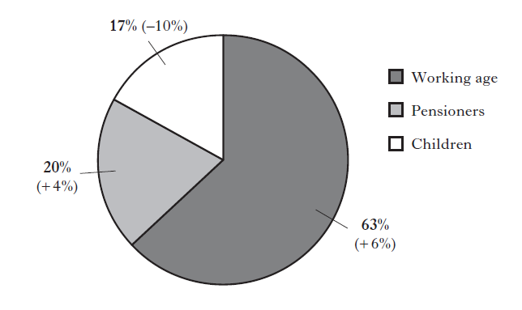

- Look at Diagram Q5A and Q5B.

Discuss the possible consequences of the 2050 population structure for the future economy of Malawi and the welfare of its citizens.

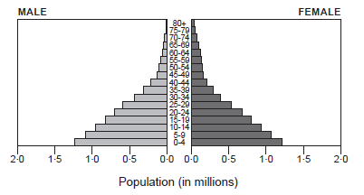
Diagram Q5A: Population Pyramid for Malawi, 2010
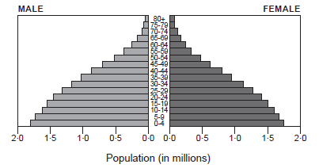
Diagram Q5B: Projected Population Pyramid for Malawi, 2050

Sub-topic: Rural

- Referring to a rainforest or semi-arid area you have studied, discuss the impact of land degradation on the people, economy and the environment.
6

- For a named rainforest, or semi-arid area:
- explain soil conservation strategies that have reduced land degradation;
and
- comment on the effectiveness of these strategies.
10

- Explain the consequences of rural land degradation on the people and their environment.
5

- Select two soil conservation strategies from a rainforest area, or two from a semi-arid area.

Referring to named areas:
(i) explain how they help to conserve soil in rural areas;
(ii) evaluate the effectiveness of each of your chosen methods.
6
Semi-Arid areas |  | Rainforest areas
Contour ploughing |  | Agro-forestry schemes
Shelter belts |  | National parks
Managed grazing |  | Crop rotation
Strip cropping |  | Selective felling

Unit 3: Global Issues

Development and Health

- Using named examples, suggest reasons for the wide variations in development which exist between Developing Countries.
6

- Explain why using only one development indicator, such as Gross Domestic Product (GDP) per capita, may fail to reflect accurately the true quality of life within a country.
3

- Study Table Q3.
To what extent does the information in the table suggest that the six countries are at different levels of development?
4
Table Q3: Selected indicators of development for six developing countries

Region | % adult illiteracy rate | Infant mortality rate (per 1000 live births) | Crude Birth Rate (per 1000 population) | GNI per capita (PPP) US $
Afghanistan | 68 | 70 | 35 | 1960
Angola | 29 | 102 | 45 | 6323
Botswana | 87 | 36 | 24 | 14792
Egypt | 26 | 19 | 24 | 10790
Indonesia | 7 | 25 | 19 | 8970
Niger | 85 | 60 | 50 | 873

- Malaria, cholera and bilharzia/schistosomiasis are water related diseases which remain the biggest causes of death in Developing Countries.

Referring to one water related disease you have studied:

(i) Explain the physical and human factors which put people at risk of contracting the disease.
4

(ii)Evaluate the varying effectiveness of measures that can be taken to combat the disease and
8

(iii) Explain the benefits to a Developing Country of controlling the disease.
4

- Many Developing Countries are attempting to reduce the death rate of children under 5 by implementing Primary Health Care strategies.

Evaluate the effectiveness of primary health care strategies you have studied.
6
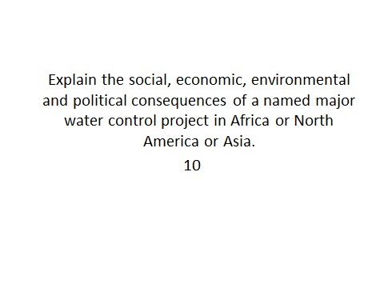
RBM

