Turnbull High School English Department
S1-S3 Course Structure

Throughout the junior phase, pupils in S1, S2 and S3 classes should cover the whole range of Experiences and Outcomes associated with English and Literacy within A Curriculum for Excellence. Their work towards these outcomes should be recorded within their PLP and their progress assessed against the published Benchmarks.

In summary, by the end of each year, pupils should have covered the following skills and evidenced these through the completion of a folio of work:
Reading
Skills  - Use reading strategies to understand, analyse and evaluate a variety of texts, including Prose, Drama, Poetry, Media and Non-Fiction  - Find, use and organise information, including developing critical literacy skills  - Develop close reading skills through study of fiction & non-fiction passages | Outcomes  - Produce 2 Critical Essays of Literature (different genres)  - Demonstrate understanding of media techniques through the completion of a media related task  - Complete a selection of close reading exercises – at least 1 will be a formal assessment of pupil progress in reading
Writing
Skills  - Create a broad range of texts of increasing complexity, applying the features of a particular genre, using more sophisticated language  - Find, use and organise information  - Develop and apply knowledge and understanding of language  - Write with increasing accuracy, making effective use of spelling, grammar and punctuation | Outcomes  - Produce a piece of personal writing  (with a move to reflective writing in S3)  - Produce a piece of imaginative writing  - Produce a piece of discursive writing (ranging from a basic informative piece to discursive/persuasive in S3)
Listening & Talking
Skills  - Use listening strategies to understand, discuss, analyse and evaluate a wide range of spoken texts  - Develop higher order thinking and questioning skills  - Use verbal and non-verbal skills with greater confidence, as well as using language effectively | Outcomes  - Take part in group discussions/ group presentations  - Deliver a solo talk presentation

In addition to the outcomes above, pupils will also experience continued work to build on their basic literacy skills, scheduled library visits in S1 & S2 to encourage enjoyment and choice within reading, and interdisciplinary learning incorporating pupils’ wider knowledge from across the school.
Turnbull High School English Department
Forward Planning

- Staff will complete half-yearly plans for each year group, allowing for a review of what has been achieved in the first months, before planning the final stages of the year.

- Forward plans will cover August to December and then January to May

- Staff are free to choose the order in which they wish to deliver the skills and outcomes and which topics/texts/resources they wish to use for this purpose. However, staff must ensure that all of the skills and outcomes noted overleaf are covered during the course of the year and this should be made clear through their forward plans and records of work.

- Staff should also be aware of the schedule for sharing the PLP with parents and seek to ensure that work has been completed prior to these key dates.

- It should be noted that the outcomes for Reading/Writing do not all need to be extended pieces of work, e.g. persuasive writing skills/techniques could be demonstrated through the completion of an advert or poster.

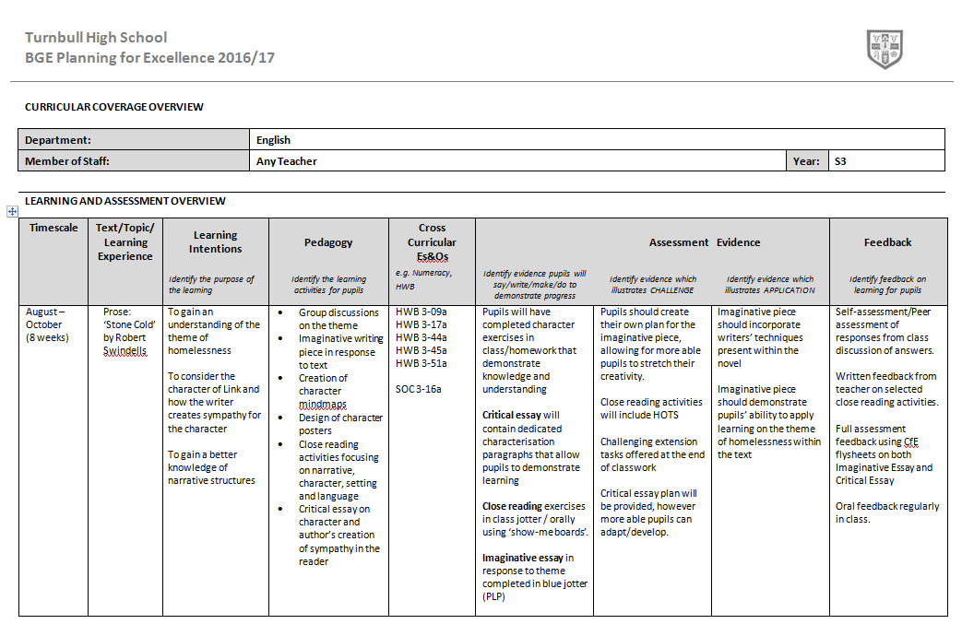
- Forward plans should be completed using the school’s Planning for Excellence sheets *:

*The document above can be found in the shared area
Turnbull High School English Department
PLP Sharing Schedule

The purpose of the PLP is to record pupil progress towards the achievement of a level, identifying their strengths and areas for development. The use of the assessment flysheets helps to make this clear. In addition, to support the school’s Family Learning agenda, the PLP should be shared regularly with parents so that they are informed of their child’s progress and able to support their child’s learning out with school. Parents are encouraged to comment within the PLP and any issues that may be raised should be followed up immediately.
The schedule below outlines the timings for sharing the PLP with parents:
June – P7 PUPILS ONLY | Primary school will share the transition work within the PLP with parents, prior to forwarding to Turnbull.
October (correlates with both S1 and S3 interim reports) | PLP shared with parents, containing at least one piece of completed work
December  (correlates with S2 reports) | By this point, the PLP should contain evidence of at least 1 critical essay, 1 other piece of writing and 1 close reading activity.
February | PLP shared with parents, containing at least one new piece of completed work
April/May  (correlates with S3 and S1 reports) | By this point, the PLP should be complete and contain evidence of at least 2 critical essays, 3 writing pieces, close reading activities and a formal talk assessment.

Example:
August – October = Critical Essay & close reading activity
October – December = Discursive writing & talk assessment
January – February = Critical essay & imaginative piece
March – May = Personal piece & close reading

Turnbull High School English Department
Formal Assessment & Intervention in S1

To support more accurate monitoring and tracking of pupils in S1, and to allow for early identification and intervention for those pupils who require it, the following programme of formal assessments will take place:
September | - All new S1 pupils will sit a baseline assessment in both reading and writing skills.  - Identified pupils will undergo a literacy intervention programme.
December | - Pupils will undertake a standardised reading assessment. Assessment of writing will be taken from work produced for the PLP.
April | - Pupils will undertake a standardised reading assessment.  - Pupils will undertake a standardised writing assessment.
May | - Timetable change and S1 pupils move into S2  - Pupils from literacy intervention programme re-join peers in S2 classes  - If required, concentrated literacy intervention can be delivered to select pupils in May & June to support transition to S2.

Intervention Programme
The intervention programme will be run in partnership with staff from the Support for Learning department. It will seek to address the issues with basic literacy skills demonstrated by pupils, offering greater support and more individualised course content.
It will include:
- Focused work on vocabulary and spelling, including the use of Literacy Planet
- Developing understanding of written language through grammar work (sentence construction, verb conjugation, punctuation etc.)
- Building improved reading skills through the use of guided reading resources, such as “Red Reading Box” and “Read Write Inc: Fresh Start”
- Applying skills in appropriate contexts
Identified pupils will be extracted from their English class and will, instead, attend a literacy class where they will receive concentrated support focused on their individual needs. Literacy intervention will be delivered in blocks of approximately 8 weeks, at the end of which pupils who have shown improvement and are more confident in their literacy skills will then return to their standard English class for the rest of the year. Should any pupil require further support with Literacy, they will continue for another block in the intervention programme.

