Literacy Planet
Instructions on Use

- Literacy Planet can be accessed online using a desktop/laptop computer, or via the app on any tablet or mobile device.

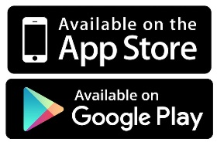
Visit the log-in page by typing the following address into any internet browser: https://app.literacyplanet.com/login

Or download the ‘Literacy Planet’ app from the relevant app store.

- Enter your unique log-in details (Hint: your username usually begins with your initials)

- The desktop version is slightly different from the app. Please refer to the appropriate section below for instructions on what to do next.

Using a desktop/laptop computer

You will see the following screen:

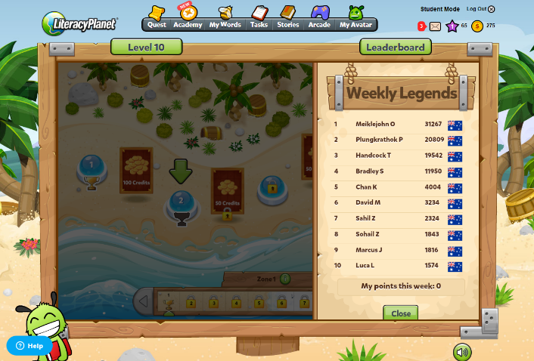

Click on the ‘Tasks’ icon at the top of the screen

If your teacher has selected any specific activities for you to try, they will show here in your ‘To Do’ list. If nothing is showing, you have either completed those tasks which have been set or your teacher has not currently selected anything for you to do.

Click on the ‘Academy’ icon at the top of the screen and select ‘Free Learning’ from the drop down menu that appears.

This will allow you to complete any activity of your choosing.

Select a level from the left and then browse through the different categories of activities available. (Please note, there may not be more than one level available to you. This will be determined by your teacher. The level number has no relation to your progress level in class. It is simply a level within the Literacy Planet programme.)

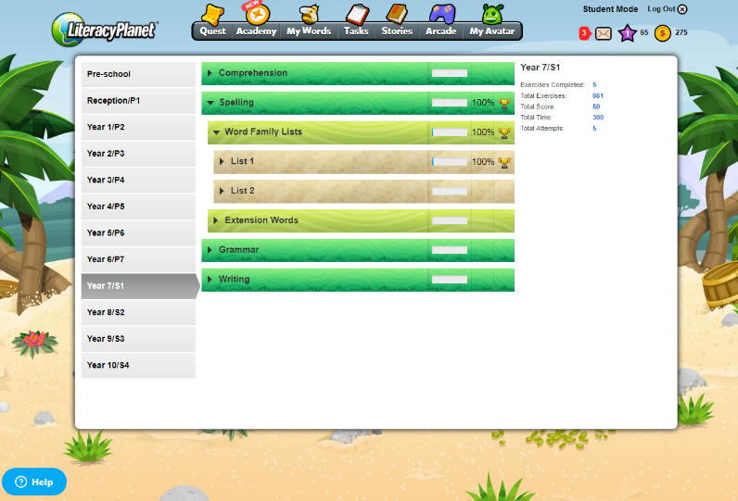

When you have chosen an activity to try, the game will immediately launch.

Your progress will be recorded in the menu screen, beside the activity, so you can always come back to it and try it again in future.

Using the App

After logging-in, you will see the following screen:
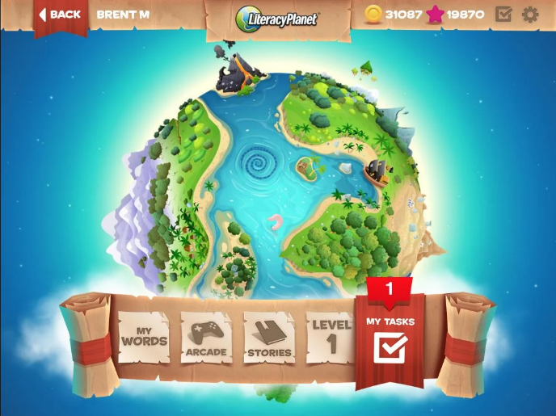

Click on ‘My Tasks’ at the bottom of the screen.

If your teacher has selected any specific activities for you to try, they will show here in your ‘To Do’ list. There is also normally a number beside the icon, to show you how many need to be completed. If nothing is showing, you have either completed those tasks which have been set or your teacher has not currently selected anything for you to do.

Slide the scrolling menu along the bottom to select a level and browse through the different categories of activities available. (Please note, there may not be more than one level available to you. This will be determined by your teacher. The level number has no relation to your progress level in class. It is simply a level within the Literacy Planet programme.)

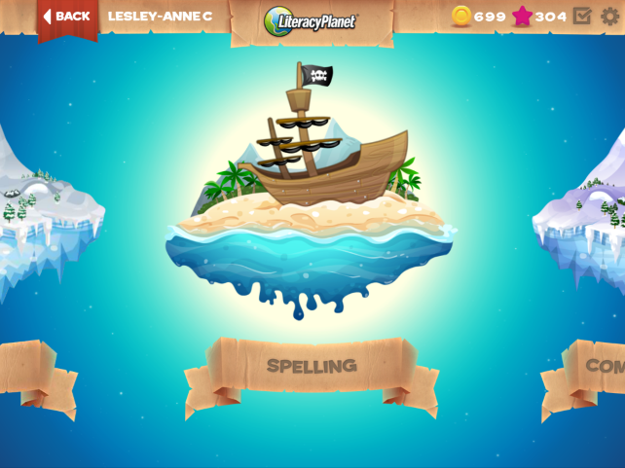

When you have chosen an activity to try, the game will immediately launch.

Your progress will be recorded in the menu screen, beside the activity, so you can always come back to it and try it again in future.

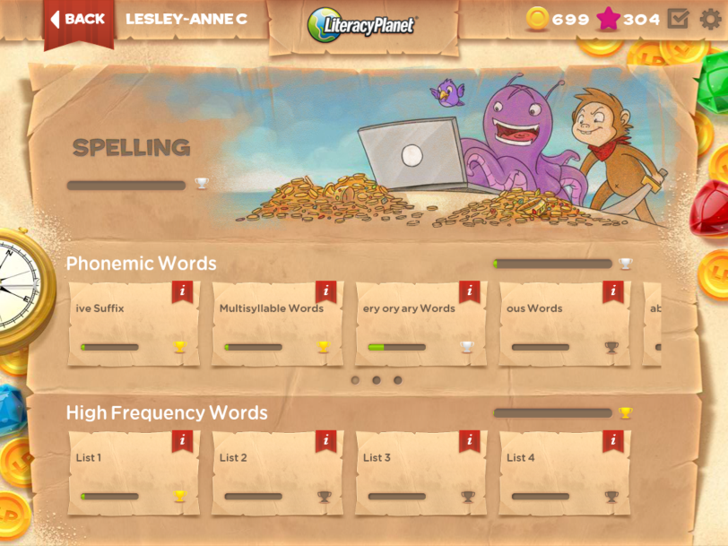

Troubleshooting

The app won’t download
- The app is free to download from both the Apple and Android stores. If you can’t get it to download, it may be to do with your device. Ensure that you are using a compatible device that has plenty of free storage space and is running the most up-to-date software.
The app won’t let me log in
- Make sure that you are using the correct username and password. See your teacher if you are unsure. Also, make sure that you are connected to the internet and that connection is stable. If you lose connection at any point, the app will close.

I can’t open the site on my tablet or phone
- You can’t open Literacy Plant on a browser on your mobile device – only from the app. Safari or Chrome on a mobile device will not work. Go to the app store and download the app for free.

The desktop site won’t let me log-in
- Make sure that you are using the correct username and password. See your teacher if you are unsure. Also, make sure that you are connected to the internet and that connection is stable. If you lose connection at any point, the app will close.
When I log in on my desktop, the screen is greyed/blacked out
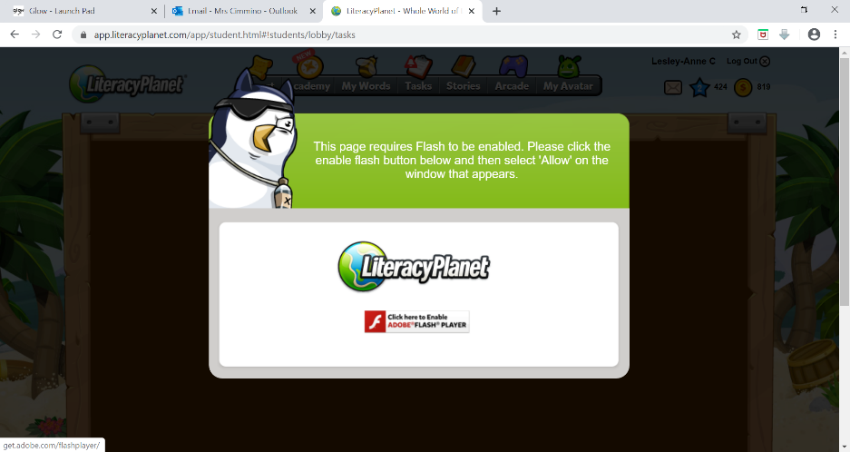
- Literacy Planet needs Flash Player to be installed and enabled on your computer in order to run the graphics for the programme. A grey/black screen normally means that flash is not enabled or installed. On some browsers, you will see a warning.

- Clicking on this warning will produce another pop-up menu asking if you wish to allow Flash Player. Select ‘Allow’ and the page should now reload and the graphics should appear.

