Department of Chemistry

Exam Questions for CfE Higher Chemistry

Unit 1 Chemical Changes and Structure

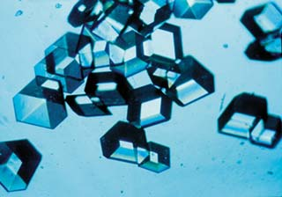

1.1 Controlling the Rate

1. The graph shows the variation of concentration of a reactant with time as a reaction proceeds.
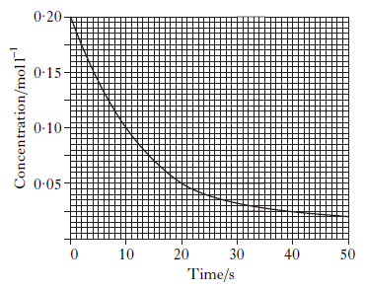
What is the average reaction rate during the first 20 s?
A 0.0025 mol l^{–1} s^{–1}
B 0.0050 mol l^{–1} s^{–1}
C 0.0075 mol l^{–1} s^{–1}
D 0.0150 mol l^{–1} s^{–1}

2. The graph shows how the rate of a reaction varies with the concentration of one of the reactants.
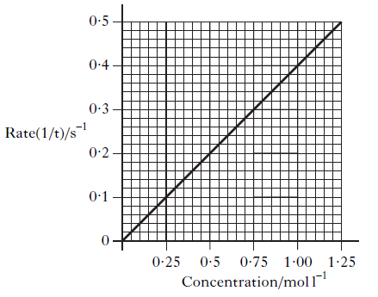
What was the reaction time, in seconds, when the concentration of the reactant was
0.50 mol l^{–1}?
A 0.2
B 0.5
C 2.0
D 5.0

3. The following results were obtained in the reaction between marble chips and dilute hydrochloric acid.
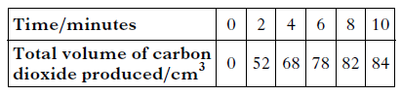
What is the average rate of production of carbon dioxide, in cm³ min^{–1}, between 2 and 8
minutes?
A 5
B 26
C 30
D 41

4. Excess zinc was added to 100 cm³ of hydrochloric acid, concentration 1 mol l^{–1}. Graph I refers to this reaction.
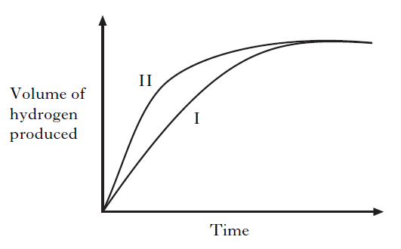
Graph II could be for
A excess zinc reacting with 100 cm³ of hydrochloric acid, concentration 2 mol l^{–1}
B excess zinc reacting with 100 cm³ of sulphuric acid, concentration 1 mol l^{–1}
C excess zinc reacting with 100 cm³ of ethanoic acid, concentration 1 mol l^{–1}
D excess magnesium reacting with 100 cm³ of hydrochloric acid, concentration 1 mol l^{–1}.

5. Which of the following is not a correct statement about the effect of a catalyst?
The catalyst:
A provides an alternative route to the products
B lowers the energy that molecules need for successful collisions
C provides energy so that more molecules have successful collisions
D forms bonds with reacting molecules.

6. In which of the following will both changes result in an increase in the rate of a chemical reaction?
A A decrease in activation energy and an increase in the frequency of collisions.
B An increase in activation energy and a decrease in particle size.
C An increase in temperature and an increase in the particle size.
D An increase in concentration and a decrease in the surface area of the reactant
particles.
7.
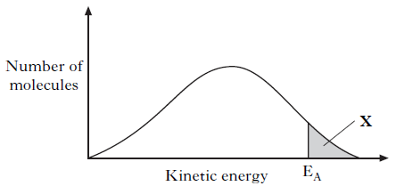
In area X
A molecules always form an activated complex
B no molecules have the energy to form an activated complex
C collisions between molecules are always successful in forming products
D all molecules have the energy to form an activated complex.

8. For any chemical, its temperature is a measure of
A the average kinetic energy of the particles that react
B the average kinetic energy of all the particles
C the activation energy
D the minimum kinetic energy required before reaction occurs.

9.
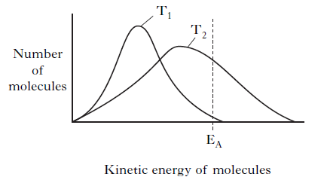

Which line in the table is correct for a reaction as the temperature decreases from T2 to T1?

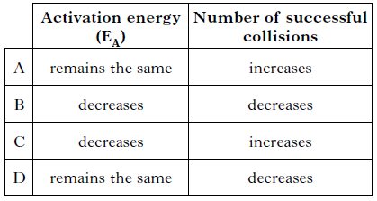
10. The potential energy diagram below refers to the reversible reaction involving reactants R and products P.
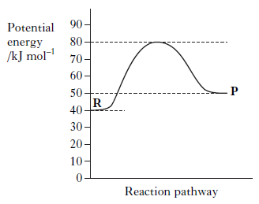
What is the enthalpy change, in kJ mol^{–1}, for the reverse reaction P R?
A + 30
B + 10
C –10
D –40

11.
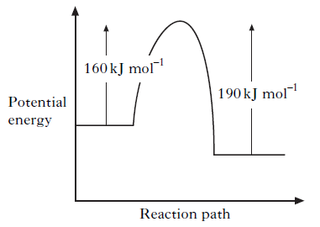
When a catalyst is used, the activation energy of the forward reaction is reduced to
35 kJ mol^{–1}. What is the activation energy of the catalysed reverse reaction?
A 30 kJ mol^{–1}
B 35 kJ mol^{–1}
C 65 kJ mol^{–1}
D 190 kJ mol^{–1}

12. A reaction was carried out with and without a catalyst as shown in the energy diagram.

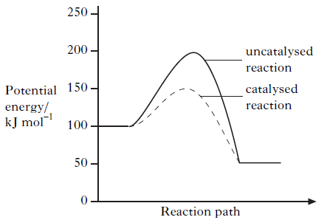

What is the enthalpy change, in kJ mol^{–1}, for the catalysed reaction?
A–100
B –50
C +50
D +100

13. The following potential diagram is for a reaction carried out with and without a catalyst.

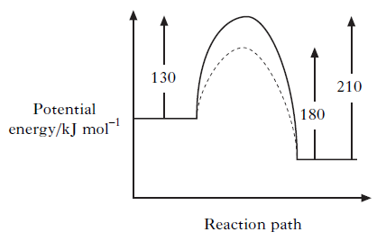
The activation energy for the catalyzed reaction is
A 30 kJ mol^{–1}
B 80 kJ mol^{–1}
C 100 kJ mol^{–1}
D 130 kJ mol^{–1}

14.

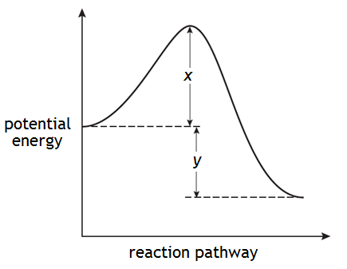
The enthalpy change for the forward reaction can be represented by
A x
B y
C x + y
D x − y. 1224B

15. A potential energy diagram can be used to show the activation energy (E_{A}) and the enthalpy change (ΔH) for a reaction. Which of the following combinations of EA and ΔH could never be obtained for a reaction?
A E_{A} = 50 kJ mol^{–1} and ΔH = –100 kJ mol^{–1}
B E_{A} = 50 kJ mol^{–1} and ΔH = +100 kJ mol^{–1}
C E_{A} = 100 kJ mol^{–1} and ΔH = +50 kJ mol^{–1}
D E_{A} = 100 kJ mol^{–1} and ΔH = –50 kJ mol^{–1}

16. Temperature has a very significant effect on the rate of a chemical reaction.

(a) The reaction shown below can be used to investigate the effect of temperature on reaction rate.

5(COOH)_{2(aq)} + 6H⁺_{(aq)} + 2MnO₄–_{(aq)} → 2Mn²⁺_{(aq)} + 10CO_{2(g)} + 8H₂O_{(l)}

The instructions for such an investigation are shown below.
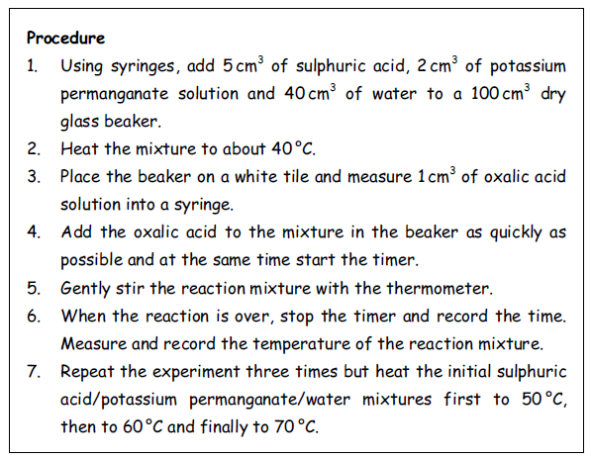

(i) What colour change indicates that the reaction is over? (1)

(ii) With each of the experiments, the temperature of the solution was measured both during heating and at the end of the reaction. When plotting graphs of the reaction rate against temperature, it is the temperature measured at the end of reaction, rather than the temperature measured while heating, that is used. Give a reason for this. (1)

(b) The graph shows the distribution of kinetic energy for molecules in a reaction mixture at a given temperature.

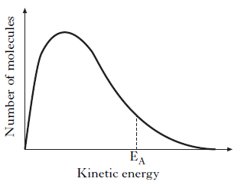
Why does a small increase in temperature produce a large increase in reaction rate? (1)
17. A student carried out the Prescribed Practical Activity (PPA) to find the effect of concentration on the rate of the reaction between hydrogen peroxide solution and an acidified solution of iodide ions.

H₂O_{2(aq)} + 2H⁺_{(aq)} + 2I–_{(aq)} → 2H₂O_{(l)} + I_{2(aq)}

During the investigation, only the concentration of the iodide ions was changed.
Part of the student’s results sheet for this PPA is shown.

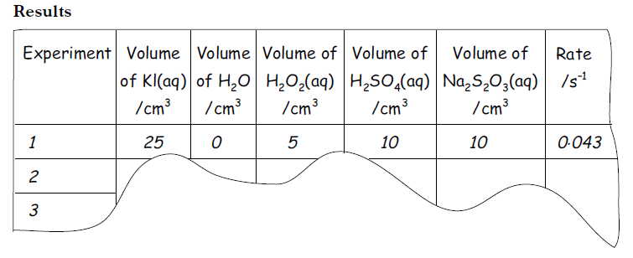
(a) Describe how the concentration of the potassium iodide solution was changed during this series of experiments. (1)

(b) Calculate the reaction time, in seconds, for the first experiment. (1) 8B3

18. The following answer was taken from a student’s examination paper. The answer is incorrect. Give the correct explanation.
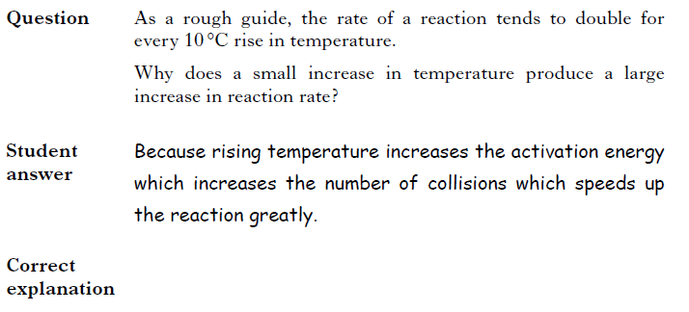

19. Hydrogen peroxide decomposes as shown:

H₂O_{2(aq)} → H₂O_{(l)} + ½O_{2(g)}

The reaction can be catalysed by iron(III) nitrate solution. What type of catalyst is iron(III) nitrate solution in this reaction? (1)
20. A student carried out three experiments involving the reaction of excess magnesium ribbon with dilute acids. The rate of hydrogen production was measured in each of the three experiments.

Experiment | Acid
1 | 100cm³ of 0.10 mol l⁻¹ sulphuric acid
2 | 50cm³ of 0.20 mol l⁻¹ sulphuric acid
3 | 100cm³ of 0.10 mol l⁻¹ hydrochloric acid

The equation for Experiment 1 is shown.

Mg_{(s)} + H₂SO_{4(aq)} MgSO_{4(aq)} + H_{2(g)}

The curve obtained for Experiment 1 is drawn on the graph.
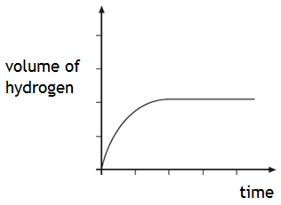
Draw curves on the graph to show the results obtained for Experiment 2 and Experiment 3.
Label each curve clearly. (2)

21. The reaction of oxalic acid with an acidified solution of potassium permanganate was studied to determine the effect of temperature changes on reaction rate.

5(COOH)_{2(aq)} + 6H⁺_{(aq)} + 2MnO₄–_{(aq)} → 2Mn²⁺_{(aq)} + 10CO_{2(g)} + 8H₂O_{(l)}

The reaction was carried out at several temperatures between 40 °C and 60 °C. The end of the reaction was indicated by a colour change from purple to colourless.

(a) (i) State two factors that should be kept the same in these experiments. (1)

(ii) Why is it difficult to measure an accurate value for the reaction time when the reaction is carried out at room temperature? (1)

(b) Sketch a graph to show how the rate varied with increasing temperature. (1)
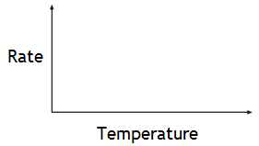
22. An experiment was carried out to determine the rate of the reaction between hydrochloric acid and calcium carbonate chips. The rate of this reaction was followed by measuring the volume of gas released over a certain time.

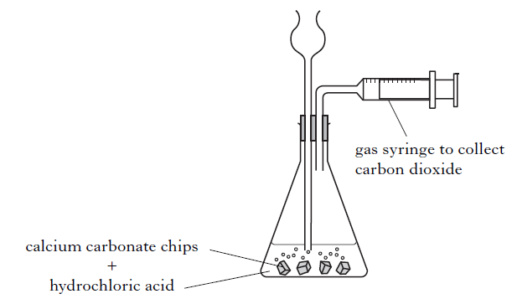

(a) Describe a different way of measuring volume in order to follow the rate of this reaction. (1)

(b) What other variable could be measured to follow the rate of this reaction? (1)

23. Enzymes are biological catalysts.

(a) Name the four elements present in all enzymes. (1)

(b) The enzyme catalase, found in potatoes, can catalyse the decomposition of hydrogen peroxide.

2H₂O_{2(aq}) → 2H₂O_{(l)} + O_{2(g)}

A student carried out the Prescribed Practical Activity (PPA) to determine the effect of pH on enzyme activity. Describe how the activity of the enzyme was measured in this PPA. (1)

(c) A student wrote the following incorrect statement.

When the temperature is increased, enzyme-catalysed reactions will always speed up because more molecules have kinetic energy greater than the activation energy.

Explain the mistake in the student’s reasoning. (1)

24. Chloromethane, CH3Cl, can be produced by reacting methanol solution with dilute hydrochloric acid using a solution of zinc chloride as a catalyst.

(a) What type of catalysis is taking place? (1)

(b) The graph shows how the concentration of the hydrochloric acid changed over a period of time when the reaction was carried out at 20 °C.
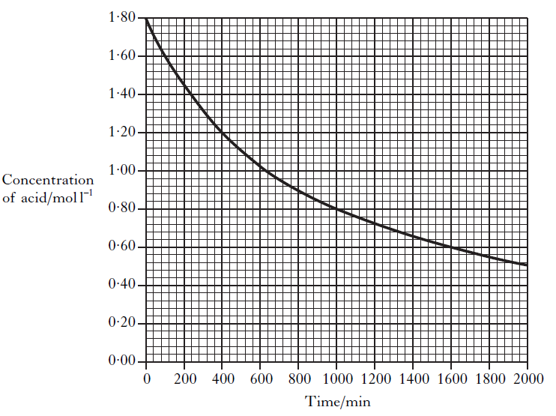

(i) Calculate the average rate, in mol l^{–1} min^{–1}, in the first 400 minutes. (1)

(ii) On the graph above, sketch a curve to show how the concentration of hydrochloric acid
would change over time if the reaction is repeated at 30 °C.(1)

1.2 Periodicity

1. An element (melting point above 3000 °C) forms an oxide which is a gas at room temperature. Which type of bonding is likely to be present in the element?
A Metallic
B Polar covalent
C Non-polar covalent
D Ionic

2. What type of bonding and structure is found in a fullerene?
A Ionic lattice
B Metallic lattice
C Covalent network
D Covalent molecular

3. At room temperature, a solid substance was shown to have a lattice consisting of positively charged ions and delocalised outer electrons. The substance could be
A graphite
B sodium
C mercury
D phosphorus

4. The two hydrogen atoms in a molecule of hydrogen are held together by
A a hydrogen bond
B a polar covalent bond
C a non-polar covalent bond
D a van der Waals’ force.

5. Which of the following does not contain covalent bonds?
A Hydrogen gas
B Helium gas
C Nitrogen gas
D Solid sulphur

6. Which of the following elements exists as discrete molecules?
A Boron
B Carbon (diamond)
C Silicon
D Sulfur

7. Which type of bonding is never found in elements?
A Metallic
B London dispersion forces
C Polar covalent
D Non-polar covalent

8. The diagram shows the melting points of successive elements across a period in the Periodic Table.

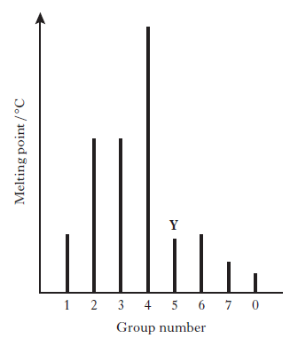

Which of the following is a correct reason for the low melting point of element Y?
A It has weak ionic bonds.
B It has weak covalent bonds.
C It has weakly-held outer electrons.
D It has weak forces between molecules.

9. As the relative atomic mass in the halogens increases
A the boiling point increases
B the density decreases
C the first ionisation energy increases
D the atomic size decreases.

10. Element X was found to have the following properties.
(i) It does not conduct electricity when solid.
(ii) It forms a gaseous oxide.
(iii) It is a solid at room temperature.
Element X could be
A magnesium
B silicon
C nitrogen
D sulphur.

11. Hydrogen will form a non-polar covalent bond with an element which has an lectronegativity value of
A 0·9
B 1·5
C 2·2
D 2·5

12. Which line in the table is likely to be correct for the element francium?

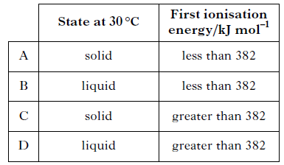

13. Which of the following elements is most likely to have a covalent network structure?

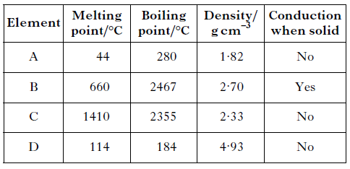

14. Which of the following elements has the greatest attraction for bonding electrons?
A Lithium
B Chlorine
C Sodium
D Bromine

15. Which of the following statements is true?
A The potassium ion is larger than the potassium atom.
B The chloride ion is smaller than the chlorine atom.
C The sodium atom is larger than the sodium ion.
D The oxygen atom is larger than the oxide ion.

16. Which of the following atoms has the least attraction for bonding electrons?
A Carbon
B Nitrogen
C Phosphorus
D Silicon

17. As the atomic number of the alkali metals increases
A the first ionisation energy decreases
B the atomic size decreases
C the density decreases
D the melting point increases.

18. Which equation represents the first ionisation energy of a diatomic element, X₂?
A ½ X_{2(s)} X⁺_{(g)}
B ½ X_{2(g)} X–_{(g)}
C X_{(g)} X⁺_{(g)}
D X_{(s)} X–_{(g)}

19. Which of the following equations represents the first ionisation energy of fluorine?
A F–_{(g)} → F_{(g)} + e–
B F–_{(g)} → ½ F2_{(g)} + e–
C F_{(g)} → F⁺_{(g)} + e–
D ½ F_{2(g)} → F⁺_{(g)} + e–

20. Which of the following reactions refers to the third ionisation energy of aluminium?
A Al_{(s)} → Al³⁺_{(g)} + 3e–
B Al_{(g)} → Al³⁺_{(g)} + 3e–
C Al²⁺_{(g)} → Al³⁺_{(g)} + e–
D Al³⁺_{(g)} → Al⁴⁺_{(g)} + e–

21. The table shows the first three ionization energies of aluminium.
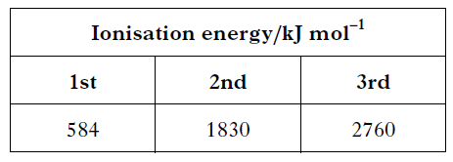
Using this information, what is the enthalpy change, in kJ mol^{–1}, for the following reaction?

Al³⁺_{(g)} + 2e– → Al⁺_{(g)}

A +2176
B –2176
C +4590
D –4590

22. The elements lithium, boron and nitrogen are in the second period of the Periodic Table. Complete the table below to show both the bonding and structure of these three elements at room temperature. (2)

Name of Element | Bonding | Structure
Lithium |  | Lattice
Boron
Nitrogen | Covalent

23. Hydrogen gas has a boiling point of –253 °C. Explain clearly why hydrogen is a gas at room temperature. In your answer you should name the intermolecular forces involved and indicate how they arise. (2)

24. (a) Atoms of different elements have different attractions for bonded electrons. What term is used as a measure of the attraction an atom involved in a bond has for the electrons of the bond? (1)

(b) Atoms of different elements are different sizes. What is the trend in atomic size across the period from sodium to argon? (1)

(c) Atoms of different elements have different ionisation energies. Explain clearly why the first ionisation energy of potassium is less than the first ionisation energy of sodium. (2)

25. The Periodic Table allows chemists to make predictions about the properties of elements.

(a) The elements lithium to neon make up the second period of the Periodic Table.

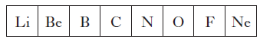

(i) Name an element from the second period that exists as a covalent network. (1)

(ii) Why do the atoms decrease in size from lithium to neon? (1)

(iii) Which element in the second period is the strongest reducing agent? (1)

(b) On descending Group 1 from lithium to caesium, the electronegativity of the elements decreases. Explain clearly why the electronegativity of elements decreases as you go down the group. (2)

26. (a) Lithium starts the second period of the Periodic Table.

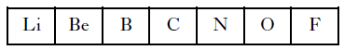

What is the trend in electronegativity values across this period from Li to F? (1)

(b) Graph 1 shows the first four ionisation energies for aluminium.

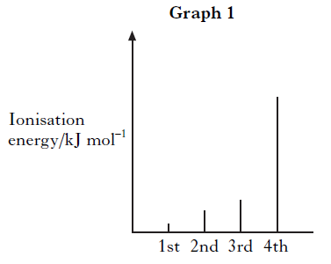

Why is the fourth ionisation energy of aluminium so much higher than the third ionisation energy? (1)

(c) Graph 2 shows the boiling points of the elements in Group 7 of the Periodic Table.

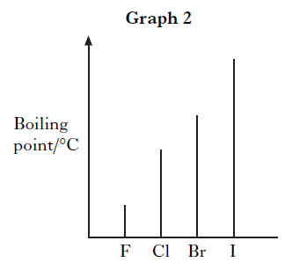
Why do the boiling points increase down Group 7? (1)

27. The following answer was taken from a student’s examination paper. The answer is incorrect. Give the correct explanation.

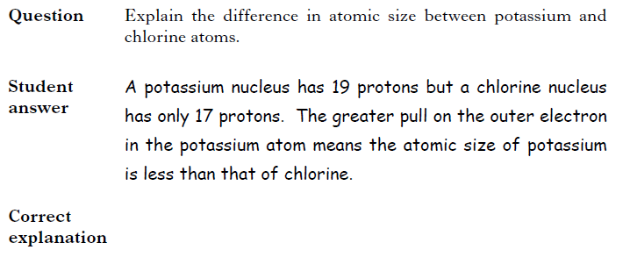

28. The elements from sodium to argon make up the third period of the Periodic Table.

(a) On crossing the third period from left to right there is a general increase in the first ionisation energy of the elements.

(i) Why does the first ionisation energy increase across the period? (1)

(ii) Write an equation corresponding to the first ionisation energy of chlorine. (1)

(b) The electronegativities of elements in the third period are listed on page 10 of the databook. Why is no value provided for the noble gas, argon? (1)

29. Attempts have been made to make foods healthier by using alternatives to traditional cooking ingredients.

(a) An alternative to common salt contains potassium ions and chloride ions.

(i) Write an ion-electron equation for the first ionisation energy of potassium. (1)

(ii) Explain clearly why the first ionisation energy of potassium is smaller than that of chlorine. (3)

30. (a) The first ionisation energy of an element is defined as the energy required to remove one mole of electrons from one mole of atoms in the gaseous state.
The graph shows the first ionisation energies of the Group 1 elements.

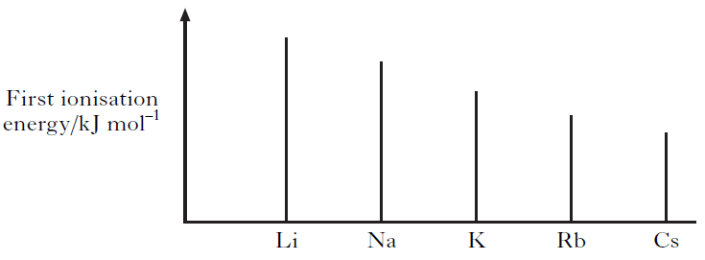

(i) Clearly explain why the first ionisation energy decreases down this group. (2)

(ii) The energy needed to remove one electron from one helium atom is
3·94 × 10^{–21} kJ.
Calculate the first ionisation energy of helium, in kJ mol^{–1}. (1)

(b) The ability of an atom to form a negative ion is measured by its Electron Affinity.
The Electron Affinity is defined as the energy change when one mole of gaseous atoms of an element combines with one mole of electrons to form gaseous negative ions. Write the equation, showing state symbols, that represents the Electron Affinity of chlorine. (1)

1.3 Structure and Bonding

1. Which of the following compounds contains both a halide ion and a transition metal ion?
A Iron oxide
B Silver bromide
C Potassium permanganate
D Copper iodate

2. Particles with the same electron arrangement are said to be isoelectronic. Which of the following compounds contains ions which are isoelectronic?
A Na₂S
B MgCl₂
C KBr
D CaCl₂

3. Which property of a chloride would prove that it contained ionic bonding?
A It conducts electricity when molten.
B It is soluble in a polar solvent.
C It is a solid at room temperature.
D It has a high boiling point.

4. Which of the following chlorides is likely to have least ionic character?
A BeCl₂
B CaCl₂
C LiCl
D CsCl

5. Which of the following compounds has the greatest ionic character?
A Caesium fluoride
B Caesium iodide
C Sodium fluoride
D Sodium iodide

6. Which of the following chlorides is most likely to be soluble in tetrachloromethane, CCl4?
A Barium chloride
B Caesium chloride
C Calcium chloride
D Phosphorus chloride

7. Which of the following compounds exists as discrete molecules?
A Sulphur dioxide
B Silicon dioxide
C Aluminium oxide
D Iron(II) oxide

8. Which of the following compounds has polar molecules?
A CO₂
B NH₃
C CCl₄
D CH

9. When two atoms form a non-polar covalent bond, the two atoms must have
A the same atomic size
B the same electronegativity
C the same ionisation energy
D the same number of outer electrons.

10. In which of the following molecules will the chlorine atom carry a partial positive
Charge (δ+)?
A Cl−Br
B Cl−Cl
C Cl−F
D Cl−I

11. Which line in the table represents the solid in which only London dispersion forces are overcome when the substance melts?

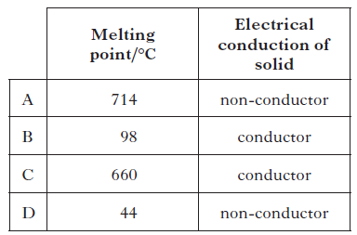

12. Which of the following structures is never found in compounds?
A Ionic
B Monatomic
C Covalent network
D Covalent molecular

13. Atoms of nitrogen and element X form a bond in which the electrons are shared equally.
Element X could be
A carbon
B oxygen
C chlorine
D phosphorus.

14. Which line in the table shows the correct entries for tetrafluoroethene? 1013B

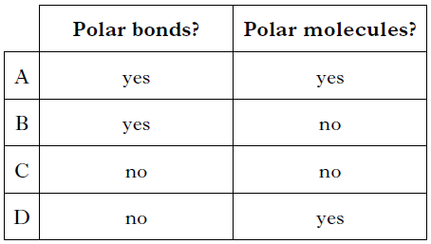

15. In which of the following compounds would hydrogen bonding not occur?

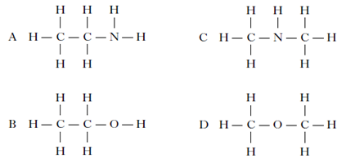

16. Coniceine is a deadly poison extracted from the plant hemlock.

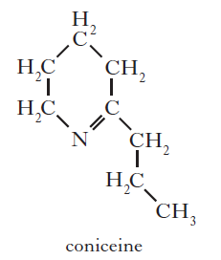

Which of the following would be the best solvent for coniceine?
A Propanoic acid
B Propan-l-ol
C Heptane
D Water

17. The structures for molecules of four liquids are shown below. Which liquid will be the most viscous?

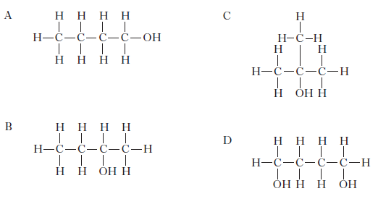

18. The shapes of some common molecules are shown. Each molecule contains at least one
polar covalent bond. Which of the following molecules is non-polar?

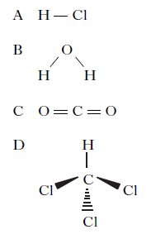

19. Some covalent compounds are made up of molecules that contain polar bonds but the
molecules are overall non-polar. Which of the following covalent compounds is made up of non-polar molecules?
A Ammonia
B Water
C Carbon tetrachloride
D Hydrogen fluoride

20. A positively charged particle with electron arrangement 2, 8 could be
A a neon atom
B a fluoride ion
C a sodium atom
D an aluminium ion.

21. Compared to other gases made up of molecules of similar molecular masses, ammonia has a relatively high boiling point.

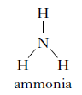

In terms of the intermolecular bonding present, explain clearly why ammonia has a relatively high boiling point. (2)

22. The formulae for three oxides of sodium, carbon and silicon are Na₂O, CO₂ and SiO₂.
Complete the table for CO₂ and SiO₂ to show both the bonding and structure of the three oxides at room temperature. (2)

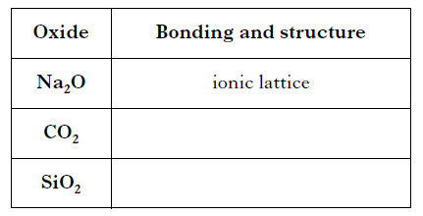

23. Hydrogen cyanide, HCN, is highly toxic. Information about hydrogen cyanide is given in the table.

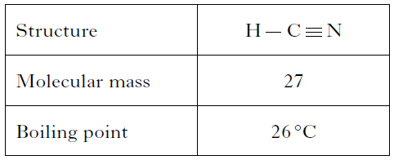

Although hydrogen cyanide has a similar molecular mass to nitrogen, it has a much higher boiling point. This is due to the permanent dipole–permanent dipole attractions in liquid hydrogen cyanide.
What is meant by permanent dipole–permanent dipole attractions?
Explain how they arise in liquid hydrogen cyanide. (2)

24. A student writes the following two statements. Both are incorrect. In each case explain the mistake in the student’s reasoning.

(a) All ionic compounds are solids at room temperature. Many covalent compounds are gases at room temperature. This proves that ionic bonds are stronger than covalent bonds. (1)

(b) The formula for magnesium chloride is MgCl₂ because, in solid magnesium chloride, each magnesium ion is bonded to two chloride ions. (1)

25. Electronegativity values can be used to predict the type of bonding present in substances. The type of bonding between two elements can be predicted using the diagram below.
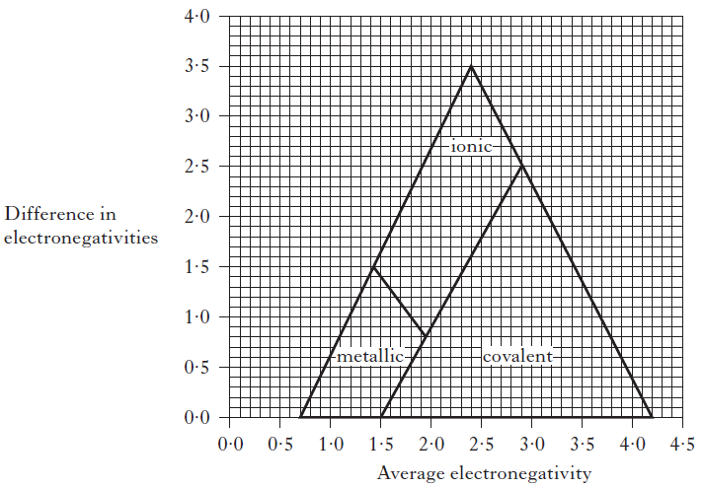
(a) Using the information in the diagram, state the highest average electronegativity found in ionic compounds. (1)

(b) The diagram can be used to predict the bonding in tin iodide.

Electronegativity of tin = 1·8
Electronegativity of iodine = 2·6
Average electronegativity = 2·2
Difference in electronegativity = 0·8

Predict the type of bonding in tin iodide. (1)

(c) The electronegativities of arsenic and chlorine are shown below.

Electronegativity of arsenic = 2·2
Electronegativity of chlorine = 3·0

Place a small cross on the diagram to show the position of arsenic chloride. Show calculations clearly. (2)
26. The structures below show molecules that contain chlorine atoms.

The compounds shown above are not very soluble in water. Trichloromethane is around ten times more soluble in water than tetrachloromethane.
Explain clearly why trichloromethane is more soluble in water than tetrachloromethane.
Your answer should include the names of the intermolecular forces involved. (3)

