Reactivity of Metals Past Paper Questions

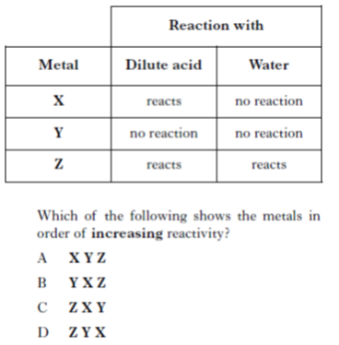

Q1. Q2.



Q3.