National 5 Chemistry

Unit 3
Chemistry In Society

Topic | Page
1 – Polymers | 1
Minitest | 6
2 – Nuclear Chemistry | 7
Minitest | 10
3 – Metals | 11
Minitest | 21
4 – Fertilisers | 22
Minitest | 25

1 – Polymers

a) Properties of plastics
Most of the plastics we use have been made by scientists from chemicals that were obtained from crude oil. Plastics are examples of polymers - very large molecules formed by the joining of many small molecules called monomers. The uses of plastics are related to their chemical properties.

b) Naming polymers
The name of the polymer comes from the name of the monomer used to make it.
For example, the monomer ethene can be used to make the polymer poly(ethene).
Notice how the prefix poly- is put in front of the name of the monomer. Brackets are put around the name of the monomer.
The table shows some examples of monomers and the names of polymers made from them.
Monomer | Polymer
propene | poly(propene)
phenylethene | poly(phenylethene)

Polymerisation is the process in which the small monomer units join together to form a large polymer molecule.

c) Addition polymerisation
Addition polymerisation is a process involving many small, unsaturated monomers combining to form one large polymer molecule.
The alkenes ethene and propene are two important feedstocks in the petrochemical industry which can also be used to make addition polymers.

How to draw structural formulae for polymers
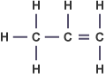
The formation of poly(ethene) from ethene is an example of addition polymerisation. Small unsaturated ethene monomers join up by the opening of the double bond allowing them to join up to form a long carbon chain.
Polymers made in this way are called addition polymers.
The monomers used to make other addition polymers are drawn in a similar shape to ethene, for example, propene.
Although this is the usual way to draw the structural formula for propene, for the purposes of showing how the molecule acts as a monomer and can form a polymer it should be drawn in a different way.
Examples of other monomers are given below.
Given the structure of the monomer the structural formula of the addition polymer can be drawn.

For example
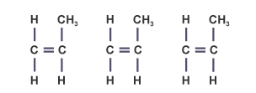
1. Three propene monomers

2. The molecules link together by partially breaking their double bonds
3. A section of a poly(propene) molecule

Remember to show only six carbon atoms in the chain if three monomers are used. Also, remember to show the 'open' bonds at each end of the polymer section. If the structure of the polymer is given then the structure of the monomer can be worked out. The example below shows the repeating unit, ie the part of the molecule that is repeated.
- Polymer backbones
The 'backbone' of a polymer can tell us whether it is an addition polymer or a condensation polymer.
A horizontal chain can be seen in the polymer below (poly(ethenol)):
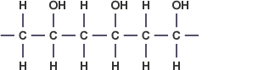
This polymer only has carbon atoms in its backbone. This indicates that the molecule was formed by addition polymerisation.

d) Condensation polymerisation
Condensation polymerisation is a process whereby many small monomer molecules join together to form one large polymer, with water, or some other small molecule formed at the same time. The monomers have more than one functional group.
- Polymer backbones
The polymer below (Kevlar) has a more complicated backbone.
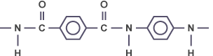
This backbone includes atoms of carbon and nitrogen. If the polymer backbone has any atom other than carbon in it (such as nitrogen or oxygen), then it was formed by condensation polymerisation.

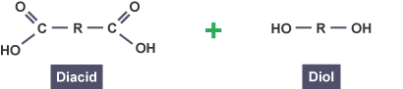
Polyesters
Polyesters are condensation polymers formed by the reaction between a diacid with a diol. Both monomers must have two functional groups.
Polyester monomers both have two functional groups
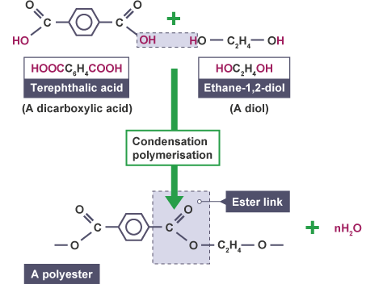
Polyesters are formed from condensation polymerisation
If you are asked to identify the monomers from a condensation polymer, simply add a water molecule back across the ester link. This is called hydrolysis.
To break the ester link, firstly identify the ester link and then just add water.
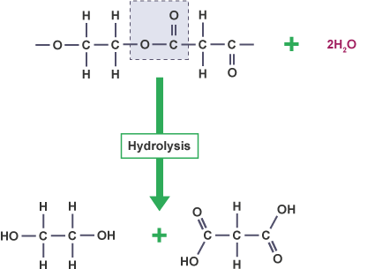

A polyester undergoes hydrolysis with the addition of water to create a diacid and a diol. During hydrolysis, water attacks the ester link and adds across it.

Natural polymers
Polymers are not simply an invention of chemists. Many are synthesised in nature and even in our bodies. The most common natural polymers are carbohydrates like starch and proteins.

f) Carbohydrates
Plants make carbohydrates which are high energy foods containing the elements carbon, hydrogen, and oxygen. They do this by the method of photosynthesis. While they produce glucose (a monosaccharide sugar) during photosynthesis, they store this as starch (a polysaccharide) which is formed by linking together many monosaccharide units within the plant.
Using glucose as a monomer, starch, which could also be known as poly(glucose) is formed.

Testing for starch
A test to distinguish starch from glucose is to shine a beam of light through 'solutions' of each. This is also called the Tyndall Beam Effect. Dispersal only happens in starch as the large starch molecules are big enough to affect the light. This is a physical test. The light will pass straight through the solution of glucose.
A chemical test for starch is to add iodine solution (yellow/brown) and look for a colour change. In the presence of starch, iodine turns a blue/black colour. It is possible to distinguish starch from other carbohydrates using this iodine solution test. For example, if iodine is added to a peeled potato then it will turn black.

Digestion of Starch
During digestion starch is broken down into glucose. Glucose is small enough to pass through the gut wall but starch cannot. This is done in the body using enzymes (biological catalysts). The main enzyme for digestion is amylase. Enzymes work best at body temperature.
To break down starch, water must be added which is the reverse of condensation polymerisation. This is known as hydrolysis. Hydrolysis is when one large molecule is broken down into smaller molecules by reaction with water.

g) Proteins
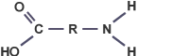
Nitrogen is an essential nutrient for all plants and animals, as it is needed to make proteins. Proteins are natural condensation polymers formed by joining together thousands of amino acid molecules.
Amino acids have a carboxyl group and an amine group

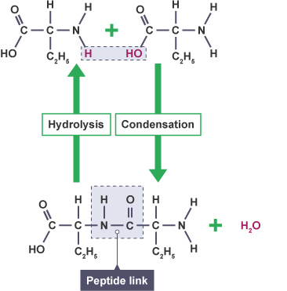
Protein formation
Two amino acids combine in a condensation reaction to form a protein and a water molecule.
Proteins have many important jobs within the body. They form the major structural materials of animal tissue including hair, nails and muscle etc. Other proteins are involved in regulating life processes. These include haemoglobin, enzymes and certain hormones like insulin.

Digestion of proteins
During digestion the proteins we eat are broken down into amino acids (by hydrolysis). These amino acids are transported around the body by blood. In the bloodstream, condensation reactions build the amino acids up to produce proteins required by the body.
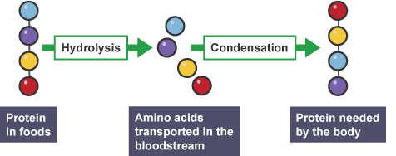

Polymers Minitest

1 Most plastics are made from chemicals obtained from which of the following?
- Coal
- Natural gas
- Crude oil

2 Which of the following processes are used in the formation of the polymer poly(ethene) from small unsaturated monomers of ethene?
- Addition polymerisation
- Additional polymerisation
- Condenstation polymerisation

3 During digestion starch is broken down into glucose. What name is given to this process?
- Condensation
- Esterification
- Hydrolysis

4 Which of the following would be formed when a protein is hydrolysed?
- A sugar
- An alcohol
- An amino acid

5 A football shirt identifies that the material is 100% polyester. Which type of synthetic fibre is polyester?
- Condensation polymer
- Addition polymer
- Thermosetting polymer

6 What are the two functional groups needed to make polyesters?
- Carboxyl and hydroxyl
- Amine and carboxyl
- Diacid and diol

7 What type of reaction was this polymer formed from?
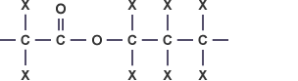
- Condensation polymerisation
- Addition polymerisation
- Addition

8 What is the name of the monomer used to make this polymer?
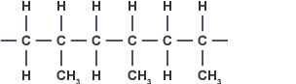
- Ethene
- Propene
- Propane

9 What type of compound is this?
- Alkanoic acid
- Diacid
- Alkanol

10 What is the name of the monomer that is used to produce the polymer poly(buta-1,3-diene)?
- buta-1,3-diene
- butene
- but-1-ene

2 – Nuclear chemistry
Nuclear chemistry is the study of the break up of unstable nuclei, which results in the emission of radiation and the release of energy. This changes the unstable nuclei into more stable nuclei.
The stability of a nucleus depends on the proton to neutron ratio or balance. Radioactive emissions change the neutron to proton ratio and at the same time releases energy.

a) Three types of radiation

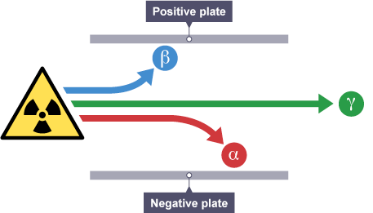
Alpha
- Slow moving positively charged particle, attracted to the negative plate.

Beta
- Fast moving negatively charged particle, attracted to the positive plate.

Gamma
- Electromagnetic radiation (travels at the speed of light). No deflection.

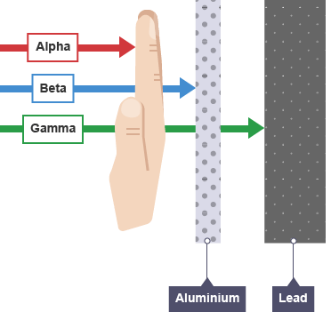
Radioactive penetration

Alpha particles
Alpha particles come from the nucleus of a radioactive atom. They consist of 2 protons and 2 neutrons; hence have a 2+ charge. A few centimeters of air or a hand will stop them.
Alpha radiation consists of helium nuclei,

Beta particles
A beta particle is an electron, .
Since the nucleus does not contain electrons, it is thought that a beta particle is formed when a neutron splits up into a proton and an electron.
While it will pass through air, it cannot penetrate thin metal foil.

Gamma waves
Gamma waves come from the nucleus of a radioactive atom. They are electronegative waves. They do not change the nature of an atom. Thick lead or concrete will absorb gamma rays.

Radioactive emission
The emission of radiation from an atom will change its nature.
Nuclear equations show the products of nuclear decay.
In nuclear equations, the sum of the atomic number and mass number on each side of the equation should balance.

Alpha emissions

Beta emissions

b) Nuclear fission and fusion

Nuclear fission
In nuclear fission the nuclei of uranium or platinum break up into 2 smaller, lighter nuclei and release a large output of energy;

Nuclear fusion
Nuclear fusion is the reverse of nuclear fission. Two light nuclei are fused together to produce a heavier nucleus.
This reaction takes place in the centre of stars, which have sufficiently high temperatures and pressures to allow this reaction to take place.

c) Half-life
Stability (or rate of decay) of a radioisotope is measured in half-life.
The decay of an unstable nucleus is a random event and is independent of chemical or physical conditions.
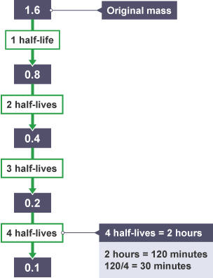
The half-life of a radioisotope is the time taken for the sample's activity to fall by half, and can be easily calculated.

Question one:
The mass of a radioisotope falls from 1.6g to 0.1g in 2 hours. What is the half-life of this radioisotope?

Answer:
Half life equals 30minutes

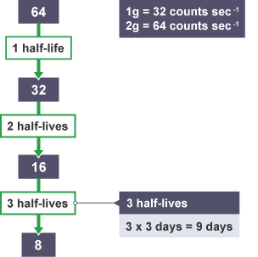
Question two
If a 1g sample of a radioisotope with a half-life of 3 days has an activity of 32 counts sec⁻¹, how long would it take for the activity of a 2g sample to fall to 8 counts sec⁻¹?

Answer
9 Days

d) Uses of radioisotopes
Radioisotopes of elements have a wide variety of uses.
Cobalt-60 | Used in medicine to treat cancer. rays can be focused on tumors.
Iodine-133 | Used to treat thyroid gland (in the neck). If the gland is enlarged, iodine-133 can be absorbed and will partially destroy it.
Carbon-14 | Used to date once-living materials.

Carbon dating
Every living organism contains the radioisotope carbon-14. Carbon-14 is formed when neutrons from cosmic radiation collide with nitrogen atoms in our atmosphere forming protons and carbon-14 atoms.
Carbon dioxide is responsible for carbon-14 entering the food chain.
Carbon-14 decays by beta-emission and has a half-life of 5730 years. This means that the beta-decay emissions can be monitored and the data used to calculate how long it has been since the material was alive.
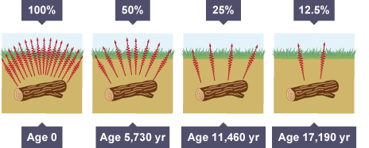
Carbon 14 decay of a buried log. Its activity has dropped to 12.5% after 17,190 years.

Nuclear Chemistry Minitest

1 Which type of radiation is positively charged?
- Alpha (α)
- Beta (β)
- Gamma (γ)

2 What determines how radioactive a nucleus will be?
- The proton:electron ratio
- The proton:neutron ratio
- The neutron:electron ratio

3 What would the penetrative limit of gamma (γ) radiation be?
- A few centimetres of air
- A sheet of aluminium foil
- Thick concrete

4 Which type of radiation can be represented by the particle shown?
- Alpha (α)
- Beta (β)
- Gamma (γ)

5 What type of particle does X represent in the equation shown?
- Alpha (α)
- Beta (β)
- Gamma (γ)

6 What type of particle does X represent in the equation shown?
- Alpha (α)
- Beta (β)
- Gamma (γ)

7 Which of the following would reduce the half-life of a radioisotope?
- The mass of the radioisotope present
- The temperature the radioisotope is stored at
- Nothing affects the half-life of a radioisotope

8 Which radioisotope is used to date the age of once living materials?
- carbon-12
- carbon-13
- carbon-14

9 After 24 days, the mass of a radioisotope was found to be one quarter its original mass. What is the half-life of the radioisotope?
- 4 days
- 6 days
- 12 days

10 A medical radioisotope has a half life of 1.5 hours. Its radioactivity was recorded as 10,000 counts min⁻¹ at 9am. What will the count rate be by 3pm?
- 625 counts min⁻¹
- 1250 counts min⁻¹
- 2500 counts min⁻¹

3 – Metals
Every metal conducts electricity. This is due to the metallic bonding found within metal elements. In metallic bonding, the outer electrons are delocalised (free to move). This produces an electrostatic force of attraction between the positively charged metal ions, and the negatively charged delocalised electrons.
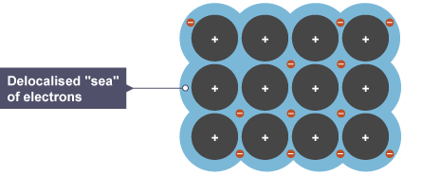
a) The structure of a metal
The ability of metals to conduct electricity stems from their delocalised electrons. As these are free to move, an electrical current can flow through metallic materials.
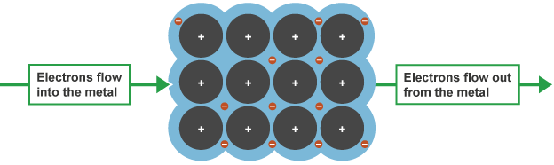

b) The electrochemical series
When metals form ions, they give away one or more of their outer electrons. Some metals, such as lithium or sodium, lose their electrons very easily. Other metals for example silver or gold do not give away electrons easily. The electrochemical series is a list of metals arranged in rank order of how easily the metal atoms lose electrons.
This can be found in the SQA Data Booklet.

c) Reactions of metals

Reactions with water
Metals can react with water, acid and oxygen. The reactivity of the metal determines which reactions the metal participates in.
When metals react with water, metal hydroxides and hydrogen gas are formed. This can be represented in different ways as shown:
Word equation
Chemical equation
Ionic equation

Reactions with acid
When metals react with acids, a salt of the metal and hydrogen gas are formed. The salt of the metal is named following the rules you learned in Unit 1 of the course.
Word equation
Chemical equation
Ionic equation

Reactions with oxygen
When metals react with oxygen, metal oxides are formed.
Word equation
Chemical equation
Ionic equation

Summary
The reactions of metals can be summed in the diagram below.
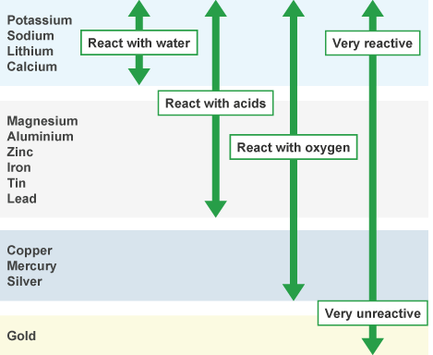

d) Electrochemical cells
When metals give away their electrons, they do so with a certain force. This force is measured in volts. When two different metals are connected together in a cell, the metal with the higher force pushes its electrons on to the other metal. In the diagram below, you can see what happens in a cell that is made from magnesium and copper in a beaker of ammonium chloride solution.
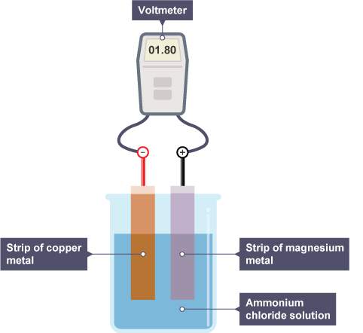
The two metals produce an electric current. The magnesium is higher up the Electrochemical series than copper, so the magnesium can push away its electrons more strongly than copper. Electrons flow along the wire and through the voltmeter from the magnesium to the copper. This is the electric current. Remember that electrons cannot move through water.
The voltmeter measures the force that pushes the electrons through the wire. If you replaced the magnesium in this cell with other metals you would obtain different voltage readings. By arranging the metals in order of their voltage readings, you can build up the electrochemical series.

The further apart the metals are in the electrochemical series, the higher the voltage. Electrons flow along the wire from the metal higher in the electrochemical series to the metal lower down.
- A cell is an arrangement where electricity is generated from a chemical reaction.
- An electrolyte is a liquid that conducts electricity. In the magnesium/copper cell the electrolyte is an ionic solution - ammonium chloride in water. The electrolyte completes the circuit in the cell.

Cells made from two half-cells
You can produce electricity from a cell which is made of two different metals where the metals are dipping into solutions of their own ions.
A simple cell has some essential features:
- It is made of two different metals.
- The metals are separated from each other by an electrolyte.
- The metals are connected by wires through which electrons can flow.
An example of zinc and copper being used to make a cell can be seen in the diagram below.
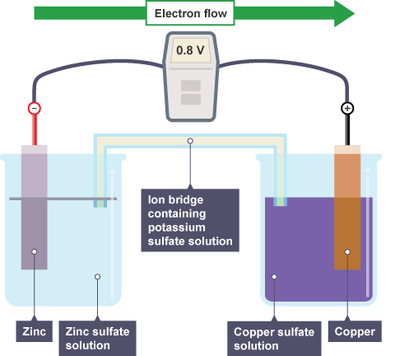
The zinc is higher in the electrochemical series, so it pushes electrons towards the copper.
The ions of the less reactive copper are forced to accept these electrons:
The purpose of the ion bridge is to complete the circuit of this cell. The ion bridge (sometimes called a salt bridge) contains an electrolyte which takes no part in the cell reactions.
The chemical reactions in cells like these are displacement reactions. Zinc can displace copper from copper(II) sulfate solution. If a displacement reaction is made to happen in a cell then useful energy in the form of electricity can be produced.

Cells with only one metal
Two metals are not always required to make a cell. As long as you have one reactive metal to give away electrons and another substance to accept the electrons then you can construct a cell. You also need an ion bridge to allow ions to move between the two solutions.
Some non-metallic substances are found in the Electrochemical series and the same rule applies - the metal, which gives away its electrons, has to be higher in the electrochemical series than the other substance for the cell to produce an electric current. The further apart the metal and the other substance are, the higher the voltage produced by the cell.
Such a cell can be made from nickel dipping into nickel(II) sulfate solution and a carbon rod dipping into a solution of iodine as shown in the diagram below.
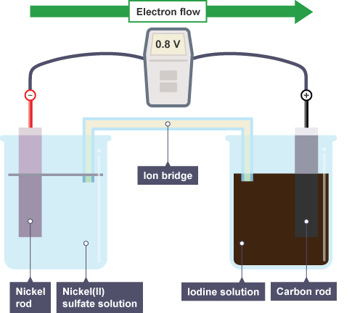
Electrochemical cell with nickel in nickel sulfate and carbon in iodine solution
In this reaction the nickel atoms give away electrons and change into nickel(II) ions:
The iodine molecules accept these electrons and change into iodide ions.
The overall equation for the reaction is:

e) Displacement reactions
Displacement reactions occur when a metal from the electrochemical series is mixed with the ions of a metal lower down in the electrochemical series. The atoms of the more reactive metal push their electrons on to ions of the less reactive metal.
An example can be seen below.
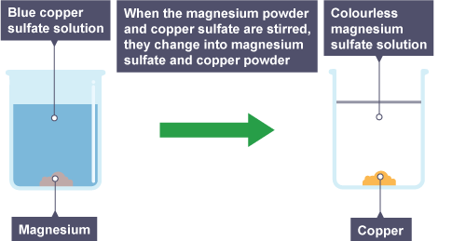
The atoms of the reactive magnesium give away electrons.
( = silvery metal atoms)
( = colourless soluble metal ions)
The ions of the less reactive copper are forced to accept these electrons.
( = blue ions)
( = brown metal powder)
The overall equation for the displacement of copper by magnesium is:
Hint: Notice that there are sometimes colour changes during displacement reactions, depending on the reactants and the products involved. Ion-electron equations for half reactions like these are given in the data booklet.
Some other examples of displacement reactions which can occur are:
- zinc displacing iron ions from iron(II) sulfate solution
- nickel displacing copper from copper(II) nitrate solution
- copper displacing silver from silver(I) nitrate solution
The higher up metal in the electrochemical series always displaces the ions of the lower down metal. Low down metals in the series cannot displace more reactive metals from their solutions. You can use this idea to predict whether a displacement reaction will occur.

f) Redox reactions
Oxidation is the loss of electrons by a reactant.
When a metal element is reacting to form a compound then it is being oxidised.
For example:
The metal atoms are losing electrons to form an ion. They are being oxidised.
This is known as an ion-electron equation.
Reduction is the opposite of oxidation. It is the gain of electrons.
Compounds reacting that result in metal elements being formed are examples of reduction reactions.
For example:
The metal ions are gaining electrons to form atoms of the element. They are being reduced.
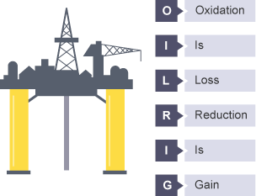
Oil Rig

Redox reactions are reactions where both oxidation and reduction are taking place.
Displacement reactions are examples of redox reactions as one species is being oxidised (losing electrons) while the other is being reduced (gaining electrons).
For example, if magnesium was added to copper sulphate solution, the magnesium metal would be oxidised, while the copper ions were being reduced.
oxidation reaction
reduction reaction
redox reaction
Another example of a redox reaction is the electrolysis of an ionic compound. During electrolysis, negative ions lose electrons at the positive electrode (oxidation) and positive ions gain electrons at the negative electrode (reduction).
Both fuel cells and rechargeable batteries are examples of energy sources that power objects through redox reactions.

g) Metal ores
Ores are naturally occurring rocks that contain metals or metal compounds in sufficient amounts to make it worthwhile extracting them. The method used to extract a given metal from its ore depends upon the reactivity of the metal and so how stable the ore is.
In each case, the metal ion in the compound gains electrons, ie they are reduced.
Ores of very reactive metals have to be melted and electrolysed with a DC (direct current) supply of electricity.
The positive metal ions are attracted to the negative electrode where they accept electrons.

For example:
(sodium ions + electrons → sodium metal)
Ores of reactive metals have to be heated with carbon or carbon monoxide in order to extract the metal.

For example:
(copper ions + carbon → copper metal + carbon dioxide)
When ores of reactive metals such as copper are heated with carbon or carbon monoxide, they are being reduced. Since it is the presence of carbon or carbon monoxide that causes the reduction to take place, we can refer to these chemicals as reducing agents.
Ores of unreactive metals only need to be heated to obtain the metal.

For example:
(silver ions → silver metal + oxygen)

Percentage composition of ores
It is useful for scientists to be able to calculate exactly what proportion of any ore is actually the desirable metal.
The example below will show you how to complete this.

Question
Tenorite (Cu₂O) is an ore of copper. Given that copper has a mass of 63.5 and oxygen a mass of 16, calculate the percentage by mass of copper in tenorite.
Answer
Begin by calculating the formula mass.
The percentage of tenorite that is copper is given by the formula:
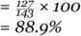
Tenorite is 88.9% copper.

Metals Minitest

1 Which of the following pairs of metals would produce the highest voltage in a cell?
- Zinc and lead
- Iron and nickel
- Magnesium and silver

2 Which of the following is an example of a displacement reaction?
- Lead and silver (I) nitrate solution
- Silver and copper (II) sulphate solution
- Magnesium and lithium sulphate solution

3 Which of the following groups of four metals is arranged in descending order of their chemical reactivity?
- Potassium, magnesium, lead and iron
- Sodium, aluminium, tin and gold
- Calcium, zinc, aluminium and silver

4 When lithium reacts with water what two products are formed?
- Lithium hydroxide and hydrogen
- Lithium hydroxide and water
- Lithium and hydrogen

5 Which of the following pairs of metals can only be extracted from their ores by electrolysis?
- Copper and tin
- Magnesium and iron
- Potassium and aluminium

6 Which type of reaction is happening in the equation below?
- Reduction
- Oxidation
- Redox

7 When iron is extracted from iron ore, it is heated with carbon monoxide. How can carbon monoxide be described in this process?
- Catalyst
- Reducing agent
- Oxidising agent

8 How are metal elements able to conduct electricity?
- Free moving ions
- Free moving protons
- Free moving electrons

9 Haematite is an ore of iron.
Calculate the percentage by mass of haematite that is iron.
- 35%
- 70%
- 87.50%

10 Gibbsite is a mineral found in aluminium ore.
Calculate the percentage by mass of gibbsite that is aluminium.
- 20.50%
- 34.6%
- 61%

4 – Fertilisers

Chemistry is extremely important to the future of food production. As the population of the world increases, more efficient ways of producing foods are required. Chemists are able to help by researching which chemicals can boost plant production.
Plants require chemical nutrients from the soil in order to have healthy growth. Three of the elements found in essential nutrient compounds are:
- nitrogen (N)
- phosphorous (P)
- potassium (K)
As plants grow, their roots extract nutrients from the soil and this means that as time goes on the level of nutrients present decreases.
The next year, plants growing in the same place would have insufficient nutrients to grow healthily. Different plants require different levels of each nutrient.
Both natural and synthetic fertilisers can be used to deliver the essential nutrients to the soil.
Sources of fertilisers
Natural fertilisers | Synthetic fertilisers
Decay of dead plants and animals | Haber Process - making ammonia from nitrogen and hydrogen
Decay of plant and animal waste | Ostwald Process - oxidising ammonia to make nitric acid

Unfortunately soluble fertilisers can be washed away by rainwater into rivers and lakes. This causes pollution resulting in fish dying and algal blooms (a green coating) covering water.

a) The Haber Process
Central to the production of fertilisers containing nitrogen, is a supply of ammonia (NH₃) which is an essential starting point for the production of fertilisers. Diatomic nitrogen has a triple covalent bond holding the atoms together. This requires a large amount of energy to break, so the direct reaction of nitrogen to hydrogen is not usually possible. The Haber Process overcomes these difficulties.
The double arrow tells us that the reaction is reversible. This is a problem as the ammonia made easily breaks down into the reactants nitrogen and hydrogen. To make this process economic and efficient, the following conditions apply.

Condition | Reason
Temperature | Moderate/Low temperature – reaction too slow: High temperature – ammonia decomposes.
Pressure | High - This increases the yield of ammonia.
Catalyst | Iron (Fe) speeds up the production of ammonia, saving energy costs.
Condenser | This cools the reaction down, turning ammonia into a liquid which is easier to extract.
Recycled reactants | Unreacted nitrogen and hydrogen are returned to the reaction, saving money.

b) Fountain experiments
The properties of ammonia can be shown in a fountain experiment.
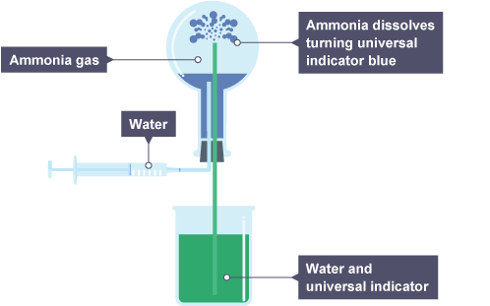
A few drops of water are injected into the flask and they dissolve some of the ammonia gas. This decreases the pressure in the flask and sucks in the water from the beaker. The indicator turns blue upon contact with the ammonium solution.

c) Nitrate fertilisers
There are many useful synthetic fertilisers containing nitrogen, phosphorous and potassium. (NPK Fertilisers). Fertilisers containing nitrate ions (NO₃⁻) not only contain an essential nutrient, but are also very soluble.
Different crops need fertilisers with different proportions of nitrogen, phosphorous and potassium. If you go to buy a fertiliser from a shop, you often find that the fertiliser is classified according to which plant it can improve the best.
Nitrate fertilisers can be made through neutralisation reactions. To complete this, a supply of nitric acid is required. Nitric acid is then used to make ammonium nitrate which is high in nitrogen.

d) Percentage composition of fertilisers
As with metal ores, it is useful to be able to calculate exactly what proportion the essential nutrients accounts for in a fertiliser.
Question
Ammonium nitrate (NH₄NO₃) is commonly used as a fertiliser. Given the relative atomic mass of hydrogen is 1, nitrogen is 14 and oxygen is 16, calculate the percentage of ammonium nitrate that is nitrogen.
Answer
Begin by calculating the formula mass.
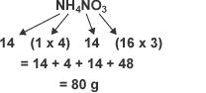
The percentage of ammonium nitrate that is nitrogen is given by the formula:
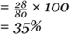
Ammonium nitrate is 35 per cent nitrogen.

Fertilisers Minitest

1 Which of these is not an essential plant nutrient?
- Nitrogen
- Platinum
- Phosphorous

2 Which of the following is a natural fertiliser?
- Ammonium phosphate
- Potassium nitrate
- Manure

3 What is the Haber process used to form?
- Nitric acid
- Ammonia
- Ammonium nitrate

4 Which of the following is a property of ammonia gas?
- Acidic
- Sweet smelling
- Soluble in water

5 What are the reactants in the Haber Process?
- Nitrogen and hydrogen
- Nitrogen and oxygen
- Carbon and hydrogen

6 Which of the following is not a reason that nitrate compounds make good fertilisers?
- Cheap and easy to manufacture
- Contain essential plant nutrients
- They are very soluble

7 How is the Haber process made more economical?
- The reaction takes place at a low pressure
- Unreacted reactants are recycled
- The reaction takes place at a low temperature

8 What is the percentage of nitrogen in the fertiliser Urea given the relative atomic mass of hydrogen is 1, carbon is 12, nitrogen is 14, and oxygen is 16?
- 23.33%
- 46.67%
- 70%

9 The compound ammonium sulphate is used as a fertiliser.
What is the percentage of ammonium sulphate that is nitrogen?
- 12.28%
- 17.07%
- 21.21%

10 Ammonium phosphate is commonly used as a fertiliser.
What is the percentage of ammonium phosphate that is phosphorous?
- 20.80%
- 28.18%
- 31%

