National 5 Chemistry

Unit 2
Nature’s Chemistry

Topic | Page
1 – Hydrocarbons and homologous series | 1
Minitest | 8
2 – Energy from Fuels | 9
Minitest | 13
3 – Consumer Products | 14
Minitest | 18

1 – Hydrocarbons and homologous series
A homologous series is a family of hydrocarbons with similar chemical properties who share the same general formula.
We will look at three series: alkanes, alkenes and the cycloalkanes.

a) Alkanes
The first homologous series is the alkanes. Their names all end in –ane.
The alkanes have many uses:
- methane – (natural gas) cooking, heating
- propane – used in gas cylinders for BBQ etc
- octane – used in petrol for cars
The general formula of the alkanes is .
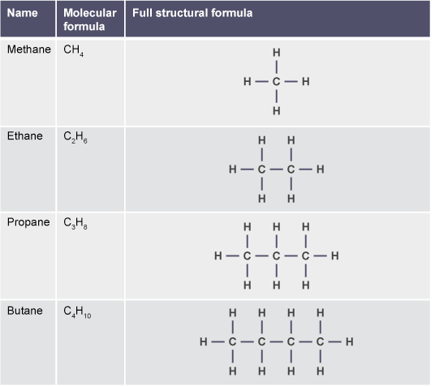
The names, molecular formula and the structural formula of the first eight alkanes must be learned. Using a mnemonic can make learning the names easier.
Methane | CH₄ | Monsters
Ethane | C₂H₆ | Eat
Propane | C₃H₈ | Pupils
Butane | C₄H₁₀ | But
Pentane | C₅H₁₂ | Prefer
Hexane | C₆H₁₄ | Hairy
Heptane | C₇H₁₆ | Haggis
Octane | C₈H₁₈ | Occasionally

Naming branched chain alkanes
There are some general rules which you should remember when naming organic compounds:
- The longest unbranched chain containing the functional group is the parent molecule, or simply the longest unbranched chain for alkanes. Remember that, the longest chain can go round a bend.
- Indicate the position of the functional group with a number, numbering from the end nearest the functional group.
- Name the branches, and indicate the number of branches.

Example
- Methyl indicates there is one carbon atom in the branch.
- Ethyl indicates there are two carbon atoms in the branch.
- The prefix 'di' indicates there are two branches.
- The prefix 'tri' indicates there are three branches.
Indicate the position of the branches with a number, numbering from the end nearest the functional group.
For more than one branch, the branches are identified in alphabetical order, ignoring any 'di', 'tri', etc, prefixes.
Each branch needs to be numbered individually, even if they are attached to the same carbon atom.
The rule is a comma between numbers, and a dash between numbers and letters.

The alkanes don't contain a functional group and so the branches are numbered from the end that gives the lowest set of position numbers for the branches.
Use the above rules to see how the names of the alkanes below are built up.
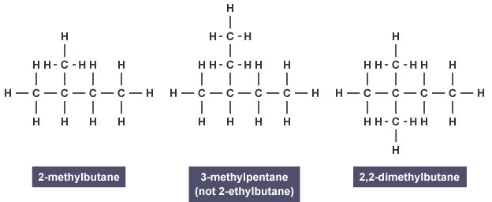

b) Alkenes
The second homologous series is the alkenes. Their names all end in –ene.
Alkenes all contain a carbon to carbon double bond which makes them more reactive than the alkanes. The alkenes have the general formula .
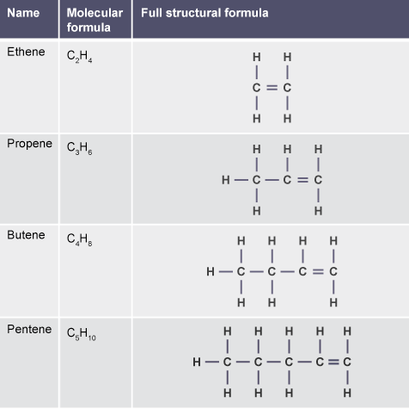
The alkenes are unsaturated. This means that they have a carbon to carbon double bond. The alkanes are saturated because they only contain single bonds. An unsaturated hydrocarbon decolourises bromine water quickly. Alkanes do this slowly. Alkenes can be used as fuels, solvents and starting materials for everyday products such as plastics and vinegar.

Naming alkenes
Naming alkenes has the same rules as alkanes.
However, the position of the carbon to carbon double bond must be identified.

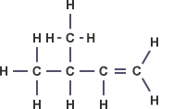
Example

3-methylbut-1-ene
Note that the functional group (in the case of alkenes, the double bond) is given the lowest possible number first, before any branches are numbered.

c) Cycloalkanes
The third homologous series is the cycloalkanes. Their names all end in –ane and begin with cyclo-, for example cyclopropane.
The cycloalkanes have the general formula .
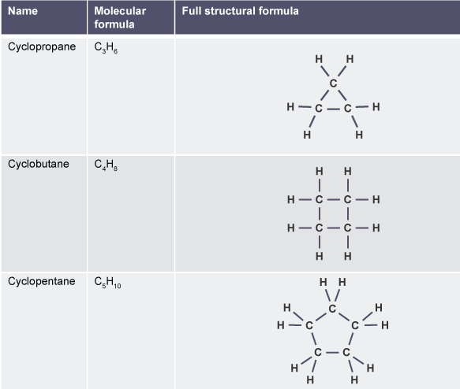
Even though they have the same general formula as the alkenes, the cycloalkanes are saturated and contain only single bonds. This means that they do not quickly decolourise bromine solution.
Many cycloalkanes are used in motor fuel, natural gas, kerosene, diesel and other heavy oils.

d) Combustion reactions
All hydrocarbons (including alkanes, alkenes and cycloalkanes) can undergo combustion reactions with oxygen to give the same two products. Hydrocarbon fuels burn when they react with oxygen in the air. As all hydrocarbons only contain the elements carbon and hydrogen, the only products will be oxides of these elements. So as long as enough oxygen is present for complete combustion, the two products formed will be carbon dioxide (CO₂) and water (H₂O). The word equation for this reaction is shown below.
The products from the combustion of hydrocarbon fuels can be identified with the following set up in the lab.
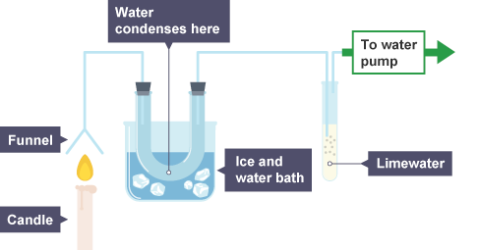
Carbon dioxide gas turns limewater from colourless to milky white. In the above experiment, the limewater in the boiling tube changes colour indicating carbon dioxide is produced by combustion of the hydrocarbon fuel.
If water is produced it will condense in the U-tube cooled by the ice water. This results in cobalt chloride paper changing the colour from blue to pink.
Incomplete combustion (when there is an insufficient supply of oxygen) could lead to toxic carbon monoxide (CO) being produced instead of carbon dioxide.

e) Addition reactions
Alkenes are more reactive than alkanes and cycloalkanes because they have a double bond. While alkanes, alkenes and cycloalkanes undergo combustion reactions with oxygen, only alkenes can participate in addition reactions.
In an addition reaction, the double bond of the alkene partially breaks when the reactant molecule attacks and adds on across it.

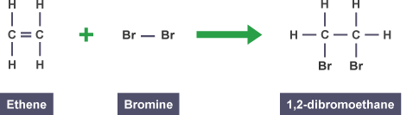
Example

Addition of bromine water can be used as a test for unsaturation.
Alkenes quickly turn bromine water colourless, while alkanes and cycloalkanes do not.
The experiment shown below is an example of how to distinguish between alkanes and alkenes by adding bromine water.
The addition of bromine to an alkene is called bromination.

Other small molecules can be added across double bonds in alkenes. If hydrogen is added, then the corresponding alkane molecule is formed.

Example
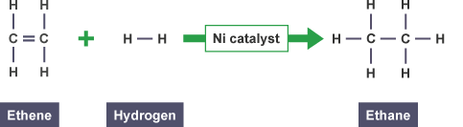
The addition of hydrogen to an alkene is called hydrogenation.

If water is added to an alkene, then an alkanol (alcohol) is produced.
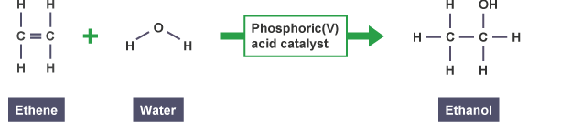
The addition of water to an alkene is called hydration.

f) Isomers
Isomers are compounds with the same molecular formulae but different structural formulae.
They have the same number of each type of atom but may have different physical and chemical properties.
This diagram shows butane and methylpropane. (Methylpropane used to be called iso-butane, but the correct name is methylpropane).
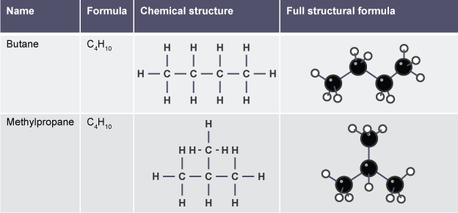
Both have a molecular formula of .
The structural formulae are different though, so they are isomers of each other.

Hydrocarbons and homologous series Minitest

1 Which of the following is a hydrocarbon?

2 What is the formula for octane?

3 Which of the following could be the formula for an alkene?

4 Which of the following hydrocarbons would rapidly decolourise bromine solution?
- Propene
- Propane
- Cyclopropane

5 Which of these molecules is saturated?
- 3-methyl pentane
- hex-2-ene
- 2-methylbut-2-ene

6 What is the name for the following molecule?
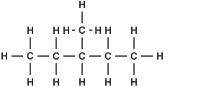
- 3-methylpentane
- 3-methylhexane
- 2-ethylbutane
7 What is the general formula for cycloalkanes?

8 Which of the following molecules is an isomer of heptane?
- 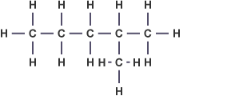
- 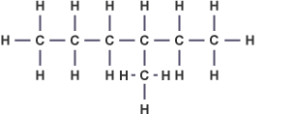
- 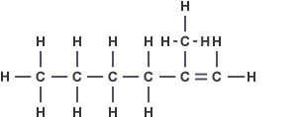

9 What type of reaction does this equation represent?
- Combustion
- Hydrolysis
- Addition

10 Which of the following is the shortened structural formula for butene?

2 – Energy from fuels

a) Combustion reactions
Many different compounds can be used as fuels, most commonly alkanes and alcohols. When these fuels burn, they release heat energy and light energy to the surroundings in exothermic reactions. Endothermic reactions take in heat energy.
These reactions are known as combustion reactions and can be represented by different equations.
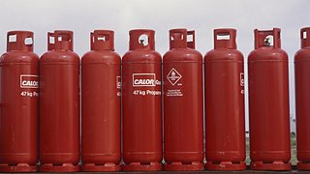
For example, propane gas tanks are commonly sold on petrol station forecourts. These gas bottles have a wide variety of uses including portable heating and cooking for caravans and barbecues.
When propane burns in a plentiful supply of oxygen, it produces both carbon dioxide and water. This change can be represented by a word equation or a formula equation.

Word equation

Balanced formulae equation

A balanced formulae equation, along with the formula triangles you learned in Unit One can be used to calculate information on the quantities of reactants or products involved in a particular reaction.
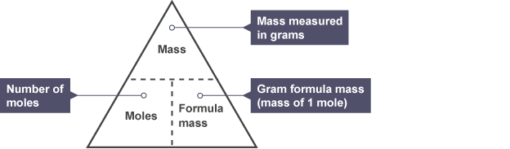

Examples

Example one
Calculate the number of moles of oxygen required for the complete combustion of 132g of propane.

Step 1 Start with the balanced equation.

Step 2 Use the information from the question to calculate how many moles of the known reactant or product are actually used.
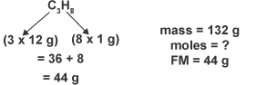

Step 3 Use the balanced equation to work out how many moles of the reactant or product you are asked to calculate this equates to.

From the equation, 1 mole of propane will react with 5 moles of oxygen.
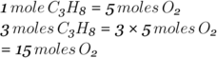

Example two
If 32g of methane gas are burned in a plentiful supply of oxygen, calculate the mass of carbon dioxide produced.

Step 1: Start with the balanced equation

Step 2: Use the information from the question to calculate how many moles of the known reactant or product are actually used.
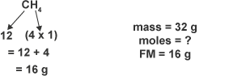
Calculating the formula mass of methane

Step 3: Use the balanced equation to work out how many moles of the reactant or product you are asked to calculate this equates to.
From the equation, 1 mole of methane will produce 1 mole of carbon dioxide. So;
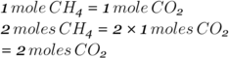

Step 4 Be careful - this question asked for the mass of carbon dioxide, not the number of moles. Use the formula triangle once more to convert this number of moles to a mass.
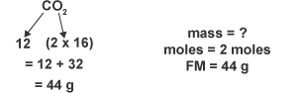
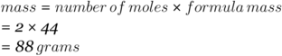

b) Calculating the energy released when fuels burn
Some fuels are better than others at releasing energy during combustion reactions. The energy released (sometimes called enthalpy) is calculated using the following equation:
= the heat energy released (in kJ or kJ mol⁻¹)
= the specific heat capacity of water. It is a constant, 4.18 kJ kg⁻¹ ˚C⁻¹
= the mass of water (in kg) (100cm³ = 0.1kg)
= the change in temperature (˚C)
This formula is very easy to recall if you remember that "Every house can't make triangle toast!"

Example
Question : A spirit burner was filled with ethanol (C₂H₅OH) and used to heat a copper can containing 200 cm³ of water. The temperature of the water rose from 22˚C to 27˚C.
Calculate the heat energy released from this combustion of ethanol.

Energy of fuels Minitest

1 In the equation , what does c represent?
- The mass of liquid
- The specific heat capacity
- The change in temperature

2 What are the products of combustion reactions when hydrocarbons are burned in a plentiful supply of oxygen?
- Carbon dioxide and water
- Carbon monoxide and water
- Carbon (soot) and water

3 If 48 grams of methane (formula mass 16 g) is burned, what mass of carbon dioxide (formula mass 44 g) will be produced?
- 132 grams
- 88 grams
- 44 grams

4 When a sample of methane was burned, the heat produced raised the temperature of 100 cm³ of water from 20.2°C to 29.3°C.
Calculate the heat energy released by this reaction.
- 0.38 kJ
- 3.8 kJ
- 3803 kJ

5 A sample of methanol was burned, and the heat used to warm 100cm³ of water. 7.106 kJ of heat energy was produced by the reaction.
What will be the temperature increase in the water?
- 15˚C
- 17˚C
- 19˚C

6 Which equation shows the correctly balanced equation for the combustion of pentane?

7 If one mole of propane is burned, how many moles of water will be produced?
- One
- Two
- Four

8 Methanol was burned in a spirit burner and raised the temperature of 800cm³ of water from 20˚C to 85˚C. Use these values to calculate how much heat energy was released?
- 2.17 kJ
- 21.73 kJ
- 217.36 kJ

9 What is the temperature increase when butane is burned, releasing 125.4 kJ of heat energy that is used to heat 1500cm³ of water?
- 20˚C
- 25˚C
- 30˚C

10 In an experiment, propan-1-ol was burned, releasing 6.688kJ of heat energy. The heat released was used to heat 200 cm³ of water which was initially 23˚C. What was the temperature of the water after the experiment?
- 8˚C
- 25˚C
- 31˚C

3 – Consumer products

a) Alcohols
Alcohols, also known as alkanols, have the hydroxyl functional group –OH. They are a homologous series and have the general formula . Their names all end in –ol.
The rules for naming an alcohol are the same as before. The hydroxyl functional group is the most important part of the molecule and the carbon chain is numbered to give it the lowest branch number.

Example
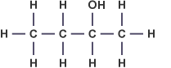
Butan-2-ol
The position of the functional group and any branches must be identified.
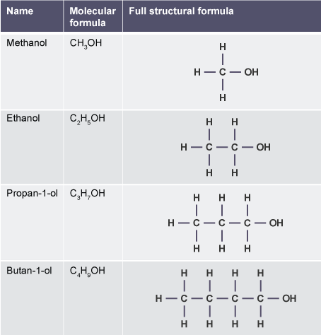
Alcohols have a wide variety of uses. While ethanol is most famous for its presence in alcoholic drinks, many other alcohols exist and are commonly used as fuels and solvents. Propan-2-ol is widely used in hand gels and disinfectant wipes. Alcohols are particularly useful as fuels due to their high flammability and the fact that they burn cleanly.

b) Carboxylic acids
Carboxylic acids, also known as alkanoic acids, all contain the carboxyl functional group –COOH. Their names all end in '–oic acid'. When naming carboxylic acids, the position of the carboxyl group does not need to be identified with a number, as it is always found at the end of the carbon chain, and so is on the first carbon.
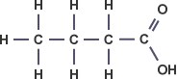
Butanoic acid
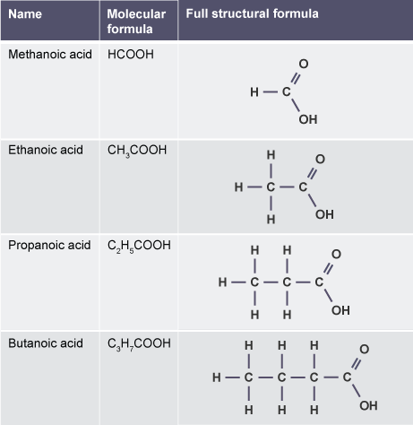
One of the most widely used carboxylic acids is vinegar. Also known as ethanoic acid, it has far more uses than simply being added to chips, and is commonly used in chemicals used to treat limescale in bathrooms or inside kettles. Many foods are also preserved in vinegar (pickled) to make them last for longer periods of time. Lots of other carboxylic acids have less pleasant smells than vinegar and some are highly corrosive so must be handled with care.

c) Esters
Esters are formed by the condensation reaction between an alcohol and a carboxylic acid. This is known as esterification. Esters have characteristic smells and are insoluble in water. They are commonly used as fragrances and perfumes.
( means a reversible reaction)
They have the functional group:

(R means rest of the molecule.)
The functional group (-COO) is known as the ester link.

Naming esters
To name an ester:
- Change the alcohol name to end in –yl.
- Change the acid name to end in –oate.
- Alcohol name goes to the front, acid name to the back.

Example
The ester propyl ethanoate which is responsible for the distinct pear drop smell associated with the sweet can be made by the condensation reaction between propanol and ethanoic acid.
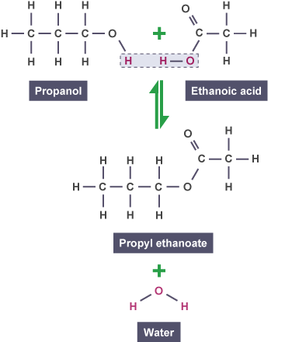

Esters can be made in the lab using apparatus illustrated in the diagram below.
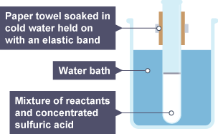

Consumer Products Minitest

1 What is the name of this carboxylic acid?
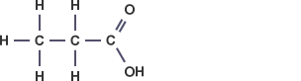
- Propanoic acid
- Ethanoic acid
- Pentanoic acid

2 Which of the following is not a use of alcohols?
- Fuels
- Flavourings
- Solvents

3 Which of these structures shows the ester ethyl methanoate?
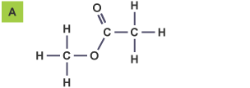
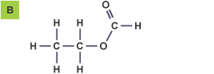
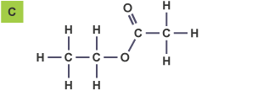

4 What type of reaction is this an example of?
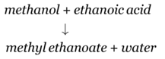
- Addition
- Hydrolysis
- Condensation

5 Which of these molecules is an isomer of butan-2-ol?
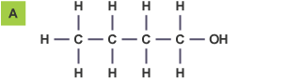
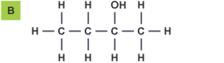
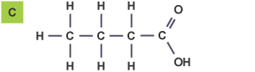

6 Which of these reasons is not a consideration when handling many carboxylic acids?
- They are strong acids
- They are flammable
- They are corrosive

7 What is the catalyst used to produce esters in the lab?
- Dilute hydrochloric acid
- Sodium hydroxide
- Concentrated sulfuric acid

8 What is the name of the ester formed when butanol and ethanoic acid react together?
- ethyl butanoic acid
- ethyl butanoate
- butyl ethanoate

9 Ethanol can be dehydrated using a catalyst. Which of the following could be produced during this reaction?
- Ethane
- Ethene
- Ethanoic acid

