National 5 Chemistry
Unit 1
Chemical changes and structures

Topic | Page
1 – Rates of Reaction | 1
Minitest | 7
2 – Elements & Atomic Structure | 10
Minitest | 14
3 - Bonding Related to Properties of Materials | 15
Minitest | 19
4 – Chemical Formulae | 21
5 – Balancing Equations | 23
Minitest | 24
6 – The Mole | 25
Minitest | 27
4 – Acids and Bases | 28
Minitest | 33
Glossary | 34

1 - Rates of reaction
There are four factors that affect the rate of a chemical reaction:
- temperature
- concentration
- particle size
- use of a catalyst

For a reaction to occur, the particles that are reacting must collide with each other. Only some of all the collisions that take place cause a chemical change to happen. These are called 'successful' collisions. The greater the number of 'successful' collisions, the faster the rate of a reaction. This is called the 'collision theory'.

a) Temperature
If the temperature is increased, the particles have more energy and so move quicker. Increasing the temperature increases the rate of reaction because the particles collide more often and with more energy. The higher the temperature, the faster the rate of a reaction will be.
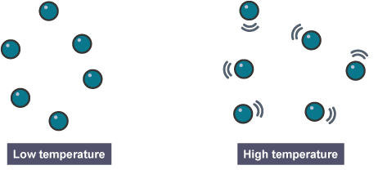
Look at the graph of the reaction between hydrochloric acid and calcium carbonate. Notice how an increase in temperature leads to an increase in the speed of release of carbon dioxide, but not the total volume of carbon dioxide released.
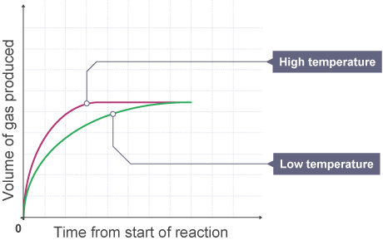

b) Concentration
If the concentration of reactants is increased, there are more reactant particles moving together. There will be more collisions and so the reaction rate is increased. The higher the concentration of reactants, the faster the rate of a reaction will be.
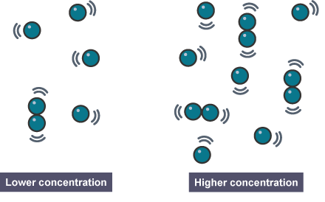

c) Particle size
By decreasing the particle size of a reactant, we are increasing its surface area. The greater the surface area, the higher the chance of collisions, thus the faster the rate of reaction. The smaller the particle size the faster the reaction.
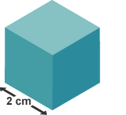
Think of a cube where the length of every side is 2 cm.
The area of one face of the cube will be 2 x 2 = 4 cm².
The cube has six faces, so the total surface area is
4 cm² x 6 = 24 cm².

We could cut that cube horizontally and vertically along each face so that we have eight smaller cubes.
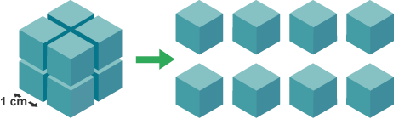
Each of the small cubes has a face area of 1 cm x 1 cm = 1 cm².
The six faces give a total surface area for each smaller cube of 6cm².
There are eight cubes so the total surface area is 6 cm² x 8 = 48cm².

d) Use of a catalyst
A catalyst speeds up the rate of a reaction but it is not used up in the reaction. If a catalyst is present, the reacting particles can collide more successfully with less energy and so the reaction can take place at a lower temperature.

Enzymes
Enzymes are biological catalysts.
They occur naturally in the body and help with digestion. They are used in the production of alcohol (zymase) and digestion of food (amylase). Enzymes are specific. This means that they can only catalyse one reaction.
Many enzymes work best at body temperature. While they do work at lower temperatures, they are less effective. At high temperatures, the enzyme molecule changes shape (denatures) and no longer speeds up the reaction.

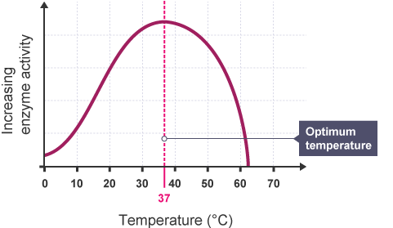

d) Monitoring the rate of a reaction
The rate of a chemical reaction is a measure of how fast the reactants are being used up and how fast the products are being made.
The rate can be determined by measuring:
- changes in the concentration of the reactants or products
- changes in the mass of the reactants or products
- changes in the volume of the reactants or products
For example, when dilute hydrochloric acid reacts with zinc metal, zinc chloride and hydrogen gas are produced.
There are two simple ways to measure the rate of this reaction in the lab.
- If the reaction is set up on a balance as shown, the mass of the apparatus can be monitored throughout the reaction. As hydrogen bubbles escape, the apparatus will lose mass.
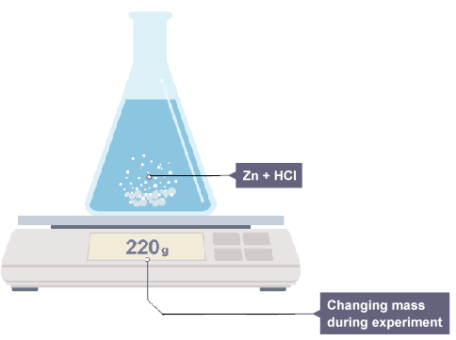
- An alternative way to monitor the reaction is by collecting and measuring the volume of the gas as it is produced. The gas can be collected in a gas syringe or over water (as long as it is insoluble in water).
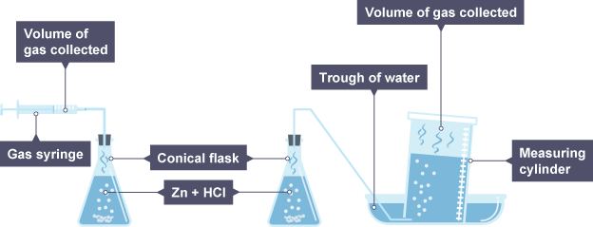
Two different ways to measure the volume of a gas that is produced

e) Calculating the rate of a reaction
Using the results of experiments like these, the average rate of the reaction can be calculated. No matter which quantity is measured during the course of a reaction, the average rate of reaction can be calculated using the equation below.
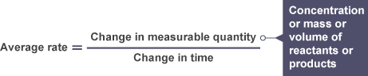
The change in measurable quantity can be read from a table of results or from a graph produced from results.
As the rate is changing throughout the reaction, we are calculating the average rate over a given time period.
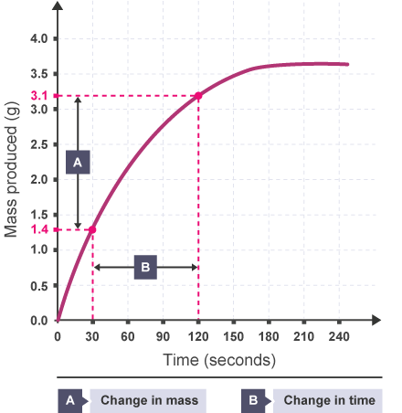
For example, the graph below could be used to calculate the average rate over any period of time

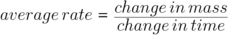
Using this graph, we can calculate the average rate between 30 seconds and 120 seconds.

The unit that rate is measured in depends on the measurable quantity. Since a change in mass is measured in grams and a change in time in seconds in this example, the unit of rate would be grams per second (g s⁻¹). Similarly, if a change in concentration is measured (in mol l⁻¹), then rate will have the unit moles per litre per second (mol l⁻¹ s⁻¹) or a change in volume measured in cubic centimetres, centimetres cubed per second (cm³ s⁻¹).

f) Rate graphs
In chemistry, graphs can be used to follow the course of a reaction. A graph can tell us many things about a reaction.
The graph below shows two similar reactions.
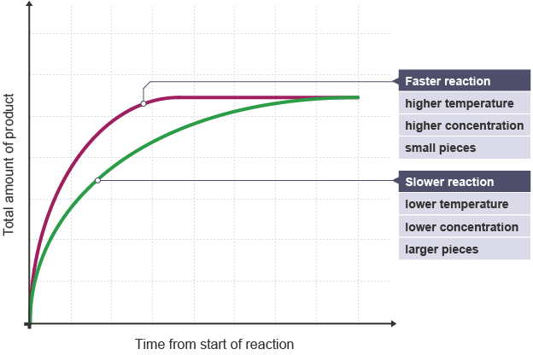
The magenta line has a steeper gradient and represents conditions favouring a faster reaction than the green line. When the reaction is finished (the end-point) the graph goes flat as no more products are being produced.

Rates of Reaction Minitest

1 Which of the following factors will not speed up a chemical reaction?
- Increasing the temperature of the reaction
- Increasing the particle size of reactants
- Increasing the concentration of reactants

2 A pupil places 10g of potato into 1 mol/l hydrogen peroxide solution.
The potato has a biological catalyst inside it that breaks the hydrogen peroxide down to water and oxygen gas.
What term is used to describe a biological catalyst such as catalase?
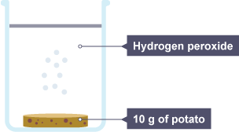
- Fermentation
- Enzyme
- Protein

3 A pupil places 10g of potato into 1 mol/l hydrogen peroxide solution.
The potato has a biological catalyst inside it that breaks the hydrogen peroxide down to water and oxygen gas.
The pupil counts 15 bubbles of oxygen given off every minute.
What could she do to the 10g of potato that would increase the number of bubbles per minute?
- Cook it before use
- Cut it into smaller pieces
- Use 5g instead

4 A pupil places 10g of potato into 1 mol/l hyrogen peroxide solution.
The potato has a biological catalyst inside it that breaks the hydrogen peroxide down to water and oxygen gas.
What would happen to the number of bubbles per minute if she used a less concentrated hydrogen peroxide solution instead of the original 1 mol/l?
- Stay the same
- Increase
- Decrease

5 A pupil places 10g of potato into 1 mol/l hyrogen peroxide solution.
The potato has a biological catalyst inside it that breaks the hydrogen peroxide down to water and oxygen gas.
What would happen to the number of bubbles if the temperature was increased to 30°C?
- Increase
- Decrease
- Stay the Same

6 Which of the following reactions would be the fastest?
- 1 mol/l hydrochloric acid reacting with zinc powder
- 1 mol/l hydrochloric acid reacting with a lump of zinc
- 0.5 mol/l hydrochloric acid reacting with zinc powder

7 In which of the following reactions would hydrogen be produced the fastest?
- Calcium powder and 2 mol/l hydrochloric acid
- Calcium lumps and 2 mol/l hydrochloric acid
- Calcium powder and 4 mol/l hydrochloric acid

8 What does a catalyst do?
- Speeds up a reaction and is not used up in the reaction
- Slows down a reaction and is not used up in the reaction
- Speeds up a reaction and is used up in the reaction

9 A pupil monitors the rate of a reaction by measuring the volume of gas that is being produced every 15 seconds.
What will her units be when calculating the rate of reaction?
- g s⁻¹
- cm³ s⁻¹
- mol l⁻¹ s⁻¹

10 Which line on this rate graph shows the slowest reaction?
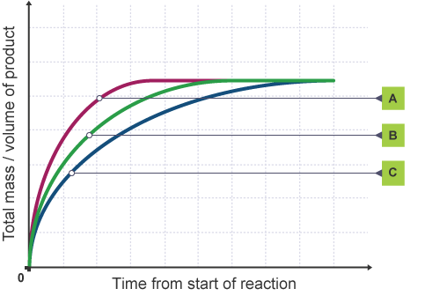
- A
- B
- C

2 – Elements and Atomic Structure

a) The Periodic Table
The periodic table brings order to information about the chemical elements. It helps chemists to understand why elements react as they do.
There are more than 100 elements which are arranged in the periodic table and each is represented by a symbol. A section of the periodic table is shown below which illustrates how the elements are arranged.
The SQA Data Booklet gives more information.
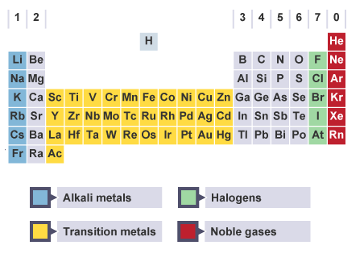
The chemical elements are arranged in order of increasing atomic number.
The horizontal rows are called periods and the vertical columns are called groups.
Elements with similar chemical properties are in the same group of elements.

The properties of the main groups of elements
- The elements in group 1 are known as alkali metals. They react rapidly (very fast) with water, producing an alkaline solution and hydrogen gas. The metals become more reactive as you go down the group.
- The elements in group 7 are known as halogens. Fluorine and chlorine are gases. Bromine is one of only two liquid elements. Iodine is solid. They exist as diatomic molecules - they have two atoms in each molecule. As you go down the group the halogens become less reactive.
- The elements in group 0 are known as noble gases. They are very unreactive and exist as individual atoms (monatomic).
- The transition metals are elements which are found between groups 2 and 3. Well known examples are iron, copper and gold. They are generally quite dense (heavy) and many form brightly coloured compounds.

b) Structure of the atom
Everything in the world is made up of atoms. The structure of the atom is what gives an element its chemical and physical properties.
Atoms are made up of three smaller particles called electrons, protons and neutrons.

Electrons
Negatively charged particles that spin around the positive centre of the atom in circles called energy levels. Their mass is so small it is nearly zero.

Protons
Positively charged particles that are contained in the nucleus of the atom (the centre) they have a mass of 1amu (atomic mass unit).

Neutrons
Particles with no charge are also contained in the nucleus of the atom. They too have a mass of 1amu.
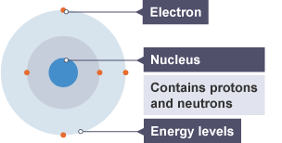

The nucleus has an overall positive charge as it contains the protons.

Particle | Mass | Charge | Location
Electron | Approx 0 | -1 | Energy level
Proton | 1 amu | +1 | Nucleus
Neutron | 1 amu | 0 | Nucleus

Every atom has no overall charge (neutral). This is because they contain equal numbers of positive protons and negative electrons. These opposite charges cancel each other out making the atom neutral.

Atomic number
Each element has its own atomic number.
Elements are arranged in the periodic table in order of increasing atomic number. For example hydrogen has the atomic number of one, helium two, lithium three etc.
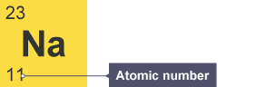

Mass number
The mass number is given at the top left of the element's symbol, for example, sodium has a mass number of 23.

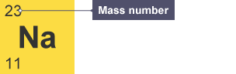
We know that the atomic number of sodium is 11. This tells us that sodium has 11 protons and because it is neutral it has 11 electrons.
The mass number of an element tells us the number of protons AND neutrons in an atom (i.e. the two particles that have a measureable mass).
Sodium has a mass number of 23amu. Since sodium has 11 protons, the number of neutrons is given by mass number – number of protons (23 - 11) = 12 neutrons.

Element | Mass number | Protons | Neutrons
Magnesium | 24 | 12 | 12
Potassium | 39 | 19 | 20
Carbon | 12 | 6 | 6

Isotopes
Isotopes are atoms with the same atomic number but different mass number.
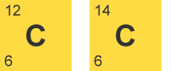
These two carbon atoms are isotopes. Each has the same number of protons but a different number of neutrons.

Relative atomic mass
Elements are made up of isotopes so the mass given in the data booklet is called the relative atomic mass (RAM).
The relative atomic mass of each element shown in the data book is calculated from the masses of all the isotopes of an element taking into account the percentage proportion of each.
Example: There are two isotopes of chlorine:
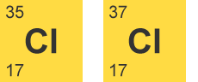
Since the RAM of chlorine is 35.5, chlorine-35 must be more abundant because its mass number is closer to the RAM.

Electron Arrangement
The electron arrangement of all atoms can be found in the data booklet. All the electrons are arranged into energy levels. These energy levels can only hold a certain number of electrons.
The first energy level (the one nearest the nucleus) can hold a maximum of 2 electrons with the others being able to hold up to a maximum of 8 electrons (only true for the first 20 elements).
Example: sodium has the electron arrangement 2,8,1.
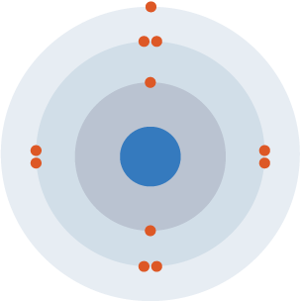
An atom of sodium has 11 electrons. The first two fill the innermost energy level. The second energy level is also full, holding eight electrons and one electron remains in the outer energy level.
Elements in the same group of the periodic table have the same number of outer electrons.
It is the number of outer electrons that give an element its chemical properties. This is why elements in the same group of the periodic table have similar properties.

Atomic Structure Minitest

1 What is the centre of an atom called?
- The protons
- The nucleus
- The electrons

2 What is the charge on an electron?
- One positive
- No charge
- One negative

3 If atoms contain charged particles, why do they not have a charge?
- They contain the same number of protons as electrons
- The charge is locked away in the nucleus
- They contain equal numbers of protons and neutrons

4 What is the atomic number of an atom equal to?
- The number of protons in the nucleus
- The number of neutrons in the nucleus
- The numbers of protons and neutrons in the nucleus

5 What are isotopes?
- Compounds with the same molecular formulae but different structural formulae
- Atoms with the same mass number but different atomic number
- Atoms with the same number of protons but a different number of neutrons

6 Where are the electrons inside an atom?
- The electrons are in the nucleus of an atom
- They are arranged in energy levels
- The electrons are spread equally throughout the atom

7 Which of the three sub-atomic particles is the lightest?
- The proton
- The neutron
- The electron

8 Which elements have similar chemical properties?
- Elements in the same period of the Periodic Table
- Elements with the same number of electrons in their outer energy level
- Elements with similar mass numbers

9 How many neutrons does this atom of carbon have?
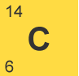
- 6
- 8
- 14

10 Hydrogen has three isotopes and a relative atomic mass of 1.0079. Which isotope is the most abundant?
- Hydrogen with atomic mass of 1
- Hydrogen with atomic mass of 2
- Hydrogen with atomic mass of 3

3 – Bonding Related to Properties of Materials
Atoms can be held together by chemical bonds. When atoms form bonds, they can achieve a stable electron arrangement. To achieve a stable electron arrangement atoms can lose, gain or share electrons. There are different types of bonds that hold atoms together.

a) Covalent bonding
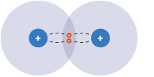
A covalent bond is a shared pair of electrons between atoms of two non-metal elements.
A covalent bond happens when the positive nuclei from two different atoms are held together by their common attraction for the shared pair of electrons held between them.
Covalent bonds are strong bonds.
Atoms that share pairs of electrons form molecules. A molecule is a group of atoms held together by covalent bonds.

A diatomic molecule is a molecule containing only two atoms. There are seven diatomic elements that you have to remember and a simple mnemonic to help with this. If you remember "I Bring Clay For Our New House” then you will have remembered that the seven diatomic elements are Iodine, Bromine, Chlorine, Fluorine, Oxygen, Nitrogen and Hydrogen.
Diagrams can be used to show how the outer electrons are shared to form the covalent bonds in a molecule.

Hydrogen (H₂)
Both hydrogen atoms have only one electron, but by forming a single covalent bond, both can have a full outer shell. The shape of the molecule formed is called linear.
A shared pair of electrons between two hydrogen atoms
This can also be shown as H-H.

Methane (CH₄)
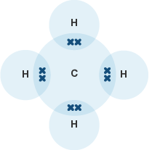
Carbon atoms have four outer electrons so need four more for a full outer shell. The carbon forms four single bonds to the hydrogen atoms, so all the atoms now have a full outer shell of electrons. The shape formed is called tetrahedral.

A methane molecule has four shared pairs of electrons

Ammonia (NH₃)
Nitrogen atoms have five outer electrons so needs three more for a full outer shell. Nitrogen forms three single covalent bonds to hydrogen atoms. The shape formed is called pyramidal.

Water (H₂O)
Oxygen atoms have six outer electrons so need two more for a full outer shell. The oxygen forms two single covalent bonds with the two hydrogen atoms. The shape formed is called bent.

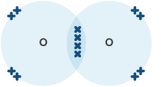
More than one bond can be formed between atoms leading to double and triple bonds. Examples of these are diatomic oxygen (double bond) or nitrogen (triple bond).

Oxygen molecules have a double bond: two shared pairs of electrons
This could also be written as:

Substances that consist of covalent molecules are usually gases or liquids at room temperature. Covalent substances that are solids with high melting points have much larger molecules.

A covalent network structure consists of a giant 3-dimensional lattice of covalently bonded atoms.
Boron, carbon and silicon are all examples of covalent network elements. Diamond and graphite, two forms of carbon and compounds like silicon dioxide and silicon carbide are all covalent networks.
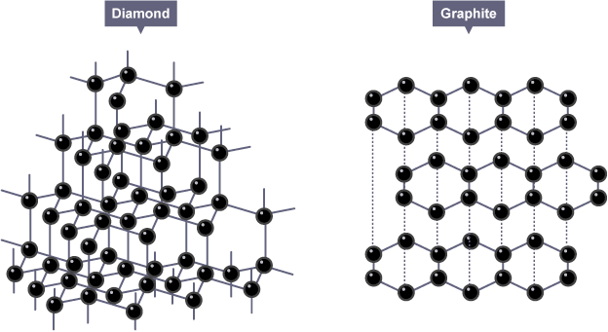
Diamond has a tetrahedral structure. Graphite has a layered, planar structure.

b) Ionic bonding
Ionic bonds are formed between a metal and non-metal, for example sodium chloride.
- An atom of sodium will lose an electron and form a positive ion.
- An atom of chlorine will gain an electron and form a negative ion.
The ionic bond is the electrostatic force of attraction between a positively charged metal ion and a negatively charged non-metal ion.

Metals form positive ions because they lose electrons to become stable.
Example:
Magnesium (Mg) has the electron arrangement 2,8,2.
To become stable it must lose its two outer electrons to obtain a full outer energy level.
Atoms are neutral because they have equal numbers of protons and electrons however, when they lose two electrons they are no longer neutral. They change into ions with a two positive charge.
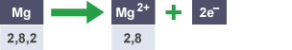

Non-metals form negative ions because they gain electrons to become stable.
Example:
Chlorine (Cl) has an electron arrangement 2,7.
To become stable it must gain an electron to obtain a full outer energy level.
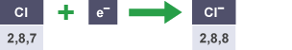

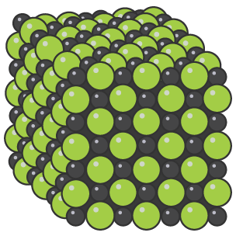
When these two charged particles come together they form an ionic bond because the positive magnesium ion is attracted to the negatively charged chloride ion.
Ionic compounds form what is known as a lattice structure. This is a regular repeating arrangement of metal and non-metal ions which creates compounds with very high melting points which conduct when molten or in solution but never when solid.
Ionic compounds dissolve in water easily, when they do this their lattice breaks up completely. Therefore they can conduct as their ions are free to move.

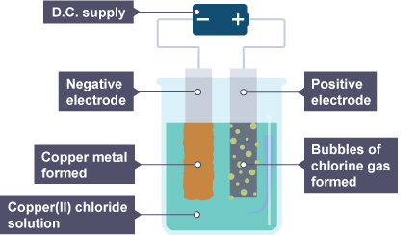
Electrolysis
Electrolysis is the breaking up of an ionic solution using electricity.
The copper chloride solution is broken up because electricity is passed through the solution. A direct current (DC) power supply must be used if the products of electrolysis are to be identified.
The positive copper ions are attracted to the negative electrode. When the copper ions get to the electrode they pick up two electrons to form copper metal.
The negatively charged chloride ions are attracted to the positive electrode. When the chloride ions get to the electrode they lose their extra electrons to become chlorine gas.

c) Summary of bonding
 | Ionic lattice | Covalent network | Discrete covalent molecules
Boiling and melting points | High | Very high | Low
State at room temperature | Solid | Solid | Liquid or gas
Conduction of electricity | Only when molten or in solution | Never (except graphite) | Never

Ionic lattice
All ionic compounds have a high melting point and boiling point. They conduct when molten or in solution as the ions are free to move. They can be broken down by electrolysis.

Covalent network
All covalent network structures have very high melting points and boiling points. They are all hard and do not conduct electricity.

Covalent molecular
They have low melting points and boiling points. They do not conduct electricity. Some covalent molecular compounds have higher melting points than expected.

Bonding Related to Properties of Materials Minitest

1 Which of the following pairs are both diatomic elements?
- Hydrogen and helium
- Iodine and nitrogen
- Boron and fluorine

2 How can the bonding in silicon dioxide (SiO₂) be described?
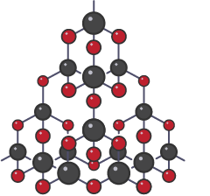
- Ionic
- Discrete covalent molecular
- Covalent network

3 Why do ionic compounds not conduct when they are solid?
- Their atoms are not free to move
- Their electrons are not free to move
- Their ions are not free to move

4 In the compound tin(IV) chloride, a small group of atoms are held together by shared pairs of electrons. What type of bonding is present in tin (IV) chloride?
- Ionic
- Discrete covalent molecular
- Covalent network

5 Which of these compounds are made up of diatomic molecules?
- Nitrogen monoxide (NO)
- Magnesium oxide (MgO)
- Carbon dioxide (CO₂)

6 Which of these does not have a covalent network structure?
- Chlorine
- Diamond
- Graphite

7 How can the shape of methane (CH₄) molecules be described?
- Bent
- Tetrahedral
- Pyramidal

8
Substance | Melting Point (°C) | Boiling Point (°C) | Electrical conductivity as a solid | Electrical conductivity as a liquid | Electrical conductivity in aqueous solution
A | 1538 | 2862 | Good | Good | Insoluble
B | 1414 | 3625 | Poor | Poor | Poor
C | 650 | 1091 | Good | Good | Insoluble
D | 801 | 1413 | Poor | Good | Good
E | -182 | -162 | Poor | Poor | Poor
F | 851 | 1633 | Poor | Good | Good
The table shows the properties of some different substances. Which substances are covalent?
- B + E
- A + C
- C + E

9 Which of these diagrams best represents the attractions that form the covalent bond holding the atoms together in the molecule?
- 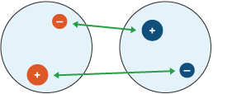
- 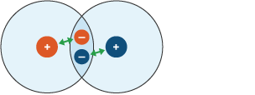
- 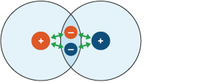

4 – Chemical formulae

a) Formula from names of compounds
The chemical formula of a covalent molecular substance gives the number of atoms per molecule. The formula of a covalent network or ionic compound gives the simplest ratio of atoms/ions in the substance.
Sometimes the name of the compound gives information about the formula of that compound. Names of these compounds have prefixes that give the number of atoms of certain elements in each molecule.
Prefix | Number of atoms
Mono- | One
Di- | Two
Tri- | Three
Tetra- | Four
Penta- | Five
Hexa- | Six
For example, carbon monoxide contains one carbon atom joined to one oxygen atom, so it has the formula CO.

b) Valency
Valency is the combining power of an element. Elements in the same group of the periodic table have the same valency. The valency of an element is related to how many electrons are in the outer shell.
Group number | 1 | 2 | 3 | 4 | 5 | 6 | 7 | 8
Valency | 1 | 2 | 3 | 4 | 3 | 2 | 1 | 0
The noble gases have the valency 0 as they do not usually combine with other elements.

To write the chemical formula for a compound it is best to use the S.V.S.D.F system.
- Step one - write down the symbols of both the elements involved.
- Step two - beneath each symbol, write it’s valency. Memorising the above table is useful.
- Step three - swap the valencies over.
- Step four - if the valencies can be simplified, divide them both by the smaller of the two numbers. If one of the numbers is already one, then they cannot be divided and simplified any further.
- Step five - write the formula.

Example one
What is the formula for potassium oxide?
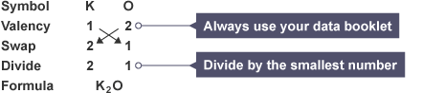

Example two :
What is the formula for carbon sulfide?
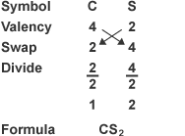

c) Formulae of compounds containing group ions
Group ions contain two or more atoms and usually have a negative charge. The formulae of these ions can be found in the data booklet. We can take the number of charges on the ion as the valency of the ion.

Example:

What is the formula for calcium nitrate?
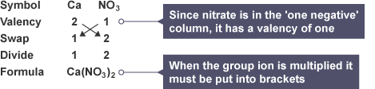

d) Formula using Roman numerals
Some elements, particularly the transition metals, do not always have the same valency in their different compounds. The valency of these elements is usually given in roman numerals inside brackets.
Roman Numeral | Number
I | One
II | Two
III | Three
IV | Four
V | Five
VI | Six

Example
What is the formula for copper (I) oxide?
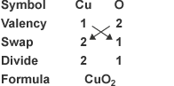

5 – Balanced equations
A chemical equation is said to be balanced when there are the same number of the same type of every atom on both sides of the equation.

Copper and oxygen reaction - getting a balanced equation
Balanced symbol equations show what happens to the different atoms in reactions.
Take a look at this word equation for the reaction:
Copper and oxygen are the reactants because they are on the left of the arrow. Copper oxide is the product because it is on the right of the arrow.
If we just replace the words shown above by the correct chemical formulae, we will get an unbalanced equation, as shown here:
Notice that there are unequal numbers of each type of atom on the left-hand side compared with the right-hand side. To make things equal, you need to adjust the number of units of some of the substances until you get equal numbers of each type of atom on both sides.
Here is the balanced symbol equation:
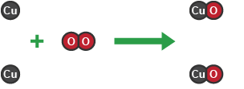
You can see that now there are two copper atoms and two oxygen atoms on each side. This matches what happens in the reaction.
2 copper atoms react with an oxygen molecule to form 2 units of copper oxide (CuO)

Balancing equations
To balance equations on your own, follow these simple rules:
- Check that all the formulae in the equation are correct.
- Deal with only one element at a time.
- Balancing is adding BIG numbers. You cannot change any of the small numbers in a chemical formula. If balancing is required, put the number in front of the substance.
- Check each element again and repeat step 3 again if needed.

Example
This equation is unbalanced. There are four carbon atoms on the left hand side and only one on the right. To balance the carbon, add a big '4' in front of the carbon dioxide.
Next, to balance the hydrogen. We have 8 atoms of hydrogen on the left hand side in C ₄ H ₈ and only 2 on the right hand side. To balance the hydrogen atoms, add a big '4' in front of H ₂ O.
We’re not finished yet. Now that the carbon and hydrogen have been balanced, we only have to balance the oxygen. We have 2 atoms of oxygen on the left, but in total on the right (taking into account what we have balanced already) we have 12 oxygen atoms. This can be balanced by adding a big '6' in front of the diatomic oxygen molecule on the left hand side.
The balanced equation will be:

Chemical formulae and balanced equations Minitest

1 What is the chemical formula for sodium bromide?

2 What is the chemical formula for calcium phosphide?

3 What is the chemical formula for titanium tetrachloride?

4 What is the chemical formula for dinitrogen trioxide?

5 What is the chemical formula for ammonium sulfate?

6 What is the chemical formula for iron(II) chloride?

7 What is the chemical formula for copper(II) hydroxide?

8 What is the chemical formula for calcium hydroxide?

9 Which of the following values are the correct values for a, b and c required to balance the equation
- a = 2, b = 1 and c = 2
- a = 3, b = 1 and c = 3
- a = 2, b = 2 and c = 4

10 Which of the following values are the correct values for a, b and c required to balance the equation
- a = 1, b = 3, c = 2 and d = 4
- a = 1, b = 3, c = 2 and d = 2
- a = 1, b = 2, c = 2 and d = 2
6 – The Mole
a) Gram Formula Mass (GFM)
The gram formula mass (GFM) of a substance is known as the mass of one mole.
Relative atomic masses of selected elements can be found in the SQA Data Booklet. These can be used to calculate the gram formula mass of a substance.

For example
What is the mass of one mole of calcium chloride?
To calculate this, work out the formula of calcium chloride then add all the mass numbers together.
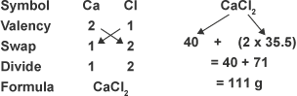
One mole of calcium chloride has a mass of 111 g.

b) Mole calculations based on mass
To calculate the mass of a higher number of moles, or even calculate the number of moles in a certain mass, a formula triangle can be used.
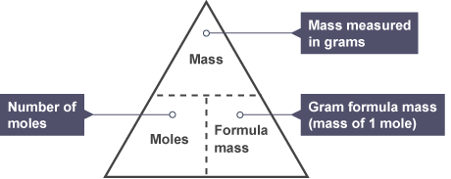
Using the formula triangle is straightforward. Simply cover whatever part of the triangle you are trying to work out.

Example
How many moles are present in 25 g of calcium carbonate?
Step One: Calculate GFM of calcium carbonate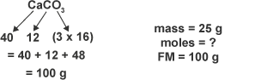
Work out the formula we need to use, given by covering up number of moles.

Step Two : Put the numbers in to the formula:

c) Concentration of solutions
Solutions are formed when solutes dissolve in solvents. If the number of moles of solute and the volume of solvent used is known, the concentration of the solution can be calculated.
The concentration of a solution is measured in moles per litre (mol l⁻¹) and can be calculated using this formula triangle:
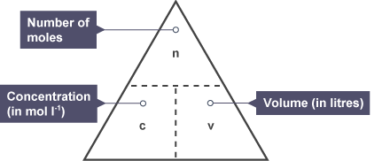
Using the formula triangle gives three useful formulae:
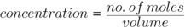
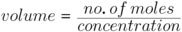

Example one
Calculate the concentration of the solution formed when 0.25 moles of potassium nitrate are dissolved in 500 cm³ of water.
The formula we need to use, given by covering up concentration is:
Remember that the volume always has to be changed into litres.

Example two
Calculate the number of moles in 200cm³ of 0.5 mol l⁻¹ sodium hydroxide (NaOH) solution.
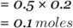

Example three
Calculate the volume of sodium hydroxide used in 1 mol l⁻¹ solution containing 2 mol of solute.
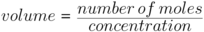

The mole and concentration of solutions Minitest

1 What is the gram formula mass of oxygen?
- 16g
- 32g
- 8g

2 What is the gram formula mass of lithium chloride?
- 42.5g
- 7g
- 35.5g

3 What is the mass of 1 mole of carbon dioxide?
- 12g
- 28g
- 44g

4 What is the mass of 1 mole of sodium sulphate?
- 119g
- 71g
- 142g

5 How many moles are there in 24g of carbon?
- 2 moles
- 1 mole
- 0.5 moles

6 How many moles are there in 50g of calcium carbonate (CaCO₃)?
- 2 moles
- 1 mole
- 0.5 moles

7 What is the mass of 0.5 moles of magnesium chloride?
- 47.75g
- 95.5g
- 59g

8 What is the number of moles of potassium hydroxide used to make 100cm³ of 0.1 mol l⁻¹ solution?
- 10 moles
- 0.1 mole
- 0.01 moles

9 What is the concentration of hydrochloric acid solution used if 2 moles are dissolved in 100cm³ of water?
- 20 mol l⁻¹
- 2 mol l⁻¹
- 0.02 mol l⁻¹

10 What volume of sodium hydroxide is needed to produce a 0.1 mol l⁻¹ solution containing 0.5 moles of solute?
- 5 litres
- 5 cm³
- 50 litres

7 – Acids & bases
The pH scales measures the acidity or alkalinity of a solution. Acids and bases have a wide variety of uses and can react together in neutralisation reactions.

a) The pH scale
How acidic or alkaline a substance is (the pH of the substance) can be measured using the pH scale, a continuous range that stretches from below 0 to above 14. Most common pH values occur between 0 and 14.
Acids have a pH of less than 7.
Alkalis have a pH more than 7.
Water and neutral solutions have a pH of exactly 7.
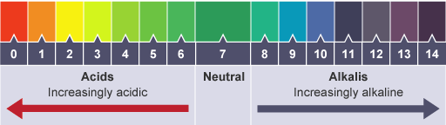
The pH is a measure of the concentration of hydrogen ions in a solution.

b) Forming acids and alkalis
- Metal Oxides
Alkalis are soluble bases. An alkaline solution can be formed when a metal oxide is dissolved in water. An acidic solution can be formed when a non-metal oxide is dissolved in water.
For example, magnesium oxide dissolves to form alkaline solutions.
Soluble metal oxides produce alkalis when dissolved in water.

Example one
What will happen to the pH of water if barium oxide is added?
Using the data booklet we find that barium oxide is a metal oxide. Checking its solubility on page 8 of the data booklet we see that it will dissolve. It is therefore a soluble metal oxide and it will increase the pH.

Example two
What will happen to the pH of water if aluminium oxide is added?
Using the data booklet we find it is a metal oxide. Checking its solubility on page 8 we find it is insoluble. It will therefore have no effect on the pH of water.

- Non-metal Oxides
Sulfur dioxide and nitrogen dioxide however, will dissolve to form acidic solutions.
Soluble non-metal oxides produce acids when dissolved in water.

c) Hydrogen and hydroxide ions
Acidic and alkaline solutions can conduct electricity because they have ions that are free to carry charge. Look at the formulae of these acids. They all contain H⁺ ions.
Acid name | Formula | Ionic Formula
Hydrochloric acid | HCl | H⁺(aq) Cl⁻(aq)
Sulfuric acid | H₂SO₄ | 2H⁺(aq) SO₄²⁻(aq)
Nitric acid | HNO₃ | H⁺(aq) NO₃⁻(aq)
When an acid is diluted the concentration of H⁺ ions is decreased and the pH increases towards 7. Look at the formulae of these alkalis. They all contain OH⁻ ions.
Alkali name | Formula | Ionic Formula
Sodium hydroxide | NaOH | Na⁺(aq) OH⁻(aq)
Calcium hydroxide | Ca(OH)₂ | Ca²⁺(aq) 2OH⁻(aq)
Lithium hydroxide | LiOH | Li⁺(aq) OH⁻(aq)
The more concentrated an acid or alkali the better it conducts. When an alkali is diluted the concentration of OH⁻ ions is decreased and the pH decreases towards 7.

d) Water and neutral solutions
Water molecules can break down into hydrogen ions and hydroxide ions.
This is a reversible reaction. A small proportion of water molecules break up to form hydrogen ions and hydroxide ions. Some of these hydrogen and hydroxide ions then react together again to form water molecules.
This is called an equilibrium and is present in water and all aqueous solutions.
In water and neutral solutions, the concentration of hydrogen ions is equal to the concentration of hydroxide ions.
All acidic solutions contain more hydrogen ions than hydroxide ions.
All alkaline solutions contain more hydroxide ions than hydrogen ions.
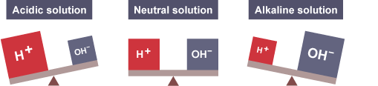

e) Diluting acids and bases
Adding water to an acid or base will change its pH. Water is mostly water molecules so adding water to an acid or base reduces the concentration of ions in the solution.
When an acidic solution is diluted with water the concentration of H⁺ ions decreases and the pH of the solution increases towards 7.
To make the pH change by 1, a tenfold dilution is required (eg adding 9 cm³ of water to 1 cm³ acid). The acid is becoming less acidic.
Similarly, when an alkali is diluted with water the concentration of OH⁻ ions decreases. This causes the pH of the alkali to fall towards 7, making the solution less alkaline as more water is added.

f) Neutralisation
Neutralisation is the reaction of an acid with a base that results in the pH moving towards 7.
It is a useful process that occurs in everyday life such as in the treatment of acid indigestion and the treating of acidic soil by adding lime.
Neutralisation also moves the pH of an alkali down towards seven.
Several different bases can neutralise acids, and water is always produced as a result of these reactions.

Equations for neutralisation
Metal oxides and alkalis are two types of base. Basic substances neutralise acids, resulting in the pH of the acid increasing towards 7, and water being produced. A soluble base dissolves in water to form an alkaline solution.

Acids can also be neutralised by metal carbonates. In the neutralisation reaction between an acid and a metal carbonate, there are three products. The hydrogen ions (H⁺) from the acid react with the carbonate ions (CO₃²⁻) to form water and carbon dioxide gas. A salt is also produced.
Carbon dioxide can be tested for using lime water (turns from colourless to chalky white).

Naming salts
To name the salt, the metal ion from the alkali (or base) replaces the hydrogen ion from the acid - (alkali to front, acid to back).
For example:

Acid name | Salt name ending
Hydrochloric acid | ...chloride
Sulfuric acid | ...sulfate
Nitric acid | ...nitrate

During neutralisation the H⁺ ion from the acid joins with the OH⁻ ion from the alkali. This is why water is formed in these reactions.
This is true for all neutralisation reactions.

g) Ionic equations and spectator ions
Ionic equations are different to symbol equations.
For example, an equation showing hydrochloric acid being neutralised by sodium hydroxide:

The ionic equation for the above process shows the charges involved. State symbols are added and ions in solution are separated with a sign.

Spectator ions are ions that are present during the reaction but are unchanged by the reaction, and so are present in the same state and charge on both sides of the equation.
This ionic equation can be shortened further by removing the spectator ions.
Re-writing the equation without the spectator ions gives:
This change occurs in every neutralisation reaction.

h) Titrations
A titration experiment can be carried out to accurately measure the volume of substances that react in chemical reactions.
This technique is commonly used in neutralisation reactions and can also be used to calculate an unknown concentration (of either the acid or alkali).
When titrating, it is essential to measure things as accurately as possible.
The experiment is carried out by following these steps:
- If the sample is a solid, it is weighed using an accurate balance, and then dissolved to make up a known volume of solution (usually 100 cm³).
- A pipette is used to measure accurately a volume of this solution - for example, 10 cm³. A safety pipette filler is used to draw solution into the pipette. This is emptied into a conical flask.
- A few drops of an indicator may be added to the conical flask. This will show a change of colour when the titration is complete.
- A second chemical is placed in a burette. This other solution is of a chemical that will react with the sample in the conical flask. Often the solution in the burette is an acid of a precise, known concentration.
- The solution from the burette is run into the conical flask. The solution is added one drop at a time, with swirling to mix the solutions as the end-point is approached. Eventually, a colour change shows that the correct amount has been added to react completely with the sample in the conical flask.
- The volume of solution added from the burette is noted. The titration results can then be used to calculate the concentration of the sample in the conical flask.
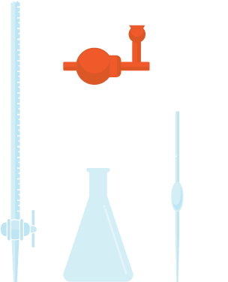
Titration apparatus: a burette, conical flask, safety pipette filler and pipette.

Acids and Bases Minitest

1 Omitting the spectator ions, which of the following is the ionic equation for the reaction of an acid and an alkali?

2 What type of solution would be formed when sulfur dioxide dissolves in water?
- Alkaline solution
- Acidic solution
- Neutral solution

3 What would be the pH of the solution formed when sodium oxide dissolves in water?
- Above 7
- Equal to 7
- Less than 7

4 Potassium chloride dissolves to form a neutral solution. What does this tell you about the ions involved?
- There are more hydrogen ions than hydroxide ions
- There are more hydroxide ions than hydrogen ions
- There are the same concentrations of hydrogen ions as hydroxide ions

5 Which salt is made when calcium carbonate reacts with hydrochloric acid?
- Sodium chloride
- Calcium chloride
- Carbon chloride

6 Which of the following are the correct products from the reaction between magnesium hydroxide and sulfuric acid?
- Magnesium sulfate + water
- Magnesium sulfate + water + carbon dioxide
- Magnesium sulfate + hydrogen

7 If equal volumes of equimolar (same concentration) solutions of the chemicals below were measured, which would contain the most hydrogen ions?
- Sodium sulfate
- Lithium carbonate
- Nitric acid

8 Which of the following happens to the pH of an acid when it is neutralised?
- The pH does not change
- The pH increases towards 7
- The pH decreases towards 7

9 Which of the following has the correct pH values for acids, alkalis and neutral solutions?
- Acid , Alkali and Neutral
- Acid , Alkali and Neutral
- Acid , Alkali and Neutral

Term | Meaning
atom | All elements are made of atoms. An atom consists of a nucleus containing protons and neutrons, surrounded by electrons.
atomic number | The number of protons in the nucleus of an atom. Also called the proton number.
electron | Sub-atomic particle, with a negative charge and a negligible mass relative to protons and neutrons
electron arrangement | The order electrons are arranged into between different energy levels.
mass number | The number of protons and neutrons found inside the nucleus of an atom.
neutron | Uncharged sub-atomic particle, with a mass of 1 relative to a proton.
nucleus | The central part of an atom. It contains protons and neutrons, and has most of the mass of the atom. The plural of nucleus is nuclei.
proton | Sub-atomic particle with a positive charge and a relative mass of 1.
catalyst | Changes the rate of a chemical reaction without being changed by the reaction itself.
enzyme | Proteins which catalyse or speed up chemical reactions.
product | A substance formed in a chemical reaction.
reactant | Chemicals present at start of a reaction.
acid | Substance producing more hydrogen ions than hydroxide ions when dissolved in water.
alkali | Substance producing more hydroxide ions than hydrogen ions when dissolved in water
pH | A measure of hydrogen ion concentration
salt | The substance formed when the hydrogen ion in an acid is replaced by a metal ion.
spectator ion | An ion that is exactly the same on both sides of an ionic equation.
titration | A method for accurately finding volumes involved in chemical reactions.

