**NATIONAL 5 CHEMISTRY**

[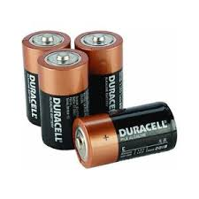](http://www.google.co.uk/url?sa=i&rct=j&q=&esrc=s&frm=1&source=images&cd=&cad=rja&uact=8&docid=CZ1QpTJ-I4RJwM&tbnid=WfqO-zIjKWLNQM:&ved=0CAUQjRw&url=http://www.ebay.co.uk/bhp/duracell-lr14-batteries&ei=zwc9U8mjD6He7AapuYH4Dw&bvm=bv.63934634,d.ZGU&psig=AFQjCNFurvEob80VfoDsZkojyvMLI5JBhw&ust=1396594989812092)Unit 3

Chemistry in Society

ANSWERS

Exam Questions

**Metals**

1. C (1)

2. B (1)

3. D (1)

4. B (1)

5. C (1)

6. D (1)

7. D (1)

8. D (1)

9. C (1)

10. D (1)

11. D (1)

12. C (1)

13. A (1)

14. A (1)

15. A (1)

16. A (1)

17. D (1)

18. Delocalised (free) electrons (1)

Electrons are free to move

Electrons can pass through

|  |  |  |  |
| --- | --- | --- | --- |
| **19.** | **(a)** | d.c. or direct current 1 | Not acceptable :  Battery, lab pack |
|  | **(b)** | Chlorine gas  Bubbles of gas  Gas given off  Fizzing/effervescence  Green/yellow gas  Cl2(g) 1 |  |

|  |  |  |  |
| --- | --- | --- | --- |
| **20.** | **(a)** | A B  On or close to the wires **1** | Not acceptable :  Arrow in solution or arrow continues into solution or ion bridge →  Negates:  Also negates if arrow also drawn on wire correctly. |
| **(b)** | State symbols not needed.  Negative sign on electron not needed.  **1** |  |
| **(c)** | Ion bridge/salt bridge  Filter paper soaked in salt solution/electrolyte. **1** | Not acceptable:  Ion-electron bridge  Electrolyte or bridge on its own. |

|  |  |  |  |
| --- | --- | --- | --- |
| **21.** |  | **1** |  |

|  |  |  |  |
| --- | --- | --- | --- |
| **22.** | **(a)** | displacement  redox **1** | Not acceptable:  Oxidation/reduction |
| **(b) (i)** | B/negative **1** |  |
| **(b) (ii)** | As per data booklet, ignore state symbols.      **1** |  |

|  |  |  |  |
| --- | --- | --- | --- |
| **23.** |  | FM = 232·5 (1)  200·5/232·5 x 100 = 86·2% or 86% (1)  86·2% or 86% on its own 2 marks  Use of atomic numbers max 1 mark, must have working to gain the mark, 83·3%  Metal other than Hg max 1 mark |  |

|  |  |  |  |
| --- | --- | --- | --- |
| **24.** |  | reduction  reduced 1 | Redox  Redox and reduction  0 marks  (cancelling applies) |

|  |  |  |  |
| --- | --- | --- | --- |
| **25.** |  | 25g **1** |  |

|  |  |  |  |
| --- | --- | --- | --- |
| **26.** | **(a)** | oxidation **1** |  |
| **(b)** | Left to right indicated on or near the wire. **1** | Not acceptable:  if line goes into cell 0 marks |
| **(c)** | C, graphite, carbon **1** |  |

|  |  |  |  |
| --- | --- | --- | --- |
| **27.** | **(a)** | Can be circled on either side or both sides or identified in some other way  **1** |  |
| **(b)** | Ignore state symbols (-ve sign not needed for e)  **1** |  |
| **(c) (i)** | Zinc copper carbon or any metal below copper in ECS.  Zinc sulphate solution/Zn2+(aq) (or any other soluble zinc salt) or a solution containing ions of metals above zinc in ECS.  **1** | **Not acceptable:**  Zn2+ on its own or with any other state symbol.  Zinc sulphate without solution.  Zinc solution. |
| **(c) (ii)** | To complete/finish the circuit/cell.  To allow ions to flow/move/transfer (between the two beakers).  To carry the ions (between the two beakers).  To provide ions to complete the circuit. | **Not acceptable:**  To transfer ions from zinc to copper  To carry the current  To conduct electricity  To allow electrons to flow through the wire on its own  Any mention of electrons on their own  Allow electricity to pass through /flow  To connect (the) electrolytes  To keep (the) circuit flowing  To connect the circuit  **Negates:**  Allow electrons to flow -unless specifically stated through the wire. |

|  |  |  |  |
| --- | --- | --- | --- |
| **28.** | **(a)** | (metal) 3  0·9 **1** | **Not acceptable:**  (Metal) C |
| **(b)** | (metal) 2 and (metal) 3  0·2 and 0·9  allow for follow through for incorrect answer in (a)  (metal) 3 and students answer in (a) **1** | **Not acceptable:**  any other combination |
| **(c)** | 0/ 0·0 / zero  **1** | **Not acceptable:**  No voltage |

|  |  |  |  |
| --- | --- | --- | --- |
| **29.** |  | Ignore state symbols  Correct symbols to be used **1** | **Not acceptable:**  Use of = sign |

|  |  |  |  |
| --- | --- | --- | --- |
| **30.** |  | D **1** |  |

|  |  |  |  |
| --- | --- | --- | --- |
| **31.** |  | D  **1** |  |
| **32.** |  | A **1** |  |
| **33.** |  | B  **1** |  |

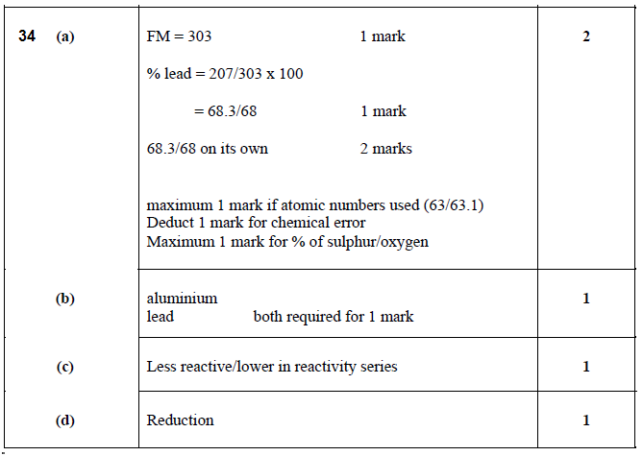

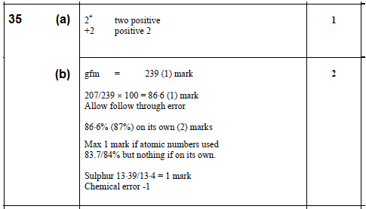

**Properties of Plastics**

1. A (1)

2. C (1)

3. B (1)

4. A (1)

5. D (1)

6. D (1)

7. C (1)

|  |  |  |  |
| --- | --- | --- | --- |
| **8.** |  | or  **1** | **Not acceptable:** |

|  |  |  |  |
| --- | --- | --- | --- |
| **9.** |  | Diagram must show three monomer units linked together  One end bond missing no penalty **1** | **Not acceptable:**  If molecule closed at both ends zero marks. |

|  |  |  |  |
| --- | --- | --- | --- |
| **10.** |  | D **1** |  |

|  |  |  |  |
| --- | --- | --- | --- |
| **11.** | (a) | allow one slip – missing H atom OR missing C – H bond but not C=O or – O – H  ignore brackets around correct monomer. **1** | **Not acceptable:**  COOH if expanded must be correct.  Repeating unit and monomer shown with no indication of steps involved (professional judgement). |
| (b) | Polar covalent **1** | **Not acceptable:**  Covalent  Any reference to networks  Hydrogen bonding |

|  |  |  |  |
| --- | --- | --- | --- |
| **12.** | (a) | both end bonds must be present, dotted lines, squiggles /  allow one missing C to F bond/  allow one missing F  don’t penalise for size/shape of F  must have 6 carbons  ignore brackets **1** | **Not acceptable:**  missing C to C bond/  no end bonds  Fl  Carbon to carbon double bond  F at end |
| (b) | Addition/ additional **1** |  |

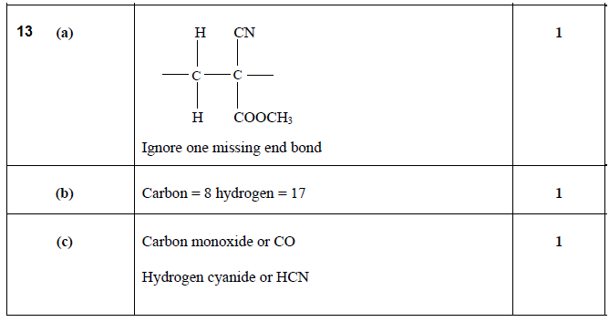

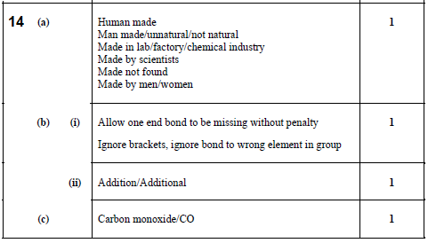

15. (a) hydroxyl (1)

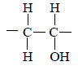 (b)

Allow shortened formula but must show bonds (1)

(c) Soluble in water/dissolves (1)

Breaks down in water

Degrades in water

Disintegrates in water

**Fertilisers**

1. C (1)

|  |  |  |  |
| --- | --- | --- | --- |
| **2.** | (a) | Arrows drawn from unreacted gases to hydrogen and nitrogen box or catalyst box or between these two  **1** |  |
|  | (b) (i) | Platinum, Pt **1** |  |
|  | (b) (ii) | It is an exothermic reaction  The reaction produces heat **1** |  |

|  |  |  |  |
| --- | --- | --- | --- |
| **3.** |  | Speed up reaction, too slow at 200ºC **1** | **Not acceptable:**  Any mention of decomposition  Cost  **Negates:**  Faster & produces more ammonia |

|  |  |  |  |
| --- | --- | --- | --- |
| **4.** |  | FM = 174g (1 mark)  78/174 × 100 = 44.8 (1 mark)  44.8 or 45 on its own 2 marks  Using atomic numbers 44% (max 1 mark)  44 must have working  If use mass of one potassium max 1 mark  If use S or O max 1 mark | **Not acceptable:**  44 on its own zero  If use element not in potassium |

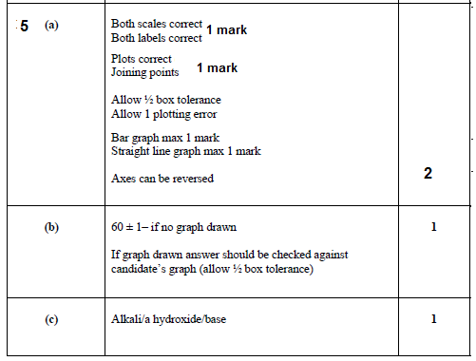

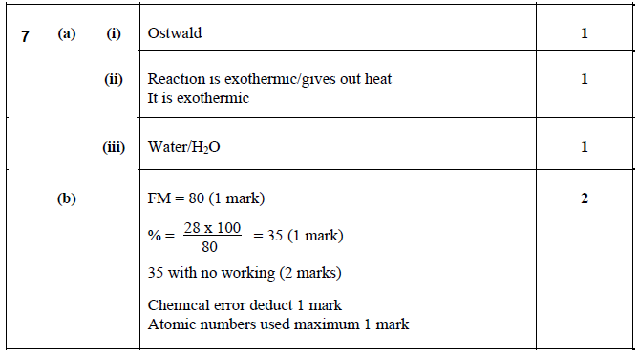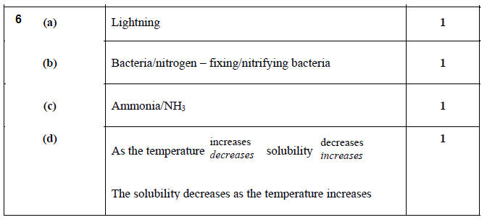

**Nuclear Chemistry**

|  |  |  |  |
| --- | --- | --- | --- |
| **1.** |  | A |  |

|  |  |  |  |
| --- | --- | --- | --- |
| **2.** | (a) |  |  |
|  | (b) | 8 days **1** |  |

|  |  |  |  |
| --- | --- | --- | --- |
| **3** | (a) | **1**  Atomic numbers not required- if shown, they must be correct  Mass numbers shown top left as in question paper |  |
|  | (b) | No effect/no change **1** |  |
|  | (c) | ¼ or 0.25 or 25% **1** |  |

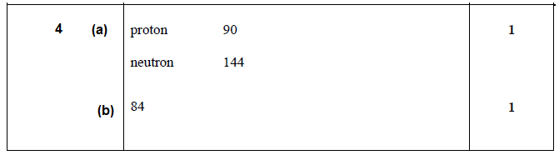

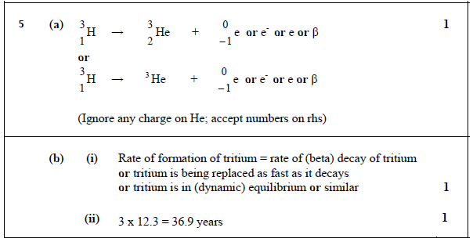

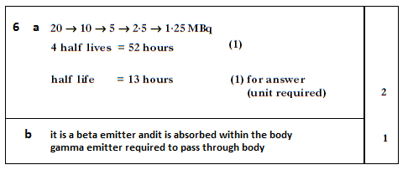

7 (a) time for the activity (or number of nuclei) (of a radioactive source) to reduce

to half the original number/activity/its value (1)

(b) Activity 160 to 80 kBq ⇒ 6 hours (1)

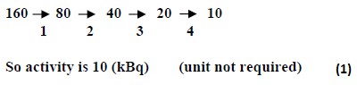 (c)

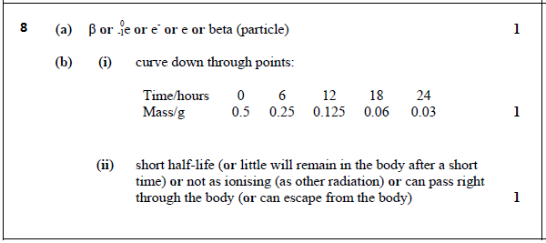

9. C (1)

10. C (1)

**Chemical Analysis**

1. D (1)

2. C (1)

3. B (1)

4. C (1)

|  |  |  |  |
| --- | --- | --- | --- |
| **5.** | (a) | Indicator/named acid/base indicator  pH/universal indicator **1** | **Not acceptable:**  Ferroxyl indicator  Bicarbonate indicator |
|  | (b) | Apply mole ratio  0.002 : 0.004 **1** mark  0.004 on its own **1** mark |  |

|  |  |  |  |
| --- | --- | --- | --- |
| **6.** |  | Apply mole ratio 1:1  0·001: 0·001 **1** mark  0·001 = c x 0·025  c = 0·04 **1** mark |  |

|  |  |  |  |
| --- | --- | --- | --- |
| **7.** | (a) | 16·0/ 16 **1** |  |
| (b) | **1 mark**      **1 mark**    **1 mark**  Or 0·2025 (if 16·2 used)  = 0·20/0·203 if rounded  Allow follow through for incorrect answer above. |  |

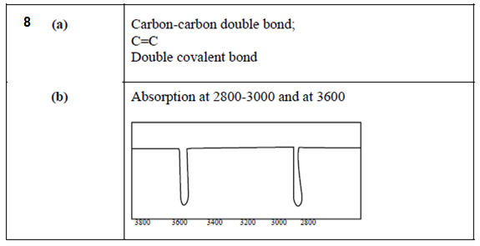

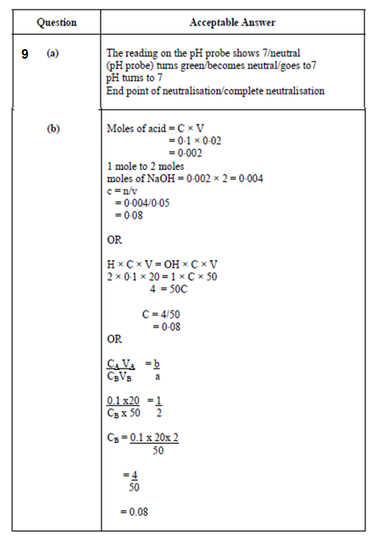

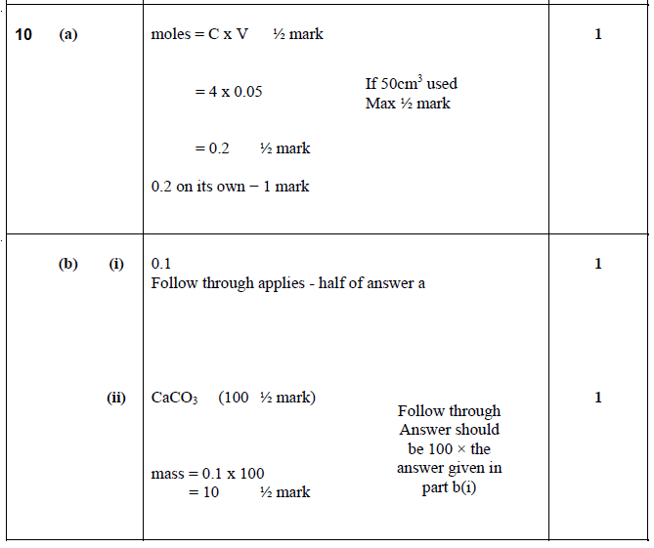

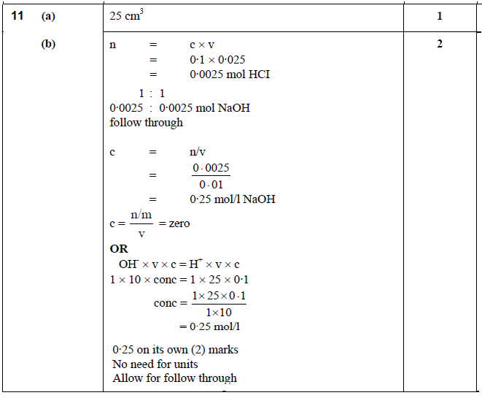

**Problem Solving Questions**

|  |  |  |  |
| --- | --- | --- | --- |
| **1.** | (a) | As the percentage increases…the density decreases  As the percentage decreases…the density increases  Density increases as percentage decreases  Density decreases as percentage increases etc **1** | **Not acceptable:**  As the density increases percentage decreases eg wrong cause and effect |
|  | (b) | 20 **1** |  |

|  |  |  |  |
| --- | --- | --- | --- |
| **2.** | (a) | Red, pink, orange, yellow **1** |  |
|  | (b) | Line must be increasing  Line stops at pH7 or below  **1** |  |

|  |  |  |  |
| --- | --- | --- | --- |
| **3.** | (a) | Ionic  Ionic lattice  Ionic network  **1** | **Not acceptable:**  Ionic molecular  Lattice on its own  Network on its own  Sodium to chlorine bonds |
|  | (b) | As concentration increases/decreases freezing point decreases/increases  The freezing point decreases/increases as concentration increases/decreases  As concentration increases freezing point gets colder  **1** | **Not acceptable:**  Wrong cause & effect eg:  As freezing point decreases concentration increases. |
|  | (c) | -1.8 to -2.0 inclusive  **1** | **Not acceptable:**  Statement  Less than -1.5 |

|  |  |  |  |
| --- | --- | --- | --- |
| **4.** | (a) | **1**  2·96/2·9605/2·961/2·9605263 on its own – 1 mark  3·0 or/3 with working | 2·9 or 3·0 or 3 without working – zero marks |

|  |  |  |  |
| --- | --- | --- | --- |
| **5.** | (a) | B **1** |  |

|  |  |  |  |
| --- | --- | --- | --- |
| **6.** | (a) | (solution) C  Last one/bottom one  **1** |  |
|  | (b) | any value above 4·4 and below 6·0 (not inclusive)  must acknowledge both parameters  number within range **1** | **Not acceptable:**  value below 6·0  value above 4·4 |

|  |  |  |  |
| --- | --- | --- | --- |
| **7.** | (a) | both required for **1** mark  allow one missing H or one missing C to H bond | **Not acceptable:**  No 5 bonded carbons |