**NATIONAL 5 CHEMISTRY**

Unit 1

Chemical Changes and Structure

[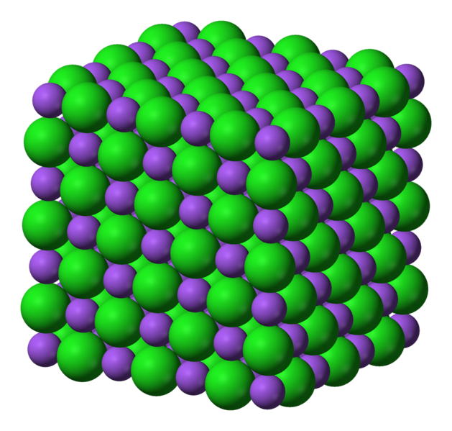](http://www.google.co.uk/url?sa=i&rct=j&q=&esrc=s&frm=1&source=images&cd=&cad=rja&uact=8&docid=MOD2Xsd_F3kXuM&tbnid=cKAN7rwh_ik-RM:&ved=0CAUQjRw&url=http://en.wikipedia.org/wiki/Sodium_chloride&ei=NAY9U7XuO4qM7AbmhoDQCg&bvm=bv.63934634,d.ZGU&psig=AFQjCNELzGhA-yajZboDiSdk1wNsPmFTlA&ust=1396594592479462)

Exam Questions

**Rates of Reaction**

***2012 Int2 2***

|  |  |  |
| --- | --- | --- |
| 1. | Rapid inflation of airbags in cars is caused by the production of nitrogen gas.  The graph gives information on the volume of gas produced over 30 microseconds. |  |
|  | Calculate the average rate of reaction, in litres per microsecond, between 2 and 10 microseconds. | 1 |
|  |  |  |
|  |  |  |

***2012 Int 2 11***

|  |  |  |
| --- | --- | --- |
| 2. | Egg shells are made up mainly of calcium carbonate. A pupil carried out an experiment to react egg shells with dilute hydrochloric acid. A gas was produced. |  |
|  | The volume of gas produced during the reaction was measured.    Plot these results as a line graph. | 2 |

***2011 H 1***

|  |  |  |
| --- | --- | --- |
| 3. | Chloromethane, CH3Cl, can be produced by reacting methanol solution with dilute  hydrochloric acid using a solution of zinc chloride as a catalyst. |  |
|  | The graph shows how the concentration of the hydrochloric acid changed over a period of time when the reaction was carried out at 20 °C.    Calculate the average rate, in mol l–1 min–1, in the first 400 minutes. | 1 |
|  |  |  |

***2012 H 2***

|  |  |  |  |
| --- | --- | --- | --- |
|  | 4. | Copper(II) carbonate reacts with dilute hydrochloric acid as shown.    A student used the apparatus shown below to follow the progress of the reaction. |  |
|  |  | The experiment was carried out using 0·50 g samples of both pure and impure copper(II) carbonate. The graph below shows the results obtained. |  |
|  |  | For the sample of pure copper(II) carbonate, calculate the average reaction rate, in  g s-1, over the first 10 seconds. | 1 |
|  |  |  |  |

***2013 H 5MC***

5. Excess marble chips (calcium carbonate) were added to 25 cm3 of hydrochloric acid, concentration 2 mol l–1.

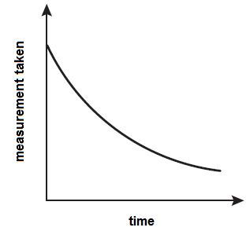

Which of the following measurements, taken at regular intervals and plotted against

time, would give the graph shown above? 1

A Temperature

B Volume of gas produced

C pH of solution

D Mass of the beaker and contents

***2007 H 4 MC***

6. The graph shows the variation of concentration of a reactant with time as a reaction proceeds.

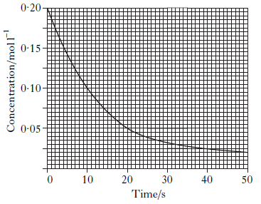

What is the average reaction rate during the first 20 s? 1

A 0.0025 mol l–1 s–1

B 0.0050 mol l–1 s–1

C 0.0075 mol l–1 s–1

D 0.0150 mol l–1 s–1

***2008 H 5MC***

7. The following results were obtained in the reaction between marble chips and dilute

hydrochloric acid.

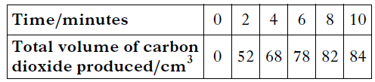

What is the average rate of production of carbon dioxide, in cm3 min–1, between 2

and 8 minutes? 1

A 5

B 26

C 30

D 41

***2010 Int2 2MC***

8.During the first 20 seconds of a chemical reaction, 5·0 cm3 of gas were given off.

The average rate of the reaction, in cm3 s–1, during the first 20 seconds is 1

A 20·0

B 5·0

C 4·0

D 0·25.

***2011 Int2 4b***

9. Research is being carried out into making chemicals that can be used to help relieve the side effects of chemotherapy.

Part of the process is shown.

*catalyst*

chemical **A** + hydrogen 🡪 chemical **B**

As the reaction proceeds the hydrogen is used up and the pressure decreases.

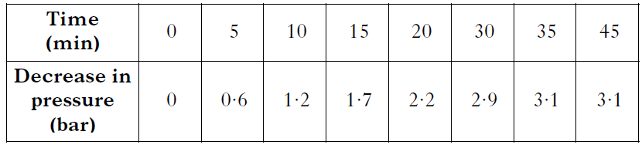

(a) Draw a line graph showing the decrease in pressure as time proceeds. 2

(b) Using your graph, at what time did the reaction finish? 1

(c) Calculate the average rate of the reaction, in bar min−1, between 10 and

20 minutes. 1

***2008 Int2 9c***

10. A student investigated the effect of temperature on the rate of starch formation. The results are shown.

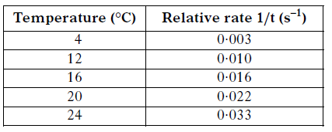

(a) Plot these results as a line graph. 1

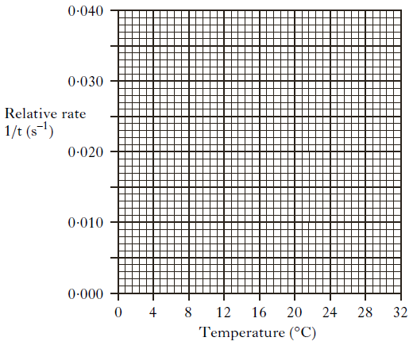

(b) At 32 °C the relative rate was 0.0125s–1.

Use this rate to calculate the reaction time, in seconds, at 32 °C. 1

**Atomic structure and bonding related to properties of materials**

***2011 Int2 1***

|  |  |  |  |  |  |  |  |
| --- | --- | --- | --- | --- | --- | --- | --- |
|  |  |  | |  | |  | |
|  | 1. (a) |  | Complete the table to match up each type of bonding and structure with its properties. | | 2 | |
|  | (b) |  | | A section of a covalent network compound is shown below.    Write the formula for this covalent network compound. | | 1 | |
|  |  |  | |  | |  | |
|  |  |  | |  | |  | |
|  |  |  | |  | |  | |

***2011 Int 2 2***

|  |  |  |
| --- | --- | --- |
| 2. | Information on some two-element molecules is shown in the table. |  |
| (a) | Complete the table to show the shape of a molecule of ammonia. | 1 |
| (b) | The hydrogen fluoride molecule can be represented as:    Showing all outer electrons, draw a similar diagram to represent a molecule of water, H2O. | 1 |
|  |  |  |
|  |  |  |
|  |  |  |

***2011 Int2 4***

|  |  |  |  |
| --- | --- | --- | --- |
|  | 3. | Write the formula for ruthenium(II) chloride. | 1 |
|  |  |  |  |
|  |  |  |  |

***2011 Int2 15***

|  |  |  |  |
| --- | --- | --- | --- |
|  | 4. | Fluoride prevents tooth decay by replacing the hydroxide ions of calcium hydroxyapatite with fluoride ions to form hard wearing calcium fluoroapatite.    Write the formula for calcium fluoroapatite. | 1 |
|  |  |  |  |
|  |  |  |  |

***2013 Int2 6***

|  |  |  |
| --- | --- | --- |
| 5. | Dishwasher tablets contain many different types of chemicals. |  |
|  | Phosphate ions, present in some types of dishwasher tablets, react with calcium ions in water forming calcium phosphate.  Write the formula for calcium phosphate. | 1 |

***2013 SG 11***

|  |  |  |
| --- | --- | --- |
| 6. | The table shows information about some useful compounds. |  |
|  | Name compound Y. | 1 |

***2013 Int2 4***

|  |  |  |
| --- | --- | --- |
| 7. | Tritium is a naturally occurring isotope of hydrogen. It can be represented as |  |
| (a) | Complete the table to show the number of particles in an atom of tritium. | 1 |
| (b) | Hydrogen has three isotopes.    The relative atomic mass of hydrogen is 1.  Which isotope of hydrogen is the most abundant? | 1 |
|  |  |  |
|  |  |  |

***2013 SG 10***

|  |  |  |
| --- | --- | --- |
| 8. | The nuclide notation for an isotope of hydrogen is |  |
|  | An isotope of copper has atomic number 29 and mass number 63. |  |
| (a) | (i) Write the nuclide notation for this isotope of copper. | 1 |
|  | (ii) How many neutrons are present in this isotope of copper? | 1 |
| (b) | A sample of copper was found to contain equal amounts of two isotopes. One has mass number 63 and the other has mass number 65.  What is the relative atomic mass of this sample of copper? | 1 |

***2013 SG 16***

|  |  |  |  |  |  |  |
| --- | --- | --- | --- | --- | --- | --- |
|  | 9. | | Metals can be extracted from their ores by different methods. | |  | |
|  |  | | Mercury can be extracted from the ore cinnabar, HgS. | |  | |
|  | |  | | Write the formula for the mercury ion in cinnabar. | | 1 | |

***2013 SG 17***

|  |  |  |
| --- | --- | --- |
| 10. | Nitrogen trifluoride, NF3, is used in the manufacture of plasma screens. |  |
| (a) | Draw a diagram showing all outer electrons to represent a molecule of nitrogen trifluoride. | 1 |
| (b) | The atoms in nitrogen trifluoride are held together by covalent bonds. | 1 |
|  |  |  |

***2012 SG 13***

|  |  |  |
| --- | --- | --- |
| 11. | Hydrogen gas is made up of diatomic molecules. |  |
|  | Draw a diagram to show how the electrons are arranged in a molecule of hydrogen, H2. | 1 |

***2012 SG 15***

|  |  |  |  |
| --- | --- | --- | --- |
|  | 12. | Ammonium phosphate is used as a fertiliser.  Write the ionic formula for ammonium phosphate. | 1 |
|  |  |  |  |

***2012 SG 18***

|  |  |  |
| --- | --- | --- |
| 13. | A student investigated how the concentration of sodium chloride in water affected the freezing point. |  |
| (a) | What type of bond is broken in sodium chloride when it dissolves in water? | 1 |
| (b) | The table shows information about the freezing point of different sodium chloride solutions.    Describe the relationship between the concentration and freezing point. | 1 |
| (c) | Predict the freezing point, in oC, of a 0·55 mol/l sodium chloride solution. | 1 |

***2011 SG 12***

|  |  |  |
| --- | --- | --- |
| 14. | Ethanol, for alcoholic drinks, can be made from glucose. |  |
|  | The table below shows the relationship between the percentage of ethanol and the density of alcoholic drinks. |  |
| (a) | Write a general statement describing how the percentage of ethanol affects the density of the alcoholic drink. | 1 |
| (b) | The density of a particular brand of alcoholic drink is 0·970 g cm-3.  Predict the percentage of ethanol in this alcoholic drink. | 1 |

***2011 SG 16***

|  |  |  |  |
| --- | --- | --- | --- |
|  | 15. | Heptane can be cracked as shown. |  |
|  |  | Aluminium oxide is used as a catalyst to speed up the reaction. |  |
|  |  | Write the formula for aluminium oxide. ______________________________ | 1 |
|  |  |  |  |

***2011 SG 18***

|  |  |  |
| --- | --- | --- |
| 16. | A student set up the following experiment to electrolyse cobalt chloride solution. |  |
|  | The formula for cobalt chloride is CoCl2.  What is the charge on the cobalt ion in CoCl2? | 1 |
|  |  |  |
|  |  |  |

**Formulae and reaction quantities**

***2012 Int2 2***

|  |  |  |
| --- | --- | --- |
| 1. | Rapid inflation of airbags in cars is caused by the production of nitrogen gas. |  |
|  | In some types of airbag, electrical energy causes sodium azide, NaN3, to  decompose producing sodium metal and nitrogen gas.  Write a formula equation for this reaction. | 1 |
|  |  |  |

***2012 Int2 15***

|  |  |  |
| --- | --- | --- |
| 2. | Rust, iron(III) oxide, that forms on cars can be treated using rust remover which contains phosphoric acid.    When painted on, rust remover changes iron(III) oxide into iron(III) phosphate. |  |
|  | The rust remover contains 250 cm3 of 2 mol l-1 phosphoric acid. |  |
| (a) | Calculate the number of moles of phosphoric acid in the rust remover. | 1 |
| (b) | Using your answer in part (i), calculate the mass of iron(III) oxide, in grams, that will be removed by 250 cm3 of 2 mol l-1 phosphoric acid. | 2 |

***2011 SG 17***

|  |  |  |
| --- | --- | --- |
| 3. | Urea reacts with water, breaking down to form carbon dioxide and ammonia. |  |
|  | Calculate the mass of ammonia produced, in grams, when 90 g of urea breaks down. | 2 |

***2011 Int2 3***

|  |  |  |
| --- | --- | --- |
| 4. | Hydrogen peroxide is a useful bleaching agent and is contained in many hair dyes. Over time, the hair dye becomes less effective as the hydrogen peroxide decomposes forming water and oxygen.  The equation for the decomposition of hydrogen peroxide is: |  |
| (a) | Balance this equation. | 1 |
| (b) | When 34g of hydrogen peroxide decomposes, 12 litres of oxygen is produced.  Calculate the volume of oxygen, in litres, produced when 1·7g of hydrogen peroxide decomposes. | 1 |

***2011 SG 20***

|  |  |  |
| --- | --- | --- |
| 5. | Metal salts can be produced by different methods. |  |
|  | Lead(II) iodide can be produced by reacting lead(II) nitrate solution with sodium iodide solution.  The equation for this reaction is: |  |
| (a) | Balance the above equation. | 1 |
| (b) | Potassium sulphate can be produced by titrating potassium hydroxide solution with dilute sulphuric acid. |  |
|  | The average volume of sulphuric acid used in the titration is 20 cm3.  Calculate the number of moles of sulphuric acid used. | 1 |

***SG 2012 15***

|  |  |  |  |
| --- | --- | --- | --- |
|  | 6. | Potassium hydroxide reacts with sulphuric acid to form potassium sulphate, which can  be used as a fertiliser. |  |
|  |  | Balance the above equation. | 1 |

***2012 SG 17***

|  |  |  |
| --- | --- | --- |
| 7. | A solution of 0·1 mol l-1 hydrochloric acid has a pH of 1. |  |
|  | Calculate the number of moles of hydrochloric acid in 50cm3 of 0·1 mol l-1  hydrochloric acid solution. | 1 |
|  |  |  |
|  |  |  |

***2012 SG 21***

|  |  |  |
| --- | --- | --- |
| 8. | Aluminium is extracted from the ore bauxite. |  |
|  | The composition of a 250 g magnet is shown. |  |
| (a) | Calculate the mass, in grams, of aluminium in the magnet.  ­­­­­Show your working clearly. | 1 |
| (b) | Using your answer to (c)(i), calculate the number of moles of aluminium in the  magnet.  Show your working clearly. | 1 |

***2013 SG 17***

|  |  |  |
| --- | --- | --- |
| 9. | Nitrogen trifluoride, NF3, is used in the manufacture of plasma screens. |  |
|  | The equation for the formation of nitrogen trifluoride, NF3 , is:    Calculate the mass, in grams, of nitrogen trifluoride produced from 7 g of nitrogen.  **Show your working clearly.** | 2 |

***2013 SG 18***

|  |  |  |
| --- | --- | --- |
| 10. | A student investigated the reaction between dilute sulphuric acid and sodium carbonate. |  |
|  | A student carried out an experiment to determine the concentration of sodium carbonate solution by titration with sulphuric acid.    The results showed that 20cm3 of sulphuric acid was required to neutralise the sodium carbonate solution. |  |
|  | Calculate the number of moles of sulphuric acid in this volume. | 1 |

**Acids and Bases**

***2011 Int2 15***

|  |  |  |  |  |  |  |  |  |
| --- | --- | --- | --- | --- | --- | --- | --- | --- |
|  | | 1. | Fizzy drinks contain acids.  These acids can attack the compound calcium hydroxyapatite which is found in tooth enamel.  The equation for the reaction is: | | |  | | |
|  |  | | | What will happen to the pH as the tooth enamel is attacked by the acids? | | | 1 | | |
|  |  | | |  |  | | |  | | |
|  |  | | |  |  | | |  | | |

***2012 Int2 13***

|  |  |  |
| --- | --- | --- |
| 2. | A student carried out the following experiment. |  |
|  | The equation for the reaction is |  |
| (a) | Rewrite the equation showing only the ions which react. | 1 |
| (b) | What term is used to describe the ions which do not react? | 1 |

***2011 SG 14***

|  |  |  |
| --- | --- | --- |
|  |  |  |
| 3. | When sulphur dioxide dissolves in water in the atmosphere “acid rain” is produced. |  |
|  |  | 1 |

***2011 SG 20***

|  |  |  |
| --- | --- | --- |
| 4. | Metal salts can be produced by different methods. |  |
|  | The salt copper(II) nitrate can be produced as shown. |  |
|  | Name substance X. | 1 |

***2012 SG 15***

|  |  |  |
| --- | --- | --- |
| 5. | Potassium hydroxide reacts with sulphuric acid to form potassium sulphate, which can be used as a fertiliser. |  |
|  | Name the type of chemical reaction taking place. | 1 |
|  |  |  |

***2012 SG 17***

|  |  |  |
| --- | --- | --- |
| 6. | A solution of 0·1 mol l-1 hydrochloric acid has a pH of 1. |  |
| (a) | What colour would universal indicator turn when added to a solution of hydrochloric acid? | 1 |
| (b) | Starting at pH 1, draw a line to show how the pH of this acid changes when diluted with water. | 1 |

***2007 Int2 19MC***

7. Which of the following increases when hydrochloric acid is diluted with water? 1

A Rate of reaction with magnesium

B Concentration of H+ ions

C Electrical conductivity

D pH

***2007 Int2 20MC***

8. Which of the following statements describes the concentrations of H+(aq) and

OH–(aq) ions in pure water? 1

A The concentrations of H+(aq) and OH–(aq) ions are equal.

B The concentrations of H+(aq) and OH–(aq) ions are zero.

C The concentration of H+(aq) ions is greater than the concentration of OH–(aq) ions.

D The concentration of OH–(aq) ions is greater than the concentration of H+(aq)ions.

***2006 Int2 23MC***

9. When hydrochloric acid with a pH of 3 is diluted with water to give a solution with a

pH of 6, the concentration of

A H+(aq) ions decreases

B OH–(aq) ions decreases

C H+(aq) ions and the concentration of OH–(aq) ions become equal

D H+(aq) ions and the concentration of OH–(aq) ions remains unchanged 1

***2006 Int2 24MC***

10. Which of the following sodium compounds is a base?

A sodium carbonate

B sodium chloride

C sodium nitrate

D sodium sulphate 1

***2006 Int2 2c***

11. Ammonia gas NH3(g), can be dissolved Hydrogen chloride gas HCl(g), can be

in water to form concentrated dissolved in water to form concentrated

ammonia solution. hydrochloric acid.

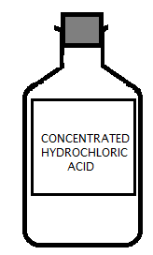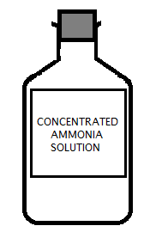

If both bottles are placed next to each other in a fume cupboard and the stoppers removed, both liquids evaporate and a white cloud is formed where the two gases meet.

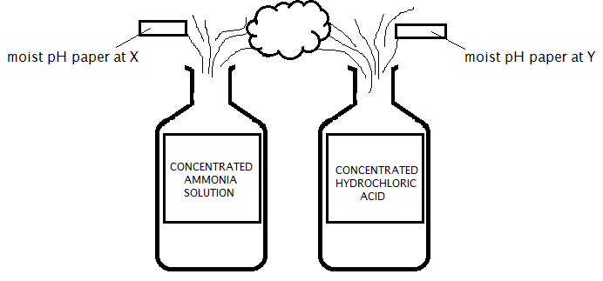

(a) State the colour of the pH paper at (i) X and (ii) Y. 1

(b) The white cloud appears because the gases react to form a salt. Name the salt. 1