Everyday Consumer Products Past Paper Questions



1. 2.

3.



4.



5.

6.

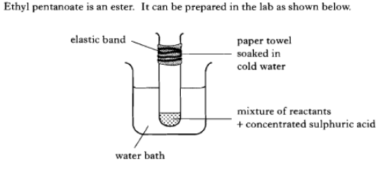7.

1. Why is the reaction mixture heated with a water bath?
2. What is the purpose of the wet paper towel?

8. Suggest 2 safety procedures that must be followed when making esters in the laboratory

9. State a use for vinegar

10. Vinegar is a solution of which chemical?