CfE Higher Chemistry
Unit 3
Chemistry In Society

Topic | Page
1 – Getting the most from reactants | 2
Minitest | 10
2 – Equilibria | 13
Minitest | 16
3 - Chemical energy | 18
Minitest | 24
4 – Oxidising and reducing agents | 26
Minitest | 29
5 – Chemical analysis | 31
Minitest | 37
Glossary | 39

Information sourced from
Scholar
BBC Bitesize – Higher Chemistry

1 – Getting the most from reactants

a) The design stage
The routes and conditions used in the chemicals industry will always be chosen to maximize economic efficiency.
The choice of synthetic route or processes to be undertaken will also consider safety and environmental issues.
When designing the practical route required to produce a marketable product, there are several key considerations.
- availability and cost of feedstocks
- sustainability of feedstocks
- size of yield
- formation of side products that can be recycled, used in the process or sold to increase profit

Environmental considerations
Processes in the chemical industry need to consider the environmental impact of the reactions they are undertaking. Chemical companies must seek to minimise waste by recycling where possible while avoiding either using or producing toxic chemicals.
While waste is often unavoidable, producing waste that can decompose or biodegrade naturally is preferable.

b) Molar ratio
A balanced chemical equation can be used to show how the quantities of reactants relate to the quantities of products in the reaction.
Consider the following reaction:
Aluminium can be obtained from aluminium ore (Al₂O₃) by a process called electrolysis. Oxygen is also produced by this reaction.
The balanced equation for this process is:
The equation shows you that for every two moles of aluminium oxide oxidised, four moles of aluminium metal are obtained along with three moles of oxygen gas.
The formula mass of each reactant or product can be used to calculate the reacting masses.

Example
Calculate the mass of aluminium formed when 51 g of aluminium oxide are electrolysed.
Firstly, the formula mass of aluminium oxide can be calculated using the formula and masses found in the data book.
This formula triangle can be used to explain the relationship between the formula mass (the mass of one mole) with any mass and the number of moles that it represents.
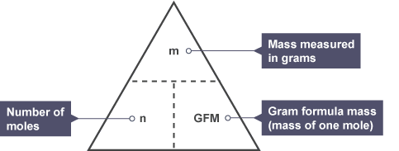
Using this triangle for the information from the question, we can calculate how many moles of aluminium oxide 51 g is by using the formula
The molar ratio from the balanced equation must be considered to tell us how many moles of aluminium will be released.
To finish off the question, we must change one mole of aluminium into a mass.
So, 55 g of aluminium oxide will produce 27 g of aluminium upon being electrolysed.

c) Moles and solutions
The molar ratio of a chemical reaction is also useful for reactions involving solutions.
Calculating the mass or number of moles of a reactant or product can also be achieved by using the following formula triangle.
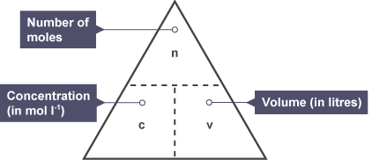

Example
What mass of sodium sulfate is formed when 250 cm³ of 0.1 mol l⁻¹ sodium hydroxide is neutralised by an excess of sulfuric acid.
The question tells you that there is an excess of acid, so the sodium hydroxide will control how much product is obtained. Using the triangle will give how many moles of sodium hydroxide actually react.
The molar ratio from the balanced equation must be considered to tell us how many moles of sodium sulfate will be formed.
Lastly, the number of moles of sodium sulfate must be converted into a mass.
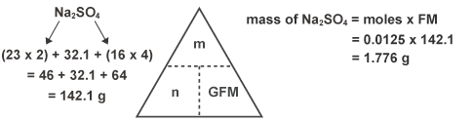

d) Molar volume
The molar volume is the volume occupied by one mole of any gas. The same value is obtained for all gases at the same temperature and pressure.
The value of the molar volume will be different for different temperatures and pressures and it is measured in litres per mole .
As one mole of every gas will occupy the same volume at a given temperature and pressure, we can use volumes and the molar ratio to calculate volumes of reactants or products.
Consider the following reaction:
Ammonia (NH₃), which is both a useful and profitable compound, can be produced in the chemical industry from the relatively cheap reactants nitrogen and hydrogen. The balanced equation for this process is:

Example
When 400 cm³ of nitrogen reacts with excess hydrogen, calculate the volume of ammonia that will be produced.
Looking at the balanced equation, we can see that one mole of nitrogen reacting results in the formation of two moles of ammonia.
The question does not give us information about the masses involved, but since the products and reactants are at the same temperature and pressure, we know that one mole of each product and reactant will occupy the same volume.
The molar ratio of nitrogen to ammonia from the balanced equation is 1:2. This means that if 400 cm³ of nitrogen are used then we will form double that volume of ammonia.

e) Percentage yield
The percentage yield of a chemical reaction is an important consideration in industrial chemistry.
It can be calculated to compare the yield (quantity) of product actually obtained with what could have been obtained in theory, if all of the reactants were converted with no loss or waste.
Obviously total conversion under ideal circumstances will be 100 per cent, but in reality, that will not happen.
The formula for the percentage yield calculation as found in the data booklet is:
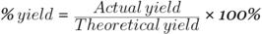
The higher the percentage yield is, the more efficient the reaction. Esterification and other reversible reactions can never result in 100 per cent conversion of reactants into products.

Example
5 g of methanol (CH₃OH, formula mass = 32 g) reacts with excess ethanoic acid (CH₃COOH) to produce 9.6 g of methyl ethanoate (CH₃OOCCH₃, formula mass = 74 g). Calculate the percentage yield.
The actual yield (9.6 g) is given in the question. You must first calculate the theoretical yield.
The balanced equation for the reaction shows that one mole of methanol can produce one mole of methyl ethanoate.
Replacing the numbers of moles with their equivalent formula masses shows that:
%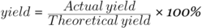
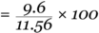

f) Atom economy
The atom economy of a chemical reaction is a measure of the percentage of reactants that become useful products.
Inefficient, wasteful processes have low atom economies. Efficient processes have high atom economies, and are important for sustainable development, as they use fewer natural resources and create less waste.
The atom economy of a reaction can be calculated:
Note that the total mass of reactants can be substituted for products in this equation because in every reaction the total mass of products equals the total mass of reactants. This is shown below:

Example
What is the atom economy for making hydrogen by reacting coal with steam?
Write the balanced equation:
The masses of all the chemicals involved can be written below each species in the balanced equation.
The total mass of products = 44 + 4 = 48 g (note that this is also the same as the total mass of reactants (12 +36))
The mass of desired product (H₂) = 4 g
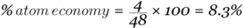
This process has a low atom economy and is therefore an inefficient way to make hydrogen. It also uses coal, which is a finite (non-renewable) resource.
It is possible for chemical reactions with a high percentage yield to have a low atom economy.
This problem arises when processes have large quantities of unwanted by-products produced.

g) Excess reactants
A good way to ensure that one reactant fully reacts is to use an excess of the other reactant. This is financially efficient when one of the reactants is very cheap.
When one reactant is in excess, there will always be some left over. The other reactant becomes a limiting factor and controls how much of each product is produced.
While using excess reactants can help to increase percentage yields, this is at the expense of atom economy.
A balance between the economic and environmental value of the use of excess reactants must be established.

Example one
What volume of CO₂ would be produced when 5 g of calcium carbonate (CaCO₃) reacts with excess hydrochloric acid (HCl)? (molar volume = 22.4 litres mol⁻¹)
Start with a balanced equation and look at the molar ratio. We know the acid is in excess, so the number of moles of calcium carbonate that react will control how many moles of product are formed.
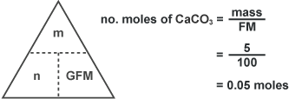

Example two
Which reactant is in excess when 0.25 g of magnesium is added to 100 cm³ of 0.1 mol l⁻¹ hydrochloric acid (HCl)?
Start with a balanced equation.
The equation shows that one mole of magnesium will react with two moles of acid. Use the information in the question to calculate how many moles of each reactant are present.
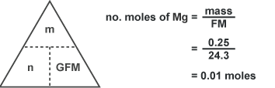
For all of the magnesium to be used up, we would need twice the number of moles of acid and this is not the case.
All of the acid could react with half the number of moles of magnesium. From the calculation, it is clear that magnesium is in excess.
All of the acid will react with 0.005 moles of magnesium, leaving 0.005 moles of magnesium unreacted.

Getting the most from reactants Minitest

1 What are feedstocks?
- Raw materials or chemicals used to produce more profitable chemicals
- Products from chemical reactions that are sold for profits
- Catalysts used to make processes more efficient

2 Which of the following would be grounds for reconsidering a chemical process that has been designed?
- Producing a side-product
- Producing toxic gases
- Producing waste that can decompose or biodegrade naturally

3
What mass of copper (formula mass = 63.5 g) would be produced when 16 g of copper(II) oxide (formula mass = 79.5 g) reacts with excess hydrogen gas?
- 315.5 g
- 12.77 g
- 6.39 g

4 Which of the following factors will affect the molar volume of a gas?
- Temperature
- Formula mass of the gas
- Type of intermolecular bonding present

5 The ester propyl ethanoate (formula mass = 102 g) can be formed from propanol (GFM = 60 g) and ethanoic acid (GFM = 60 g) as shown below:
If 3 g of propanol react to form 1.8 g of propyl ethanoate, what is the percentage yield for this process?
- 35 per cent
- 45 per cent
- 55 per cent

6 The ester propyl ethanoate can be formed from propanol and ethanoic acid as shown below:
Why is the percentage yield never 100 per cent for this process?
- The ester destroys the catalyst
- Some of the product is lost
- The reaction is reversible

7 The ester propyl ethanoate (formula mass = 102 g) can be formed from propanol (formula mass = 60 g) and ethanoic acid (formula mass = 60 g) as shown below:
What is the atom economy for this process?
- 70 per cent
- 85 per cent
- 100 per cent

8 Calculate the mass of nitrogen dioxide (formula mass = 46 g) which is produced when 119 cm³ of nitrogen (formula mass = 28 g) is sparked in excess oxygen (assume molar volume is 23.8 l mol⁻¹).
- 0.46 g
- 4.6 g
- 460 g

9 Calculate which reactant is in excess when 0.655 g of zinc (formula mass = 65.5 g) reacts with 20 cm³ of hydrochloric acid, concentration 0.5 mol l⁻¹.
- Zinc
- Hydrochloric acid
- Neither

10 Calculate which reactant is in excess when 25 cm³ of 1 mol l⁻¹ sulfuric acid is mixed with 25 cm³ of 1 mol l⁻¹ sodium hydroxide.
- Sodium hydroxide
- Sulfuric acid
- Neither

2 - Equilibria

a) Dynamic equilibrium
Many chemical reactions are reversible. In these reactions, there is both a forward reaction (where reactants are made into products) and a reverse reaction (where product molecules break down to form reactants).
The Haber process, the industrial route to the formation of ammonia from nitrogen and hydrogen gas, is an example of a reversible reaction.
In a reversible reaction, you can never obtain 100 per cent conversion of reactants into products. Reversible reactions will always result in a mixture of reactants and products being formed.
While this isn't a major problem with the Haber process, it can often result in expensive reactant molecules not being completely converted into products.
As the forward reaction slows down, the reverse reaction will speed up until they are both taking place at the same rate. This is called the equilibrium position.
At equilibrium the concentration of reactant and products remain constant but NOT necessarily equal.
Equilibrium can only be obtained in a closed system where the reaction is carried out in a sealed container and none of the reactants or products are lost.
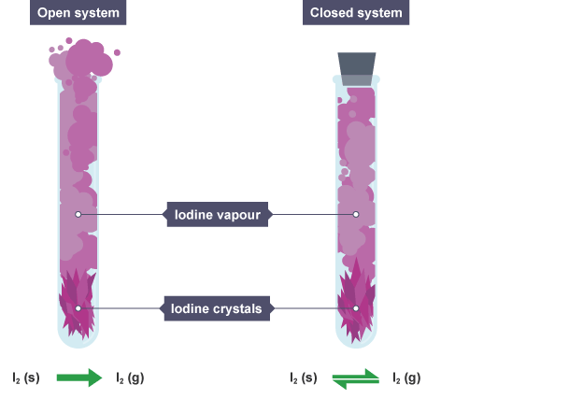
For example, iodine crystals break down to form purple iodine vapour. In an open system, the vapour escapes and the reaction progresses until all of the crystals have vaporised, and all of the vapour has escaped.
If a stopper is placed on the boiling tube, a closed system is formed. The iodine crystals break down to form purple iodine vapour, but both the crystals and vapour remain.
In the closed system, equilibrium has been established.
In an open system, products (or reactants) are lost, therefore equilibrium cannot be established.

b) Factors affecting equilibrium position
Once equilibrium has been established, chemists can control certain reaction conditions to influence the position of the equilibrium.
Altering the reaction conditions can result in the yield of products increasing, and the process being more profitable.
Le Chatlelier’s principle states that if a system at equilibrium is subjected to any change, the system will adjust itself to counteract the applied change.
There are a number of factors that can be changed.

Concentration
Adding a chemical that is present on either side of the equation will cause a shift in the position of the equilibrium, as the system adjusts to counteract the change.

Consider the following equilibrium:
If hydrochloric acid was added to the equilibrium mixture, both hydrogen ions (H⁺) and chloride ions (Cl⁻) are being added.
Hydrogen ions are on the right hand side of the equilibrium, therefore the equilibrium will shift to the left hand side to compensate, resulting in a higher concentration of reactants.

Adding sodium hydroxide (NaOH) will also affect the position of the equilibrium.
While neither sodium ions (Na⁺) or hydroxide ions (OH⁻) are present on either side, the hydroxide ions will remove H⁺ ions and the equilibrium will shift to the right hand side to replace the hydrogen ions that were removed.

Temperature
Altering the temperature of an equilibrium mixture results in a shift depending on the enthalpy change of the reaction.
Consider the equilibrium between colourless dinitrogen tetroxide and brown nitrogen dioxide.
- An increase in temperature favours the endothermic reaction.
In the above equilibrium, the enthalpy change shows that the forward reaction is endothermic. Increasing the temperature will shift the equilibrium to the right hand side.
This results in more nitrogen dioxide being formed and the reaction mixture becoming darker in colour.
- A decrease in temperature favours the exothermic reaction.
In the equilibrium above, decreasing the temperature will favour the backwards reaction.
This will shift the equilibrium to the left, resulting in the formation of more dinitrogen tetroxide and the reaction mixture becoming lighter in colour.

Pressure
Changing the pressure of the equilibrium mixture can affect the position when the equilibrium involves chemicals in the gaseous state.
- An increase in pressure favours the side with the lower gas volume.
In the above reaction, sulfur dioxide and oxygen react together to form sulfur trioxide.
There are three moles of gaseous reactants on the left hand side of the equation and two moles on the right hand side.
This means that an increase in pressure would move the equilibrium to the right and result in more sulfur trioxide being formed.
Pressure can only affect the position of equilibrium if there is a change in the total gas volume. The reaction between hydrogen and iodine to form hydrogen iodide is an example of a reaction that pressure does not affect.
Both sides of the reaction have two moles of gases, so changing the pressure does not favour either side of the equilibrium.

Catalysts
Adding a catalyst to a reaction at equilibrium has no effect on the position of equilibrium.
It does however allow equilibrium to be reached more quickly, or established at a lower temperature, which makes reactions more profitable.

Equilbria Minitest

1 In a system at equilibrium, how do the rates of the forward and reverse reactions compare?
- The rate of the forward reaction is greater
- The rate of the reverse reaction is greater
- The rates of the forwards and reverse reactions are equal

2 In the Contact Process, sulfur dioxide is converted into sulfur trioxide and the following equilibrium is set up:
If sulfur dioxide is added to the mixture, what happens to the position of the equilibrium?
- The equilibrium shifts to the right
- The position of the equilibrium remains unchanged
- The equilibrium shifts to the left

3 In the Contact Process, sulfur dioxide is converted into sulfur trioxide and the following equilibrium is set up:
If a catalyst is added to the mixture, what happens to the position of the equilibrium?
- The equilibrium shifts to the right
- The position of the equilibrium remains unchanged
- The equilibrium shifts to the left

4 In the Contact Process, sulfur dioxide is converted into sulfur trioxide and the following equilibrium is set up:
If the pressure was increased in the above reaction, what happens to the position of the equilibrium?
- The equilibrium shifts to the right
- The position of the equilibrium remains unchanged
- The equilibrium shifts to the left

5 In the Haber process, ammonia (NH₃) can be produced from nitrogen and hydrogen.
How would increasing the temperature effect the position of equilibrium?
- The equilibrium shifts to the right
- The position of the equilibrium remains unchanged
- The equilibrium shifts to the left

6 Look at this reaction.
What would be the best conditions for increasing the yield of methane?
- Low temperature; low pressure
- Low temperature; high pressure
- High temperature; high pressure

7
If hydrochloric acid is added to the mixture, what will happen to the position of equilibrium?
- The equilibrium shifts to the right
- The position of the equilibrium remains unchanged
- The equilibrium shifts to the left

8
If sodium hydroxide is added to the mixture, what will happen to the position of equilibrium?
- The equilibrium shifts to the right
- The position of the equilibrium remains unchanged
- The equilibrium shifts to the left

9 Which of the following factors would not affect the equilibrium position for the reaction shown?
- Addition of silver nitrate
- Increasing the pressure
- Removal of chloride ions

10 Which of the following is true of equilibrium when a catalyst is added?
- It changes the position at equilibrium
- Equilibrium will be reached more quickly
- No effect on the reaction at all

3 – Chemical energy

a) Enthalpy
An understanding of the energy involved in chemical reactions is important in the chemical industry.
Endothermic reactions that take in energy may generate additional costs through heating the reaction to ensure that the rate remains high enough.
Some exothermic reactions require no additional heating. In some cases, the energy given out by the reaction is so great, that the heat source can be removed once the reaction has begun.
The temperature must be monitored to ensure that the energy given out during the process doesn’t cause the temperature of reaction vessels to rise to unsafe levels.
The chemical energy involved in a reaction is also called the enthalpy. Chemical reactions involve an enthalpy change:
- Energy is used breaking bonds
- Energy is released when new bonds form
This means that the enthalpy change is the difference in energy between the products and the reactants.
The enthalpy change takes the form of heat given out or absorbed. The heat energy given out or taken in by one mole of a substance can be measure in either joules per mole (J mol⁻¹) or more commonly kilojoules per mole (kJ mol⁻¹).

Calculating enthalpy changes

The enthalpy change for a reaction can be calculated using the following equation:
is the enthalpy change (in kJ or kJ mol⁻¹)
c is the specific heat capacity of water.
It is a constant, 4.18 kJ kg⁻¹˚C⁻¹ and is found in the data book.
m is the mass of water (in kg) (Remember that 100 cm³ = 0.1 kg)
is the change in temperature (˚C)

Question:
A solution was made by dissolving a spatula of potassium nitrate into 50 cm³ of water. The temperature changed from 20.4˚C to 18.7˚C. Calculate the enthalpy change for this reaction.
Answer:
To calculate the enthalpy change () we must know the values for c, m and . The specific heat capacity (c) is a constant, with a value of 4.18. Since 50 cm³ of water have been used, the mass of water (m) is 0.05 kg.
From the question we can see that the temperature has decreased by 1.7 ˚C. This means that the reaction is endothermic (so will be positive).
= 4.18 x 0.05 x 1.7
= 0.3553 kJ

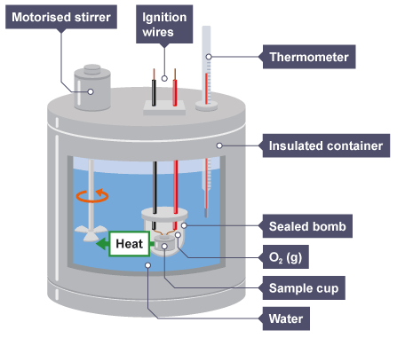
b) Enthalpy of combustion
In combustion reactions, some substances will release more energy than others.
Enthalpies of combustion can be used to compare which fuels or substances release the most energy when they are burned. They can be calculated using a bomb calorimeter.

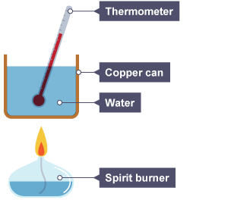
A simplified version of this can be set up in the lab with a spirit burner and a metal can as shown below.
Several measurements must be taken:
- the starting temperature of the water
- the final temperature of the water
- the mass of the burner before the experiment
- the mass of the burner after heating
- the temperature change
Fuel is burned and the temperature increase measured. The mass of fuel corresponding to the temperature increase can be used to calculate the enthalpy change of the reaction, which in turn can be used to calculate the enthalpy of combustion of that fuel.
The enthalpy of combustion of a substance is defined as the heat energy given out when one mole of a substance burns completely in oxygen.
Combustion reactions are exothermic so the value for the enthalpy change () is always negative.

Question
Ethanol (C₂H₅OH) was placed in a spirit burner and used to heat 200 cm³ of water in a copper can. When the temperature of the water had increased by 5˚C, the mass of the burner and ethanol had decreased by 0.36 g.
Calculate the enthalpy of combustion of ethanol.
Answer:
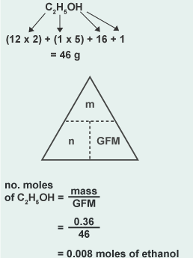
Firstly, we know that 0.36 g of ethanol burned, so we can convert this into a number of moles.

Secondly, we can use to calculate the enthalpy change in the experiment described in the question (ie when 0.008 moles of ethanol is burned).
= 4.18 x 0.2 x 5 = 4.18 kJ
Lastly, we can use the enthalpy change for the experiment in the question to calculate the enthalpy of combustion (ie when one mole of ethanol is burned).
Remember that the value obtained for the enthalpy of combustion must be negative as combustion reactions are always exothermic (energy is released).

c) Hess's Law
Hess’s Law states that the enthalpy change for a chemical reaction is independent of the route taken. This means that the enthalpy change for the overall process will be identical regardless of how many steps are taken.
Consider the following reaction:
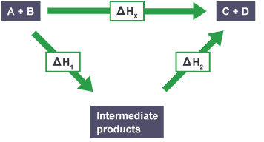
The enthalpy change for the reaction that forms products C+D directly will be the same as the sum of the enthalpy changes for the production of C+D via an indirect route where intermediate products are formed and subsequently react to produce C+D.
This is shown in the diagram.
One method of calculating an enthalpy change for a process involves rearranging a set of given reaction equations with known values.
The following points must be noted when manipulating equations:
- The enthalpy change for the process () is independent of the route taken (This is Hess’s law).
- The enthalpy change () is proportional to the quantities of reactants and products. For example, burning twice as much fuel will result in twice the enthalpy change for the process.
- If a reaction is reversed then the sign of the enthalpy change must also be reversed.
- Changing the physical state of any reactant (or product) will involve an enthalpy change.

Example one
The enthalpy changes for two reactions are shown below:
Using this data, calculate the enthalpy change for the following reaction:
The target equation (which we will denote () can be made by adding together equation one and the reverse of equation two.
Reversing equation two gives:

Example two
Hess’s Law can be used to calculate the enthalpy change for the formation of ethanoic acid from its elements.
Calculate the enthalpy change for the above reaction in kJ mol⁻¹ using the data book and the following reaction:
It is not unusual to have to assemble equations to be used yourself, relying on values from the data book.
If you are methodical, you will always arrive at the correct value for your target enthalpy. Follow these steps:
- Write out the equations to be used and number them.
- Look at the equations to see if they need to be multiplied or reversed to suit the target equation. (NB remember to change accordingly)
- (Optional) Rewrite full equations added together to check if they cancel out to the target equation.
- Calculate for your target equation. You may wish (or be asked) to express as a sum of the ∆H values for your given equations.
The target equation from the question is:
Supplementing the given equation with the equations for the enthalpies of combustion of hydrogen and carbon from the data book gives a set of three equations we can use.
To satisfy the target equation, we must double equation one, double equation two and reverse equation three. So,
.
Rewriting the equations in full after they have been multiplied/reversed accordingly gives:
By cancelling species that are present on both sides, we can see that we have arrived at our target equation:
Finally, we must use the enthalpy change values to calculate the enthalpy change for the target equation.

d) Bond enthalpies
Energy is required to break a covalent bond between two atoms to overcome the attractive force. Bond breaking is an endothermic process.
The opposite is true if we want to make new bonds. Energy is released when new chemical bonds are formed, so bond making is an exothermic process.
Breaking or making the same chemical bond will require the same energy to be put in or released.
The values for bond enthalpies are found in the data book. For some bonds, the mean bond enthalpy is quoted. This is to give an average value to work from since the precise enthalpy value for a bond may be different in different molecules.
For example, the energy needed to break a carbon to carbon single bond (C-C) in ethane (C₂H₆) will be different to the energy needed to break a carbon to carbon single bond in decane (C₁₀H₂₂).
The bond enthalpies quoted in the data book are the energies required to break one mole of a particular bond between a pair of atoms in the gaseous state. We can use these bond enthalpies to approximately calculate the enthalpy change for a given reaction.

Example
Using bond enthalpies, what is the enthalpy change when hydrogen is added to ethyne to produce ethane?
To answer this we must look at what types of bonds must be broken in the reactants and formed in the products.

Step one: Draw the full structural formulae of all the molecules from the equation. This will show exactly what bonds are involved.
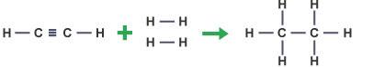

Step two: Make a list of all the bonds being broken in the reactants and their bond enthalpies using the data book.

Bond breaking:

Step three: Repeat this process for the bond making steps and all new bonds formed.

Bond making:

Step four: Calculate the enthalpy change for the reaction, remembering that bond breaking is an endothermic process and bond making is an exothermic process.

Chemical Energy Minitest

1 Which of the following is true for endothermic reactions?
- The enthalpy of reactants and products are equal
- The enthalpy of the reactants is greater than the enthalpy of the products
- The enthalpy of the products is greater than the enthalpy of the reactants

2 Which of these equations represents the enthalpy of combustion of butane (C₄H₁₀)?

3 In the equation , which of the terms is a constant?

4 3.6 g of butanol (C₄H₉OH) was burned, releasing 134 kJ of energy. What would the enthalpy of combustion of butanol be?
- 134kJ mol⁻¹
- 2754.44kJ mol⁻¹
- -2754.44kJ mol⁻¹

5 2 g of ethanol (formula mass 46 g) was burned, heating 10 litres of water from 20.2ºC to 21.6ºC. Calculate the enthalpy of combustion of ethanol.
- -1345.96 kJmol⁻¹
- -58.52 kJmol⁻¹
- -415.23 kJmol⁻¹

6 Which of the following is a definition of Hess’s law?
- The enthalpy change for a chemical reaction is independent of the route taken
- The enthalpy change when one mole of a substance is completely burned in excess oxygen
- The enthalpy change per mole of water formed when an acid is neutralised by an alkali

7 Given that the energy change when a carbon to carbon single bond is broken is +346 kJ, what is the enthalpy change when a carbon to carbon single bond is formed from two separate atoms?
- 346 kJ
- -346 kJ
- 123 kJ

8 In an experiment to calculate the enthalpy of combustion, which of the following does not need to be recorded?
- The mass of water
- The final temperature of the water
- The boiling point of the fuel

9 Why are some bond enthalpies quoted as a 'mean bond enthalpy'?
- They are the average of the enthalpies of all the bonds in the molecule
- Bonds may have different enthalpies in different molecules
- The bond enthalpies cannot be accurately measured

10 The enthalpy changes for the formation of one mole of aluminium oxide and one mole of iron(III) oxide are shown below.
Based on these equations, what is the enthalpy change for the following reaction?

4 - Oxidising and reducing agents
Oxidation and reduction reactions play important roles in chemistry. These reactions involve the loss of electrons in the case of oxidation or the gain of electrons in reduction reactions.
Oxidation and reduction reactions can be brought about by chemicals known as oxidising and reducing agents.

a) Reducing agents
A reducing agent:
- is usually a metal or a negative ion
- loses (donates) electrons to another element or ion (reducing the other species)
- is itself oxidised
For example, sodium is a reducing agent which is itself oxidised as follows:
The strongest reducing agents are the alkali metals as they have low electronegativities and lose electrons very easily.
Some molecules such as carbon monoxide (CO) are also used in the chemical industry as reducing agents to help extract metals.

b) Oxidising agents
An oxidising agent:
- is normally a non-metal or positive ion
- cause oxidation reactions to take place
- gains electrons from other atoms or ions (is itself reduced)
For example, chlorine and copper ions are both oxidising agent which are themselves reduced as follows:
The strongest oxidising agents are highly electronegative elements like the halogens.

Uses of oxidising agents
Oxidising agents are frequently used because of the effectiveness with which they can kill fungi and bacteria, and can inactivate viruses. Group ions such as dichromate (Cr₂O₇²⁻) and permanganate (MnO₄⁻) ions are strong oxidising agents in acidic solutions.
They are useful in the chemistry lab when forming aldehydes, ketones and carboxylic acids from alcohol molecules.
Hydrogen peroxide (H₂O₂) is an example of a molecule which is a strong oxidising agent.
It is used in everyday life as a means of breaking down coloured compounds, whether in clothes or hair.

c) Redox reactions
A redox reaction is one in which both oxidation and reduction take place.
Equations for redox reactions can be produced by adding together the two ion-electron equations representing each half-step (either reduction or oxidation).
The ion-electron equations must be balanced and added together.
Displacement reactions are a good example of redox reactions. Metals higher in the electrochemical series will displace lower metals from a solution of their ions.
For example, if magnesium metal is added to a solution of blue copper sulfate, the solution decolourises and copper metal forms on the surface of the magnesium.
Magnesium metal is oxidised (loses electrons) to form magnesium ions. The ion-electron equation for the oxidation step is:
The reduction reaction involves copper ions in the solution being reduced (gaining electrons) to form copper metal, and is shown by the following ion-electron equation:
The sulfate ion is a spectator and doesn't participate in the reaction. Some ion-electron equations for common elements can be found in the data booklet.
Adding the two half equations so that the electrons cancel out gives the equation for the redox reaction.
When the equations do not add together to cancel the electrons on the left and right hand sides, the equations must be multiplied to balance out when they are added together.

Example: Write the ion-electron equation for the displacement reaction between silver nitrate and zinc.
Firstly, write both ion-electron equations.
The imbalance in the number of electrons means that the ion-electron equation involving silver (the reduction step) must be multiplied by two before the equations are added together.

d) Complex ion-electron equations
The data booklet has some examples of complex ion-electron equations. As well as ions and electrons, they involve hydrogen ions (H⁺) and water (H₂O). For example, consider permanganate ions (a strong oxidising agent).
Complex ion-electron equations can be written if they don't appear in the data booklet. Several steps must be followed.

Example
What is the ion-electron equation for the reduction of dichromate ions to chromium(III) ions?
The basic change involved from the question can be written.
Firstly, we can balance the chromium ions on both sides.
As there is oxygen present on the left hand side, we can balance this by adding water molecules to the right hand side.
The addition of water has added hydrogen into the equation, which must also be balanced.
This can be achieved by adding hydrogen ions to the left hand side.
Finally, the electric charge must be balanced on both sides. Totalling the charge on the left hand side gives an overall charge of 12+ (the total of the charges on the negative dichromate ion and positive hydrogen ions), while the right hand side is 6+ (from the two chromium ions).
The charge can be balanced by adding electrons to the left hand side to give a balanced complex ion-electron equation:

e) Summary
To write complex ion-electron equations:
- Balance the atoms that are already present on both sides.
- If the number of oxygen atoms needs to be balanced, add the same number of water molecules to the opposite side (the side with the lower total oxygen).
- Add twice the number of hydrogen ions (H⁺) as water molecules added to the opposite side.
- Complete the equation by adding the total number of electrons needed to balance the overall electrical charge.

Oxidising and reducing agents Minitest

1 In redox reactions, what happens to the reducing agent?
- It is oxidised
- It does not participate in the reaction and remains unchanged
- It is reduced

2 Which of the following process involves the use of an oxidising agent?
- Acidified potassium permanganate being used to form ethanoic acid from ethanol
- Using carbon monoxide to obtain iron from iron ore in a blast furnace
- Lithium aluminium hydride being used to change propanone into propan-2-ol

3 Which of the following reactions is an example of a redox process?
- Black carbon powder burning in oxygen to form colourless carbon dioxide gas
- Ethanol and a butanoic acid reacting together to form an ester
- Magnesium metal displacing zinc from a solution of zinc sulfate

4 What is the equation for the redox reaction involving the following two ion-electron equations?

5 What is added to complex ion-electron equations to balance the electrical charge?
- Water molecules (H₂O)
- Hydrogen ions (H⁺)
- Electrons (e⁻)

6 Which of the following is the correctly balanced ion-electron equation for the change ?

7 Which of the following is the correctly balanced ion-electron equation for the change Br₂ (l) giving BrO⁻(aq)?

8 Which of the following is the correctly balanced ion-electron equation for the change ClO₃⁻ (aq) giving Cl₂ (g)?

9 Which of the following is the correctly balanced ion-electron equation for the change XeO₃ (s) giving Xe (g)?

10 Which of the following is the correctly balanced ion-electron equation for the change CrO₄²⁻ (aq) giving Cr₂O₇²⁻ (aq)?

5 – Chemical analysis
a) Chromatography
Various chemical analysis techniques can be used to help identify the chemicals present in reaction mixtures or give important information about the products of a chemical reaction.
Chromatography is an important analytical technique because it allows chemists to separate substances in complex mixtures. There are a variety of types of chromatography, which can be used in different contexts.
In chromatography, substances are separated as they travel in a mobile phase which passes through a stationary phase.
Different substances travel at different speeds, so some move further than others in a given time.

Paper chromatography
In paper chromatography, the stationary phase is a sheet of chromatography paper. The mobile phase may either be an aqueous (water-based) liquid or a non-aqueous (carbon-based) organic solvent.
An example of an organic solvent is propanone - which is the main chemical in nail varnish remover.
For each chemical in the sample, there is a dynamic equilibrium between the stationary phase and the mobile phase.
The overall separation depends upon how strongly attracted the chemicals are to the mobile and the stationary phases.
This produces a chromatogram where different samples can be compared to a reference material.
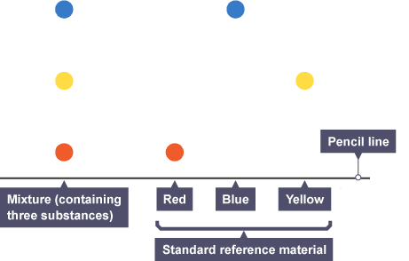

Thin layer chromatography
Thin layer chromatography (TLC) is similar to paper chromatography but instead of paper, the stationary phase is a thin layer of an inert substance (eg silica) supported on a flat, unreactive surface (eg a glass plate).
TLC has some advantages over paper chromatography. For example:
- the mobile phase moves more quickly through the stationary phase
- the mobile phase moves more evenly through the stationary phase
- there is a range of absorbencies for the stationary phase
TLC tends to produce more useful chromatograms than paper chromatography, which show greater separation of the components in the mixture - and are therefore easier to analyse.
The distance a sample travels can depend on the size or the polarity of the molecules involved. Larger molecules take longer to move up the chromatography paper or TLC plate, whereas smaller molecules are more mobile.
Likewise, the polarity of the molecules can affect how far the spots travel, depending on the type of solvent used. Polar molecules will be more strongly attracted to polar solvents, and so would move further if a polar solvent was used as opposed to a non-polar solvent.
The distance that spots move can be compared to the overall distance the solvent has moved and comparisons and measurements made.

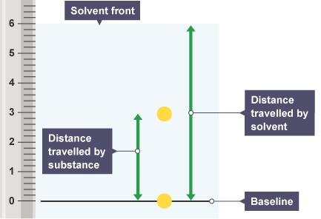

Gas chromatography
In gas chromatography (GC), the mobile phase is an inert gas (eg helium).
The stationary phase is a very thin layer of an inert liquid on an inert solid support - such as beads of silica packed into a long thin tube (this flexible tube is coiled many times inside a thermostatically-controlled oven to keep it at a constant temperature).
GC is used to separate complex mixtures. It is much better at this than thin-layer or paper chromatography.
This is because it is more sensitive - allowing the determination not only of what chemicals are in the mixture, but also how much of each chemical there is.
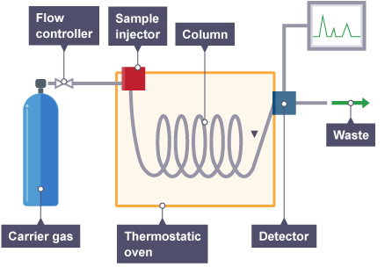
The mixture to be analysed is injected into the stream of carrier gas. As it passes along the column (long thin tube) it separates into the different substances.
Substances with a greater affinity (attraction) for the mobile phase reach the detector at the end of the column more quickly. Substances with a greater affinity for the stationary phase move more slowly through the column.
Gas chromatography can be used to detect banned substances in urine samples from athletes, or by forensic investigators to detect the presence of fuels that may have been used to deliberately start fires.
A gas chromatogram might show the time along the x-axis and the strength of response along the y-axis.
The amount of time that a substance takes to pass through the column is called it retention time. The retention time of an unknown substance can be compared with standard reference data to help to identify it.

Three main pieces of information can be gathered from a gas chromatogram:
- the number of compounds in the mixture - represented by the number of peaks
- how much of each compound is present - represented by the height of the peak (higher = more)
- the retention time - indicated by the position of the peak

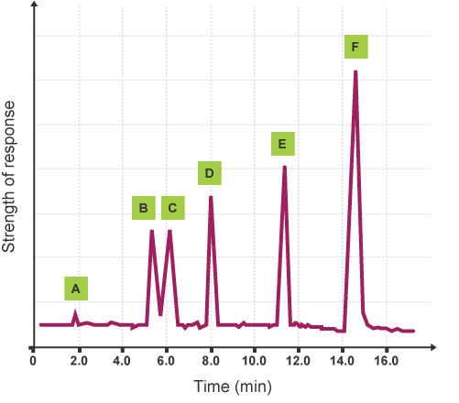
This gas chromatogram shows that:
- substance A was present in the smallest quantity (it has the smallest peak)
- substance A had the shortest retention time
- substances B and C were present in equal amounts
- substance F had the longest retention time
- substance F was present in the greatest quantity (it has the largest peak)
- substance F had the greatest affinity for the stationary phase

b) Volumetric titrations
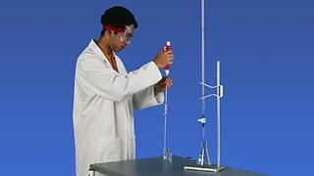
A titration experiment can be carried out to accurately measure the volume of substances that react in chemical reactions.
This technique utilises a standard solution (a solution of an accurately known concentration) which is titrated against portions of an unknown concentration until the reaction is just complete.
This end-point can be shown by using an indicator. Volumetric titrations are popular in acid-base reactions.
When titrating, it is essential to measure things as accurately as possible.
The experiment is carried out by following these steps:

Step one
If the sample is a solid, it is weighed using an accurate balance, and then dissolved to make up a known volume of solution (usually 100 cm³).

Step two
A pipette is used to measure accurately a volume of this solution - for example, 10 cm³. A safety pipette filler is used to draw solution into the pipette. This is emptied into a conical flask.

Step three
A few drops of an indicator may be added to the conical flask. This will show a change of colour when the titration is complete.

Step four
A second chemical is placed in a burette. This other solution is of a chemical that will react with the synthesised chemical sample in the conical flask. Often the solution in the burette is an acid of a precise, known concentration.

Step five
The solution from the burette is run into the conical flask. The solution is added one drop at a time, with swirling to mix the solutions as the end-point is approached. Eventually, a colour change shows that the correct amount has been added to react completely with the synthesised chemical in the sample.

Step six
The volume of solution added from the burette is noted. The titration results can then be used to calculate the amount of the synthesised chemical in the sample, and therefore find its purity.

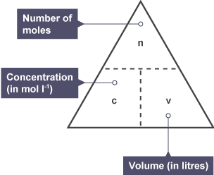
c) Redox titrations
The quantity of oxidising or reducing agent present in a redox reaction can be calculated from the results of a titration by using the balanced redox equation - this tells us the molar ratio of reactants, and the formula triangle linking number of moles with concentration and volume.
The mass of vitamin C in a tablet can be determined by redox titration. An iodine solution of known concentration and starch indicator are used.
A vitamin C tablet is dissolved in deionised water in a beaker and transferred to a 250 cm³ standard flask. This is made up to the graduation mark using deionised water (and the washings of the beaker).
25 cm³ of this solution is transferred by pipette, to a conical flask and starch indicator is added. The iodine can be added by burette until the vitamin C solution turns blue/black. This can be repeated and an average taken.

Example
The results of the titration described above show that 17.6 cm³ of 0.031 mol l⁻¹ iodine solution was required to reach the end-point with 25 cm³ of vitamin C solution. Calculate the mass of vitamin C (C₆H₈O₆) in the original tablet.
The balanced redox equation for the process is:
This shows that one mole of vitamin C will react with one mole of iodine. You can used to calculate how many moles of iodine were required from the average volume and concentration in the question.
This means that a 25 cm³ portion of the vitamin C solution contains 5.5456 x 10⁻⁴ moles of vitamin C. The original vitamin C tablet was dissolved in 250 cm³ of water, so:
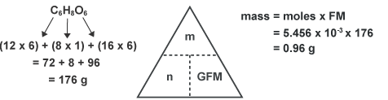

Chemical Analysis Minitest

1 Which of the following is not associated with chromatography?
- Mobile phase
- Separation phase
- Stationary phase

2 What is an advantage of thin layer chromatography (TLC) over paper chromatography?
- The mobile phase moves more evenly through the stationary phase
- The apparatus is cheaper
- The absorbencies are constant in the mobile phase

3 Which of the following does not affect how far spots travel up a chromatogram?
- The polarity of the molecules
- The formula mass of the molecules being separated
- The temperature of the solvent used

4 What shows the concentration of compounds present on a gas chromatogram?
- The number of peaks shown
- The height of the peaks shown
- The order the peaks come in

5 In an acid/base titration, where should the acid be?
- In the pipette
- In a standard flask
- In the burette

6 Which of the following titrations would not require an indicator to be used?
- Hydrochloric acid and sodium hydroxide
- Potassium permanganate and iron sulfate
- Vitamin C and iodine

7 What volume of 0.2 mol l⁻¹ calcium hydroxide (Ca(OH)₂) is required to neutralise 20 ml of 0.4 mol l⁻¹ sulfuric acid (H₂SO₄)?
- 20 ml
- 80 ml
- 40 ml

8 What is the concentration of sodium sulfite solution, 25 cm³ samples of the solution reacted with an average titre of 15.35 cm³ of 0.01 mol l⁻¹ acidified potassium permanganate solution.
The redox equation for the reaction is:
- 0.015 mol l⁻¹
- 0.15 mol l⁻¹
- 1.5 mol l⁻¹

9 Calculate the concentration of an iodine solution if 12.5 cm³ reacts completely with 20 cm³ of 0.1 mol l⁻¹ sulfite solution.
Reduction:
Oxidation:
- 0.06 mol⁻¹
- 0.16 mol⁻¹
- 0.26 mol⁻¹

10 A 250 cm³ solution of vitamin C (C₆H₈O₆) was prepared by dissolving a tablet in deionised water. A 25 cm³ sample of the solution was titrated against 0.015 mol l⁻¹ iodine solution, using starch indicator. The average titre was 17.4 cm³.
Calculate the mass of vitamin C in the original tablet, given the gram formula mass of vitamin C is 176 g, and the redox equation:
- 0.26 g
- 0.36 g
- 0.46 g

Term | Meaning
Avogadro's constant | this is the number of atoms in one mole of an element. In particular, it is the number of atoms in 12.0g of the isotope carbon-12. This number is given the symbol L and has a value of 6.02 x 10²³
Bond enthalpies | the amount of energy needed to break one mole of a bond in a gaseous molecule
Chromatography | an analytical method where mixtures are separated into their components by partitioning between a stationary and mobile phase. The stationary/mobile phases are solid/liquid in paper and thin layer chromatography, and liquid/gas in gas-liquid chromatography.
Dynamic equilibrium | achieved when the rates of two opposing processes become equal, so that no net change results
Endothermic reactions | absorb heat energy from the surroundings
End-point | the point at which the reaction is just complete
Enthalpy change | for a reaction is defined as the change in heat energy when 1 mole of reactant is converted to product(s) at constant pressure, and has the symbol ΔH and units of kJ mol⁻¹
Enthalpy of combustion | is the enthalpy change that occurs when 1 mole of a substance is burned completely in oxygen
Enthalpy of neutralisation | is the energy change (in kJ) when an acid is neutralised to form 1 mole of water
Enthalpy of solution | is the energy change (in kJ) when 1 mole of the substance dissolves in water
Equilibrium | the state reached by a reaction mixture when the rates of forward and reverse reactions have become equal
Exothermic reactions | release heat energy, which is given up to the surroundings
Feedstocks | a reactant from which other chemicals can be extracted or synthesised. Feedstocks are themselves derived from raw materials either by physical separation or by chemical reaction

Formula unit | the term 'formula unit' is a general term. A formula unit may be an atom (for all elements which do not exist as diatomic molecules), a molecule (for all covalent molecular substances) or the simplest ratio of atoms or ions (for network or lattice substances).
Hess's law | the enthalpy change for a chemical reaction is independent of the route taken, providing the starting point and finishing point is the same for both routes
Ion-electron equations | a half-equation, either an oxidation or a reduction, which in combination of the opposite type, can be part of a complete redox equation
Molar volume | the volume occupied by one mole of a substance. For gases, the units used are _ mol⁻¹. (Note that some texts will quote the molar volume in units of decimetres cubed per mole (dm³ mol⁻¹)
Oxidation | is a loss of electrons by a reactant in any reaction
Oxidising agent | a substance which accepts electrons
Potential energy diagram | shows the enthalpy of reactants and products, and the enthalpy change during a chemical reaction
Reducing agent | a substance which donates electrons
Reduction | is a gain of electrons by a reactant in any reaction
Retention time | the time taken for an individual peak to traverse the gas-liquid chromatographic column after the injection time
Specific heat capacity | relates the energy change in a liquid to the change in temperature.  For water it has a value of 4.18 kJ kg⁻¹ ºC⁻¹. In other words, when 1 kg of water absorbs 4.18kJ of heat its temperature will rise by 1ºC.
Standard solution | a solution of accurately known concentration
Theoretical yield | the theoretical yield is the maximum possible amount of product in a reaction, i.e. all of the reactant(s) have been converted into product
Thermochemical equation | states the enthalpy change for the reaction defined, with reactants and products in the states shown
Titration | determines the volume of reactant solution required to react completely with the test solution
Volumetric analysis | involves analysis using a solution of accurately known concentration in a quantitative reaction to determine the concentration of another substance

