**HIGHER CHEMISTRY**

**Nature’s Chemistry**

**Exercises for revision and homework**

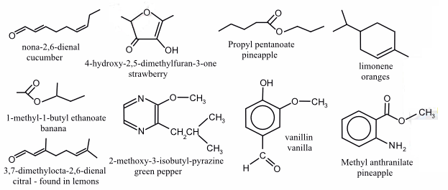

Contents

Hydrocarbons, alcohols and carboxylic acids (revision Nat 5) 3

Esters 9

Fats and Oils 14

Proteins 19

The Chemistry of Cooking and Oxidation of Food 27

Antioxidants 41

Fragrances 42

Skin Care and free radical reactions 46

Functional groups and properties 48

**This booklet is to be used to aid revision in study periods and at home. You should work through all the exercises during the course of the unit. Your teacher may decide to set some of the work as homework.**

Some of the questions in the booklet may be in the Extension test and prelim!

# Level 2Hydrocarbons, alcohols and carboxylic acids (revision Nat 5)

**1.** Write the systematic names for



a) b)

**2.** Write the structural formulae and names of 3 isomers of pentene.

**3.** Identify the homologous series each of the following molecules belongs to and name the functional group present.



a) b)



c) d)



e) f)

**4.** Draw the full structural formulae for each of the following compounds.

a) 2,4-dimethylheptane b) 3-ethyl-2-methylpentane. c) Butan-2-ol

d) Pentan-1-ol e) Ethanoic acid f) butanoic acid

**5.** The percentage of carbon by mass in pentane is

A 85.7

B 83.3

C 81.8

D 29.4

**6.** Which of the following has isomeric forms?

A C2H3Cl

B C2H5Cl

C C2HCl

D C2H4Cl2

**7.** Which hydrocarbon is not a member of the same homologous series as the others?

|  |  |
| --- | --- |
|  | Relative formula mass |
| A | 44 |
| B | 72 |
| C | 84 |
| D | 100 |

**8.** Which of the following hydrocarbons always gives the same product when one of its hydrogen atoms is replaced by a chlorine atom.

A Hexane

B Hex-1-ene

C Cyclohexane

D Cyclohexene

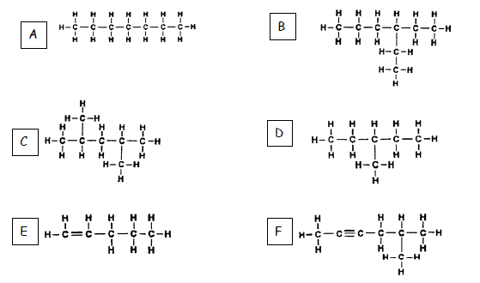

**9.**

**a)** Give the systematic names for each of the above hydrocarbons,

**b)** Identify the **two** molecules which are isomers of each other.

**c)** Draw the full structural formula of the cycloalkane which is an isomer of E.

**d)** Draw the full structural formula of ALL the products obtained when

molecule E reacts with

i) chlorine

ii) hydrogen

iii) hydrogen bromide

**e)** Which of the above molecules would be produced by reforming octane?

**10.** Look at this reaction sequence and name reactants A and B.

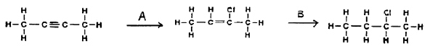

**11.**The functional group in an alcohol is called the…

**A** hydride group

**B** hydroxyl group

**C** oxide group

**D** hydroxyl group

**12.** What is the general formula for the alcohol series?

**A** CnH2n +2 OH

**B** C nH2n -2 OH

**C** C nH2n - 1 OH

**D** C nH2n + 1 OH

**13.** What is the name of this molecule?

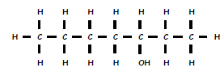

**A** Octan-3-ol

**B** Heptan-5-ol

**C** Octan-5-ol

**D** Heptan-3-ol

**14.** Which of the following is a primary alcohol?

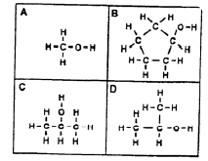

**15.** Which of the following shows propan-2-ol?

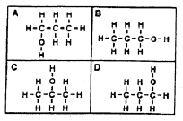

**16.** What is the correct systematic name of this molecule?



**A** 2-methylbutan-1-ol

**B** 2-methylpropan-3-ol

**C** 3-methylbutan-1-ol

**D** 2-methylpropan-1-ol

**17.** Which of the following is an isomer of this molecule?

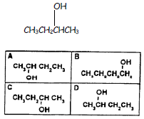

**18.** Butadiene is the first member of a homologous series of hydrocarbons called the dienes.

What is the general formula for this series?

A CnHn+2

B CnHn+3

C CnH2n

D CnH2n-2

**19.** The structural formula for a trihydric alcohol will have three….

A carbon atoms

B hydrogen atoms

C methyl groups

D hydroxyl groups

**20.** What is the systematic name of this molecule?

**A** Ethan-1,1-diol

**B** Ethane-1,2-diol

**C** Ethan-1,1-ol

**D** Ethan-1,2-ol

**21.** What is meant by a **hydroxyl group**?

**22.** Write the general formula for the alkanoic acids.

**23.** Name and draw the functional group found in all carboxylic acids.

**24.** Draw the structural formulae for the following carboxylic acids:

a) Pentanoic acid

b) 2-methylpropanoic acid

c) Benzoic acid

# Esters



**1.** Which two types of chemicals react together to produce an ester?

**2.** Copy the chemical structure shown below and circle the ester link.

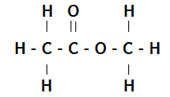

**3.** Name and draw the structural formula of the ester formed when each of the following chemicals reacts together.

a) ethanol and methanoic acid b) methanol and propanoic acid

c) butanoic acid and pentanol d) ethanoic acid and propanol

**4.** Which of the following consumer products is **least** likely to contain esters?

A flavourings

B perfumes

C solvents

D toothpastes

**5.** Which of these represents the full structural formula of ethyl propanoate?

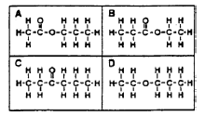

**6.** Which of these would be formed from propanol and methanoic acid?

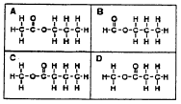

**7.** Which reactants would react together to produce this molecule?



**A** Methanoic acid and ethanol

**B** Ethanoic acid and methanoic acid

**C** Propanoic acid and water

**D** Methanol and ethanoic acid

**8.** Sodium hydrogencarbonate is added to the mixture after esterification to

**A** remove excess alkanol

**B** remove excess water

**C** make the pH more acidic

**D** remove excess acid

**9.** In ester preparation which of the following is most commonly used as a

catalyst?

**A** Concentrated sulphuric acid

**B** Concentrated hydrochloric acid

**C** Concentrated nitric acid

**D** Concentrated phosphoric acid

**10.** What would hydrolysis of this molecule produce?



**A** Propanol and methanoic acid

**B** Propanoic acid and methanol

**C** Ethanoic acid and ethanol

**D** Ethanol and ethanone

**11.** Draw the structural formula of the esters formed from……………………………

**a)** methanoic acid and propan-1-ol

**b)** ethanoic acid and butan-2-ol

**c)**

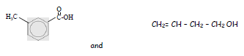

**12.** Which of the following is an ester?

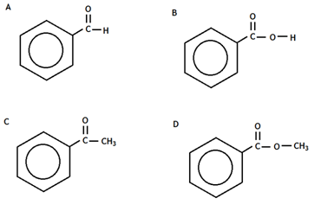

**13.** Rum flavouring is based on a compound with the formula shown,

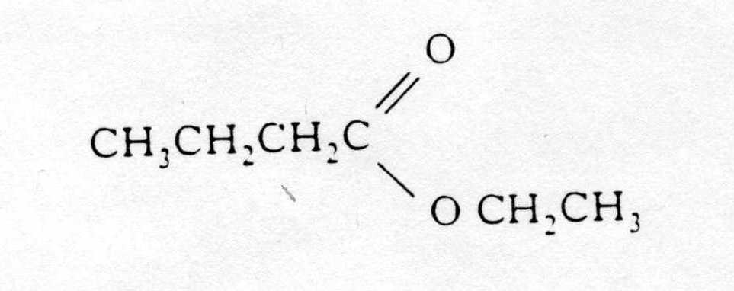

It can be made from

A ethanol and butanoic acid

B propanol and ethanoic acid

C butanol and methanoic acid

D propanol and propanoic acid

**14.** Give three uses of esters.

**15.** A pupil made the ester ethyl propanoate in a test tube and poured the reaction mixture into a beaker containing sodium hydrogen-carbonate solution.

a) Name the acid and alcohol used to make the ester.

b) What two things would the pupil observe when the ester is poured into the sodium hydrogen- carbonate solution?

c) The pupil heated the reaction mixture using a hot water bath. Why was the reaction mixture not heated directly with a Bunsen flame?

**16.** One of the chemicals released in a bee sting is an ester that has the structure shown.

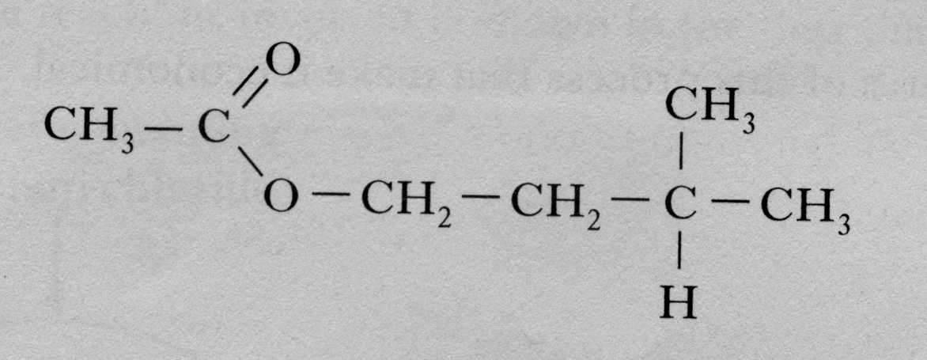

This ester can be produced by the reaction of an alcohol with an alkanoic acid.

(a) Name this acid.

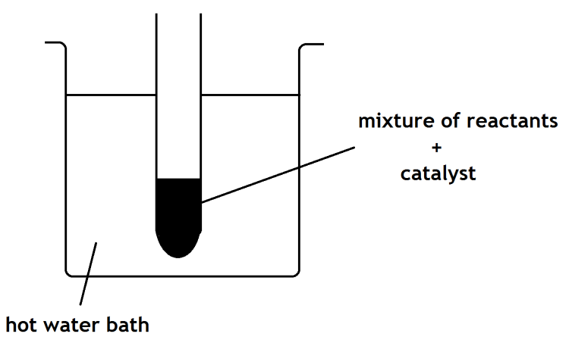(b) The ester can be prepared in the lab by heating a mixture of the reactants with a catalyst.

1. Name the catalyst used in the reaction.

1. What improvement could be made to the experimental setup shown in the above diagram?

Fats and Oils

**1.** Fats and oils can be classified as

A soaps

B fatty acids

C esters

D polyesters

**2.** Which of the following decolorises bromine water least successfully?

A palm oil

B hex-1-ene

C cod liver oil

D mutton fat

**3.** In the formation of “hardened” fats from vegetable oils, the hydrogen

A causes cross-linking between the chains

B causes hydrolysis to occur

C increases the carbon chain length

D reduces the number of carbon to carbon double bonds.

**4.** The structural formula for glycerol is

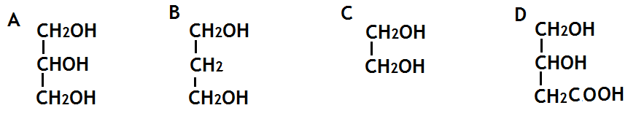

**5.** The production of fatty acids and glycerol from fats in foods is an example of

A hydrolysis

B hydrogenation

C dehydration

D dehydrogenation

**6.** Explain, in terms of structure, why fats are solids and oils are liquids at room temperature.

**7.** Foodstuffs have labels that list ingredients and provide nutritional information.

The label on a tub of margarine lists **hydrogenated vegetable oils** as one of the ingredients.

Why have some of the vegetable oils in this product been hydrogenated?

**8.** a) Draw the extended structural formula for a molecule of glycerol.

b) What is the systematic name for a molecule of glycerol.

c) Explain why fats are sometimes referred to as triglycerides

d) What do you understand by the term ‘fatty acid’?

**9.** The structure of a fat molecule is shown above.

(a) When the fat is hydrolysed, a fatty acid is obtained. Name the other product obtained in this reaction.

(b)Oils are liquid at room temperature; fats are solid. Why do oils have lower melting points than fats?

**10.** Mutton fat contains a compound called as tristearin.

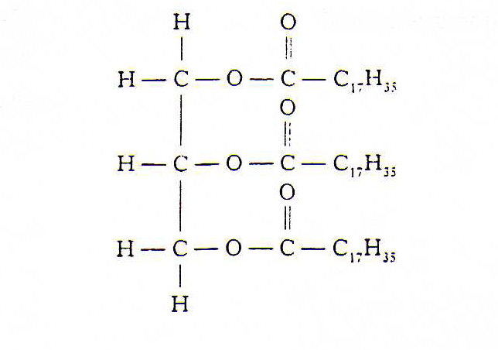

Tristearin is hydrolysed in the body during digestion by an enzyme known as lipase.

(a) Give **one** reason why fats can be a useful part of a balanced diet.

(b) To which set of compounds do enzymes belong?

(c) The hydrolysis of tristearin produces a fatty acid.

Name the other product of the reaction.

**11.** A triglyceride is best described as

**A** an ester molecule made by joining three fatty acids and one glycerol molecule

**B** an ester mixture of three fatty acids and one glycerol molecule

**C** an ester molecule made by joining three glycerol molecules and one fatty acid molecule

**D** an ester mixture of three glyceride molcules

**12.** Both solid and liquid fats are

**A** mixtures of triglycerides in which the fatty acids are always identical.

**B** mixtures of different esters.

**C** mixtures of esters formed from unsaturated acids

**D** mixtures of triglycerides formed from fatty acids which can be the same or different.

**13.** On hydrolysis, a fat molecule would produce

**A** three molecules of glycerol and one molecule of fatty acid.

**B** three molecules of glycerol and three molecules of fatty acid.

**C** one molecule of glycerol and three molecules of fatty acids.

**D** one molecule of glycerol and one molecule of fatty acid.

**14.** The composition of four fats and oils ( A, B, C and D) can be estimated using this key. Each area of shading represents the involvement of a particular fatty acid.

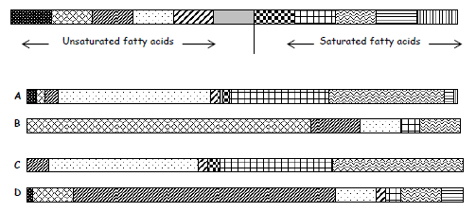

**a)** Which substance would be the least healthy in terms of diet?

**b)** Which substance is likely to have the lowest melting point?

**c)** Which substance is made from the largest number of fatty acids?

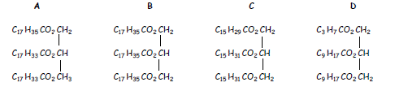**15.**

**a)** Which of the above molecules would NOT react rapidly with bromine water?

**b)** Which of the above molecules would require the least amount of hydrogen for hydrogenation?

**c)** Place the above molecules in order of increasing melting point.

**16.** The hydrolysis of a fat produces glycerol and fatty acids.

a) What does the term hydrolysis mean?

b) State the ratio of glycerol molecules to fatty acid molecules.

c) A triglyceride produces only glycerol and palmitic acid, CH3(CH2)14COOH, on hydrolysis.

i) Draw the structural formula for the triglyceride.

ii) Explain whether the triglyceride is likely to be a fat or an oil.

**17.** Explain why edible oils are sometimes used as lubricants for farm machinery.

# Proteins



**1.** Essential amino acids are

**A** found in all plant proteins

**B** only made by the human body

**C** necessary for making all proteins

**D** needed by but not made in the body

**2.** A protein with the shape shown here is known as

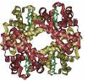

**A** fibrous

**B** cyclic

**C** tubular

**D** globular

**3.** The catalytic action of an enzyme depends most on its molecular

**A** size

**B** shape

**C** mass

**D** formula

**4.** When an enzyme is denatured it

**A** functions more easily

**B** functions exactly the same

**C** functions more slowly

**D** stops functioning

**5.** An example of a protein with a fibrous nature is

**A** haemoglobin in the blood

**B** insulin from the pancreas

**C** keratin in the hair

**D** enzymes

**6.** What type of reaction is digestion?

**A** Hydrolysis

**B** Condensation

**C** Dehydration

**D** Hydration

**7.** The digestion of a protein molecule produces

**A** amino acids

**B** simple sugars

**C** amines

**D** enzymes

**8.** Which of the following types of bond are broken during the hydrolysis of proteins?

**A C=O**

**B C-N**

**C C-H**

**D N-H**

**9.** Describe two reasons why we need protein in our diet.

**10.** What four elements are present in proteins?

**11.** What is meant by the term ***essential amino acids?***

**12.** When amino acids join together to form a protein molecule, what other chemical is produced?

**13.** Which of the following must contain nitrogen?

A an enzyme

B an oil

C a polyester

D a carbohydrate

**14.** On complete hydrolysis, a peptide produced 5 amino acids represented by the letters

P, Q, R, S and T. The following fragments were produced on partial hydrolysis.

Peptide partial hydrolysis TS + QP + RT + SQ

Which one of the sequences below could be the correct one for the arrangement of amino acids

in the peptide?

A P-T-S-Q-R

B R-T-S-P-Q

C Q-P-T-S-R

D R-T-S-Q-P

**15.** Copy and complete the table giving details of proteins found in the human body.

|  |  |  |
| --- | --- | --- |
| Name of protein | Where found | Function |
| Keratin |  | Structural support |
| Insulin |  | Controls blood glucose |
| Haemoglobin | Red blood cells |  |
| Amylase | Saliva and pancreas |  |
| Collagen |  | Structural support |
| Myosin | Muscles |  |
| Immunoglobins | Blood, tears, saliva, skin |  |

**16.** Proteins can be denatured under acid conditions. During this denaturing, the protein molecule

A changes shape

B is dehydrated

C is neutralised

D is polymerised

**17.** When two amino acids condense together, water is eliminated and a peptide link is formed.

Which of the following represents this process?

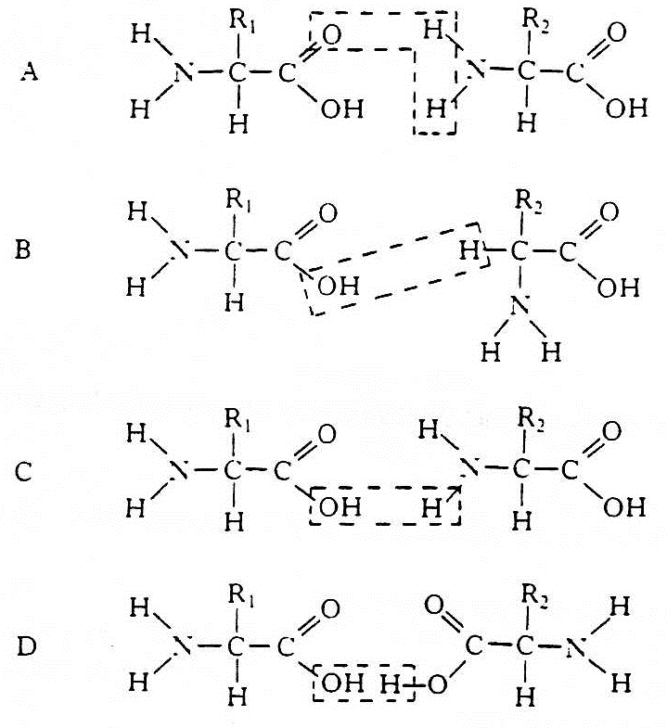

**18.** Some amino acids are called α(alpha) amino acids because the amino is on the carbon atom next to the acid group. Which of the following is an α(alpha) amino acid?

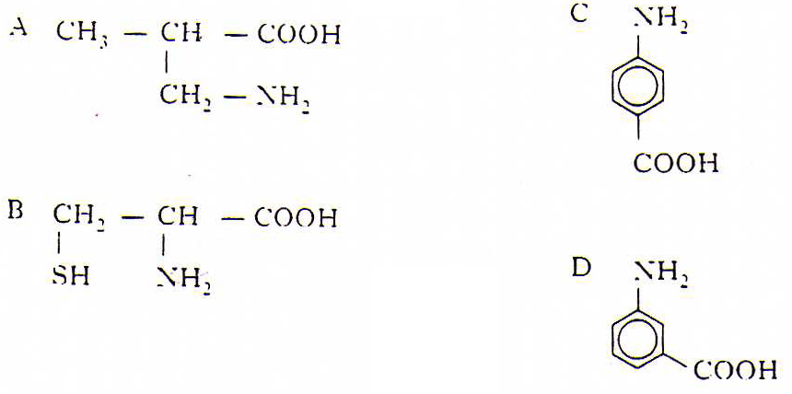

**19.** The following is part of a protein molecule (the bond angles are not correctly shown).

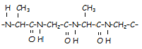

a) Draw the extended structural formula of **two** amino acids obtained on hydrolysis of this protein.

b) Draw an amide link.

**20.** An enzyme found in potatoes can catalyse the decomposition of hydrogen peroxide.



The rate of the decomposition of hydrogen peroxide can be studied using the apparatus shown.

(a) Describe how this apparatus can be used to investigate the effect of temperature on the rate of decomposition of hydrogen peroxide.

(b)The graph shows how the rate of the enzyme catalysed reaction changes with temperature.



Why does the reaction rate decrease above the optimum temperature of 40 "C?

**21.** Examine the graphs below.

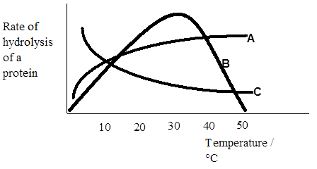

a) Which graph is likely to represent the results from a series of reactions using an enzyme? Explain your answer

b) To which family of compounds do enzymes belong?

c) Name the four elements which must be present in all enzyme molecules.

**22.** Glycine is an amino acid with the following structure.

a) Draw the structure of part of the polymer chain that would be formed when three glycine molecules polymerise.

b) What type of polymerisation process is taking place?

**23.**

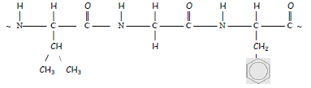

**a)** Which type of natural substance has the structure shown?

**b)** Draw the structural formulae for the molecules formed when the fragment is hydrolysed.

**c)** To which class of substances do the hydrolysed products belong to?

**d)** Why can the molecule shown be called a polypeptide?

**24.** Peptides are molecules built up from amino acids: a dipeptide is formed from two amino acid molecules, a tripeptide from three amino acid molecules and a polypeptide from many amino acid molecules.

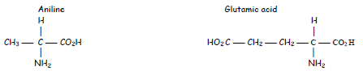

**a)** Draw the structural formula of the dipeptide formed from alanine and glutamic acid.

**b)** Name the other product of the reaction.

**c)** Name the type of reaction involved.

**d)** Go back to your drawing for answer a) and circle the peptide link.

**25.** Imagine a protein molecule built up of the following repeated 500 times.

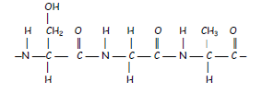

Calculate its molecular mass, remembering to add in an H and an OH to complete each end of the entire molecule.

# Level 2The Chemistry of Cooking and Oxidation of Food

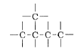

**1.** Copy the following carbon skeleton 3 times and add one hydroxyl group to each to make a primary, secondary and tertiary alcohol.

Which of the following alcohols is a tertiary alcohol?

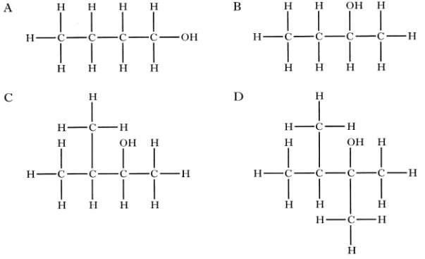

**2.** Draw the structural formulae for each of the following alcohols and state whether the alcohol is a primary, secondary or tertiary alcohol.

a) Pentan-3-ol. b) 2-methylbutan-1-ol c) 3-ethylpentan-3-ol.

**3.** Compound X is a secondary alcohol.

(a)Name compound **X.**

(b) Draw a structural formula for the tertiary alcohol that is an isomer of compound X.

**4.**

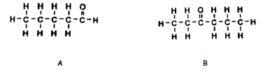

**a)** Name the functional group in both molecules.

**b)** To which homologous series does molecule A belong to?

**c)** Name molecule A.

**d)** To which homologous series does molecule B belong to?

**e)** Name molecule B.

**f)** Draw the full structural formula of the molecule which could be oxidised to make molecule A.

**g)** What would be the effect on Benedict’s Solution if it was warmed with B?

**5.** What is the general formula for aldehydes and ketones?

**6.** What is the name of the functional group found in aldehydes and ketones?

**7.** 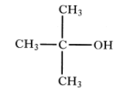The compound shown is an example of

A a primary alcohol

B a secondary alcohol

C a tertiary alcohol

Dan aldehyde

**8.** Which of the following is an aldehyde?

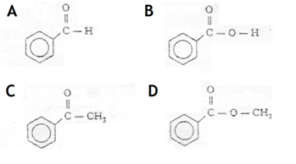

**9.** Which of the following compounds is a ketome?

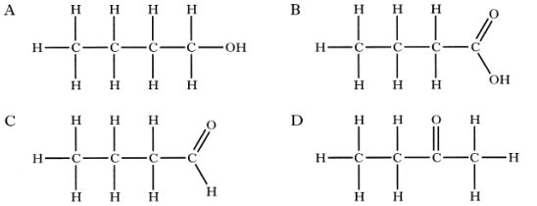

**10.** Which is true of a compound with the following formula?

CH3CH(OH)CH3

A It is a primary alcohol

B It can be oxidised to an aldehyde

C It is a tertiary alcohol

D It can be oxidised to a ketone.

**11.** Look at the diagram and answer the questions that follow.

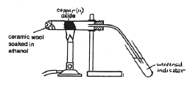

**a)** What type of alcohol is ethanol?

**b)** Name the type of reaction undergone by the ethanol.

**c)** State the function of the copper(II)oxide.

**d)** The universal indicator changes from green to red. Name the product which causes this change.

**e)** The copper(II)oxide changes from black to brown. Write the ion-electron half equation for this change.

**f)** What change would the copper(II)oxide have shown if the alcohol used had been………

i) butan-2-ol

ii) 2-methylbutan-1-ol

iii) 2-methylbutan-2-ol (3)

**g)** Name another reagent which could have been used instead of Copper(II)oxide.

**12.** Which process is used to convert methanol to methanal?

A oxidation

B condensation

C hydration

D hydrogenation

**13.** Which of the following alcohols can be oxidised to give a ketone?

A 2-methylbutan-1-ol

B 2,3-dimethylpentan-1-ol

C 3-methylbutan-2-ol

D 2-methylbutan-2-ol

**14.** What colour change happens when acidified dichromate is reduced?

**A** Blue to orange

**B** Orange to green

**C** Green to orange

**D** Orange to purple

**15.** Oxidation of a primary alcohol produces

**A** an aldehyde

**B** an alkane

**C** a ketone

**D** an alkane

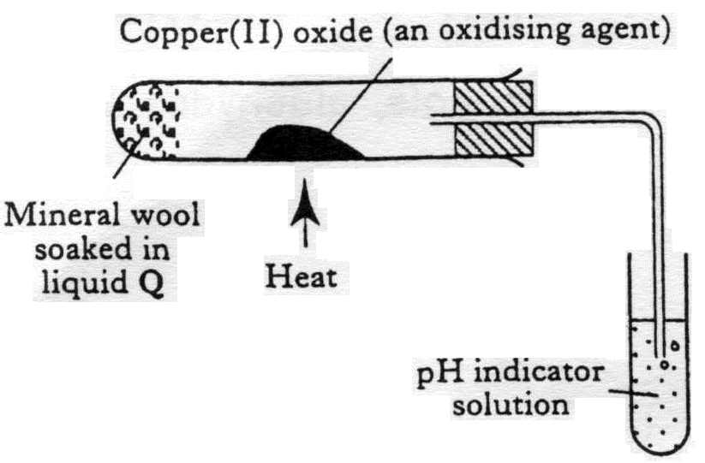**16.** After heating for several minutes as shown in the diagram, the pH indicator solution turned red. Liquid Q could be

A propanone

B paraffin

C butan-1-ol

D butan-2-ol

**17.** What compound is formed by the oxidation of propan-2-ol?

A CH3CH2CHO

B CH3CO CH3

C CH3CH2COOH

D CH3CH2 CH2OH

**18.** Which of the following would NOT be easily oxidised by acidified dichromate?

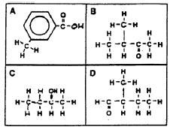

**19.** Use this grid to answer the following

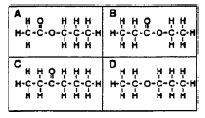

**a)** Which molecule is an aldehyde?

**b)** Which molecule is an ketone

**20.** During oxidation, what happens to the ratio of O:H atoms in a hydrocarbon?

**21.** Although aldehydes and ketones contain the carbonyl functional group, they have different structures.

(a) In what way is the structure of an aldehyde different from a ketone?

(b) Due to the difference in structure only aldehydes react with Benedict’s reagent. What colour change would be observed int he reaction?

(c) Name another suitable oxidising agent that could be used in the reaction in place of Benedict’s reagent

(d) When butanal is oxidised the compound with the formula C3H7COOH is produced. Name this compound

**22.** Two compounds A and B, both have the formula C4H8O. They were both mixed separately with Fehling’s solution and the mixtures warmed in a water bath. Only compound B gave an orange-red precipitate.

a) Name compounds A and B.

b) Draw the extended structural formulae of A and B.

c) Name another reagent which could also be used to show the difference between compound A and B and say what would happen when this reagent is reacted with A and B.

**23.** Which box, or boxes, show(s) a substance which

|  |  |  |
| --- | --- | --- |
| A CH3CH2OH | B CH3CHOHCH3 | C CH3CH2COOH |
| D CH3COCH3 | E CH3CH2CHO | F CH3COOH |

a) can be oxidised to an alkanal (aldehyde)?

b) is an alkanone (ketone)?

c) is an alkanoic (carboxylic) acid?

d) is a primary alcohol?

e) can be formed by the oxidation of B?

**24.** Propan-1-ol, can be oxidised by passing the alcohol vapour over hot copper(II) oxide.

a) Draw a labelled diagram of the apparatus that would be used to carry out this experiment in the laboratory.

b) Oxidation of propan-1-ol yields a compound X, formula C3H6O, which can be further oxidised to compound Y, formula C3H6O2.

i) Name and draw the structure of compound X.

ii) Name and draw the structure of compound Y.

c) Name two other oxidising agents which could be used to carry out the oxidation.

d) If propan-2-ol was used in place of propan-1-ol there would be only one oxidation product. Name and draw the structure of this product.

**25.** "Self-test" kits can be used to check the quantity of alcohol present in a person's breath.The person blows through a glass tube until a plastic bag at the end is completely filled.

 The tube contains orange acidified potassium dichromate crystals that turn green when they react with ethanol. The chemical reaction causing the colour change is:



The more ethanol present in the person's breath, the further along the tube the green colour travels.

a) What is the purpose of the plastic bag?

b) Why are the potassium dichromate crystals acidified?

c)Name a carbon compound formed by the reaction of ethanol with acidified potassium dichromate crystals.

**26.** Propanone is a widely used solvent. It can be made from propene.

Using full structural formulae show the steps involved in this preparation and name the reagent used in each step.

**27.** Alkanols can be oxidised to alkanoic acids.

CH3CH2CH2OH **step 1** CH3CH2CHO **step 2** CH3CH2COOH

Propan-1-ol propanal propanoic acid

(a) Why can **step 1** be described as an oxidation reaction?

(b) Acidified potassium dichromate solution can be used to oxidise propanal in **step 2** . What colour change would be observed in this reaction?

**28.** Two reactions involving a carbon compound, A, are shown.

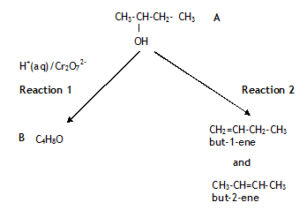

(a) Name compound A.

(b)Draw a structural formula for compound B.

**29.** Give 3 ways that fatty foods are affected when they react with oxygen.

**30.** Chemists have developed cheeses specifically for use in cheeseburgers.

(a) When ordinary cheddar cheese is grilled the shapes of the protein molecules change and the proteins and fats separate leaving a chewy solid and an oily liquid.

What name is given to the change in protein structure which occurs when ordinary cheddar is grilled?

(b) To make cheese for burgers, grated cheddar cheese, soluble milk proteins and some water are mixed and heated to no more than 82 °C. As the cheese begins to melt an emulsifying agent is added and the mixture is stirred.

(i) Why would a water bath be used to heat the mixture?

(ii) A section of the structure of a soluble milk protein is shown below.

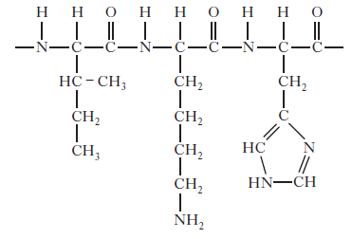

Draw a structural formula for any one of the amino acids formed when this section of protein is hydrolysed.

iii) The emulsifier used is trisodium citrate, a salt formed when citric acid is neutralised using sodium hydroxide.

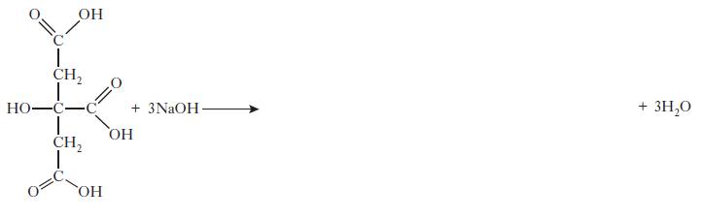Copy and complete the equation below showing a structural formula for the trisodium citrate formed.

**31.** A student closed his eyes and held his nose. Another pupil gave him a teaspoon of strawberry jam to eat. Explain why the student could tell that the food was sweet, but not what the actual flavor was.

**32.** Explain why broccoli should be cooked in water but asparagus should be cooked in oil.

**33.** Flavour molecules in different foods are shown below.



For each molecule suggest if it should be cooked in oil or water.****Soaps and emulsifiers

**1.** Explain what is meant by the terms

a) hydrophilic b) hydrophobic.

**2.** Describe how soap can clean a fat stain from clothing. You should use the following words in your answer:

***ionic head covalent tail hydrophobic hydrophilic polar non-polar***

**3.** Soap can be produced by the reaction of fats and oils with sodium hydroxide solution.

a) Name the kind of reaction that is taking place.

b) Describe the structure of soap

**4.** Small children can find it difficult to swallow tablets or pills so ibuprofen is supplied as an “infant formula” emulsion.

The emulsifier used is polysorbate 80. Its structure is shown below.

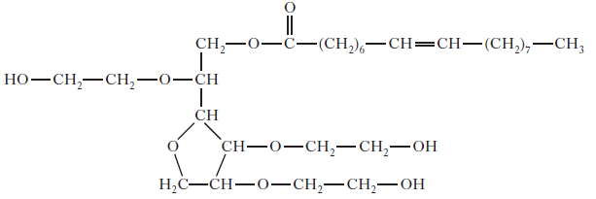

Explain why this molecule acts as an emulsifier.

**5.** Glycerol monostearate is an emulsifier used in chocolate.

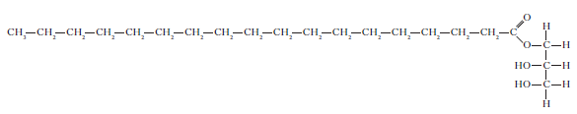

a) Why is glycerol monostearate added to chocolate?

b) Draw a structural formula for glycerol.

c) Copy the structure and label the hydrophobic and hydrophilic areas of the molecule

**6.** Stearic acid reacts with sodium hydroxide solution to form sodium stearate.

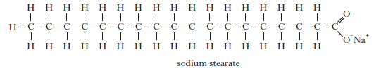

(i) Name the type of reaction taking place when stearic acid reacts with

sodium hydroxide.

(ii) **Explain fully** how sodium stearate acts to keep grease and non-polar

substances suspended in water during cleaning.

# Level 2Antioxidants

**1.** Why are antioxidants added to foods?

**2.** What is meant by a free radical?

**3.** Give the names of 3 natural antioxidants and state which foods they are found in.

**4.** Describe how orange juice can stop apples from going brown after they have been cut.

**5.** Apples and bananas turn brown when cut or bruised. The first step of the reaction causing the browning is shown below.

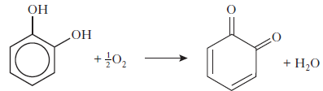

What type of reaction is this?

# Fragrances



**1.** Which unit makes up every terpene?

**2.** How many carbons there are in an isoprene unit?

**3.** What is the systematic name for isoprene?

**4.** What is an oxidised terpene known as?

**5.** Give 3 uses of essential oils.

**6.** Two typical compounds that are present in many perfumes are shown.

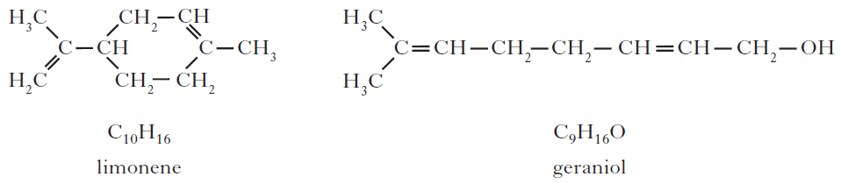(*a*) Why does geraniol evaporate more slowly than limonene?

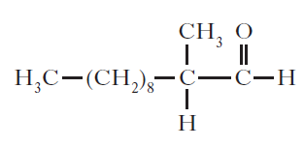(*b*) The structure of one of the first synthetic scents used in perfume is shown below.

(i) Name the family of carbonyl compounds to which this synthetic scent belongs.

(ii) Copy and complete the structure below to show the product formed when this scent is oxidised.



**7.** A team of chemists are developing a fragrance for use in a shower gel for men.

(a) To give the gel a fruity smell the chemists are considering adding an ester.

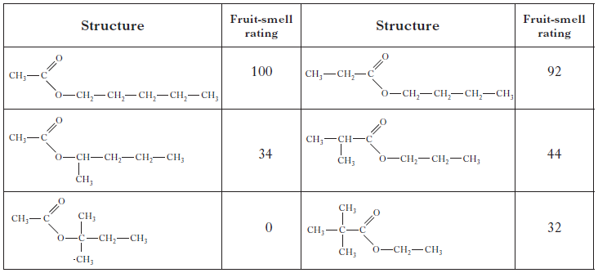They synthesise six isomeric esters. Volunteers smell each ester and give it a rating out of one hundred depending on how fruity the smell is.

(i) Name the ester with the fruit-smell rating of 92.

(ii) Shown below are the structures of three more isomers.

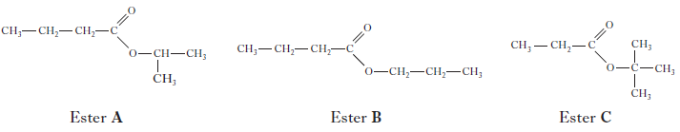

Put these esters in order of decreasing fruit-smell rating.

(b) To create a fragrance for men, the compound civetone is added. Draw a structural formula for the alcohol that can be oxidised to form civetone.

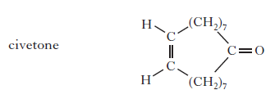

(c) To make the shower gel produce a cold, tingling sensation when applied to the skin, menthol is added. Like terpenes, menthol is formed from isoprene (2-methylbuta-1,3-diene).

Copy the diagram of the structure of menthol below and circle an isoprene unit.

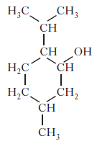

**8.** Limonene is one of the terpene molecules responsible for the flavour of lemons.

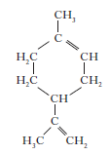

How many isoprene units are used in theproduction of one limonene molecule?

A 1

B 2

C 3

D 4

**9.** Myrcene is a simple terpene.

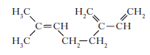

Terpenes contain at least one isoprene unit.Which of the following shows a correctly highlighted isoprene unit?

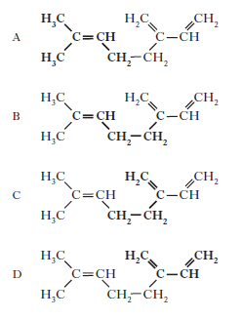

# Level 2Skin Care and free radical reactions

**1.** What are the three steps for the reaction between alkanes and halogens?

**2.** Write out each of the three steps for the reaction between chlorine gas and ethane under the action of UV light.

**3.** What is meant by a free-radical scavenger?

**4.** Suncreams contain antioxidants.

a) The antioxidant, compound A, can prevent damage to skin by reacting with free radicals such as NO2•.

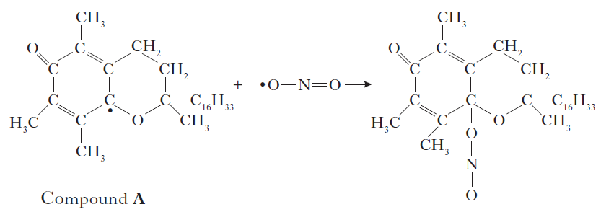

Why can compound A be described as a free radical scavenger in the reaction shown above?

b) Another antioxidant used in skin care products is vitamin C, C6H8O6.



Copy and complete the ion-electron equation for the oxidation of vitamin C.

**5.** Fluorine reacts with methane via a free radical chain reaction.

Some steps in the chain reaction are shown in the table below.

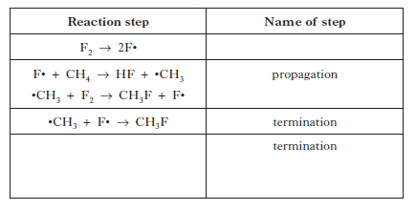

Copy and complete the table by:

a) inserting the missing name for the first step;

b) showing another possible termination reaction in the final row of the

table.

# Level 2Functional groups and properties

**1.** In which of the following liquids does hydrogen bonding occur

A Ethanol

B Ethyl ethanoate

C Hexane

D Pent-1-ene

**2.** Which line in the table shows the correct functional group for each homologous series?

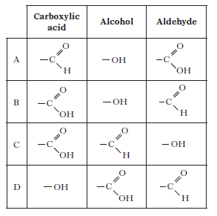

**3.** Aspartame is added to many soft drinks as a sweetener. Its structure is shown below.

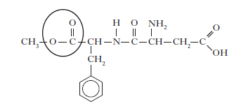

Name the functional group circled.

**4.** Shown below is the structure of asprin.

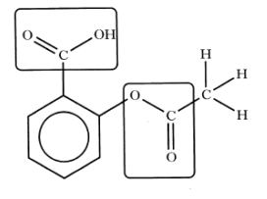

What two functional groups are highlighted?

A Carbonyl and ester

B Hydroxyl and carbonyl

C Hydroxyl and Carboxyl

D Ester and carboxyl

**5.** Vanillin and zingerone are flavour molecules.

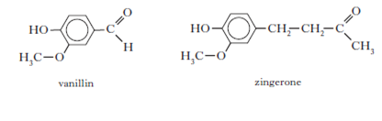

Which line in the table correctly compares the properties of vanillin and zingerone?

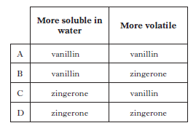

**6.** Erythrose can be used in the production of a chewing gum that helps prevent tooth decay.

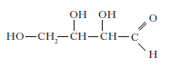

Which of the following compounds will be the **best** solvent for erythrose?

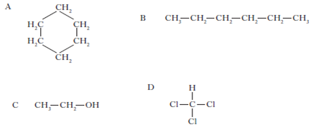

**7.** Dental anaesthetics are substances used to reduce discomfort during treatment. Lidocaine is a dental anaesthetic.

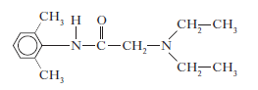

Lidocaine causes numbness when applied to the gums. This effect wears off as

the lidocaine is hydrolysed.

One of the products of the hydrolysis of lidocaine is compound **C**.

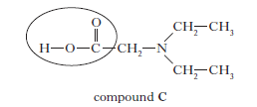

a) Name the functional group circled above.

b) Draw a structural formula for the other compound produced when lidocaine is hydrolysed.

c) The table below shows the duration of numbness for common anaesthetics.

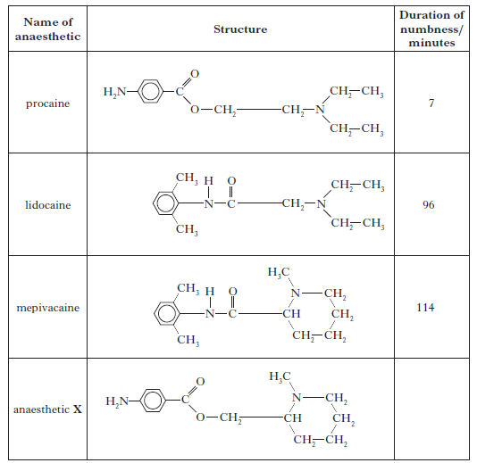

Estimate the duration of numbness, in minutes, for anaesthetic **X**.

(*d*) i) When forensic scientists analyse illegal drugs, anaesthetics such as lidocaine are sometimes found to be present.

The gas chromatogram below is from an illegal drug.

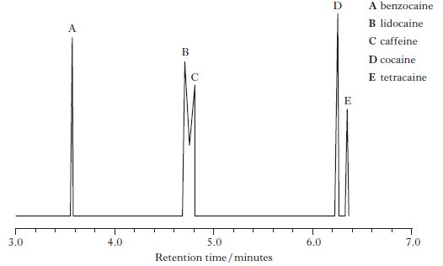

The structures of benzocaine and tetracaine are shown below.

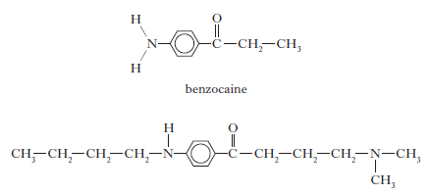

Suggest why benzocaine has a shorter retention time than tetracaine.

ii) Why is it difficult to obtain accurate values for the amount of lidocaine

present in a sample containing large amounts of caffeine?

**8.** Noradrenaline and phenylephrine cause increases in the blood pressure because the part of each of these molecules that they have in common has the correct shape to allow them to bind to a certain human protein.

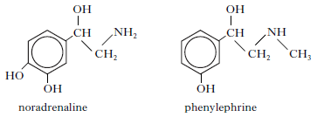

The part of these molecules which is the correct shape to bind to the protein is

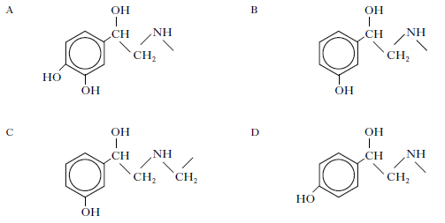

**9.** Triethanol amine and triisopropyl amine are bases used to neutralise acidic

compounds in the hairspray to prevent damage to the hair.

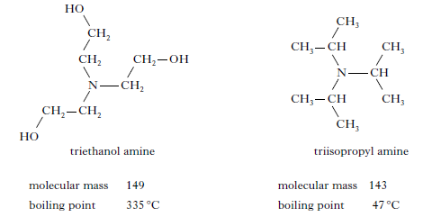

In terms of the intermolecular bonding present, **explain clearly** why triethanol amine has a much higher boiling point than triisopropyl amine.

**10.** Aspirin and oil of wintergreen are used in medicine. Their structures are shown below.

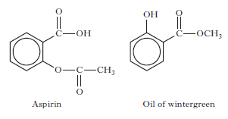

Identify the term which can be applied to aspirin but **not** to oil of wintergreen.

A Aldehyde

B Ketone

C Ester

D Carboxylic acid

**11.** Paracetamol is one of the most widely used pain relievers. It has the structure:

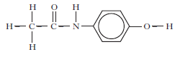

Which functional groups are present in a paracetamol molecule?

A Aldehyde, amine and hydroxyl

B Ketone, amine and hydroxyl

C Amide link and hydroxyl

D Amino acid and hydroxyl

**12.** The structure of caryophyllene, which can be extracted from clove oil, is

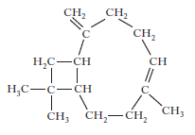

Which of the following would be the best solvent for extracting caryophyllene?

A Hexane

B Hexanal

C Hexanol

D Hexanone

**13.** Ibuprofen is one of the best selling pain killers in the UK.

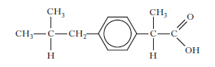

Ibuprofen tablets should not be taken by people who suffer from acid indigestion. Name the functional group present in ibuprofen that makes this

drug unsuitable for these patients?