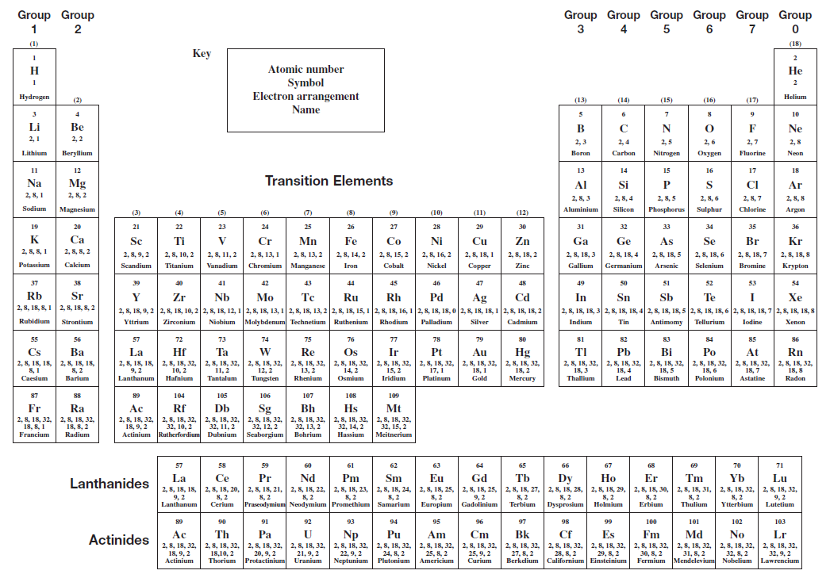

Table of Contents

Controlling the Rate of Reaction 3

Reaction Profiles Catalysts, Reaction Pathway and Activation energy 11

Periodicity 20

Structure and bonding 26

# This booklet is to be used to aid revision in study periods and at home. You should work through all the exercises during the course of the unit. Your teacher may decide to set some of the work as homework.

# Some of the questions in the booklet may be in the Extension test and prelim! Controlling the Rate of Reaction



**1.** A pupil made the following observations on dripping taps. 45cm3 of water was collected from Tap A in 3 minutes. 340 cm3 of water was collected from Tap B in 20 minutes. By calculating the average rate of loss of water from each tap, find out which tap was dripping faster.

**2.** A farmer records the weight of his pigs every Monday. Here is part of the record for one of the pigs.

|  |  |  |  |
| --- | --- | --- | --- |
| Date | Weight (kg) | Date | Weight (kg) |
| Jan 1 | 75.85 | Jan 22 | 83.70 |
| Jan 8 | 76.50 | Jan 29 | 86.90 |
| Jan 15 | 79.10 | Feb 5 | 92.10 |

Calculate the average rate of weight gain per week:-

i) during the first week ii) during the first three weeks iii) over the five week period

**3.** A pupil was attempting to measure the rate of a chemical reaction which produced a gas. After six seconds 8cm3 of gas had been collected. After ten seconds the total volume of gas collected was 14cm3. Calculate the average rate of the reaction during this time interval (from six to ten seconds).

**4.** The graph below shows the volume of hydrogen gas released when a 10cm strip of magnesium (mass = 0.1g) was added to 30cm3 of 1 mol l-1 hydrochloric acid.

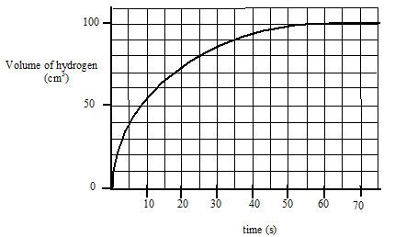(a) Calculate the average rate of reaction

i) over the first 15 seconds

ii) between 20 and 30 seconds

(b) How long did it take for the reaction to stop?

(c) The graph shows that the rate of reaction changes as the reaction proceeds. Explain why it changes in this way.

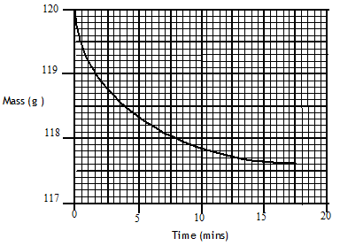**5.** Marble chips (calcium carbonate), reacted with excess dilute hydrochloric acid.

The rate of reaction was followed by recording the mass of the container and the reaction mixture over a period of time. The results of the experiment are shown in the following graph.

(a) Write a balanced equation for the reaction.

(b) Give a reason for the loss of mass of the container.

(c) Calculate the average rate of reaction over the first five minutes.

(d) Why does the average rate of reaction decrease as the reaction proceeds?

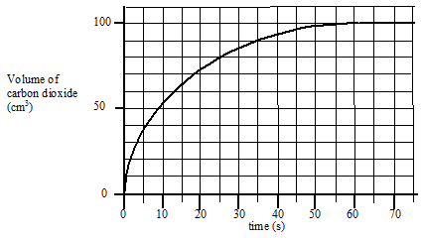**6.** The results shown below were obtained when 0.42 g of powdered chalk was added to 20cm3 hydrochloric acid, concentration 2 mol l-1 (an excess of the acid).

(a) Sketch the graph and add a **solid** line to the graph to show what would happen if 0.42g of chalk lumps was used instead of powdered chips.

(b) Add a **dotted** line to the graph to show what would happen if 20 cm3 of 3 mol l-1 hydrochloric acid was used instead of 2 mol l-1 hydrochloric acid.

**7.** 1.0 g of zinc was placed in 20 cm3 of 2 mol l-1 hydrochloric acid.

After 20 seconds the zinc was removed, washed, dried and re-weighed.

The remaining zinc weighed 0.35 g.

(a) Write a balanced chemical equation for the reaction.

(b) Calculate the average rate of the reaction.

(c) Calculate the number of moles of hydrochloric acid used up in the 20 seconds.

**8.** A pupil was investigating the effect of temperature on the rate of a chemical reaction and obtained the following data.

|  |  |  |  |  |  |
| --- | --- | --- | --- | --- | --- |
| Temperature(0C) | 15 | 25 | 33 | 37 | 44 |
| Time for reaction to  Finish (s) | 75.4 | 66.7 | 40.0 | 30.3 | 22.2 |
| Relative rate(1/t)(s-1) |  |  |  |  |  |

(a) Copy the table and calculate the relative rate of reaction at each temperature and add them to the table, putting the correct units in the brackets.

(b) Plot a graph of relative rate against temperature.

(c) Predict what the **relative rate** of the reaction will be at 50 0C.

(d) Use the graph to estimate the **time** for the reaction to finish at 40 0C.

**9.** (a) Explain

i) Why decreasing the particle size increases the rate of a chemical reaction.

ii) Why increasing the concentration speeds up a chemical reaction.

(b) Give an everyday example of a reaction speeded up by

i) decreasing the particle size

ii) increasing the concentration

**10.** When hydrochloric acid is added to a solution of sodium thiosulphate the following reaction takes place.

2HCl(aq) + Na2S2O3(aq) 🡪 2NaCl(aq) + SO2(g) + S(s) + H20(l)

Solid sulphur forms in the solution.

In one set of experiments the effect of varying the concentration of sodium thiosulphate was studied. Some of the volumes of solutions used are shown.

|  |  |  |  |
| --- | --- | --- | --- |
| Volume of 0.05 mol l-1  Na2S2O3(aq)/ cm3 | Volume of water/ cm3 | Volume of 0.1 mol l-1  HCl(aq)/ cm3 | Reaction time /s |
| 200 | 0 | 5 | 20 |
| 160 |  |  | 25 |
| 120 |  |  | 33 |
| 80 |  |  | 50 |
| 40 |  |  | 100 |

(a) Copy and then complete the table to show the volumes of water and acid that would have been used.

(b) Describe how the reaction time could have been measured.

(c) Describe how the relative rate of reaction would be obtained from each of the results.

**11.** Hydrogen peroxide can be used to clean contact lenses. In this process, the enzyme catalase is added to break down hydrogen peroxide. The equation for the reaction is:

2H2O2  **🡪** 2H2O + O2

The rate of oxygen production was measured in three laboratory experiments using the same volume of hydrogen peroxide at the same temperature.

|  |  |  |
| --- | --- | --- |
| Experiment | Concentration of H2O2/ mol l-1 | Catalyst used |
| **A** | 0.2 | yes |
| **B** | 0.4 | yes |
| **C** | 0.2 | no |

The curve obtained for experiment **A** is shown.

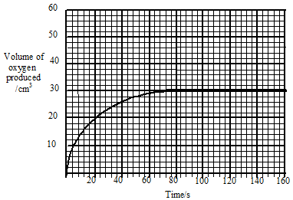

(a) Calculate the average rate of the reaction over the first 40 s.

(b) Copy the graph and add curves to the graph to show the results of experiments B and C. Label each curve clearly.

**12.** The graph shows the concentrations of reactant and product as equilibrium is established in a reaction.

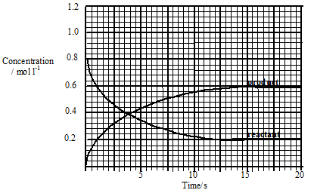

(a) Calculate the average rate of reaction over the first 10 s.

(b) The equilibrium constant for a reaction is given the symbol ***K***

In this reaction ***K*** is given by:

***K*** = equilibrium concentration of product

equilibrium concentration of reactant

Calculate the value of ***K*** for the reaction.

(c) The reaction is repeated using a homogeneous catalyst.

(i) What is meant by a homogeneous catalyst?

(ii) What effect would the introduction of the catalyst have on the value of ***K***?

**13.** Excess zinc was added to 100 cm3 of hydrochloric acid, concentration 1 mol l–1. Graph I refers to this reaction.

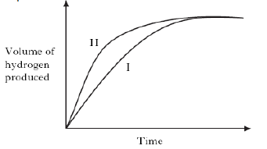

Graph II could be for…………….

A excess zinc reacting with 100cm3 of hydrochloric acid, concentration 2mol l–1

B. excess zinc reacting with 100cm3 of sulphuric acid, concentration 1 mol l–1

C. excess zinc reacting with 100cm3 of ethanoic acid, concentration 1 mol l–1

D. excess magnesium reacting with 100cm3 of hydrochloric acid, concentration 1 mol l–1.

**14.** The graph shows how the rate of a reaction varies with the concentration of one of the reactants.

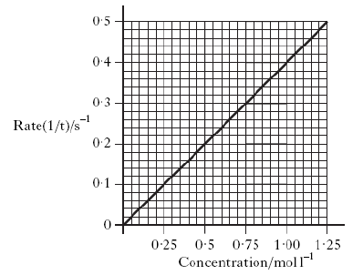

What was the reaction time, in seconds, when the concentration of the reactant was 0.50 mol l–1?

A 0.2

B 0.5

C 2.0

D 5.0

# Reaction Profiles Catalysts, Reaction Pathway and Activation energy



**1.** The potential energy diagram below refers to the reversible reaction involving reactants **R** and products **P**.

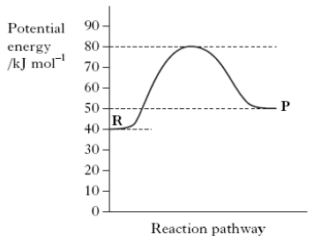

What is the enthalpy change, in kJ mol–1, for the reverse reaction **P → R**?

A + 30

B + 10

C –10

D –40

**2.** The following potential diagram is for a reaction carried out with and without a catalyst.

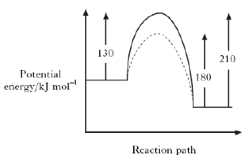

The activation energy for the catalysed reaction is

A 30 kJ mol–1

B 80 kJ mol–1

C 100 kJ mol–1

D 130 kJ mol–1.

**3.** A potential energy diagram can be used to show the activation energy (EA) and the enthalpy change (ΔH) for a reaction. Which of the following combinations of EA and ΔH could **never** be obtained for a reaction?

A EA = 50 kJ mol–1 and ΔH = –100 kJ mol–1

B EA = 50 kJ mol–1 and ΔH = +100 kJ mol–1

C EA = 100 kJ mol–1 and ΔH = +50 kJ mol–1

D EA = 100 kJ mol–1 and ΔH = –50 kJ mol–1

**4.** For any chemical, its temperature is a measure of

A the average kinetic energy of the particles that react

B the average kinetic energy of all the particles

C the activation energy

D the minimum kinetic energy required before reaction occurs.

**5.** When a catalyst is used, the activation energy of the forward reaction is reduced to 35 kJ mol–1.

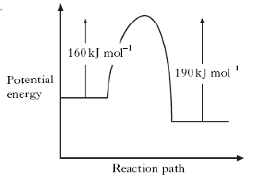

What is the activation energy of the catalysed reverse reaction?

A 30 kJ mol–1

B 35 kJ mol–1

C 65 kJ mol–1

D 190 kJ mol–1

**6.** A reaction was carried out with and without a catalyst as shown in the energy diagram.

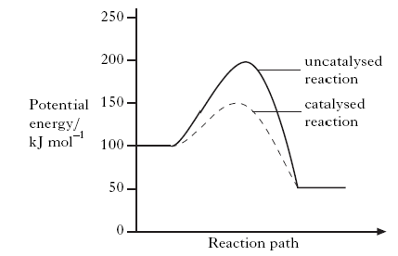

What is the enthalpy change, in kJ mol–1 for the catalysed reaction?

A –100

B –50

C +50

D +100

**7.** Which of the following is **not** a correct statement about the effect of a catalyst?

The catalyst

A provides an alternative route to the products

B lowers the energy that molecules need for successful collisions

C provides energy so that more molecules have successful collisions

D forms bonds with reacting molecules.

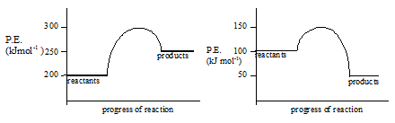**8.** a) Copy the diagrams below and mark with an arrow:-

i) the activation energy EA.

ii) the enthalpy change ΔH

b) State whether each reaction is endothermic or exothermic.

c) Calculate the value of ΔH and EA for each reaction

**9.** Copy the axes below and sketch potential energy diagrams for the following reactions, labelling the axes.

a) ΔH = -15 kJ mol-1  EA = 20 kJ mol-1

b) ΔH = +20 kJ mol-1  EA = 35 kJ mol-1

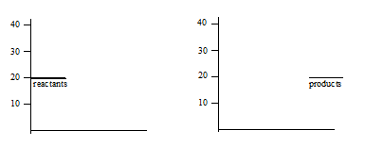

**10.** Two chemicals A and B react in solution to form C. The reaction has an activation energy of 150 kJ mol-1. If hydrogen ions are used as a catalyst the activation energy is 50 kJ mol-1. The enthalpy change for the reaction is -125 kJ mol-1. Present this information as a potential energy diagram using the template below.

Use a solid line for the uncatalysed reaction and a dotted line for the catalysed reaction.

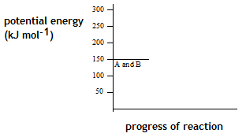

**11.** The graph shows the potential energy diagram for a urease catalysis of urea.

(a) What is the enthalpy change for the reaction?

(b) Acid is a less effective catalyst than urease for this reaction.

Sketch the diagram and add a curve to the potential energy diagram to show the hydrolysis when acid is used as the catalyst.

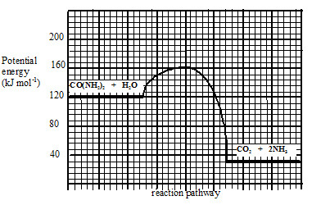

**12.** (a) Graph 1 shows the distribution of kinetic energies of molecules in a gas at300C.

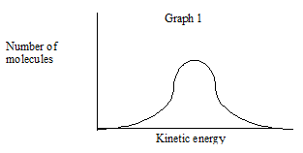

Copy the graph and add a dotted line to show the distribution of kinetic energies at 200C.

(b) In Graph 2, the shaded area represents the number of molecules with the required energy of activation, EA, for reaction to occur.

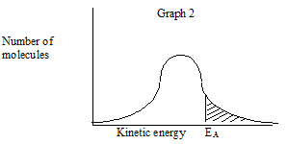

Copy the graph and draw a line to show how a catalyst affects the energy of activation.

(c) A collision involving molecules with the required energy of activation may **not** result in reaction.

State a reason for this.

**13.** What is meant by the term “activation energy”?

**14.** The decomposition of an aqueous solution of hydrogen peroxide into oxygen and water can be catalysed by iodide ions, I-(aq), or by solid manganese (IV) oxide, MnO2(s).

For each of these catalysts state, with a reason, whether the catalysis is homogeneous or heterogeneous.

An advice leaflet given to motorists when catalytic converters were first used states: “Cars fitted with catalytic converters must be run on unleaded petrol only.”

(a) Outline the reasons for fitting catalytic converters, naming the substances reacting and what happens to them.

(b) Describe in terms of adsorption how catalysts work, and state the effect this has on the activation energy for the reaction.

(c) Describe how a substance poisons a catalyst.

(d) Explain the reason for the advice given at the start of the question.

**15.**



**16.** In area **X**

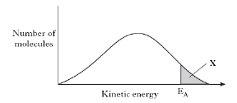

A molecules always form an activated complex

B no molecules have the energy to form an activated complex

C collisions between molecules are always successful in forming products

D all molecules have the energy to form an activated complex.

**17.** The reaction of oxalic acid with an acidified solution of potassium permanganate was studied to determine the effect of temperature changes on reaction rate.



The reaction was carried out at several temperatures between 40 °C and 60 °C. The end of the reaction was indicated by a colour change from purple to colourless.

(a) (i) State **two** factors that should be kept the same in these experiments.

(ii) Why is it difficult to measure an accurate value for the reaction time when the reaction is carried out at room temperature?

(b) Sketch a graph to show how the rate varied with increasing temperature.

**18.** As a rough guide, the rate of a reaction tends to double for every 10 °C rise in temperature.

Why does a small increase in temperature produce a large increase in reaction rate?

**19.** Enzymes are biological catalysts. They catalyse the chemical reactions which take place in the living cells of plants and animals. For example, the enzyme invertase catalyses the reaction of sucrose and water to give glucose and fructose. Enzymes are used in the manufacture of cheese, yoghurt, bread, wine, beer, lager, whisky and biological detergents. There are, therefore, many everyday examples of enzymes and they are used in many industrial processes.

a) Explain the meaning of the word catalyst.

b) Distinguish between the terms homogeneous and heterogeneous catalyst.

c) Rhodium, platinum and palladium are present as catalysts in the catalytic converters found in motor car exhaust systems. To what type of catalysts do they belong?

Explain your answer.

d) The enzyme catalase dissolves in water and the solution catalyses the decomposition of a solution of hydrogen peroxide in water. What type of catalysis is taking place?

**20.** Use the collision theory to explain why

a) increasing the concentration of a reactant increases reaction rate.

b) decreasing the particle size of a solid reactant increases reaction rate.

c) increasing the temperature increases the rate of reactions.

**21.** Many transition metals can act as catalysts. Which of the following is a

transition metal?

A Barium

B Gallium

C Vanadium

D Antimony

**22.** Kurt intended to study the effect of change in acid concentration on the reaction between nitric acid and limestone to produce carbon dioxide gas. He decided to monitor the mass of the flask as the reaction proceeded. Which of the following need not be kept constant?

A the temperature of the acid

B the shape of the flask

C the particle size of the limestone

D the mass of the limestone

# Level 2Periodicity

**1.** Copy and complete the following statements.

i) Electronegativity is a measure of the ............................... an atom in a covalent bond has for the ...................... electrons of the bond.

ii) In the Periodic table electronegativity .............................. across a period and.............................. down a group.

b) In each of the following pairs identify the element with the greater electronegativity.

i) phosphorus or carbon ii) silicon or nitrogen

**2.** All types of bonding involve electrostatic attraction between positively charged particles and negatively charged particles.

Copy and complete the table showing the three types of **strong** bonding force.

|  |  |  |
| --- | --- | --- |
| **Type of bonding** | **Positively charged particles** | **Negatively charged particles** |
|  |  | shared electrons |
| ionic |  |  |
|  | positive nucleus |  |

**3.** a) Graph 1 shows the boiling points of the Group 7 elements. Why do the boiling points increase down Group 7?

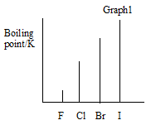

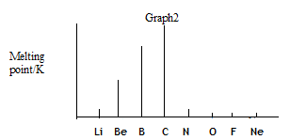 b) Graph 2 shows the melting points of elements from lithium to neon across the second period. Give reasons for the high melting points of boron and carbon.

**4.** The Periodic Table below has been divided into four sections - **A, B, C** and **D.**

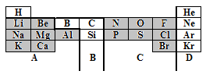

a) State the type of structure in each of the four sections A, B, C and D.

b) In which section(s) will London’s Dispersion forces between the particles be significant?

c) Using elements in the above table as examples, explain briefly the difference between a covalent molecular substance and a covalent network substance.

**5.** a) Which arrow (A) or (B) indicates correctly a decrease in atomic size?

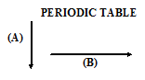 b) Explain why atomic size decreases in this way.



**6.** a) Define the **first ionisation energy** of an element**.**

b) Which arrow (A) or (B) indicates correctly a decrease in the first ionisation energy of elements?

c) Give two reasons why the ionisation energy decreases in this way.

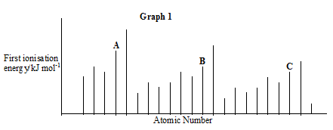**7.** The graph below shows the first ionisation energies of successive elements with increasing atomic number.

Elements A, B and C belong to the same group of the Periodic Table. Identify the group

**8.** Explain why the third ionisation energy of magnesium (7750 kJ mol-1) is so much greater than the third ionisation of aluminium (2760 kJ mol-1).

**9.** Ionisation energies can be found by applying an increasing voltage across test samples of gases until the gases ionise.

The results below were obtained from experiments using hydrogen atoms and then helium atoms.

|  |  |  |
| --- | --- | --- |
| Element | Voltage at which an atom  of gas ionises/V | |
| hydrogen | 13.6 | no further change |
| helium | 24.6 | 54.5 |

a) Why are there two results for helium but only one for hydrogen?

b) (i) Write an equation which would represent the first ionisation energy of helium gas.

(ii) Why is the first ionisation of helium higher than that of hydrogen?

c) The ionisation energy, I.E. , can be found from:

I.E. = voltage x 1.6 x 10-19 J

Calculate a value for the first ionisation energy of helium.

**10.** Use this table to answer the following questions.

|  |  |  |  |  |
| --- | --- | --- | --- | --- |
| **Ionisation Energy (kJ mol -1)** | **1st** | **2nd** | **3rd** | **4th** |
| Lithium | 526 | 7310 | 11800 | - |
| Sodium | 502 | 4560 | 6920 | 9540 |
| Magnesium | 744 | 1460 | 7750 | 10500 |

a) Explain why no value is given for the fourth ionisation energy of Lithium.

b) Explain why the first ionisation energy of Sodium is less that the first ionisation

energy of Magnesium.

c) Explain why the first ionisation energy of Sodium is less than the first ionisation

energy of Lithium.

d) Explain why the second ionisation energy of Sodium is far larger than the second

ionisation energy of Magnesium.

**11.** An ionic radius is the distance from the nucleus to the outermost energy level in an ion.

|  |  |  |  |  |  |  |  |  |
| --- | --- | --- | --- | --- | --- | --- | --- | --- |
| **Ion** | Li+ | Be2+ | B3+ | C4+ | N3- | O2- | F- | Ne |
| **Radius (pm)** | 68 | 35 | 23 | 16 | 171 | 132 | 133 | - |

a) Why do values decrease from Lithium to Carbon?

b) Why is there a large increase from Carbon to Nitrogen?

c) Why is there no value for Neon?

**12.** The graph shows the melting points of successive elements across a period in the periodic table

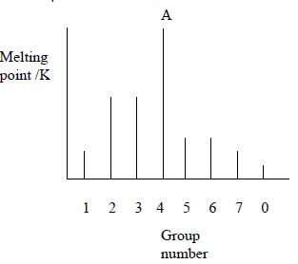

a) Use a data booklet to help you decide which period of the Periodic Table is covered by this graph.

b) Which type of element has the lowest melting point?

c) What type of bonding is present in element A?

**13.** The spike graph shows the variation in the first ionisation energy with atomic number for sixteen consecutive elements in the periodic table. The elements at which the spike graph starts are not specified.

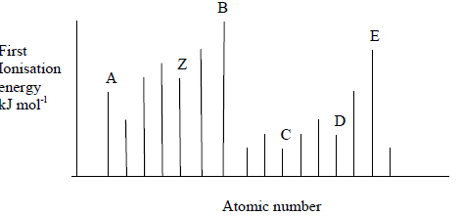

a) State the meaning of “first ionisation energy”.

b) Explain why the graph supports the idea that the properties of the elements are “periodic” in character.

c) One of the lettered elements belongs to the same group as Z. Which one?

d) Which letters represent elements that are noble gases?

# Level 2Structure and bonding

**1.** Here are the shapes of some common molecules.

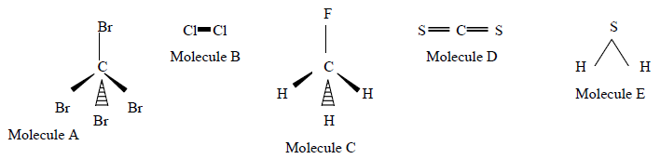

a) What word is used to describe the shape of molecules A and C?

b) Which molecule has the same shape as a molecule of water?

c) Which molecule(s) have polar covalent bonds and consist of polar molecules?

d) Which molecule(s) have polar covalent bonds but are non-polar molecules?

e) Which TWO molecules contain bonds which are considered to be pure covalent?

**2.** The shapes of some common molecules are shown. Each molecule contains at least one polar covalent bond. Which of the following molecules is non-polar?

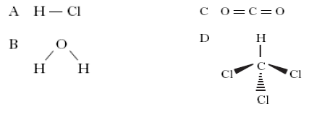

**3.** At room temperature, a solid substance was shown to have a lattice consisting of positively charged ions and delocalised outer electrons.

The substance could be

A graphite

B sodium

C mercury

D phosphorus.

**4.** When two atoms form a non-polar covalent bond, the two atoms **must** have

A the same atomic size

B the same electronegativity

C the same ionisation energy

D the same number

**5.** a) There are three types of structures that are found in elements:

1) metallic lattice

2) covalent network

3) covalent molecular

Use the elements in period 2 (elements 3 to 10) to give one example of each

type of structure.

b) Look at the substances listed below and decide whether each would conduct electricity. **You must explain your answer**.

i) solid rubidium chloride

ii) liquid gallium

iii) liquid nitrogen

**6.** Use the table below to answer the following questions.

|  |  |  |  |
| --- | --- | --- | --- |
| Compound | Formula | Formula Mass (g) | Boiling Point (OoC) |
| Ethane | CH3 CH3 | 30 | - 89 |
| Methanol | CH3OH | 32 | 64 |
| Hydrazine | NH2 NH2 | 32 | 113 |
| Silane | SiH4 | 32 | -112 |

a) Which of the above compounds will have hydrogen bonding?

b) Explain why the boiling point of Hydrazine is much higher than silane.

c) Draw the full structural formula for

i) Hydrazine and ii) methanol

d) Why is the boiling point of Hydrazine higher than that of methanol?

**7.** The elements from sodium to argon make up the third period of the Periodic Table.

(a) On crossing the third period from left to right there is a general increase in the first ionisation energy of the elements. Why does the first ionisation energy increase across the period?

(b) The electronegativities of elements in the third period are listed on page 10 of the databook. Why is no value provided for the noble gas, argon?

**8.** Which of these is true for a covalent network?

**A** molecules are linked by London’s forces

**B** covalent bonds extend throughout the structure

**C** covalent bonds exist within molecules

**D** covalent bonds link ions into one network

**9.** Hydrogen will form a non-polar covalent bond with an element which has an electronegativity value of

**A** 0·9

**B** 1·5

**C** 2·2

**D** 2·5.

**10.** Which property of a chloride would prove that it contained ionic bonding?

**A** It conducts electricity when molten.

**B** It is soluble in a polar solvent.

**C** It is a solid at room temperature.

**D** It has a high boiling point.

**11.** In a covalent molecular substance…..

**A** all molecules are joined to each other by covalent bonds

**B** London’s forces link atoms within each molecule

**C** covalent bonds only exist within distinct molecules

**D** all the atoms are linked to form a lattice

**12.** London’s Dispersion forces…………

**A** are so weak as to be unimportant

**B** determine the melting point

**C** weaken the covalent bonds

**D** make the atoms larger

**13.** Non-polar solvents tend to dissolve.....

**A** metallic substances

**B** ionic substances

**C** polar substances

**D** non-polar substances

**14.** Ionic compounds have high melting points because……

**A** the forces between the ions are strong

**B** the atoms share more than one electron

**C** they have stable electron arrangements

**D** there are an equal number of positive and negative ions

**15.** Ions are held together in a lattice by

**A** shared electrons

**B** electrostatic forces

**C** covalent bonds

**D** exchanging protons

**16.** Solid metals are able to conduct electricity because……

**A** their outer electrons are free to move

**B** their inner electrons are free to move

**C** their ions can move in the lattice

**D** the atoms can move in the lattice

**17.** Which of the following atoms has the least attraction for bonding electrons?

**A** Carbon

**B** Nitrogen

**C** Phosphorus

**D** Silicon

**18.** Which of the following reactions refers to the third ionisation energy of aluminium?

**A** Al(s) → Al3+(g) + 3e–

**B** Al(g) → Al3+(g) + 3e–

**C** Al2+(g) → Al3+(g) + e–

**D** Al3+(g) → Al4+(g) + e–

**19.** At room temperature, a solid substance was shown to have a lattice consisting of positively charged ions and delocalised outer electrons.

**A** graphite

**B** sodium

**C** mercury

**D** phosphorus

**20.** Noble gases are described as monatomic because they all

**A** form molecules in which every atom is the same

**B** exist as single uncombined atoms

**C** have very stable electron arrangements

**D** belong to the same group in the periodic table

**21.** Element **X** was found to have the following properties.

(i) It does not conduct electricity when solid.

(ii) It forms a gaseous oxide.

(iii) It is a solid at room temperature.

Element **X** could be

**A** magnesium

**B** silicon

**C** nitrogen

**D** sulphur.

**22.** Which of the following shows the types of bonding in **decreasing** order of strength?

**A** Covalent : hydrogen : London’s forces

**B** Covalent : London’s forces : hydrogen

**C** Hydrogen : covalent : London’s forces

**D** London’s forces : hydrogen : covalent

**23.** There are many types of attractive force, some are weak and some are strong.

**A** positively charged ions and negatively charged ions

**B** temporary dipole and induced dipole

**C** positively charged nuclei and delocalised electrons

**D** permanent dipole and permanent dipole

**E**  positively charged nucleii and shared electrons

Identify the statement(s) referring to

a) London’s forces

b) the forces between oxygen and hydrogen atoms in water

c) the intemolecular forces in HCl gas.

d) ionic bonds

**24.** Which of the following substances is a non-conductor but becomes a good conductor on melting?

A Solid potassium fluoride

B Solid argon

C Solid potassium

D Solid tetrachloromethane

**25.** Particles with the same electron arrangement are said to be isoelectronic. Which of the following compounds contains ions which are isoelectronic?

A Na2S

B MgCl2

C KBr

D CaCl2

**26.** The covalent bond in hydrogen chloride gas is polar and the molecule is polar. The covalent bonds in silicon tetrachloride are also polar. Explain why the silicon tetrachloride molecule is non-polar.

**27.** What type of bond is broken when ice is melted?

**A** Covalent

**B** Polar covalent

**C**  London’s forces

**D** Hydrogen bonds

**28.** Which of the following has a covalent molecular structure?

A Argon

B Fullerne

C Calcium chloride

D Silicon dioxide

**29.** There are many types of bonding force between atoms and molecules.

|  |  |  |
| --- | --- | --- |
| **A**  permanent dipole to permanent dipole interactions | **B**  non-polar covalent bonds | **C**  hydrogen bonds |
| **D**  ionic bonds | **E**  metallic bonds | **F**  London dispersion forces |

a) Identify the three forces present in hydrogen fluoride.

b) Identify the force(s) present in

i) methane ii) sodium chloride iii) hydrogen bromide iv) neon v) oxygen

c) Identify the bond(s) and/or force(s) of attraction

i) responsible for the low boiling point of argon.

ii) that can exist **between** molecules.

iii) that allow electrons a lot of free movement.

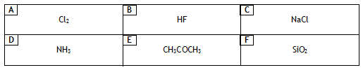**30.** Which of the compounds below have:

Identify the substance(s) where the intermolecular forces are

a) London’s forces **only.**

b) hydrogen bonds

**31.** a) What is meant by “the electronegativity” of an element?

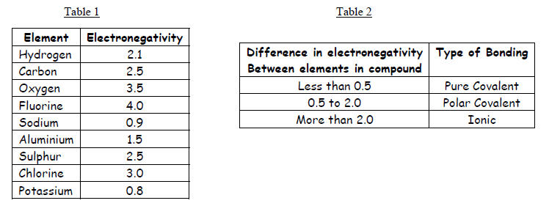

b) Look at the information in tables 1 and 2, then use the information to predict the type of bonding in the compounds named below

i) hydrogen sulphide

ii) sodium fluoride

iii) potassium oxide

iv) aluminium chloride

v) ethane

vi) water

**32.** Elements and compounds show a variety of structures.

|  |  |  |
| --- | --- | --- |
| **A**  Cl2 | **B**  Na | **C**  NaCl |
| **D**  SiO2 | **E**  NH3 | **F**  C(diamond) |

Identify the substance(s)

a) with a tetrahedral arrangement of bonds in a covalent network.

b) which can conduct electricity because of delocalised electrons.

c) with discrete covalent molecules

**33.** Many of the properties of water arise from the presence of polar O - H bonds which make the water molecules polar.

Carbon dioxide contains polar C = O bonds but its molecules are non-polar.

a) Explain this difference with the aid of diagrams of each molecule, showing polarities.

b) Water is unusual in that in the solid form (ice) is less dense than the liquid form

Explain why water behaves in this way.

**34.** Both bonded and non-bonded pairs of electrons repel each other and this determines the shape of the molecule.

The following procedure is used to find the total number of pairs of electrons around a central atom.

(i) Note the number of electrons in the outer energy level (shell) of the central atom.

(ii) Note the number of other atoms present --- each atom provides one electron for bonding.

(iii) Add (i) and (ii) to give the total number of electrons.

(iv) Divide this number by two to give the number of electron pairs - both bonded and non- bonded pairs.

**Example:-** with ammonia, NH3, N is the central atom.

(i) 2,5 = 5 electrons

(ii) 3H 3 x 1 = 3 electrons

(iii) Total = 8 electrons

(iv) 8 electrons gives four pairs.

Since NH3 only has 3 bonds there is one non-bonded pair. The 4 pairs of electrons repel each other, giving the pyramid shape of the ammonia molecule as shown in the first row of the table.

Copy and complete the table.

|  |  |  |  |  |  |
| --- | --- | --- | --- | --- | --- |
| Formula | Outer electrons in central atom | Total number of electrons | Bonded pairs | Non-bonded pairs | Molecular shape |
| NH3 | 5 | 8 | 3 | 1 |  |
| CCl4 | 4 |  | 4 | 0 |  |
| BeCl2 | 2 | 4 | 2 |  |  |
| PF5 |  | 10 | 5 |  |  |

**35.** a) Predict the type of bonding (non-polar covalent, polar covalent or ionic) between the following elements.

i) magnesium and sulphur

ii) oxygen and phosphorus

iii) nitrogen and nitrogen

iv) fluorine and oxygen

b) Justify, by reference to electronegativity values, your answers to i) and iv).

**36.** The boiling points of compounds depend on the intermolecular forces.

|  |  |  |  |
| --- | --- | --- | --- |
| Name | Formula | Molecular mass | Boiling point (0C) |
| butane | CH3CH2CH2CH3 |  | - 0.5 |
| propanone | CH3COCH3 |  | 56 |

a) Copy the table and calculate the molecular mass for each compound.

b) Explain why the boiling points are different.

**37.** The Group 5 hydrides are covalent compounds.

|  |  |  |
| --- | --- | --- |
| Compound | Enthalpy of formation/kJ mol-1 | Boiling point/K |
| NH3  PH3  AsH3 | -46  +6  +172 | 240  185  218 |

a) What is the trend in stability of the group 5 hydrides?

b) Explain why the boiling point of NH3 is higher than the boiling point of PH3 and AsH3.

**38.**The table below shows the boiling point, molecular mass and structure of the simplest alkanol, methanol, the simplest alkanoic acid, methanoic acid and the ester methyl methanoate which forms when the acid and the alkanol react together in a condensation reaction.

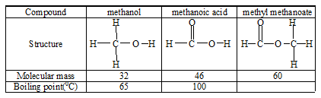

a)Using **molecular mass** as the **only criterion**, use the boiling points of methanol and methanoic acid to predict the boiling point of methyl methanoate and put it in the table.

b) The boiling point of the ester is in fact 320C. Explain in terms of the intermolecular forces why this value is so different from your prediction.

**39.** The bar chart shows the melting points of chlorides of elements 3 to 20 (with no bars for 10, 15 and 18).

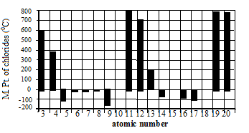

a) Copy and complete this statement describing the pattern for these **melting points** related to the **Group number.**

**In general** as the Group number increases the melting point of the chloride ................

b) Explain why no values are given for elements 10 and 18.

c) **From the bar chart**, state which of the chlorides has the weakest forces between the molecules.

d) Predict a value for the melting point of the chloride of element 15.

**40.** Consider the substances: potassium, bromine and potassium bromide.

a) Construct a table to show the type of bonding, the structure, the solubility or reaction with water, the state at room temperature and the electrical conductivity of the three substances.

b) Explain the solubility of potassium bromide in water in terms of its bonding.

**41.** Explain in terms of its structure and bonding why silicon carbide can be used to make stones for sharpening chisels and knives.

**42.** Lithium iodide is quite soluble in non-polar solvents e.g. white spirit (a mixture of hydrocarbons).

a) What does this statement suggest about the type of bonding in lithium iodide?

b) State, with an explanation, whether you would expect lithium fluoride to be more or less soluble than lithium iodide in non-polar solvents.

**43.** Tin iodide can be prepared directly from its elements.

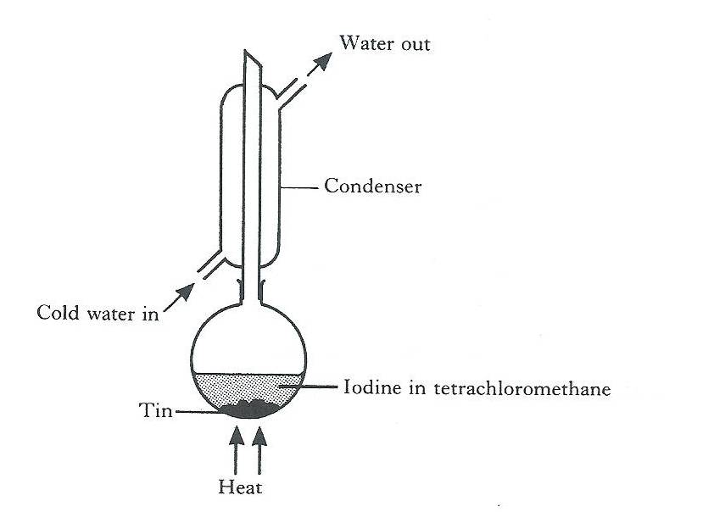Excess tin is heated for about an hour with iodine dissolved in tetrachloromethane.

Tetrachloromethane, which has a boiling point of 77 oC, acts as a solvent for both the iodine and the tin iodide that is formed.

When the reaction is complete, the excess tin is removed. On cooling the remaining solutions, orange crystals of tin iodide appear.

The crystals have a melting point of 144 oC.

**(a)** Why is a condenser used when heating the reaction mixture?

**(b)** Give **two** pieces of evidence from the method of preparation which suggests that tin iodide is a discrete molecular covalent compound.

**(c)** What type of bonds would be broken when tin iodide melts?