TASK 1 Paying for items we buy (goods and services - also known as products)

There are many ways to pay for the things we need and want to buy. Here are a few suggestions.

Investigate what these words mean and complete the table. The first one is done for you.

TERM |  | DEFINITION | IMAGE & SOURCE
1 | Cash | Money in the form of coins or notes  Source: Google Search | Source: Google Images
2 | Debit Card – Contactless
3 | Debit Card – Chip and PIN
4 | Apple Pay
5 | Pingit
6 | Cheque
7 | Store card

TASK 2 How to pay for goods or services?

From the following list, identify how you could pay for each item and justify ie, say why you would use that method of payment.

The first one is done for you. Try to use a different method for each.

ITEM  PRICE £ | Bottle of water  Price – 60p | Holiday for 4 to Majorca (Thomson’s Travel Agency)  Price – £494 per person | Supreme Being  T-shirt from eBay website  Price – £95 | ‘Family shop’ from Asda supermarket  Price – £45 | John Lewis sofa  Price – £549 | Cinema trip for 1 adults and 1 child  Price – £22.20
Method | Cash
Justification | It is a small amount to pay and customers are likely to have small ‘change’ with them

Reminder: Cash, Debit Card (contactless AND Chip and Pin), Apple Pay, Pingit, Cheque, Store Card
TASK 3 How to pay for large purchases

When buying goods and services, an exchange process takes place:

The seller supplies the product to the customer in exchange for payment from the customer.

There are times when we would like to purchase (buy) an item although we may not have enough ‘money’ to pay for it immediately. We may have to borrow the money if we want or need it now. (We could of course, save money regularly and buy it at a later stage).
There are several ways to pay for more expensive purchases eg, a wedding, a car, a new house, a 4K TV.

- Using an online source, find out what the following terms mean. Remember to quote your source of information.

- What are the costs associated with the method? (Hint – interest rates are a cost)

- What are the benefits of using this method?).

METHOD | Definition/Source | Benefits of this method | Costs of this method
Bank Loan

Mortgage

Hire Purchase

Hint: Length of time to pay back, when can you use the item, interest rate charged, when does the item belong to you?

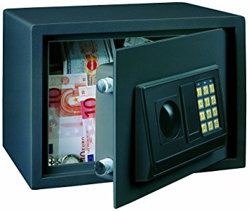
TASK 4 What would you do if …?

You have received a sudden windfall of £20, 000.
(a large sum of money that is won or received unexpectedly)

- You have to decide how to deal with this money.
  - What can you do with this windfall to make it grow in value? (ie, make it worth more). You have some options to choose from and can use more than one:
- Put the money in a safe and don’t tell anyone the code
- Start a small business
- Put the £20, 000 in a bank or building society
- Buy lottery tickets
- See a Financial Advisor to be given advice on what to do

With this windfall, I have decided to: | My reasons are:

TASK 5 Why save?

Explore some of the main reasons that people save. This could range from saving up for something specific or putting aside money ‘just in case’.

- You could ASK family, friends and teachers:

If they save: WHY they save WHERE they save WHAT they save FOR HOW LONG they save FOR

Ask at least 3 people and record your findings. (This is called primary or field research, as you are finding out by asking people directly).

- Setting the challenge

  - You would like to save for the following items:
    - A school trip to New York; which will happen in February 2022 - £650
    - A birthday present for 2 months time - £10
    - New clothes for a Christmas Dance - £50

CREATE a realistic savings plan to help you pay for these purchases. You get an allowance of £10 per week and you have additional income of £5 a week from dog walking. How long will it take in order to save up for the item? Can you afford to pay for the items? If not, which will you give up? What other sources of income could you use to help you save money? (Refer to page 9 for an example)

TASK 6 Completing the Report *THIS IS TO BE HANDED IN OR EMAILED TO YOUR TEACHER

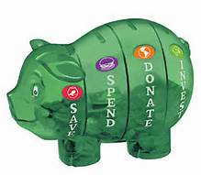
By now you have found out a lot about:

- SAVINGS | - INVESTMENTS | - BORROWING

You now need to create a REPORT for the teacher that will:

OUTLINE the costs and benefits of Saving, Investing and Borrowing. This means giving a summary of your findings.

You can choose how to report on your new knowledge by producing ONE of the following to show the costs and benefits of Savings, Investments and Borrowing money.

- MIND MAP/POSTER
- PRESENTATION SOFTWARE (MS PowerPoint, Prezi or similar to make an EFFECTIVE presentation)
- A NEWS REPORT FOR A TEEN MAGAZINE (MS Publisher, MS Word or similar DTP software)

