Administration and IT

Communication in Administration

Emerging Technologies

I can explore the latest technologies and consider the ways in which they have developed. TCH 1-05a

I can explore the impact, contribution and use of various software applications and emerging hardware in business.
TCH 3-08a

I can present conclusions about the impact of technologies on the economy, politics and the environment. TCH 4-07a

Learning Intentions:

You learning intentions are:

- Understand why organisations need to communicate with employees/customers and suppliers.
- Understand the factors taken into consideration when choosing a method of communication.
- Understand what emerging technologies mean.
- Identify the different types of emerging technologies and when to use them.

Success Criteria:

You success criteria are to:

- Be able to explain why organisations need to communicate with employees/customers and suppliers.
- Be able to describe the factors taken into consideration when choosing a method of communication.
- Be able to explain what emerging technologies mean.
- Be able to identify the different types of emerging technologies and when to use them.

An organisations ability to communicate information to the right people at the right time is vital for an organisation to succeed. Effective communication will allow an organisation to meet its targets and send the correct message it wants. An Administrative Assistant will also need to decide what technology to use to communicate effectively with fellow employees, suppliers and customers; examples of effective communication include giving the correct phone messages to employees, sending out the correct price lists or directions to customers or suppliers.

The technology that is decided upon will depend on what is being communicated and why.

The choice of technology that can be used is wide varying, with established technology already in use (like the Internet and websites)and emerging technologies which are technologies that are new, creative and allows you to communicate in different ways.

Emerging Technologies

The emerging technologies that can be used by organisations and what we will be learning about are:

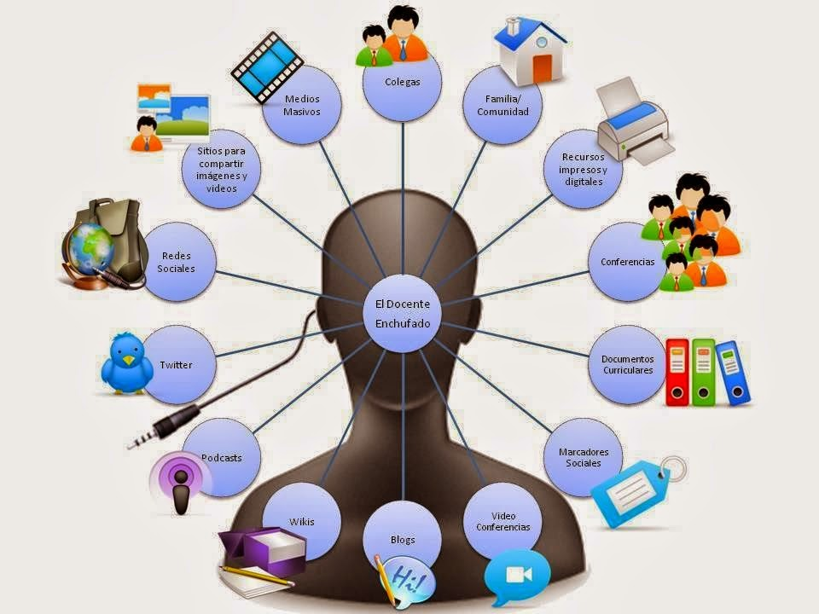
- Emails
- E-diary
- Websites
- Texting
- Blogs
- Discussion groups and forums
- Instant messaging
- Podcasts/Vodcasts
- Twitter
- Facebook
- LinkedIn
- Virtual Learning Environments (VLEs)

Choosing a Method of Communication:

When communicating with customers, clients and employees it is important that the correct method of communication is used:
- Is it appropriate? Will all intended recipients receive the information?
- Is it the most cost effective
- How quickly is the information required?

As you learn about the different emerging technologies, you have to decide:

- Why each one is being used and what the benefits are of using that particular technology.
Task 1: In your jotters answer the following questions:

- Explain why it’s important for an organisation to communicate effectively with staff/customers and suppliers? 2
- Describe what you think emerging technologies is. 1
- Identify 3 types of emerging technologies that a business could use for communication. 3
- Explain the factors an organisation need to consider when deciding what method of communication to use. 2

Emerging Technologies:

Emails:
Emails are commonplace and they can be sent and received while at your
desk or if you are on the move via your laptop and smartphone. The
advantages of using email is that you can:

- You can get instant replies to your email.
- You can send attachments for people to view.
- You can send group emails, allowing for more than one person to view your email – good for making decisions.

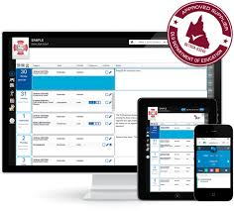
E-diary:
E-diaries are used by organisations to check on employee’s availability so that
they are able to participate in meetings and events for the organisation.
E-diary will allow the Administrative Assistant to book times and alert the
employees when the meeting will take place and how long it will be. It also helps
to cut down on double booking employees for meetings/events.

Websites:
Many organisations will have their own website. They will use this to
communicate with customers – promoting their products with pictures,
product details (size, colour etc) and customer reviews – to encourage
people to buy the product or use the service. Many organisations have
an e-commerce facility on their website, which allows customers to
purchase products online. Organisations will also use their website to keep (potential) customers informed of special offers etc. There will also be a feedback page, where customers can have their say on the organisation and its product or service.

Texting:
One of the easiest ways of staying in touch with employees and customers/clients is to text them messages. This is easily done because everyone uses a mobile phone. It is also good to get instant replies to a question or decision that is needed. Other advantages of texting are:

- You can send a question to more than one person.
- It is cheap and easy to use.
- A person can access the question anywhere and at any time.
- It is available 24 hours a day.

Task 2: In your jotters answer the following questions:

1 For each of the following scenarios, identify which methods of communication would be used by the Administrative Assistant:

a) Claire, the receptionist for Allied Domeq Ltd, needs to get an answer to a delivery problem from the Sales and Finance managers, as well as let the Distribution Manager know that the delivery will be delayed. What method of communication would she use and why? 2

b) Salman, the Sales Manager, has changed the sales prices and taken new photos of the products that they wish to sell. What method of communication would he use and why? 2

ii) Salman also wishes to send the new price lists and the photographs to all the managers of the organisation and to get the approval. What method of communication would he use and why? 2

c) Melissa, receptionist at Home 4 U needs to set up a meeting with the Area Managers of Shawlands, West End and Paisley for a meeting to be held next month. What method of communication would she use and why? 2

2 Give 2 advantages of using emails as methods of communication. 2

3 Other than selling products, give a reason for an organisation to use a website for communication purposes. 2

4 Explain why email is good method of communication. 2

Social Media:
Social media is a way of communicating to other people via your computer,
allowing you to exchange pictures, information, ideas, opinions etc.
Social media is becoming more popular with businesses as a way to
communicate with customers and potential customers. This will include blogs,
forums, podcasts, the use of Facebook, Twitter and instant messaging. The advantages of a business using social media are:

- It allows a person/business to get in touch with people quickly.
- Customers/visitors/suppliers and staff can stay in touch with business.
- Files can be sent to clients, suppliers for them to view
- Businesses can monitor competition and see what they are doing
- Businesses can keep up with what’s going on in the world, in case it affects them.

Blogs:
Blogs are setup on the Internet by individuals who wish to communicate
their thoughts and opinions on a particular topic; there are blogs on virtually
anything you can think of – photography, business education, recipes, personal
diaries, hobbies etc. Blogs can bring people from around the world who share
similar interests together to share ideas make friends and even do business together. Businesses will monitor blogs, if they are set up for their products/services, to see what people are thinking.

Discussion Groups and Forums:
A discussion group is an online forum for individuals to discuss topics of
interest. Posters add their comment, which others can read and then respond to.
It is an informal and voluntary way to exchange ideas and information and keeps
people up-to-date on topics of interest. Businesses will monitor discussion groups/forums, if they are set up for their products/services, to see what people are thinking.

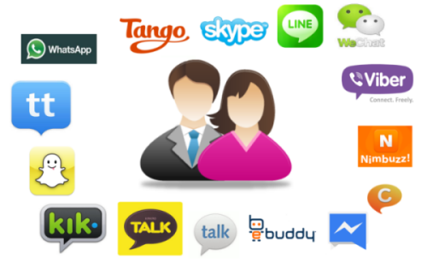
Instant Messaging:
Instant Messaging (IM) is a way of communicating in real time (instantly).
You can send IMs to anyone who is online at the same time, and you can
reply immediately to messages sent to you, and so on. Two or more people
can join in a ‘conversation’ at the same time. IMs can be used to have a quick
conversation between colleagues working on the same project in different
areas of the office. Instant messaging is not a secure method of communication.

Podcasts and Vodcasts:
Podcasting/vodcasting is an audio/visual file which can be downloaded to a
computer or mobile device (such as a smartphone or tablet). It means that
people can listen or watch at a time that is convenient to them. Businesses
can send videos on demonstrations or speeches to employees,
clients and customers.

Twitter:
An information network that connects people to the latest stories, ideas,
opinions and news. Individuals choose to ‘follow’ whoever interests them,
whether this is an individual, business, news outlet etc. Businesses can use
Twitter to quickly share information about their products and services.
It also allows a ‘conversation’ between the follower and the business about a
product/service, which can then be ‘re-tweeted’ to many more potential customers.

Facebook:
A social networking site that lets you connect with friends, co-workers, and
others who share similar interests or who have common backgrounds.
Businesses use these services as it gives them direct access to customers and potential customers. They will be able to use Facebook to monitor what customers think about their products/services and look for new customers to sell to.

LinkedIn:
Is a business version of Facebook – it connects individuals with people they
know on a professional basis. It allows the user to see other people’s
business contacts and to ask for introductions in order to do business with them.

Virtual Learning Environments (VLEs):
Use the Internet to allow remote access to learning materials, for
example notes, tasks, homework, tests etc. Students can either work
through the materials at their own pace before submitting to the ‘teacher’
for checking and tracking, or they can participate while a teacher conducts
a live class – communicating through a microphone, chat rights, or by writing
on the ‘board’. Edmodo is a VLE that you may have used in school.

It may also be used to:
- advertise products and job vacancies (perhaps using social media)
- e-commerce – selling online 24/7 (or buying from suppliers)
- contacting customers/suppliers via email
- web conferencing – face to face discussions eg using software such as Skype

Task 3: In your jotters answer the following questions:

1 Explain why a business uses of Twitter, Facebook and LinkedIn. 3

2 Explain the benefits to a business of using blogs/discussion groups as a method of communication. 2

3 Describe the use of Virtual Learning Environments (VLE). 1

4 Describe a situation as to when instant messaging would be used by a business, and give an advantage of using this type of communication. 2

5 Give 2 advantages to a business of using social media as a method of communication. 2
6 Copy the table into your jotters and write beside each scenario, which emerging technology is being used: 7

 | Scenario: | Emerging Technology:
1 | Amanda, bank clerk at RBS in Glasgow, wants to discuss the new account that is being launched with her fellow bank clerk, who works in Paisley – using the secure online service.
2 | Alana has posted comments about her new chocolate cake recipe and would like other people to try it and make comments on it.
3 | Harris has decided to follow the Financial Times newspaper, so that he can get the recent news about the stock exchange.
4 | Barrs Ltd are about to launch a new drink and have created the drinks own page to find out what people think about it.
5 | Shawlands Academy has set up live link to certain classes that pupils can participate in, while at home.
6 | Sending out information to all employees working in the Marketing department.
7 | Meeting scheduled for all directors, next week.

