LEVEL 4 BUSINESS – GLOBALISATION

HOMEWORK 1


Tesco and Walmart are keen to set up stores in India.

India is one the major growth countries in the world.
1 | Using the following word bank to complete the paragraphs which follow: | 6
transport | languages | websites
e-mail | globalisation | communications

Many organizations such as Tesco and Walmart are keen to set up in
as many countries as possible, this is known as ………………………………………

It is easier for organisations to trade globally because of improvements in ………………………………. and …………………………………………………… The use of ………………………. and …………………………………. improves communication with customers

The number of people speaking different ……………………………… also helps globalisation.
2 The definition of a multinational is: 1

Please tick one
True
An organisation which operates in one country

An organisation which sells and produces goods in more than one country
An organisation which has got lots of branches in one country

3 Give 4 examples of global brands (not the ones mentioned in your notes). 4

4 Give 2 reasons you think organisations want to operate globally? 2

1
2

5 ICT helps businesses to operate globally. Write the correct form of ICT to the statements which follow: 4

Enables goods to be sold worldwide using the internet
Staff can hold meetings with colleagues in different countries without the need to travel
Messages can be sent from one computer to another
Staff can send each other short text messages
(17)
LEVEL 4 BUSINESS – GLOBALISATION

HOMEWORK 2

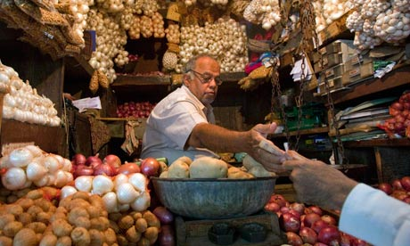 |  |   Tesco wants to start trading in India. They have not traded there before.
1 | Use your notes to identify 5 suitable reasons why Tesco would want to set up in India. 5
2 | Use your notes to 5 identify problems that Tesco might face if they set up in India. 5
(10)
LEVEL 4 BUSINESS – GLOBALISATION

HOMEWORK 3

1 The following images represent the problems that globalisation can cause. Write beside each image a short statement about each problem. 5

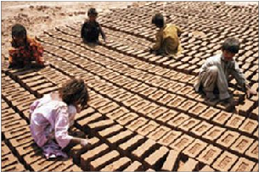

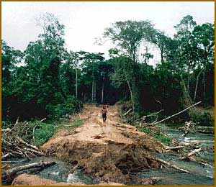


2 Many people are in favour of globalisation.

Tick the 5 statements which are advantages of globalisation for the people of the world. 5

Tick
Children can be used to manufacture goods
More employment opportunities are available
More goods are available for people to buy
Diseases are spread more easily
More money is available to spend on health and education
There is more understanding between people of different countries and cultures
Forests can be cut down
Technology is available for more people in the world to use

3 | 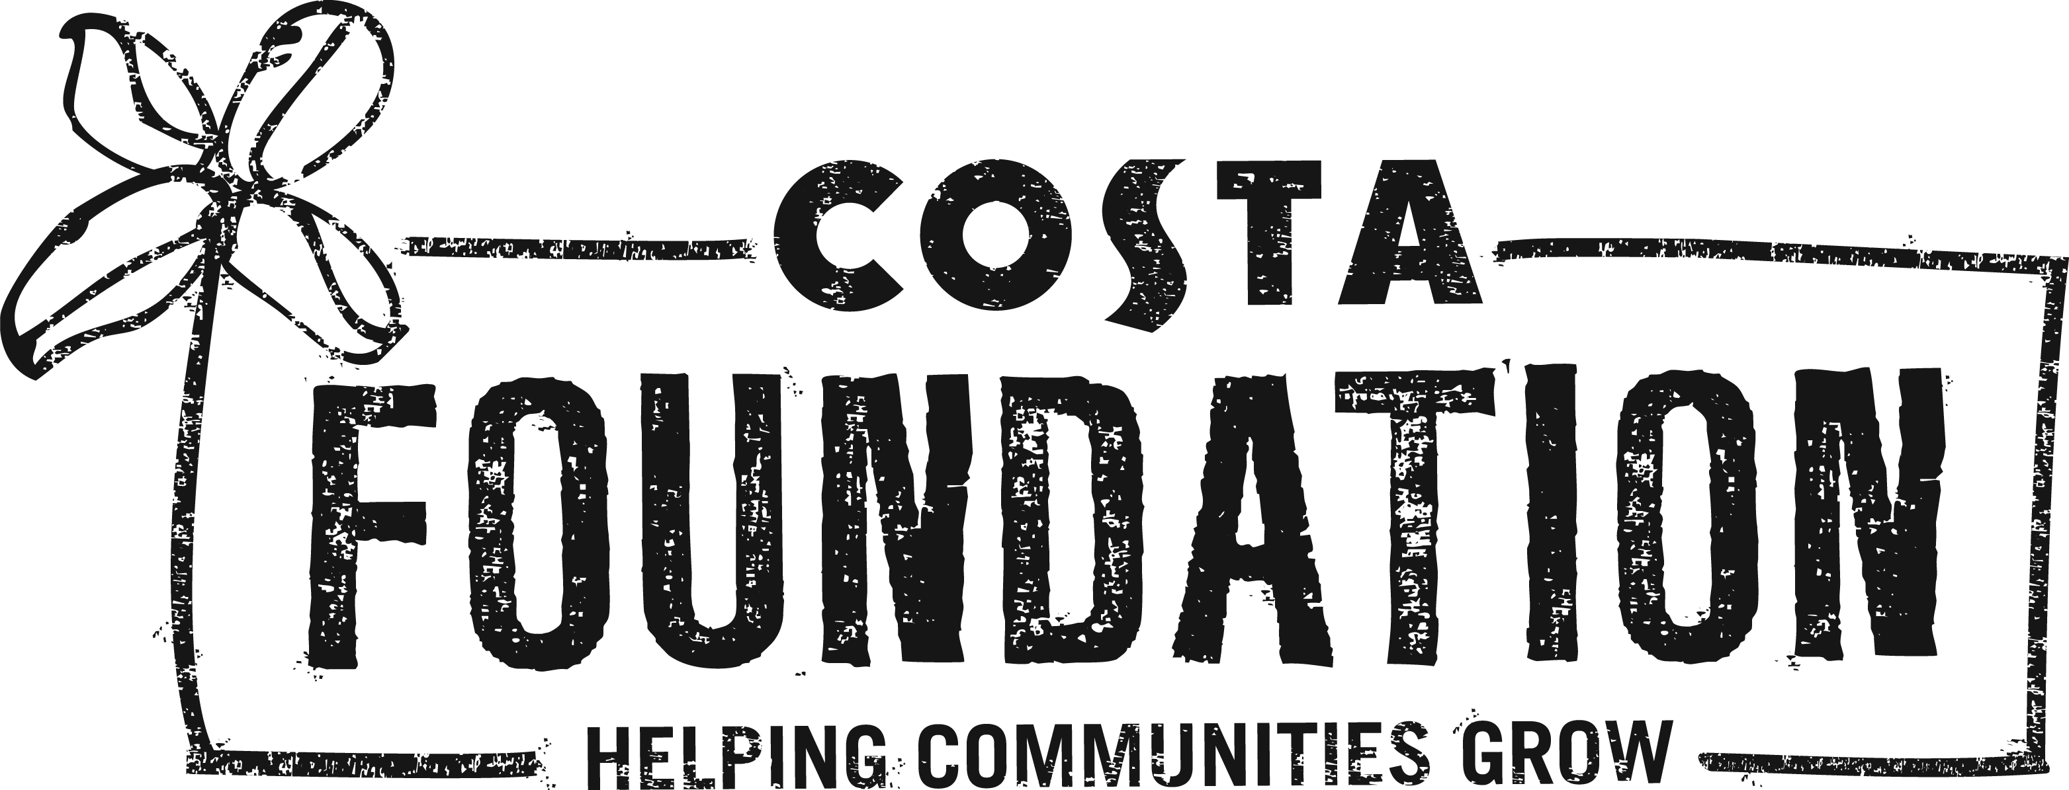    100% of the coffee Costa uses comes from sustainably grown beans sourced from Rainforest Alliance Certified farms.  To achieve the Rainforest Alliance Certification, farms must ensure the people who grow the coffee, and the land they grow it on, are carefully supported and sustained. So whenever you drink Costa coffee, you’re also doing your bit for coffee growers and their communities.
a | Why do you think Costa likes to help the coffee growers and their families? 1
b | How do coffee farms achieve Rainforest Alliance certification? 2

(13)

