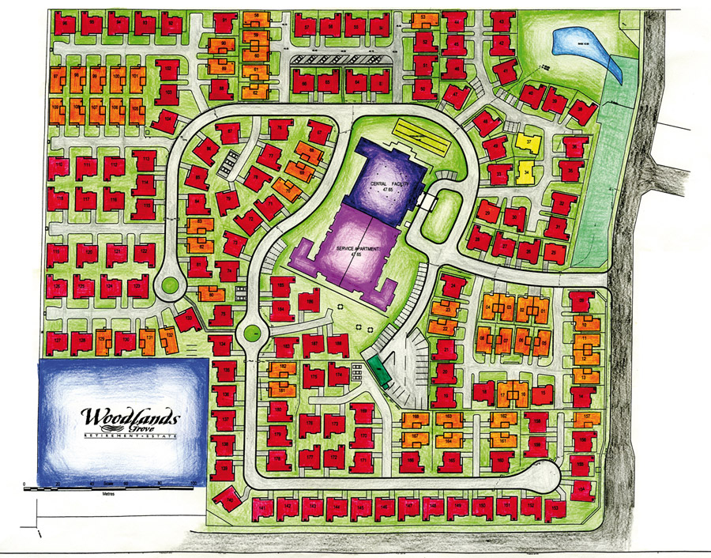

**Spiritual**

**Centre**

Bowling Green

Leisure

&

Retail

Running Track