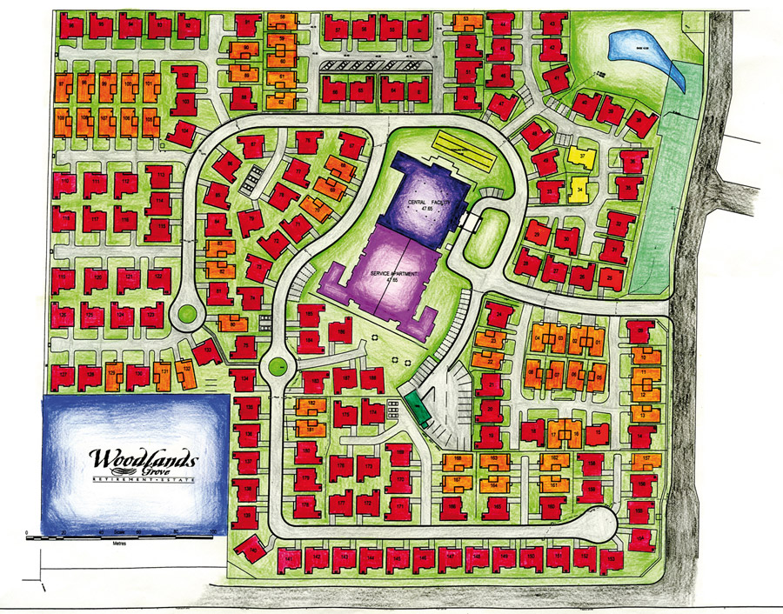

**1Nightingale**

**1Teresa**

**3.Fry**

**4.Beveridge**

**5.Freud**

**6.Piaget**

**7.Doolittle**

Cariton – The Virtual Village Plan

1.aleNighting

2.Teresa

3.Fry

4.Beveridge

6.Piaget

7.X