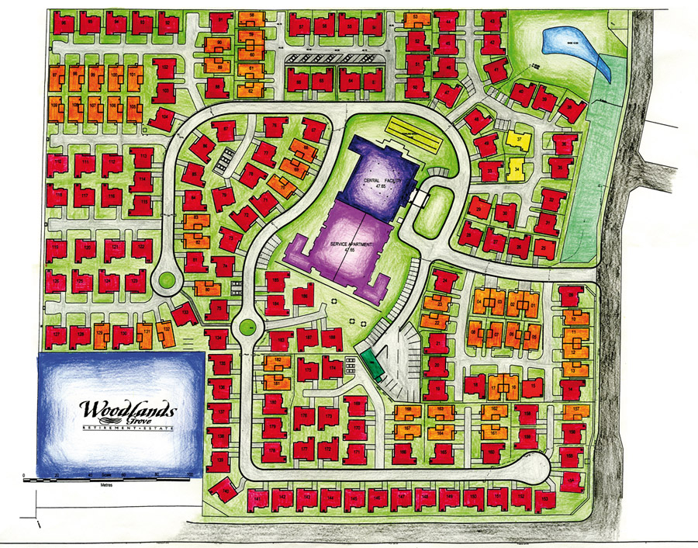

Boating lake

9 hole golf course

Cricketpitch

Footballpitch