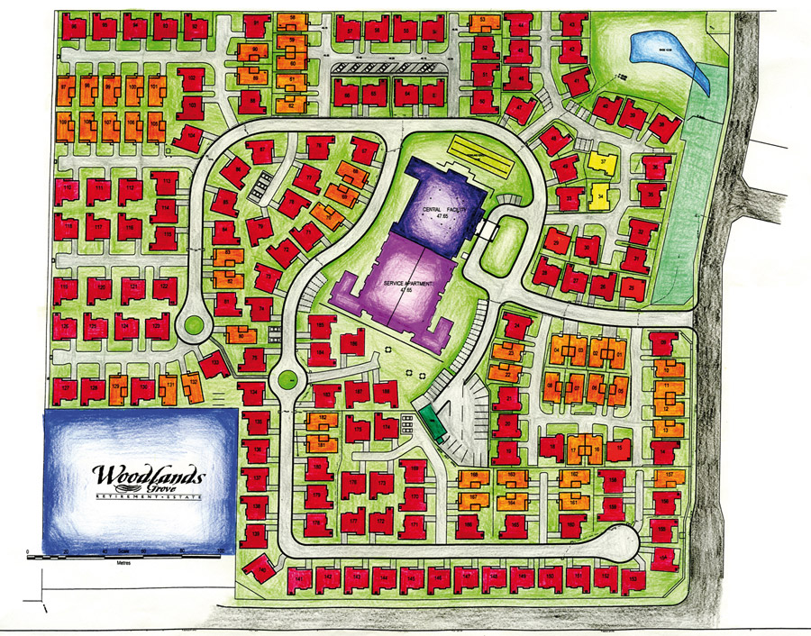

**Leisure & Retail Complex**

**Spiritual**

**centre**

**Community School**

**Cariton Sheltered Care**

**Health Centre**

**Cariton**

**Arms**