****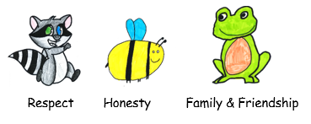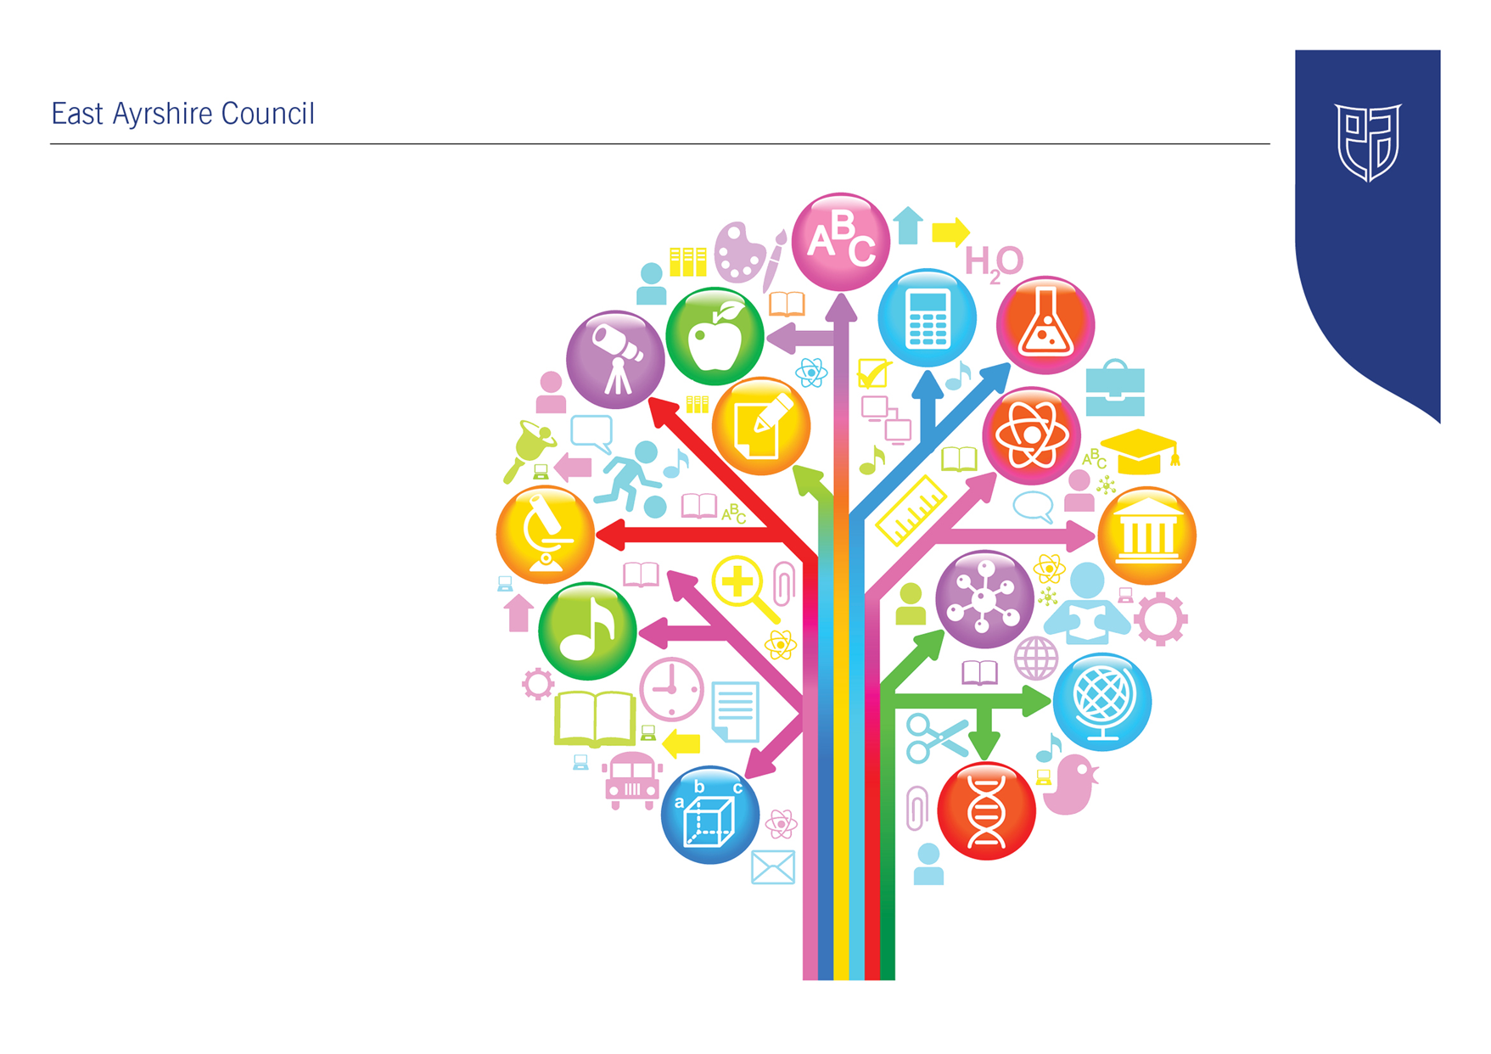

Standards and Quality Report

2022-23

Sorn Primary School

|  |
| --- |
| **Establishment Context** |
| Sorn Primary School is a small school within the village of Sorn, near Mauchline. The school has a large rural catchment area, with the roll capped at 59. At present the school roll is 29 pupils, with 2 classes P1-3, P4-7 with a split in the morning for Literacy and Numeracy of P1/2, P3/4, P5/6/7.  The school experienced significant transition with seven Head Teachers over the last seven years. A new substantive Head Teacher was established from August 2021 allowing the school to benefit from more stable and consistent leadership over the last two years. The positive impact of this has been identified through self-evaluation by staff, parents and pupils.  A detailed Quality Assurance Calendar, which is also cross referenced with the Quality Indicators, has been created and used during session 2023/24. This has ensured a robust timetable of quality assurance and a clear method by which activity can be monitored and evaluated.  During May 2023 the school was visited by HMIE for a thematic inspection based on Curriculum Design. It was An extremely productive and positive experience. The lead inspector highlighted in her feedback that the curriculum changes and planning, the evaluation procedures and the development planning are strong and well structured. The advice was to ‘continue doing exactly what you are doing’.  There was also a discussion with the lead inspector concerning the development of a three or five year plan which the Head Teacher was keen to implement in addition to the annual school improvement plan. This would be based on overarching, cyclical improvements in planning, learning, teaching and assessment in a format presented to the lead inspector. The documentation presented for this was looked upon very favourably by HMIE and will be established from the session 2023/34.  **Improvement Priorities for Session 22-23:**   * Literacy - Writing * Numeracy - Attainment * Health and Wellbeing * Digital Skills & Development of the Young Workforce |

|  |
| --- |
| **Establishment Vision, Values and Aims** |
| During the session 2021/2022 the school vision, values and aims were created through collaboration of the whole school community. We made a conscious decision to make our aims based on what you would see if you walked into our school. This has made them more tangible and more easily evaluated.  **Vision**  We are **cared for, grateful, positive** and **healthy** and we can **become anything we put our minds to**.  We dare to be **AMAZING**!  **Values**  Respect Honesty Family & Friendship    **Aims**  **When you walk into Sorn Primary School you will see …**   * **smiles and hear laughter – happiness is our number one priority!** * our pupils enjoying **creative, exciting and engaging learning** experiences which are based on delivering a **broad, balanced and relevant** curriculum. * we are **not afraid of failing** or getting things wrong, we know that these are signs that we are learning. **We love a challenge!** * we **respect** each other’s **beliefs and opinions**. We know that we can **agree to disagree** about things but we always **value other people’s thoughts and feelings** and we remain **open to new ideas**. **We respect everyone equally!** |

**Links to self-evaluation documentation:**

[**Parent Carer HGIOUS Evaluations June 2023**](https://sway.office.com/MoMUGVuNRA45lEOB?ref=Link)

[**Pupil School Evaluation Session 2022/23**](https://sway.office.com/ValsxZOyn7TBStdV?ref=Link)

[**Staff School Evaluation Session 2022/23**](https://sway.office.com/0Q97Z9t1KHhQPQDc?ref=Link)

|  |  |  |  |  |  |
| --- | --- | --- | --- | --- | --- |
| **Improvement Priority**  *(Expressed as outcomes for learners)* | | By May 2023 there will be improved attainment in writing of children in Primary 1-7, resulting in most (75-90%) of children being ‘on track’ in relation to their national expectation. | | **Rationale for improvement priority based on evidence**   * **Quantitative Data**   Results from tracking and monitoring and from SNSAs 21-22 show a deficit in writing in comparison to the other areas of literacy.   * **People’s Views**   Both staff and pupil questionnaires identify writing as an area for development. Parents have asked specifically for online tutorials or workshops to help support their children’s learning.   * **Direct Observation**   Teaching staff and HT have observed significant gaps in understanding in writing. | |
| **NIF Priorities**  Improvement in attainment, particularly in literacy and numeracy | | | **NIF Driver**   * Teacher professionalism * Parent/carer involvement and engagement * Curriculum and assessment * Performance information | | **HGIOS/ HGIOSELCC QI’s for self-evaluation**  2.2, 2.3, 2.5, 3.2 |
|  | | | | | |
| **Progress and Impact** | * Data shows 62% of pupils on track or exceeding national expectation, this is lower than the target set. The amendment of the SIP improvement outcome to include percentages was discussed recently with education managers and Education Scotland representatives as well as teaching staff. It was agreed that percentages were not necessarily an effective way to track progress in a school of only 29 pupils e.g. in a stage of three pupils, one pupil not achieving accounts for 30% of the results and it may not be clear that this pupil may be on the additional support needs register with significant learning difficulties. Going ahead to next year’s school improvement plan we will work together to devise a way in which attainment can be more accurately represented to account for this. * Planning for Literacy has been the focus of regular collegiate hours through staff meetings and in-service. During this time an evaluation of current planning and its impact on the children’s attainment has been evaluated. Changes have been made to reflect these evaluations including a whole school, collaborative session on the learning targets relating to different genres of reading and writing. * Clear and progressive learning intentions and success criteria have been complied in an explicit form to ensure continuity and progression throughout the school in writing. * Staff have visited a wide variety of schools and observed the teaching of Literacy and the associated planning. Observations were then shared with all staff and alterations made to our planning, learning and teaching were developed with robust evaluation and monitoring points. * Use of new ‘Planning, Learning and Moderation’ frameworks, incorporating IDL and an identification and embedding of transferable skills all contributed to the enhanced teaching of Literacy. * Workshops held to develop parental knowledge and understanding of the writing experiences and outcomes were only attended by one parent. The development of on-line tutorials was not achieved and will be a significant part of next year’s School Improvement Plan. * Intervention meetings allowed the identification and subsequent support planning to ensure adequate provision for children through clear target setting and timetabling of PSA and EAST provision. * Robust Tracking and Monitoring Meetings have allowed staff to analyse data using a triangulation of evidence and make appropriate amendments to planning, learning and teaching. * At the end of session both Primary 1 and Primary 7 were on track or exceeding with 100% achievement of early and second level respectively in writing. All of the P4 pupils were on track or exceeding with the exception of one pupil who has been following their own learning pathway due to additional support needs. * SNSA data shows an increased percentage of pupils achieving top Bands over P1, 4 and 7. | | | | |
| **Next Steps** | * Development of parental involvement through online tutorials and open days * Continued development of use of tracking and monitoring system to aid planning and intervention processes. * Consideration of School Improvement Plan target / priority setting to better reflect the attainment and impact of improvement priorities. * Continuation of regular and robust evaluation of planning for writing in relation to impact on attainment. Subsequent developments and changes to reflect these findings. * Training from Talk for Writing planned for 18th of August In-service. | | | | |

|  |  |  |  |
| --- | --- | --- | --- |
| **Improvement Priority**  *(Expressed as outcomes for learners)* | * To become a Mentally Healthy School which ensures high quality mental health promotion and supports the mental, social and emotional health of children, families and staff. By May 2023 between 75-90% of children will be on track in relation to their national expectation.   *(This priority relates to* ***Articles 1, 6 and 24*** *of the United Nations Convention on the Rights of the Child (UNCRC):-*  *Article 1:- Everyone under the age of 18 has all the rights in the Convention.*  *Article 6:- Every child has the right to life. Governments must do all they can to make sure that children survive and develop to their full potential.*  *Article 24:- You have a right to the best health possible, to medical care and to information that will help you to stay well.)* | | **Rationale for improvement priority based on evidence**   * **Quantitative Data**   Results from tracking and monitoring show ‘on track’ for every child. This is a concern and as a staff team we felt this might actually indicate that we are not able to provide accurate data due to our lack of assessment methods.   * **People’s Views**   Both staff and pupil questionnaires identify Health & Wellbeing as an area for specific attention.   * **Direct Observation**   The mental health and wellbeing of our children, families and staff continues to be of paramount importance and we recognise the value of ensuring high quality mental health promotion across all levels. |
| **NIF Priorities**  Improvement in children and young people’s health and wellbeing | | **NIF Driver**  School improvement | **HGIOS/ HGIOSELCC QI’s for self-evaluation**  1.1, 2.1, 2.2, 2.3, 2.4, 2.5, 2.7, 3.1, 3.2 |
|  | | | |
| **Progress and Impact** | * Data shows 82% of children are on track or exceeding in terms of national expectations. * Through the new planning format, Health and Wellbeing has been addressed through discreet lessons, assemblies and interdisciplinary learning. This has positively impacted the coverage, breadth, depth and challenge associated with the learning and teaching. The embedding of the UNCRC Articles in assembly planning and the use of the Right of the Fortnight has provided the children with a more cohesive learning experience where the links between the H&WB experiences and outcomes and children’s rights have been strengthened. * The introduction of daily morning meditation, yoga or mindfulness across the school has promoted the importance of mental, social and emotional health and has allowed the children to consider strategies to use to help them relax and self –regulate. There has been a noticeable calmness across the school in the morning and the children are more focused and peaceful as they enter into their lessons. * Although we were unable to use the Columba 1400 programme or the PlayMakers programme the children’s leadership skills were developed and strengthened through the Active Schools Leadership programme and the introduction of P6/7 run lunchtime clubs. These were very successful and the feedback from the children was that they would like to continue these activities next year. * Links with outside agencies e.g. CAMHS, The Exchange, Social Work and the school nursing team have strengthened and the positive impact on the support given to children has been evident through the development of TAC meetings and use of Ayrshare to ensure a joined up approach for children and their families. * The use of discreet lessons to address Cyber Resilience and Internet Safety skills has ensured that the pupils have a sound knowledge and understanding of these areas and the introduction of the Safer Scotland school App has improved parental engagement with matters pertaining to digital safety. * A staff in-service was dedicated to CLPL for staff regarding mental wellbeing for themselves, their pupils and our families. This was very well received and the teaching staff could be seen to take the practices discussed and demonstrated into the classroom effectively. * An investigation into the different methods by which to support teacher judgements in H&WB took the form of professional reading and dialogue with other schools in the authority. Two particular programmes were recommended and we would like to introduce them next year – Glasgow Motivation and Wellbeing Profile and the Communication Friendly Award. * PEF Funds were redirected to continue to employ our classroom assistant although schools funds were still able to be used to provide more outdoor resources and musical instruments. | | |
| **Next Steps** | * Application and awarding of the Rights Respecting School Silver Award. * Introduction of both the Glasgow Motivation and Wellbeing Profile and Communication Friendly Award. * Improved sensory provision in classrooms and in the outdoor area. | | |

|  |  |  |  |
| --- | --- | --- | --- |
| **Improvement Priority**  *(Expressed as outcomes for learners)* | | * By May 2023 all children will have undertaken a comprehensive course which combines World of Work, Developing the Young Workforce and NIH resources. * All pupils will be taught explicit digital technology lessons alongside cross curricular learning and this will be evident in the forward planning and evaluation documents. | **Rationale for improvement priority based on evidence**   * **Quantitative Data**   Self-evaluation of SIP 21-22 showed little to no action on the priority.   * **People’s Views**   Parents, staff and pupils have all identified that knowledge and understanding of the ‘World of Work’ needs more coverage in school.   * **Direct Observation**   Planning and delivery of technology, enterprise and employability are currently not of an adequate standard. |
| **NIF Priorities**  Improvement in employability skills and sustained, positive school leaver destinations | | **NIF Driver**   * *School improvement* | **HGIOS/ HGIOSELCC QI’s for self-evaluation**  1.2, 2.3, 2.6, 3.3 |
|  | | | |
| **Progress and Impact** | * The curriculum and timetabling were altered to ensure coverage, depth, pace and challenge for technologies, DYW and employability skills. This included: * Weekly digital literacy lessons for the whole school which focused on digital skills. There has been a marked improvement in pupils understanding and knowledge, digital skills and use of digital technologies to support their learning in other curricular areas. * Technologies fortnight allowed staff to address areas of the technologies curriculum which had previously seen very limited coverage. This also included an open afternoon where parents were able to join the learning. * The planning, learning and teaching of Enterprise being led by our probationary teacher was excellent and the explicit teaching of associated skills leading to the creation of ‘businesses’ and the sale of products ensured coverage, and challenge for all pupils. * The development of ‘Sorn Primary School Transferable Skills’ document has provided staff, pupils and parents with a clear, concise definition of what transferable skills are and how the development of these skills impacts learning across the curriculum and employability. * ‘World of Work Week’ was a huge success with over 22 visitors joining us to discuss their jobs and careers. * In staff, pupil and parent evaluations World of Work Week was highlighted as a particular success. The pupils studied the transferrable skills framework, completed individual profiles of their learning which were sent home each evening to allow parents to discuss the learning which had taken place, used the ‘My World of Work’ website and allowed our partnerships with the local community, wider corking community and parents to become even richer. ‘World of work’ and employability skills. * Although the capacity of staff to move towards the Digital Schools Award was increased through CLPL and professional reading we did not manage to apply for the award this year. * The funds for our PEF spend on Nessie Licenses for improved digital literacy had to be redirected in order to maintain the employment of our classroom assistant, we used school funds to obtain the licenses. Staff and pupils evaluated the impact of Nessy and felt it did not have the desired effect of improving attainment so will be discontinued next year. | | |
| **Next Steps** | * Continue to develop and embed the use of digital technologies within the classroom. * Continue to embed the ‘Sorn School Transferable Skills’ framework throughout the planning, learning, teaching and assessment. * Continue the journey towards Digital Schools accreditation * Reassess the planning of Technologies Fortnight and Enterprise to allow for greater depth by creating a three year cycle of Experience and Outcome coverage. | | |

|  |  |  |  |
| --- | --- | --- | --- |
| **Improvement Priority**  *(Expressed as outcomes for learners)* | By May 2023 there will be improved attainment in numeracy for children in P1-7 which will result in an increased percentage (60-85%) of children being on track in relation to their national expectation. | **Rationale for improvement priority based on evidence**   * **Quantitative Data**   Results from tracking and monitoring and from SNSAs 21-22 show a significant drop in levels between P3 and P5   * **People’s Views**   Staff identified the difficulty in completing the numeracy planners and therefore the gaps in learning which can be seen in the middle years.   * **Direct Observation**   Teaching staff and HT have observed gaps in learning, progression, coverage and depth throughout the numeracy curriculum. | |
| **NIF Priorities**  Improvement in attainment, particularly in literacy and numeracy | **NIF Driver**   * Parent/carer involvement and engagement * Curriculum and assessment   Performance information | | **HGIOS/ HGIOSELCC QI’s for self-evaluation**  2.2, 2.3, 2.5, 3.2 |
|  | | | |
| **Progress and Impact** | * Data shows 62% of pupils on track or exceeding national expectation. * Planning was supported by a clear timeline of blocks of teaching to help support teaching staff with coverage whilst ensuring progression, depth, pace and challenge. This has had different impacts in different classrooms. The P1-2 class have been able to follow the timetable successfully and felt the new blocks of learning worked effectively for them. The P3-4 class were fortunate enough to have an outstanding probationer but due to their day out, numeracy topics had to be moved so that the class were taught discreet topics at this time so the timing of the blocks of learning was more difficult to follow. The P5-7 class found it extremely difficult to follow the blocks of learning. The increased amount of outcomes in second level and the dependency on some of the topics requiring previous or other knowledge to build upon made following the timings challenging. * No parents took the opportunity to attend the Numeracy workshop provided by the school. It became evident that workshops during the day did not suit working parents and when the sessions were organised to coincide with Parent Consultation evening timing was an issue. It was not possible to create the online tutorials we had hoped and this will be considered for next year’s improvement plan. * Use of new ‘Planning, Learning and Moderation’ frameworks, incorporating IDL and an identification and embedding of transferable skills all contributed to the enhanced teaching of Numeracy. * At the end of session all pupils in P1 and 7 were on track with 100% achievement of Early and Second level respectively in numeracy. Three out of five of the P4 pupils achieved First level, one of the two pupils who didn’t has been following their own learning pathway due to additional support needs. * Robust Tracking and Monitoring Meetings have allowed staff to analyse data using a triangulation of evidence and make appropriate amendments to planning, learning and teaching. * The amendment of the SIP improvement outcome to include percentages was discussed with education managers and Education Scotland representatives as well as teaching staff. It was agreed that percentages were not necessarily an effective way to track progress in a school of only 29 pupils e.g. in a stage of three pupils, one pupil not achieving accounts for 33% of the results and it may not be clear that this pupil may be on the additional support needs register with significant learning difficulties. Going ahead to next year’s school improvement plan we will work together to devise a way in which attainment can be more accurately represented. | | |
| **Next Steps** | * Continual monitoring of impact of planning formats and systems including the creation of a cyclical planner for some topic areas to allow them to be taught just twice through a level to provide more depth of learning. * Development of parental involvement through numeracy and mathematics based open afternoons and online tutorials. * Continued development of use of tracking and monitoring system to aid planning and intervention processes. | | |

|  |  |  |
| --- | --- | --- |
| **Pupil Equity Fund: Evaluation** | | |
| *Approach/Intervention* | *Impact*  *Report on how you have improved outcomes for learners impacted by poverty* | What evidence do you have of positive impact?  Outline the data that supports your findings. |
| Outdoor equipment and Musical instruments to improve Health and Wellbeing | Unfortunately, due to circumstances beyond the schools control, the PEF funding had to be redistributed (see below). However the musical instruments and outdoor equipment were still purchased through the school fund. | The creation of a music club, increased pupil leadership in outdoor activities at break times and the children’s feedback regarding the new equipment have shown a positive impact on the children’s mental health. This, in turn, has enables all children and particularly those impacted by poverty positively. |
|  |  |  |
| Classroom Assistant | Our classroom assistant has worked with individuals and small groups, identified by the teaching staff, throughout the year on a wide variety of academic needs. | There has been an increase in overall attainment but also significant gains for those on individual pathways for learning. ACEL data shows a 100% achievement of levels at P1, 4 and 7 other than P4 in Numeracy which was 75% (which equates to 1 of the 4 pupils who is determined to achieve First level in the first term of next session)., |

|  |  |
| --- | --- |
| **Establishment Self Evaluation: How Good is Our School? 4 Quality Indicators** | |
| Quality Indicator 1.3 Leadership of Change | **5** |
| Quality Indicator 2.3 Learning, Teaching and Assessment | ***5*** |
| Quality Indicator 3.1 Ensuring Wellbeing, Equality and Inclusion | ***4*** |
| Quality Indicator 3.2 Raising Attainment and Achievement | ***4*** |

|  |
| --- |
| **Establishment Capacity for Improvement** |
| **Data Analysis**  ACEL Data for Session 2022/23 shows that all P1, P4 and P7 achieved the national expected level in all areas other than P4 Numeracy which was at 75% This represents one pupil who is determined to achieve First level in the early part of Term 1 next session.  SNSA data shows 75% of pupils at Band 6+ in Literacy (3 out of 4 pupils – the fourth pupil achieving Band 5 and is EAL) and 100% Band 6+ for Numeracy.  From P4 identified pupils two pupils achieved Bands 9+ and 8 and two achieved Band 7 in Numeracy which correlates with the ACEL data. In both P4 Reading one pupil achieved a Band 9+, two pupils a Band 8 and one a Band 7. In writing two pupils achieved a Band 9+, one pupil a Band 8 and one pupil a Band 7.  P7 Numeracy one pupil achieved a Band 11+ and the other three achieved Band 8, in Reading one pupil achieved a Band 11+ and the other pupils achieved a Band 9, Writing two pupils achieved a band 11+, one a 10 and one a Band 8.  Teaching staff are now much more confident in terms of analysing data and making adjustments to children’s learning journeys as a result.  We have decided that we would like to reintroduce GL Assessments next session to add to our assessment profile.  **Self-Evaluation**  The Quality Assurance Calendar details the different Quality Indicators to be assessed each term. Through the use of Microsoft Forms questionnaires for staff and parents and a written version of HGIOURS to record pupil self-evaluations, evidence is collected which can then be used to inform development plans.  Responses to the parental questionnaires are shared through the Head Teacher Weekly Update three weeks after being posted out. Responses are given to any questions which have either a ‘Disagree’ ‘Strongly Disagree’ or ‘Don’t Know’ response. Next year there will be an introduction of a termly report to detail the direct impact each self- evaluation has on the development plan.  During 2022/23 it has been difficult to get through all five themes in the pupils HGIOURS and we will be looking to work these over a two year cycle from next session to ensure the responses are considered with more depth.  Staff and pupils both completed the ‘Learning across the four contexts in Sorn Primary School’ document which allowed us to consider the evidence for each of the key quality indicators more deeply.  **Improvement Planning**  Next session we will be moving to using a three year or possibly five year plan to support our SIP and Quality Assurance Calendar. As a staff we identified that we require a longer term plan which is based on the continual improvement of planning, learning, teaching and assessment across all sectors and subjects.  Following our thematic visit from HMIE we were signposted to examples of good practice from two other contacts in Scotland, Kirkbean PS Dumfries and Galloway and John McDonald who was previous Head Teacher at Gartocharn in West Dunbartonshire Council. Both have been contacted and visits have been planned for the start of next session.  The Head Teacher has also requested to take part in the authority based Learning Visits and contacted the EAC Education Scotland support, Chris Flanagan, to ask for a visit early in the session to discuss the different processes and procedures in place for improvement planning and quality assurance from a more national view point.  Class teachers were given the opportunity this year to visit a number of other schools in EAC to observe certain areas of the curriculum. This was extremely successful in terms of up levelling teacher’s knowledge and understanding and we are looking towards making this a more embedded practice through the next school session. We will also be continuing our study of ‘The Teaching Delusion’ to allow us to qualify and quantify the observations we are making and then assess what impact these findings could have for our school.  **Quality Assurance Calendar**  The introduction of a much more robust and detailed Quality Assurance Calendar has supported staff with clear objectives and developmental paths as well as well-planned and timed evaluative processes throughout the year.  The calendar is being evaluated by all staff and alterations will be considered for next session. |