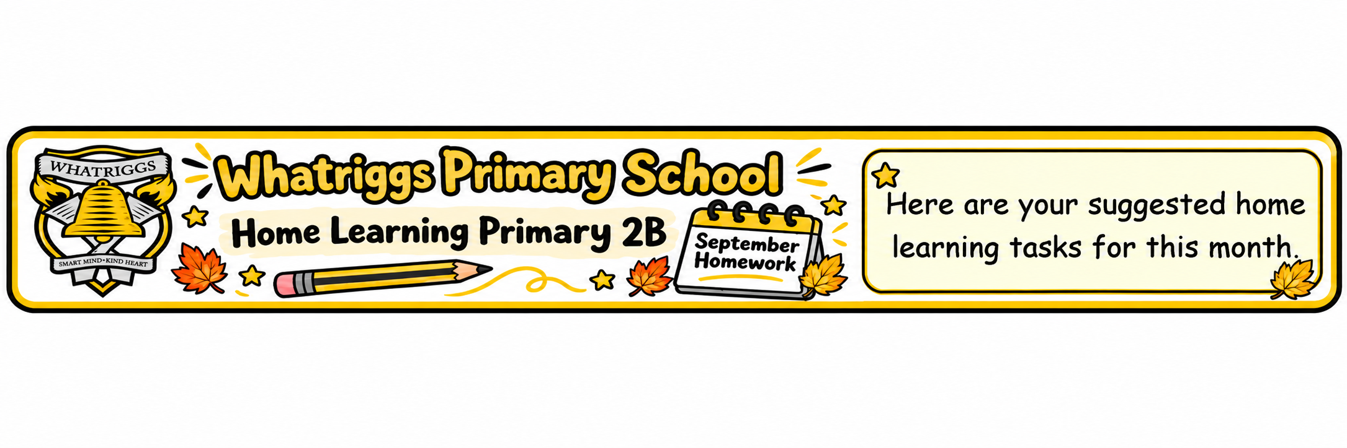
Numeracy  Place Value Number Detectives.  Find numbers up to 100 in your home or outdoors. Try to write the number in different ways –  - As numerals  - In words  - Make the number using objects, such as pasta or beads.  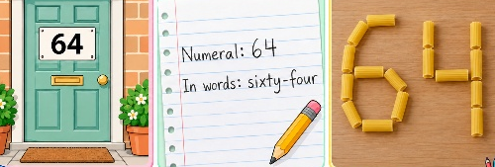 | Numeracy  2D Shape Hunt  Find 2D shapes around your home. Identify the name of the shape and how many sides and corners it has.     | Literacy  Reading    Read the book you have been allocated.  We have been reading Elmer in class. Try to retell the story to your family. You can listen to the story again online.  https://youtu.be/DmD02WayhbA?si=s237p6AYX15TrM1r | Literacy  Spelling / Handwriting  Continue to work on writing you name accurately. Practise your letter formation using the sheet provided.  Complete the ‘sh’ homework sheet in homework folder.  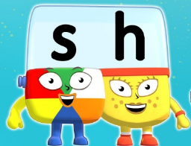
Interdisciplinary Learning  Transport  We are learning about the different ways to travel. Choose a form of transport and make a poster to show your understanding.  Label the different parts.  Make it bright and colourful.  Here is an example. | 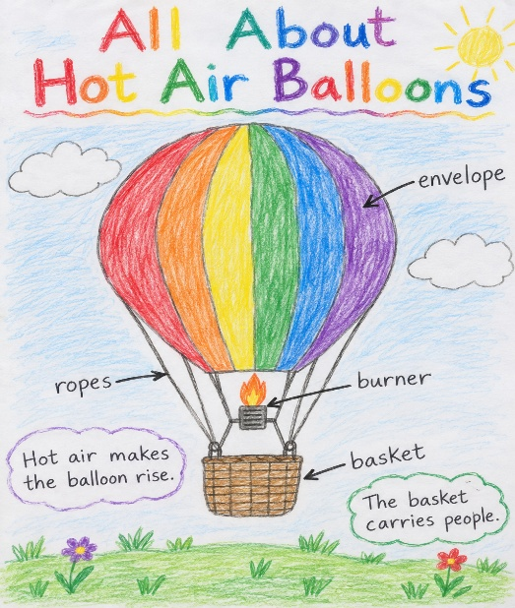 | HWB/ PE  Ball Skills    Practise throwing and catching a ball.  Kindness  One of our school values is kindness. Do something kind for someone at home eg. tidy up, make a thank you card, give a hug. | Science  Water    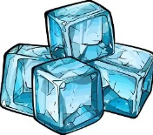  We are exploring water. Have a go at making jelly or ice cubes at home to discover how water can change from a liquid to a solid.

