**Educate, empower & protect the entire school community.**

Downloading your App:   
  
Step 1:**If you are using an IOS device, go to the Apple App Store and search ‘**Safer Schools Scotland**’. If you are using an Android device, go to the Google Play store and search ‘**Safer Schools Scotland**’.  
  
**Step 2:**Select ‘Download’.

**Logging In:**

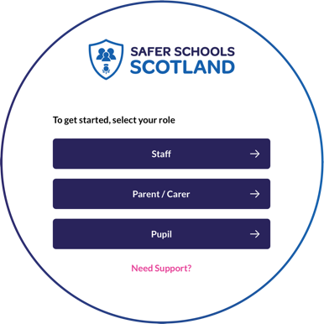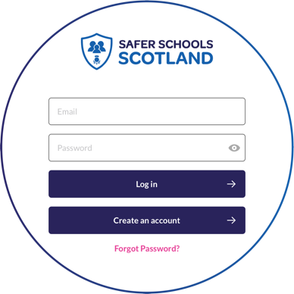

Please follow the below instructions.

**Creating An Account:**

**Step 1**  
If you haven’t already, please create an account by selecting **your role** on the login screen of your App.

**Step 2**:   
To create and account, click ‘**Create an account**’ and   
input your full name, email, and password you wish to use.   
You’ll also be asked to confirm your password. Once you’re   
ready, click ‘**Register**’ and this will create your account.

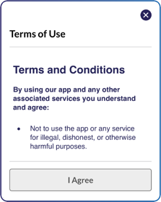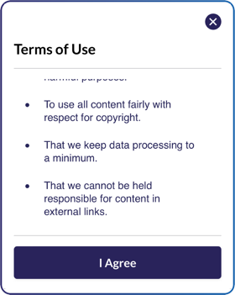

**Step 3**:   
After you register, you will be asked to read and agree to the   
Terms and Conditions. After reading and scrolling to the bottom,   
the ‘**I agree’** button will be available to select.   
  
**Step 4**:   
Time to select your school! To add your school,   
simply type your school name in the search bar and click ‘**Continue**’.

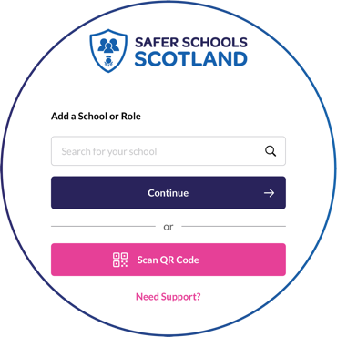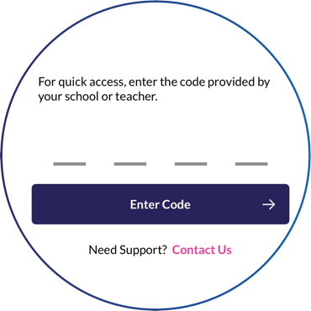

You will then be asked to input your entry code that you have received from your school that is relevant to your role. Type in your code and click ‘**Submit**’. You’ll be asked to confirm this by clicking ‘**Continue’**.   
  
Alternatively, if you have been given a QR entry code by your school, when adding your school simply select ‘**Scan QR Code**’ and scan your code.

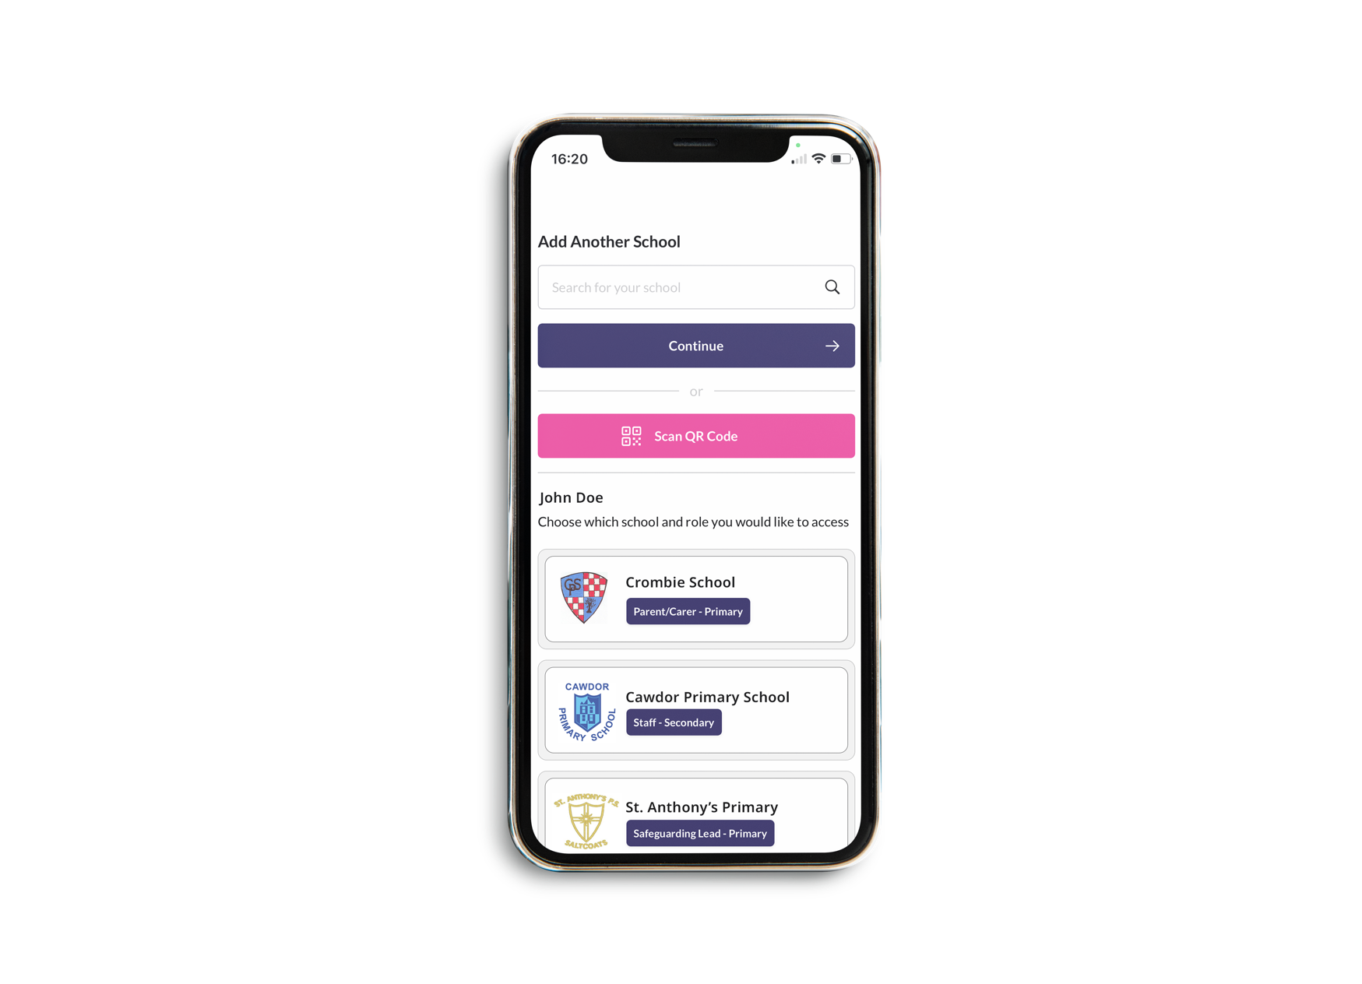

**Top Tip**: Did you know that your App features Multi-School Login? This means that you are a Staff member in one school with a child in another, or if you are a Parent/Carer of children in different schools, you have access to multiple schools without having to log in and out of the app.

**Step 5**: To add another school or role, on your Safer Schools app account, click your profile icon on the top right corner, navigate to ‘**Account Information’** and select **‘Add Another School or Role’** then simply repeat Step 4.

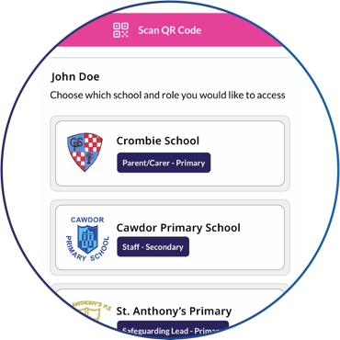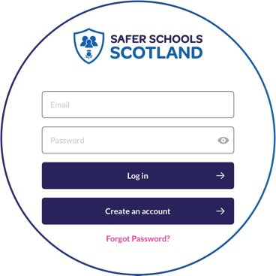

**Logging into your App:**

**Step 1**: When you have opened the App, you should input your email address and password that you used to create your account. Once you’re ready, click ‘**Log In**’.

**Step 2**: When you log in, you will see your chosen school(s) that you have added to your account. Simply click the school that would like to view!