Whatriggs ECC

Induction Pack
2025-2026
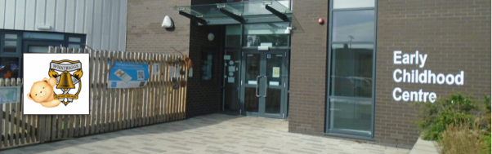

Contents

Arriving at the ECC…………………………...
Keyworkers…………………………………………..
Communication……………………………………..
Snacks and Meals………………………………..
Curriculum for Excellence…………………
Pre-birth to Three……………………………..
A day in the life……………………………………
Personal Care…………………………………………
Outdoor Learning………………………………….
Other Professionals…………………………….
Transition from 2-3 to 3-5…………………
Transition to Primary 1………………………..
Absences and Illnesses………………………..
Medication……………………………………………….
Contact Information…….……………………….
Arriving at the ECC
When you arrive at the ECC your entry door will depend on what playroom your child is in. Please see below for further information on the entry/exit doors.
Before coming along for your child’s first session at the ECC can we please ask you to ensure you have completed and returned all relevant paperwork sent to you, as this may affect them being able to start on their assigned day. There is a checklist for this on the blog under “New Start Information”.

The Willow Room (Playroom 1)
2-3 year olds
The children will enter through the garden gate. Please wait for the gate to be opened by a staff member only from 8.55-9.05am, where you will then walk round the garden area to the Willow door. You will be greeted by a staff member at the door.
When collecting your child the garden gate will be opened at 2.45-3pm for you to collect your child.

*If your child attends 9-11.30am please drop off via the main gate and collect your child via pressing playroom 1 on the buzzer at the front door.
If your child attends 12.30-3pm drop off will be via the main entrance/front door where a member of staff will come to greet you and collect your child. Collection will remain via the side gate/garden*

If you wish to collect early, or are running late at drop off, please phone ahead and then press the “Playroom 1” or “Office” buzzer.

The Oak Room (Playroom 4)
3-5 year olds

The children will enter through the garden gate. Please wait for the gate to be opened by a staff member only from 8.55-9.05am, where you will then walk across to the Oak door. You will be greeted by a staff member at the door.

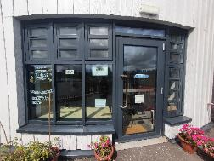
Oak playroom door

Pick up will be from the Oak Playroom door. Please do not open the gate, a staff member will open the gate from 2.45pm-3pm

- If you wish to collect your child early, or are running late at drop off, please phone ahead and then press the “Playroom 4” or “Office” buzzer.

Birch Area (Playroom 3)
3-5 year olds
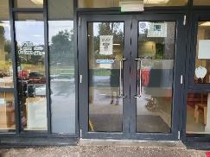

The children will enter through the garden gate. Please wait for the gate to be opened by a staff member only from 8.55-9.05am, where you will then walk round to the Birch door. You will be greeted by a staff member at the door.

Pick up will be from the Birch Playroom door. Please do not open the gate, a staff member will open the gate from 2.45pm-3pm

If you wish to collect early, or are running late at drop off, please phone ahead and then press the “Playroom 3” or “Office” buzzer.

Chestnut Area (Playroom 2)
3-5 Year Olds
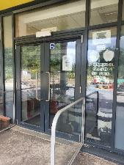

The children will enter through the garden gate. Please wait for the gate to be opened by a staff member only from 8.55-9.05am, where you will then walk round to the Chestnut door. You will be greeted by a staff member at the door.
Pick up will be from the Chestnut Playroom door. Please do not open the gate, a staff member will open the gate from 2.45pm-3pm

If you wish to collect early, or are running late at drop off, please phone ahead and then press the “Playroom 2” or “Office” buzzer.

Car park
To avoid any unnecessary congestion and traffic around the Whatriggs campus, we do ask that if you are able to walk into the centre that you do so. However, we do have a car park at the front of the building if you do require to use this.
The car park is also operating a no movement zone from 2.40-3.10pm each day to ensure the safety of all children and families using the campus, this was implemented by Police Scotland and Roads Alliance. Therefore, no access will be granted in to or out of the car park at this time. If you collect your child between these times, we ask you park out with the centre, or to be in the carpark by 2.40pm, where you will have to wait until 3.10pm to leave.
Can all car park users please be mindful of your speed as children and families are using the car park and be respectful of the very limited disabled spaces available and only use these if you have a valid blue badge to do so.
Please note, there is a one way movement system around the car park which should be adhered to at all times by following the road markings.

Pegs & Belongings
When coming along for their first session your child will be shown where their own peg will be for the ECC. We ask that you provide a change of clothes in case your child needs to be changed at any point. Also, any nappies/wipes where required.

As we are a large centre there may be other children who have the same items of clothing as you and so we must insist that ALL items brought into the ECC are labelled appropriately with your child’s full name, as we cannot take any responsibility for any un-named items going missing or going home with the wrong child. Thank you for your understanding.

Staff Team
Management team
Elaine – Head of Centre

Michelle – Depute Manager

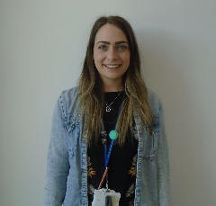
Sheree – Senior Early Learning and Childcare Practitioner

Katie – Senior Early Learning and Childcare Practitioner (part time) – currently on maternity leave. / Cheryl McCabe part time maternity leave cover
(Katie)  (Cheryl)
Amy – Senior Early Learning and Childcare Practitioner (part time)


Marion – Equity and Excellence Lead

Early Learning and Childcare Practitioners (Keyworkers)
Within the ECC we have many different members of staff who you may meet. Each child has their own keyworker and group however all staff within their room will be involved with their care and education. Your child’s keyworker will be the member of staff responsible for carrying out meetings, writing reports, updating learning journals and completing care plans and targets for their key children.
Take a look below to meet all of our fantastic keyworkers!
Birch Area
Isobel – Brown Deer

Sarah – Red Foxes

Catherine – Green Frogs

Michelle/Claire (part time/job share) – Red Squirrels

Chestnut Area
Beth – Orange Tigers
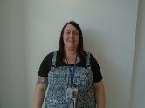
Cheryl (part time) – Yellow Giraffes
Linda - Orange Orangutans

Lee-Anne – Yellow Lions

Laura – Grey Elephants

Oak Room



Heather – Brown Dogs Margaret/Kirsty (part time/job share) – Orange Cats

Willow Room

Lorna – Robins

Mhairi - Penguins

Tracie – Flamingos

Dayna (part time) – Puffins


Early Learning and Childcare Support Assistants
Dionne (9.30am-1.30pm)

Claire (10.00am – 2.00pm)

Office Staff

Janet – Senior Clerical

Communication
At Whatriggs ECC, we use various forms of communication however the main forms which we will use to relay information on what is happening in the ECC is through Email, The Safer Schools App, Facebook/Twitter, letters/newsletter and the Glow Blog, so please ensure you check these frequently for any new information


Information on how to access the BLOG
- To access the Glow BLOG, type into your internet browser on either your smart phone, tablet or computer etc “Whatriggs ECC Blog”
- This will usually be the first search option to appear. Below is a photo of the ECC blog.
- Alternatively, you can scan the QR code and it will take you directly to our blog.

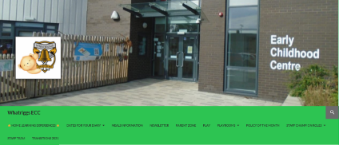

- We have many different tab sections within our Blog for you to view and explore. This includes sections such as: dates for your diary, notice board, parent zone etc.
- With your consent, we like to share photos and information on our Blog of the experiences and learning opportunities on offer within the different cohort playrooms.

Social Media
To access our social medias simply search for Whatriggs ECC, where you can follow us on Twitter or like our page on Facebook.

Information on how to download the Safer Schools APP
- Using your smartphone app store/play store, search for “Safer Schools Scotland” and download this app directly to your phone.
- Once downloaded, create an account by selecting your role (Parent/carer) and filling out the required details, once complete click register, read T&C’s and click I agree to finish.
- Then search Whatriggs ECC, select the ECC then continue. You will then be asked to input the entry code: (6430), submit and continue.
- You will then be asked to allow notifications from the App to your phone, we recommend allowing his to keep up to date with all info.

- We often send out reminders and messages through our app that will appear on your phone as a notification. You can view this in the “notification” section of the App, indicated by the Bell Icon.
- You can also click on the calendar section to see dates for your diary, and website to be directed to our Blog.
- We will be offering a training session for parents/carers on how to navigate the Safer Schools App.
- (If you need any support with the App please speak to a senior practitioner, Sheree, Cheryl or Amy at drop-off/pick-up or by telephone.)

Communication
We will also communicate daily info to you verbally at drop off and pick up where possible. However, these times can get very busy, so if you would like to get more time to speak to any member of staff please just ask and this can be arranged, or simply phone in during the day and we will do our best to get back to you as soon as we can!
You will additionally receive a monthly newsletter via your child’s learning journal, which will contain details of what we have been learning in the ECC, upcoming events, dates for your diary, staffing information and any other relevant information for that month.
We always welcome feedback and use this as a way to continually improve the service we provide. We send out a few formal questionnaires over the year, however if you have anything you would like to feedback to us or any suggestions, please feel free to let us know.
Communication and language Champions
At Whatriggs Early Childhood Centre, we are currently working towards achieving our Communication Friendly Environment Award. Within the centre, we strive to make a difference in the lives of the children and families who attend. This role enables the champions to work with small-targeted groups of children and provide 1:1 support and guidance for children with communication difficulties, whether it may be speech sounds, listening and attention skills, stammering, social interactions etc.
Effective Communication and Language skills are essential in enabling children to learn, express themselves and make friends. In our ECC we have specially trained Communication Champions who work collaboratively with the Speech and Language Therapists to support children within this area. Our Communication Champions work with staff, children and parents to provide support for children with speech, language and communication difficulties. Our Communication and Language Champions work closely with the Speech and Language team who provide the specific support required for each child’s needs.
The Communication Champions are able to place referrals to Speech and Language if they and the parents feel this may be required. We also have a communication and Language information board with relevant information such as helpline telephone numbers and Top Tips.
Communication Champions
Catherine
Michelle (part time)

Meals & Snacks
During your child’s session they will be provided with a morning snack of fruit and a lunch each day, please see the menu below for information on the meals each day.
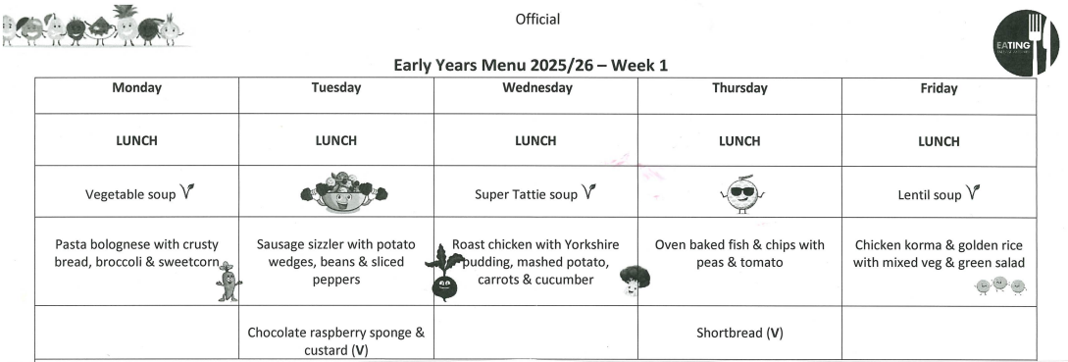
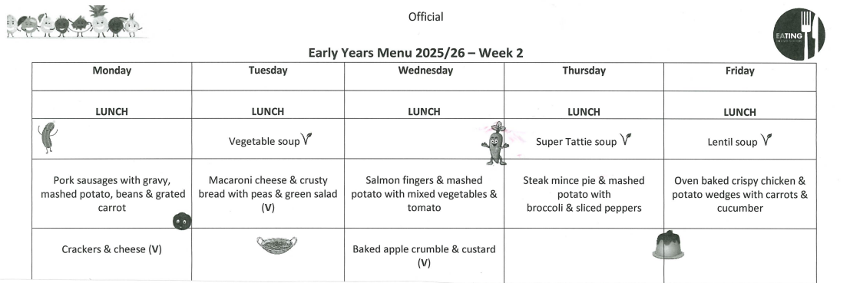
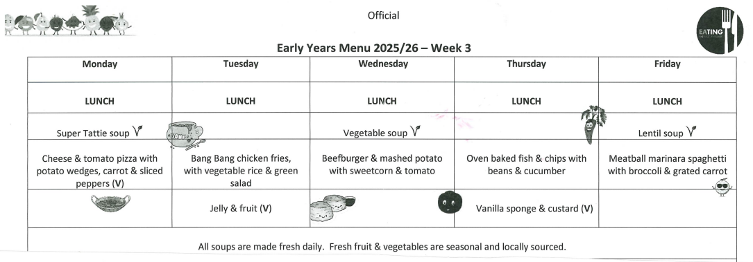

If your child has any allergies or intolerances please note this on the appropriate section of the enrolment form and speak to a member of management to discuss snacks and meals.

Snack times can vary from day to day, but we aim to usually provide the am snack from 9.30-11.00, Lunch is served at 11.45am. Milk and water are provided at meal times and are also available throughout the session as required.




During all meals, we encourage the children to use and develop their independence skills as much as possible, pouring their drinks, using cutlery and cutting their own food. We do provide assistance and guidance in order for the children to develop these skills and if they are unable to do so, we will assist where needed, however we do encourage independence where possible.



You can check daily to see what your child has eaten at Lunch by checking the lists at your child’s collection table each day.

Curriculum for Excellence

https://education.gov.scot/parentzone/learning-in-scotland/about-the-3-18-curriculum/
The curriculum for Excellence 3-18 (2004) is the curriculum that we follow to support learning and development within our 3-5 playrooms.
This is split into 8 curricular areas which are: Literacy, Maths & Numeracy, Health & Wellbeing, Science, Religious and Moral, Expressive Arts, Social Studies and Technology.
These areas are covered through a vast range of different experiences and opportunities on offer in the playroom through child-led free play, structured adult led activities, open-ended resources and group experiences. Have a look at some of the these experiences below ☺
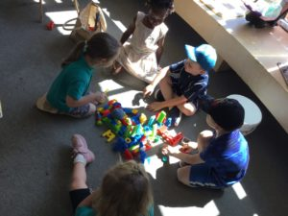
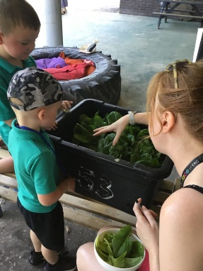
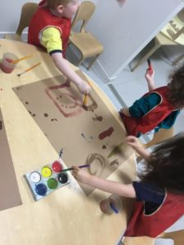

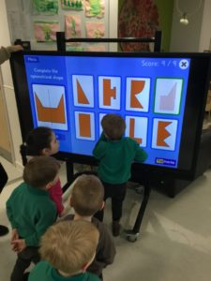
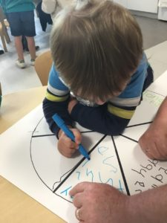
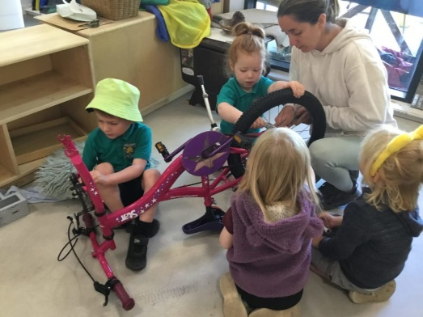

Learning Journals
To track and document your child’s learning and development, staff will take short observations of your child in note form during their session and these will be put into their own individual learning journals. This is where a lot of their individual learning and development, along with their targets will be documented.



Your child’s keyworker will upload learning observations each month for you to view. You may additionally see stories posted by various staff, informing you of other wider activities within the ECC. Please feel free to share experiences from home on your child’s journal.

We also have a guide on our Glow BLOG:


Pre-Birth to 3/ Realising the Ambition: Being Me



For our children within the Willow Playroom, we follow the Pre-birth to Three Curriculum, which has 4 key features - Rights of the Child, Relationships
Responsive Care, Respect. We also use the Realising the ambition: Being Me guidance which focuses on the 3 areas of Communication and Language, Confidence creativity and curiosity and Movement and co-ordination to support our youngest children, through exploring the types of spaces, interactions and experiences to best support children’s learning and development. Within East Ayrshire we use the 0-3 Progression Pathways alongside these to guide and promote your child’s learning and development. This is split into 5 areas which are: Communication & Relationships, Movement, Creating a Sense of Self, Sensory and Exploration & Discovery.
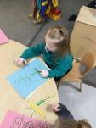
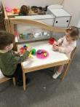
We cover a vast range of skills within all these areas through a range of experiences and activities which can be both child and adult initiated, through structured small groups, free play and focused 1-1 work. Have a look below to see some of these experiences ☺
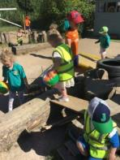
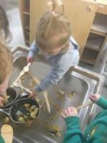

To track and document your child’s learning and development, staff will take short observations of your child in note form during their session and these will be put into their own individual learning journals. This is where a lot of their individual learning and development, along with their targets will be documented.

- We also document the planning for your child’s room and evidence of this is within a room floor book and also on your specific rooms blog page which can be found under the playrooms tab

https://blogs.glowscotland.org.uk/ea/whatriggseccmain2019/

A day in the life
This is an example of what a typical daily routine within the ECC may look like, dependant on session.

Welcome Time
Free play (Outdoor access)
Snack
Free play (Outdoor access)
Story/quiet time
Lunch
Outdoors/Gym Hall
Free play (outdoor access)
Group Time
Goodbye Time

(We also run various groups and small focused activities throughout free play which your child may join in with.)

Have a look on our blog to see information relating to the centre!
https://blogs.glowscotland.org.uk/ea/whatriggseccmain2019/



Personal Care
We understand that when starting at the ECC many parents/carers are often very anxious around their child’s toileting. Please be assured that we will accommodate and support all stages of toileting, whether your child is in nappies and not yet able to toilet themselves, using the toilet but still having accidents and needing reminders, or even fully independent at the toilet.
Please discuss with staff your child’s toileting needs and stage when attending for your first session. If your child also has any medical or additional support needs which may affect their personal care, please inform staff at their first session. If they are using nappies/pull ups, we do ask that you provide a small stock of these to be kept in the ECC. We also ask that you provide a few changes of clothes in case of any toileting accidents, as even the most confident toilet users can often take a little step back and be unsure of using the toilets at the beginning when in a new unfamiliar environment.
If you require any support around toilet training, please do not hesitate to speak to a member of staff who will be happy to provide you with support and tips for home 😊

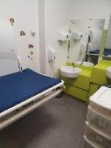
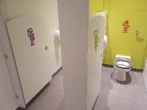
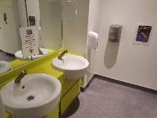
Please see below for photos of our toilets and changing facilities:

Outdoor Learning
As an ECC we provide daily access to outdoor play in all weathers. Outdoor play has a wealth of benefits some of which we have listed below!
Improves physical health – children playing outdoors are more physically active so are likely to have a healthier weight better bone density through improved strength and greater exposure to vitamin D better fundamental movement skills, improved respiratory health better immune system by experiencing a greater range of microbes improved eyesight.
Improves wellbeing – children’s wellbeing and mental health is improved by playing outdoors.
Enhances child development – high level functions such as creativity, interpersonal skills, empathy and negotiation are improved.
(Out to Play, The Scottish Government, 2018)

Due to being out in all weathers and often during the lovely Scottish rain, we do ask that you bring your child to the ECC each day in appropriate clothing and outdoor wear appropriate to the weather. We do ask that if possible you provide a pair of wellies with your child’s name clearly written on them to be kept in the ECC for outdoor use. Also, a spare change of clothes for when they may get a little muddy or wet as this sometimes cannot be avoided.
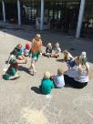

During the warmer months we also ask that you apply sun cream to your child before bringing them in for their session, this will be topped up by us as required. We have our own ECC sun cream that we use however if your child requires a specific sun cream due to allergies, please do not hesitate to make a member of staff aware of this.
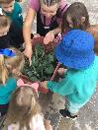

Other Professionals
Within the ECC we often work alongside a range of professionals such as Speech and Language Therapists, Health Visitors, Educational Psychologists, Community Practitioners, Physiotherapists, and other specialist roles where and when required.
If you have any involvement with any of the above mentioned professionals other than your assigned Health Visitor, please let us know this so that we can keep up to date with any requirements needed.
If we do feel that your child would benefit from involvement with any other professional services, please do not worry, we will always speak to you about this or about any other concerns before contacting other services.

Our Link Community Practitioner is Amanda Latif who is based within Shortlees ECC, but is available to provide advice, guidance and support when required. 
If you feel your child would benefit or requires any further support, please speak to a member of staff and we will provide you with information and advice on the above services and contact information when required.

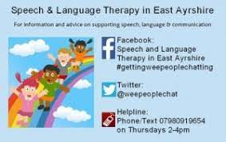




Transition from 2-3 to 3-5
If your child is within the Willow Playroom (2-3 year olds), and is continuing their ECC provision with us through to their 3-5 sessions, there are several ways in which we promote and develop this transition to ensure as smooth a transition as possible, both formal and informal.

Informal
- Shared garden
- When the 3-5 playroom is empty the 2 year old children sometimes get to have a little visit to the 3-5 playroom to have a look and explore to become more familiar with the rooms.
- We provide pictures of their new 3-5 keyworker and playroom for the children to explore whilst in the 2-3 playroom.
- When walking from front door to playroom door, the children can see in the window of the 3-5 rooms and have discussions about the playrooms.
- Future key worker visit and meet the child in the comfort of their current 2 year old playroom.

Formal
Planned days and times to allow for the new key worker to meet and explore the playroom which is gradually built up over time.
Current key worker comes to initial visit as a familiar and comfortable person to support transition. Parents are informed and kept up to date with these dates and how the experiences go.

Keyworker Passover
Scheduled time occurs for the current and future key worker to have a meeting. This is to discuss and pass over all the information and knowledge regarding your child’s interests, abilities, learning experiences.
In addition, any other needs for the new key worker to support your child and allow for a smooth and positive transition from the 2 year old room into the 3-5 room.
Transition to Primary 1
When our pre-school children are moving onto school, we support them in this big transition through many different ways, communicating with the school and working alongside them to provide a transition calendar which runs most of the year. Have a look below for a small selection of how we support transitions to school.

Walk Arounds
- We walk round the grounds of the school on occasions, which allows for informal discussions with the children in relation to what they can see. This opportunity allows the children to ask any questions and explore the school they will attend in the future. This also provides opportunity for this to be done in a way that is familiar to them, with current ECC staff that your child has built up a relationship with.

Role play
- Props from the school such as spare polo shirts and sweatshirts.
- Photos of the different areas of the school environment that the children will be using.
- Set up to represent a school classroom to allow the children to explore and process the information and experience they have been building up in relation to what school may look like.

Communal activities with the school
- Monster mash – home packs sent out from school to take part in activities at home in ECC and then that they will do when starting P1.
- P6 buddies supporting with transition visits to the school to familiarise the children with who will be their buddy.

School spaces
- Gym hall – we use this space when available throughout the ECC to build up familiarity in this environment.
- Primary 1 Playground – When available we are able to access and have use of the Primary 1 playground, making this a familiar space to the children.

Meetings with school
- ECC staff meet and discuss classes with the primary staff.
- Pass on relevant information such as healthcare needs.
- Plan communal activities.

Teacher visits
- Planned visits from the primary 1 teachers of the school your child will attend – to meet and introduce themselves to your child
- To start to get to know your child, their likes and interests and personality through discussion with your child’s current keyworker.

Absences and Illnesses

Absences and Illnesses are a common part of ECC life, especially when children first start their ECC provision. If your child is unwell and unable to attend the centre we ask that you let us know via the App or a call the morning of their session to let us know that they will be absent and an estimated return date.
TEL: 01563 551587

Please see below on how to report Absence on Safer Schools App

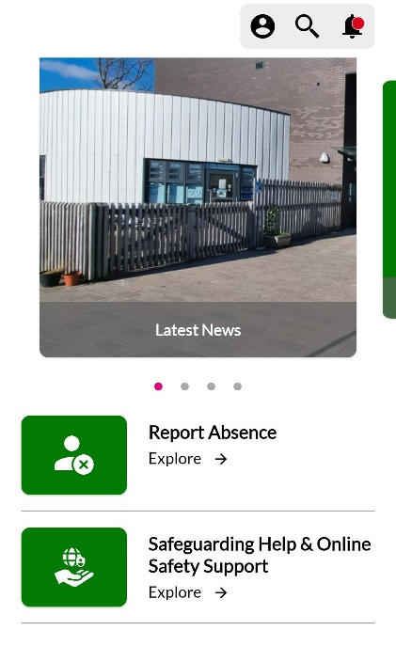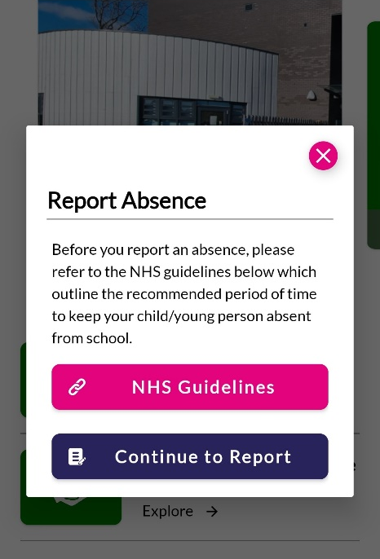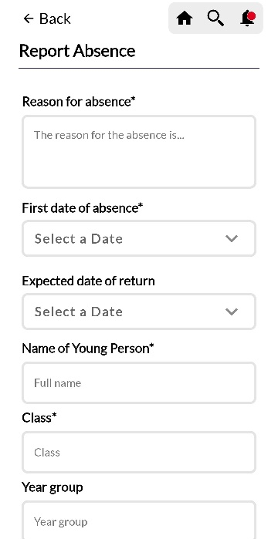

Please see the link below for information on exclusion periods for symptoms and illnesses.
https://www.nhsggc.org.uk/media/254151/exclusion-criteria-for-childcare-and-childminding-settings-poster-2018.pdf

Please be aware that if your child appears unwell at any point during their session we will give you and/or your listed contacts a call to come and collect your child, so please keep your phone available when possible.

Please be aware that attendance to the ECC is not mandatory, however we do ask that you let us know if you plan to keep your child off the ECC for any family/personal days and/or holidays.

If your child is absent and we have not received a phone call or prior notice to them not attending please expect a call from our clerical team, to enquire as to the reason for their absence.

Medication




Before bringing any medication into the ECC we ask that you attempt to give all medications out with of ECC hours where possible, for example if it needs to be given twice a day you can give a dose first thing in the morning and the second at dinner time.

If your child does have any medication that requires to be kept in the ECC for either long term use (such as an epi-pen, inhaler or Piriton), or short term use (such as anti-biotic, medicated creams), please be aware that you will need to speak to a Senior Practitioner and fill out a medication form prior to it being brought in.
When bringing in medication, all medication MUST have a pharmacy label, with the child’s name and address on it; we cannot accept any medication without this. This includes items such as Sudocreme and Calpol. This can be easily done by asking at your local pharmacy and informing them that it is for use within the ECC. With the exception of Epi-pen’s we must also insist that you have given your child the first dose of any new medication, to ensure that they do not have an adverse reaction to this.
For all liquid forms of medication, you must also provide either a medicine syringe or spoon. If it is a long-term form of medication, such as an inhaler, we do ask that you ask your doctor/pharmacy for a spare one to be kept within the ECC to save this having to be brought and taken home every day, as your child cannot attend if we do not have the medication in the building. Please note, for inhalers we are only able to store and administer reliever (blue) inhalers.

If you have any questions or concerns regarding medication please speak to either Senior Practitioner (Sheree or Cheryl/Amy) either in person or by telephone on 01563 551587
All guidance on the administration of medication can be found at the below link:
https://www.careinspectorate.com/images/documents/1427/Management%20of%20medication%20in%20daycare%20of%20children%20and%20childminding%20services_Dec%202024.pdf
Contact Information
Whatriggs ECC
Whatriggs Road
Kilmarnock, KA1 3SZ
TEL: 01563 551587

Elaine Kirk – Head of Centre
elaine.kirk@eastayrshire.org.uk or elaine.kirk@east-ayrshire.gov.uk

Michelle Murphy – Depute
michelle.murphy@eastayrshire.org.uk

Sheree Bryden – SELCP
sheree.bryden1@eastayrshire.org.uk

Cheryl McCabe – SECLP (Part Time, maternity leave cover)
cheryl.mccabe@eastayrshire.org.uk

Amy Allen – SECLP (Part Time)
amy.allen@eastayrshire.org.uk

Janet Ashton – Senior Clerical Assistant
janet.ashton@eastayrshire.org.uk

Marion McIntyre – Equity and Excellence Lead
marion.mcintyre@eastayrshire.org.uk

