
Whatriggs Early Childhood Centre
November 2024 Newsletter

Halloween fun
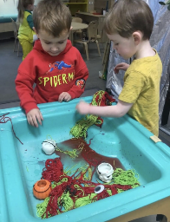
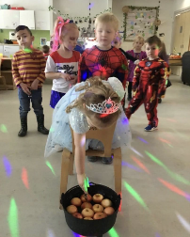
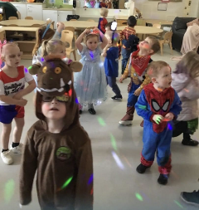
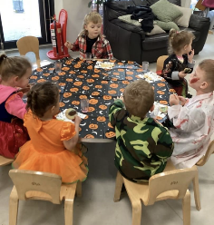
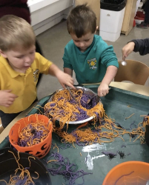
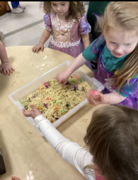

The children participated with excitement during the Halloween parties. Lots of fantastic costumes were on display, thank you for your efforts and involvement in this. The various spooky activities on the lead up to Halloween were also very popular. The children used their imaginations to engage in appropriate related role-play. Our focus was to encourage children to manage and control their emotions related to Halloween and the darker nights, the majority of children enjoyed the spooky aspect and focused on the fun rather than feeling scared.
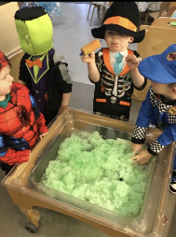
Donations
Thank you for the many donations we received for Halloween. Everyone was very kind handing in decorations, food for the party and pumpkins. This ensured we were able to have lots of Halloween fun throughout the week and during our parties.



Leading up to Bonfire night, we were then discussing fire, learning how to keep safe around fire/fireworks, as well as safety in the dark. This tied in well with what some of the rooms had been learning about, as safety had been a main focus.
Some of the children have created related pictures and the children in the Birch room used the ghillie kettle to create a small fire to toast marshmallows.


St. Andrew’s Day
On Friday 29th November, we will be celebrating St. Andrew’s day within the ECC. If your child has any items of tartan clothing, we would appreciate it if they could wear this to the ECC on this day, alternatively your child could wear something blue. We will also be singing Scottish songs and Listening to Scottish stories and rhymes.
Sponsored Dance-a-thon

During our St.Andrew’s Day celebrations, the children will also be participating in a Scottish Dance-a-thon. This will be a sponsored activity and we would appreciate any donations you can gather for this using the sponsor form that you will be provided with. The children will be learning a Scottish dance to join in with on the day and will have further opportunities to dance to a variety of Scottish music. We have also arranged for a special visitor to come along on the day to play their violin. Money raised from this will be used for the children’s Christmas activities and events and to provide the children with a present from Santa during their parties.

Early Years clothing grant
Applications re-opened on 4th November for parents of children who will be starting in the 3 year old playroom in January 2025 (born between 1st September and 31 December 2021). The application will remain open until 15th November 2024. There is £50 available per child aged 3 and 4 years whose circumstances meet the criteria for footwear and clothing grants. The link to apply for this can be found on our Facebook page and App.
Spare clothes
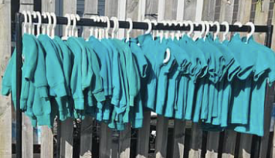
We still have some spare ECC jumpers and polo shirts, these are regularly placed outside on the clothing rail for you to help yourself (weather permitting). If these are not outside and you would like one of these, please ask a member of staff.
Home links
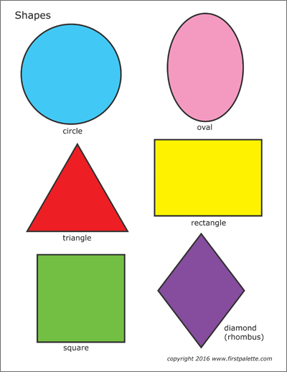
November Numeracy Challenge reminder that this month we are challenging you to have a look to see which shapes you can find in your environment. Our every day life is rich in learning opportunities and can provide an amazing chance to learn basic shapes such as circles, squares, triangles and rectangles. Using areas indoors and outdoors such as the park, the supermarket, the woodlands, the kitchen, the garden, the street, etc. can provide lots of learning experiences. So using these spaces (and any more you can think of), can you take a photo of examples of: circle, square, rectangle, triangle. While looking out for these shapes, here is some useful language you could use to help your child to identify specific shapes: ‘side, edge corne, round’.


November Health and Wellbeing home link – If you have made a poppy picture with your child at home, these can be brought into the ECC by Friday 8th November to be included on our display to celebrate world kindness day on 13th November. Thank you to the families who have already participated and created some lovely, creative poppies. All children who take part will receive a certificate.


Staff
Amy (part time senior ELCP) will be returning to the Centre in December following her maternity leave. Amy will be with us on a Thursday and Friday and also on a Wednesday afternoon. She will continue to job share with Katie who is in the Centre on a Monday, Tuesday and Wednesday morning. We are looking froweard to having Amy back with us and we will notify you of her actual date of return when this has been confirmed.

We currently have a BA primary ED student with us on placement every day until the end of November, Grace is mostly working within the Chestnut room but may also spend some time within the other playrooms.Our HNC student Chloe will aslo be starting with us on Monday 11th November and will be with us Monday-Thursday each week until the Christmas holidays. She will mostly be working within the Birch room during her placement.

Fundraising committee

Thank you to the parents who responded to our questionnaire about joining our family fundraising committee, this survey has now closed but if anyone is interested in taking part, please speak to a member of staff. As we already have fundraising activities planned for Christmas time, we will speak to the parents who have shown an interest and then plan a meeting for January, so that this can be taken forward next term.

Reminders – (Belongings)
Please discourage your child from bringing toys into the ECC to avoid items being misplaced or lost. We cannot be held responsible for any missing or damaged belongings/toys that are brought in and we don’t want children being upset if this were to happen. There have also been lots of occasions when children go home with the wrong items, please ensure all your child’s belongings are labelled so that they can be more easily returned to their rightful owner. If you realise your child has come home with something that doesn’t belong to them, please ensure this is returned. Please also ensure your child does not come dressed in good clothes, as there is lots of messy play and outdoor learning each day.

Infection Control

Please be aware of the spread of infection when sending your child into the ECC with contagious conditions. We are aware that it is difficult when your child becomes unwell and you have no other childcare arrangements in place. However, there is a strict 48 hour exclusion policy for sickness/diarrhoea and high temperatures which must be adhered to at all times. Please ensure you do not send your child to the Centre if they have a high temperature or are generally unwell.


Christmas activities/Dates for your diaries
We will be beginning our Christmas activities on Monday 2nd December and this will be the start of a very busy time within the ECC. Further details will be provided in the December newsletter and on our Facebook page but below are some dates for your diary.


Kindness elves
We are hoping that our kindness elves will be visiting again from the start of December and we will need some help to name our new friends. More information will be provided nearer the time.

Princess Court
We will be visiting our neighbours in Princess Court Sheltered housing before Christmas to provide them with a Christmas card and gift. We will also participate in some outdoor singing of our favourite Christmas songs, to get the residents into the Christmas spirit. We will notify you of dates within the next newsletter.

Parent/carer Christmas crafts stay and play
On Tuesday 3rd and Wednesday 4th December children from the 3-5 playrooms will be inviting their parents into the playroom to join in with some Christmas craft activities alongside them. We will inform you of timeslots for each room and key group nearer the time and there will be a Microsoft from for you to complete to indicate if you are able to attend.

Christmas Parties


Parties will take place on Wednesday 11th December and we have a special Grotto arriving on this day to make Santa feel at home if he is able to take time out of his busy schedule to pop in to see us!

Mince Pie and Mingle festive stay and play

We hope you can join us in our garden area on Tuesday 17th December to celebrate the festive season together with some Christmas related activities on offer. This will take place from 2.00-3.00pm and will be weather dependant. Unfortunately we will be unable to re-schedule if it is bad weather on the day. Children who do not attend on a Tuesday will also be welcome to attend if accompanied by a parent/carer. Mince pies and a drink will be provided and please wrap up warm for this outside event.

Christmas jumper day
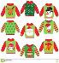

This will be taking place on Friday 13th December. We would love it if your child could wear an item of festive clothing on this day. If you have any children’s jumpers/t-shirts that no longer fit, we would appreciate any donations so that we can provide opportunities for a jumper swap prior to the day. Children will aslo be filmed singing a Christrmas song on this day which will then be made into a short video for parents to view.
On this day, Christmas lunch will also be provided.


Christmas Movie Day
This will be taking place during the last week of term, Christmas movies and popcorn/crisps will be provided.

Christmas fundraiser

We will be holding a Christmas raffle to win three different Christmas hampers and we are hoping you would be able to donate an item to be added to the hampers. We are planning to organise a food, pamper and children’s hamper and will provide a list of items for you to choose one to donate. If we receive enough items, these will then be made into hampers and raffles tickets will be sold at £1.00 a strip. We will provide you with more information nearer the time.

Christmas holiday period
The last day of term for all children will be Friday 20th December. The Centre re-opens on Monday 6th January.

We will provide you with further information relating to Christmas activities at the end of November.

