
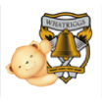
Whatriggs Early Childhood Centre
December 2024 Newsletter

St. Andrew’s Day
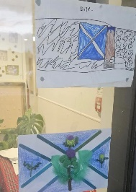



We had a great time celebrating St. Andrew’s day within the ECC on Friday 29th November. Many of the children and staff dressed for the occasion by wearing tartan or something blue. We listened to Scottish music, stories and songs and did some Scottish dancing. We enjoyed some other related activities and even sampled some yummy shortbread.

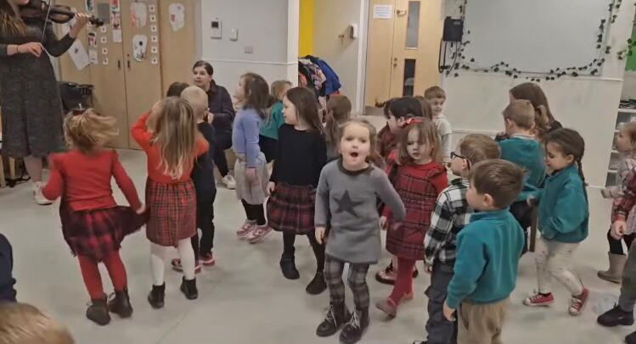
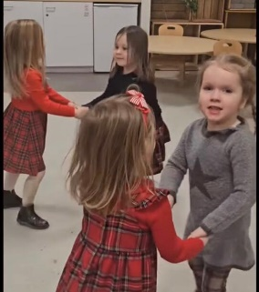
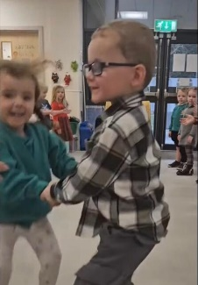
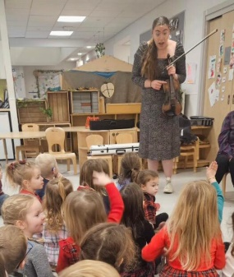
Dance-a-Thon
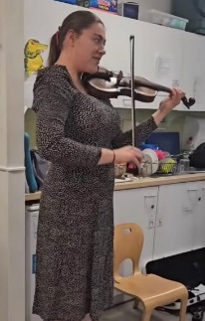
Thank you so much for all the donations that you collected for our sponsored activity, we really appreciate all of your efforts and generosity. The money raised will be used for the children’s Christmas events and activities. The children did so well and had lots of fun participating in their Scottish Dance-a-thon to celebrate St. Andrew’s Day.
We were very lucky to have Ruby visiting with her violin to provide the music to accompany the children’s dancing. She spent some time playing music for the children to dance to and then gave children the opportunity to have a turn playing the violin, showing them how to hold it properly and use the bow to make their own music. The children thoroughly enjoyed this experience and joined in with enthusiasm. Thank you to Ruby for making this day extra special for the children.
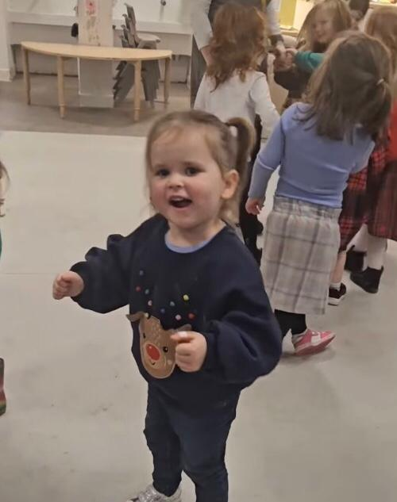
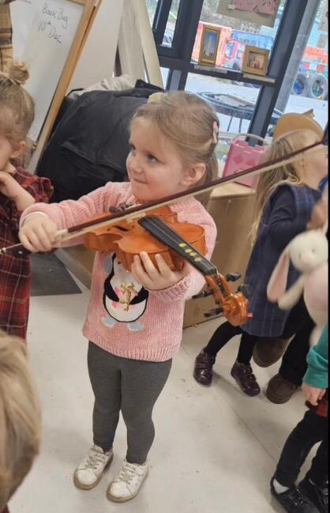
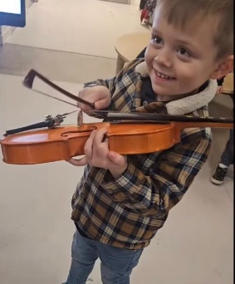
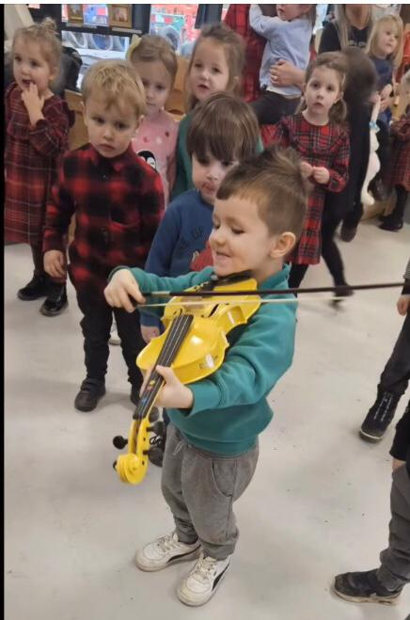
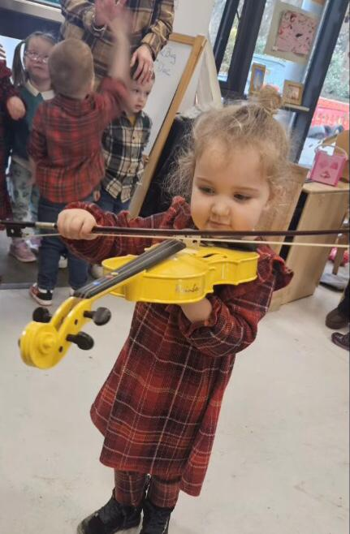
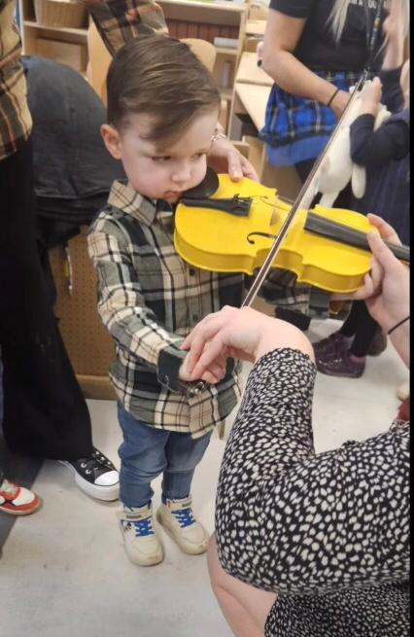
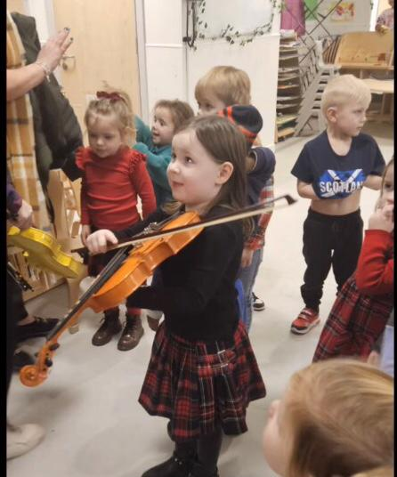
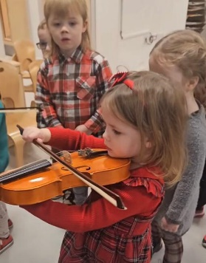
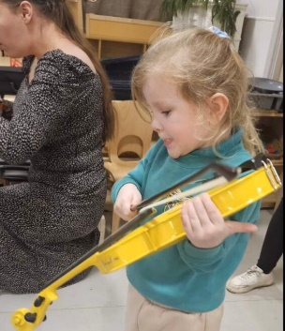
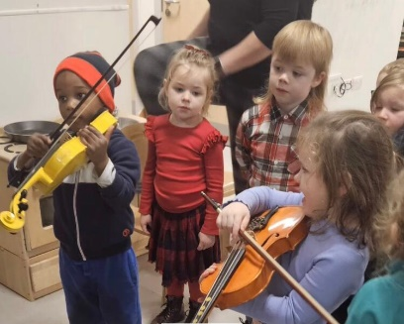

World Kindness Day
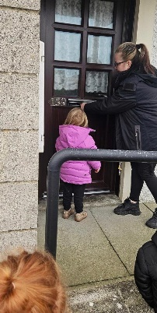
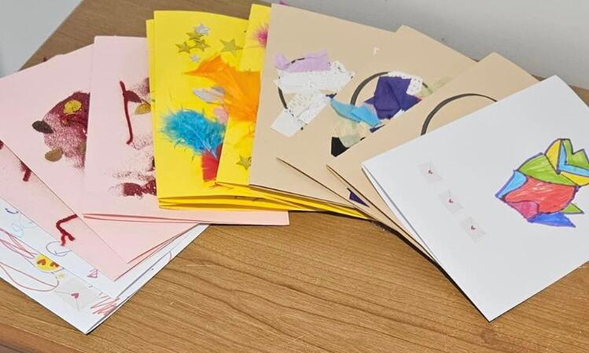
The children from all playrooms made some lovely cards for the residents at Princess Court and some of the children visited on world kindness day in November to deliver these. The residents always enjoy seeing the children and were very grateful for their cards. We will be visiting them again before Christmas with different children taking part.
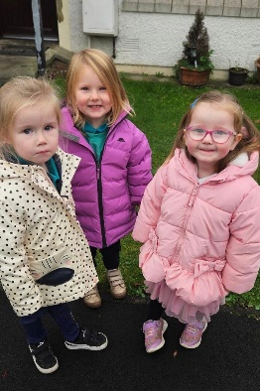
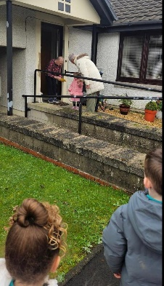

Staff

Amy (part time senior ELCP), will be returning to the Centre on Wednesday 4th December following her mat leave. She will be job sharing with Katie and will be in the Centre full day Thursday and Friday and on Wednesday afternoons.
Support Assistant interviews were held last Thursday and we hope to find out later this week who were the two successful candidates. They will be joining the Centre after the holidays in January and this will be on a temporary basis until the end of term in June.

School registration

P1 Registration week will take place from Monday 13 January 2025 until Friday 17 January 2025 for children who attain the age of 5 years between 1 March 2025 and 28 February 2026, and whose parents/carers wish them to attend school.
Registration forms should be completed online and submitted no later than Friday 17th January 2025.
Placing requests for P1’s should be completed and submitted no later than 31st January 2025.

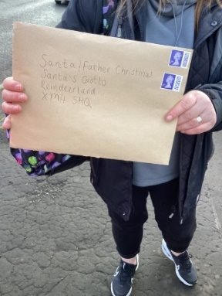
Christmas time


On Monday 2nd December we began our Christmas activities in the ECC. Throughout the month, there will be lots of emphasis on Christmas games, craft activities, stories, music and dancing.

Some of the children have already made their letters to Santa and went out for a walk to the local post box to deliver these. We are sure that Santa and his elves will soon be reading their requests and will then be busy in their workshop getting these prepared ready for delivery on Christmas Eve!



Christmas Tree

We are planning to purchase a Christmas tree for our outdoor area. We would love for you to join us in celebrating Christmas by making a special decoration with your child to hang on our tree. We hope we can all come together and create a beautiful tree to spread some Christmas cheer. We can’t wait to see what beautiful things you create to display! If you prefer, you can donate a bauble for your child to hang rather than making one.
If you would like to participate, please bring this with you on Tuesday 17th December during our Mince Pie and Mingle parent/carer stay and play event (more details below), for you to hang on the tree alongside your child.
Dates for your diary

December is always a very busy time within the ECC and an exciting and fun time for the children. Below are details reminding you of what will be happening during the month.

Parent craft days

These are taking place on Tuesday and Wednesday of this week. If you haven’t already done so, please check your child’s learning journal for available time slots and then let the staff in your child’s room know when you are planning to attend.
We hope that you are able to come along to join in with some Christmas crafts alongside your child.
Please note that due to space, only one adult per child to attend.

Christmas raffle - Hampers
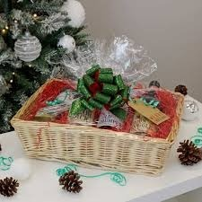
Thank you to everyone who has put their name down to donate an item or items from the list for our Christmas hampers. There are still a few items for the food hamper that havent been selected, so if anyone would still like to donate we would really appreciate it. Anyone donating to the hampers should hand in items by Monday 9th December to allow time for them to be put together.

Raffle tickets to win 1 of the hampers are now available at £1 per strip.
These will be available at the main entrance on craft days this week and from the gate next week.
The draw to win the hampers will take place on Tuesday 17th December during our Mince Pie and Mingle Christmas stay and play, we look forward to seeing who will win each of these lovely hampers.

Bookbug
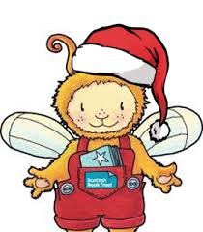
We are excited to invite you to our Christmas Book Bug session. Join us for a festive time with a Christmas story, song and rhymes.

- Thurs 5th – Birch room
- Tue 10th – Chestnut room

There will be two time slots for each of the rooms:
- 10am
- 1.30pm

If you would like to join your child for this, please let your key worker know which time slot you will be attending.

Whatriggs Primary Christmas Fair
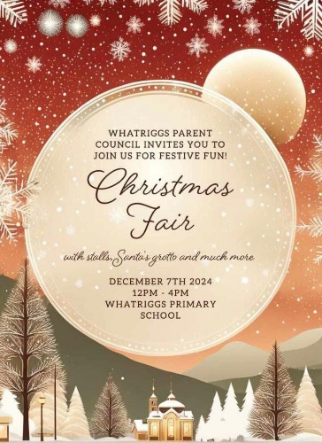
To get you in the festive spirit, Whatriggs Parent Council are holding a Christmas Fair on Saturday 7th December from 12pm – 4pm within Whatriggs Primary school.

Santa’s Grotto will be there on the day, as well as a range of stalls with lots of goodies on offer and other festive fun.

This is a great opportunity to purchase some gifts to start or finish your Christmas shopping, depending on how organised you are! This would also be a lovely day out to browse what is on offer and maybe purchase a Christmas treat for yourself or your child and join in with some Christmas fun. We are sure they would love to see you there to support the school community.

Christmas Parties

We will be having Christmas parties in each playroom on Wednesday 11th December. The parties will take place during your child’s usual session.
We have a special Grotto arriving on this day for when the children go to visit Santa. This will be set up in the school hall in the morning. If your child does not attend on a Wednesday, please let us know if you would like to bring them in to see Santa and we can provide you with a timeslot to visit with your child.



Princess Court

We are visiting the residents of Princess Court on Thursday 12th December. At this time we will be delivering a Christmas gift and card and playing some festive music while the children sing and play some instruments for the residents.


Christmas Jumper day

Christmas jumper day is on Friday 13th December. We will not be collecting money for this but children can come to the ECC dressed in festive clothing – jumper/t-shirt etc. if they wish.


Christmas lunch
The Christmas lunch will also be provided on Friday 13th December. We hope the children will enjoy this pre-Christmas celebration and the tasty, festive food that will be provided by the central kitchen on this day.

Mince Pie and Mingle

Reminder that this will take place in our garden on Tuesday 17th December from 2.00-3.00pm. We advise that you wrap up warm as we will remain outdoors. We look forward to seeing everyone on this date for some festive fun, mince pies and a drink will be provided.


Christmas movie day
We will be having a Christmas movie day for children on Thursday 19th December. This will take place during your child’s usual session.

Christmas Holiday Dates and times / Last day of term


Last day of term for all children is Friday 20th December. The Centre re-opens on Wednesday 6th January 2025. As Whatriggs Primary is closing early at 2.30pm on the last day of term, we will be opening the gate at 2.15pm on the Friday for any parents who wish to collect their child before school pick up. All children should be collected from the ECC by 2.30pm.

Although it is still a few weeks away, all the staff would like to take this opportunity to wish everybody a Merry Christmas and a Happy New Year and to thank you all for your continued support of the ECC.





