
Whatriggs Early Childhood Centre

March 2023 Newsletter

Child intake
New children have recently joined us within both our 3-5 and 2-3 rooms and will continue to do so over the next couple of weeks. We will then have reached our full intake of children for this session. We would like to welcome all children and their families to Whatriggs ECC and hope the children have lots of fun in their new environment, making friends and learning through a variety of play experiences.

Early Learning and Childcare Registration Weeks 2022/2023

Just a reminder that registration for next sessions funded early learning and childcare places opened online on Monday 27th February and continues this week, applications must be submitted by midnight on Sunday the 12th March.
Children who already attend in the 3-5 room returning for their pre-school year do not need to reapply unless you wish to apply to change sessions, or if are looking to move to a different Centre. If your child currently attends our 2-3 (willow) playroom, you must complete the online registration process for a place in the 3-5 room.
Please see East Ayrshire Council website for more information and access to the form.

Learning journey
Details of our current planning and activities with the children can be found on our Blog, this will enable you to see our focus for learning across different areas of the curriculum within the various playrooms. The planning is created following children’s interests and contributions throughout the month to ensure they are consulted in their learning. The blog also shows examples of recent activities and some of the learning that has taken place within the different playrooms.


Online communications
Please remember to look at our Facebook and Twitter for regular information and updates. Our Blog is also a great source of information which is regularly updated, so please take a look at our weekly room updates with information and photos relating to what the children have been taking part in. Our current App will soon be ending as the council are introducing the new Safer school App, we will provide you with more information when this is in place.

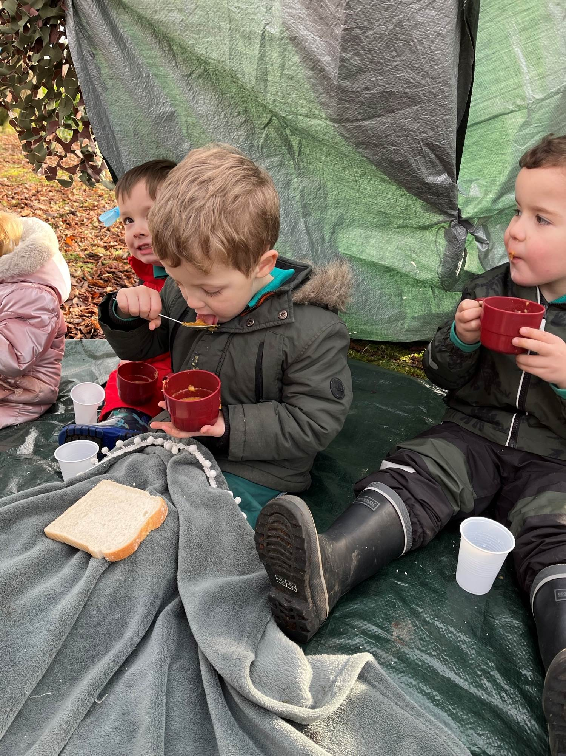
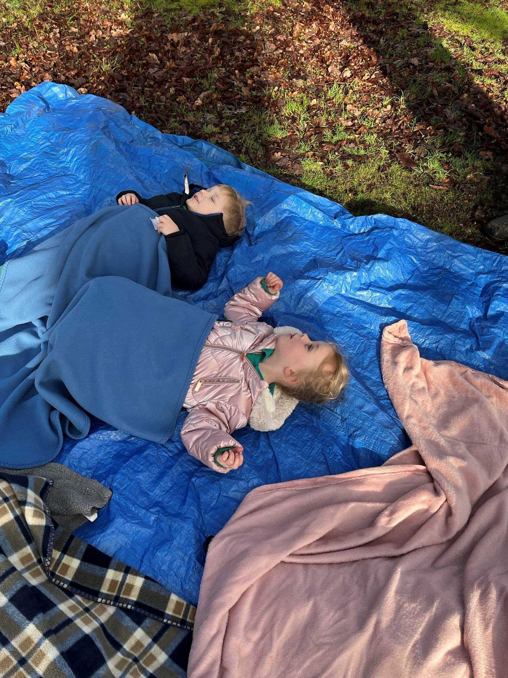
Woodland visits
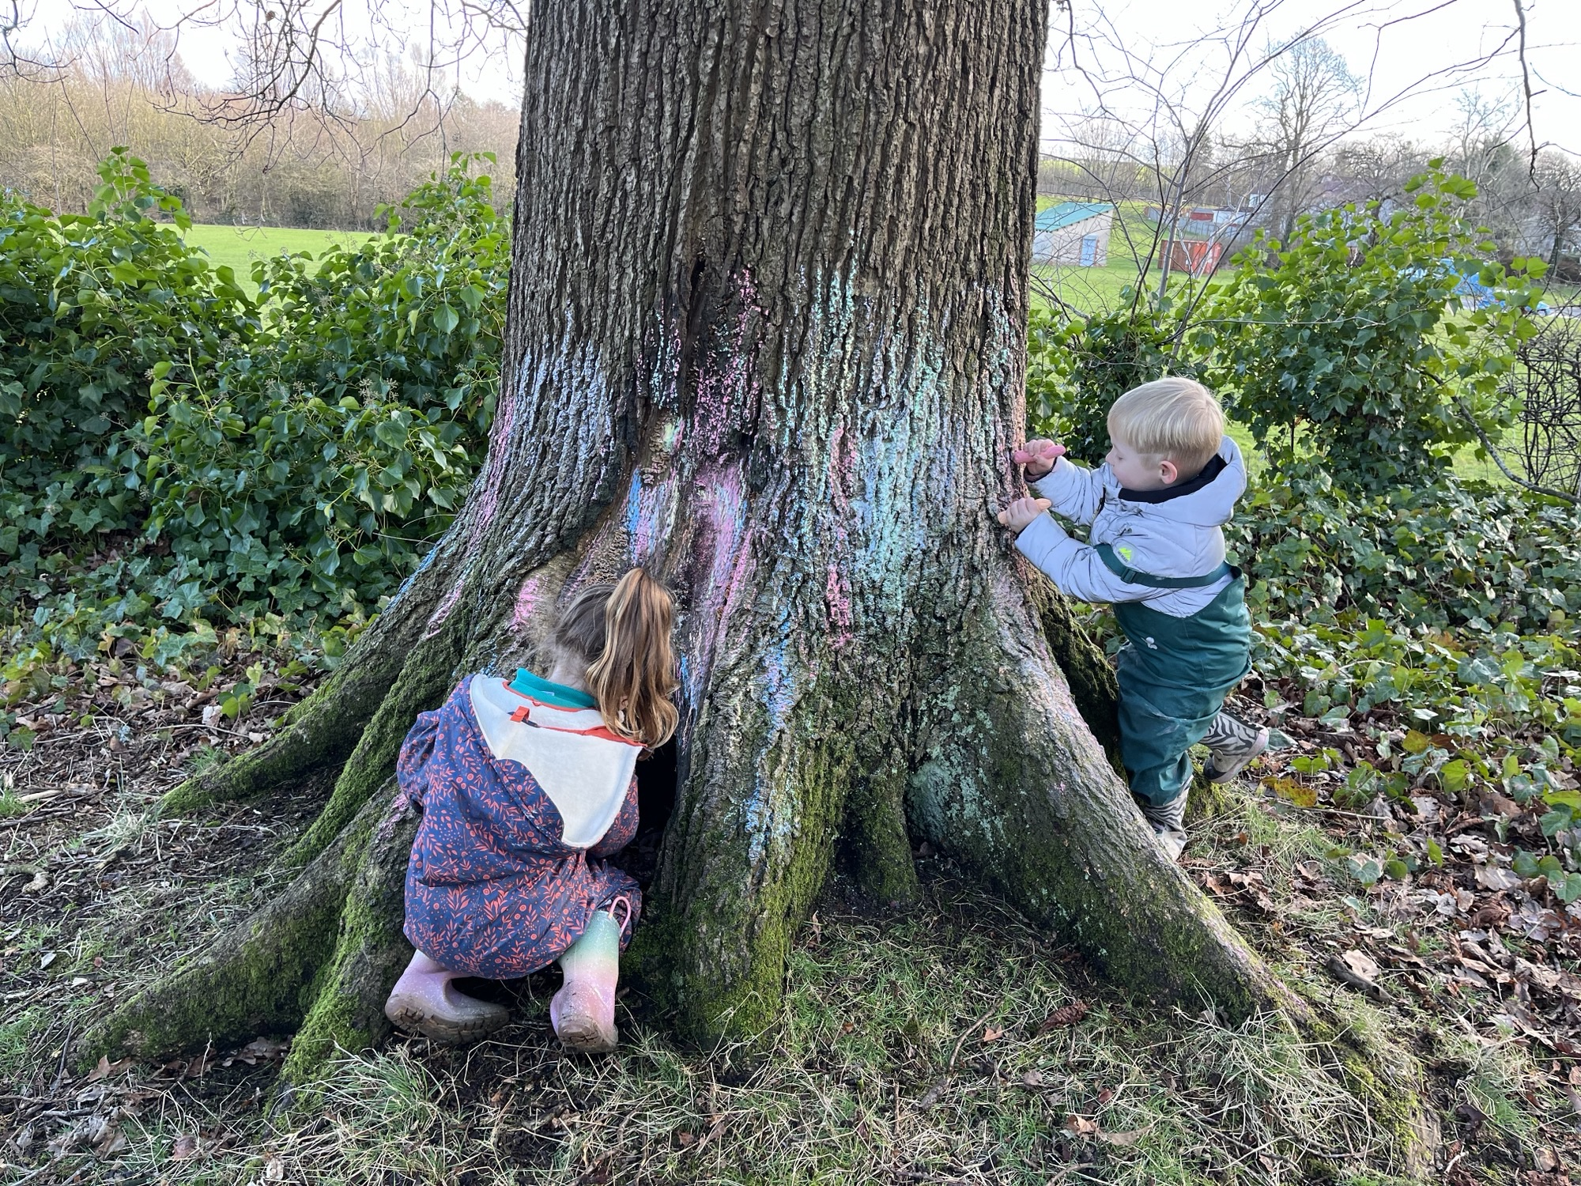
We have been continuing with our visits to the woodlands within the Bellfield Estate with the Yellow Giraffes and Blue Peacocks from Birch room finishing their last session last week.

We had made homemade soup, constructed tents and did some outdoor mindfulness when lying back, taking deep breaths and watching the clouds and trees move in the wind.
The Orange Tigers and Red Squirrels are starting their sessions to the woodlands, with the first visit focusing on bringing literacy to the outdoors.

Toothbrushing

Theresa from dental health returned to the ECC last week to brush with the children in the 3-5 rooms. If your child has just recently joined the ECC you will have received a toothbrushing information letter within your child’s welcome pack. Please ensure you have read over this and let us know if you do not wish your child to participate.

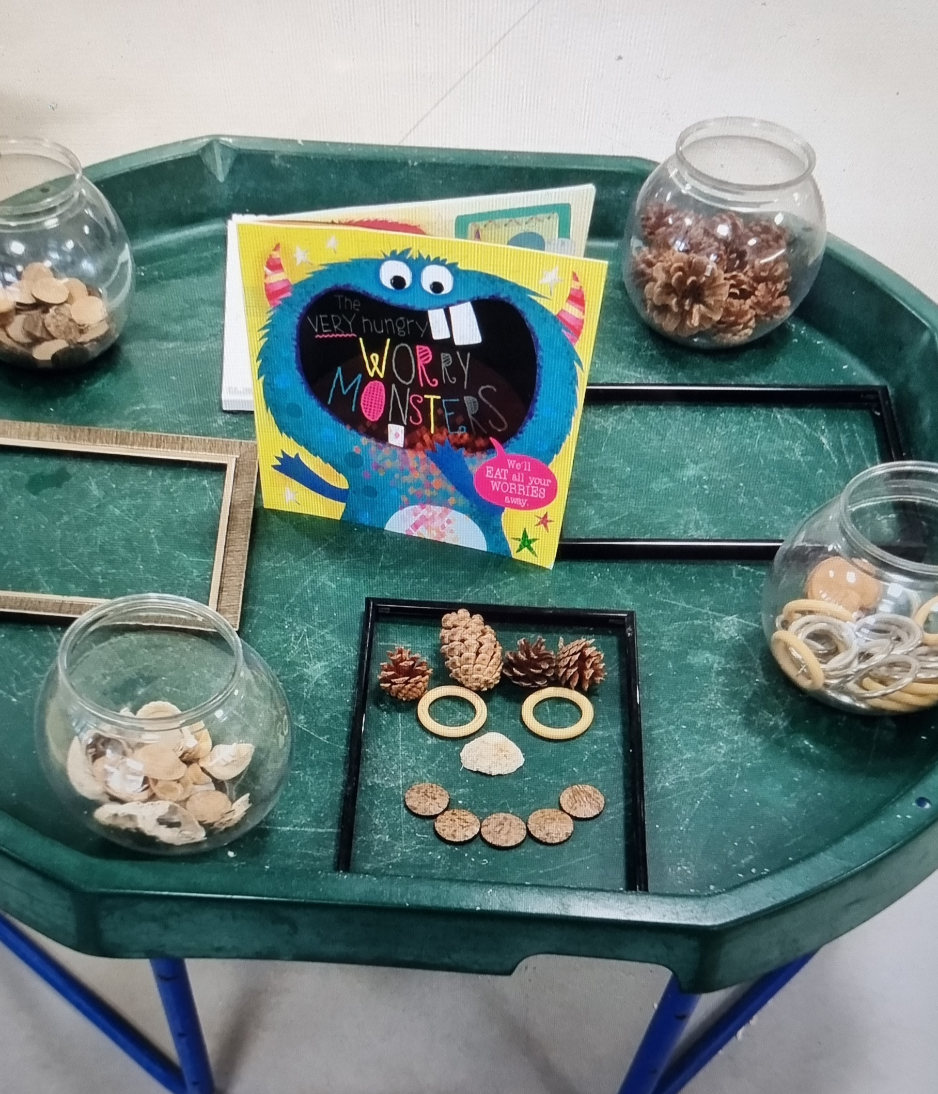
World Book Day
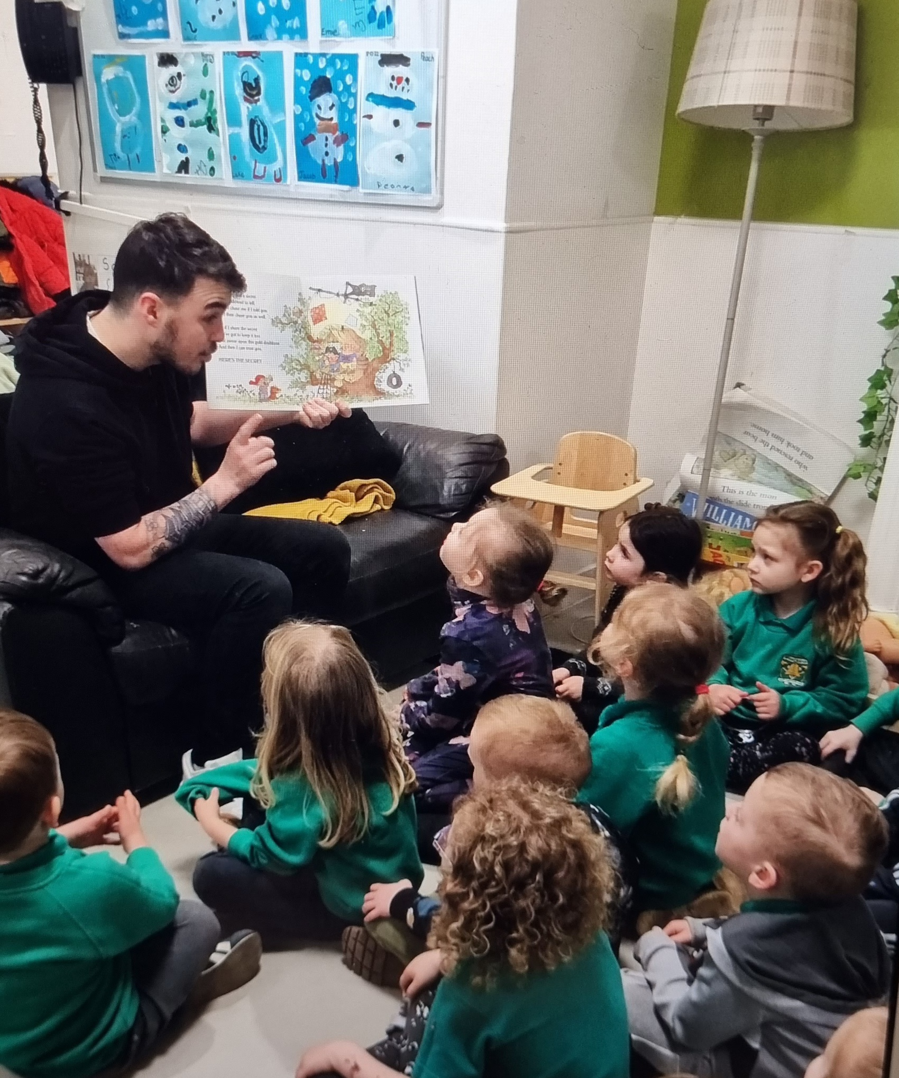
This was celebrated in the ECC last week (Thursday 2nd March), where we wore our pyjamas to nursery. We have had various related activities and visitors in reading stories throughout the week and we hope to continue this throughout the month of March as well as increasing visits to the library. The pre-school children had a visit into the primary 1 class to have a story with the teacher. We also had primary 6 children come into the ECC and read stories with the children. Some of the parents/grandparents have volunteered to come in to read a story to their child and their friends. Throughout these activities we have been focusing on the parts of a story, as well as developing listening and attention skills. Please visit the Blog to see related photos.

Bookbug sessions
These planned sessions for the 3-5 playrooms started on Monday and are continuing until Wednesday of this week. For the 2-3 playroom, this will be taking place next week on Wednesday 15th March. Thank you to those of you who came along and we hope you enjoyed the session. If you missed it this time, there will be more Bookbug sessions planned for later in the year.

Transitions / Playmakers
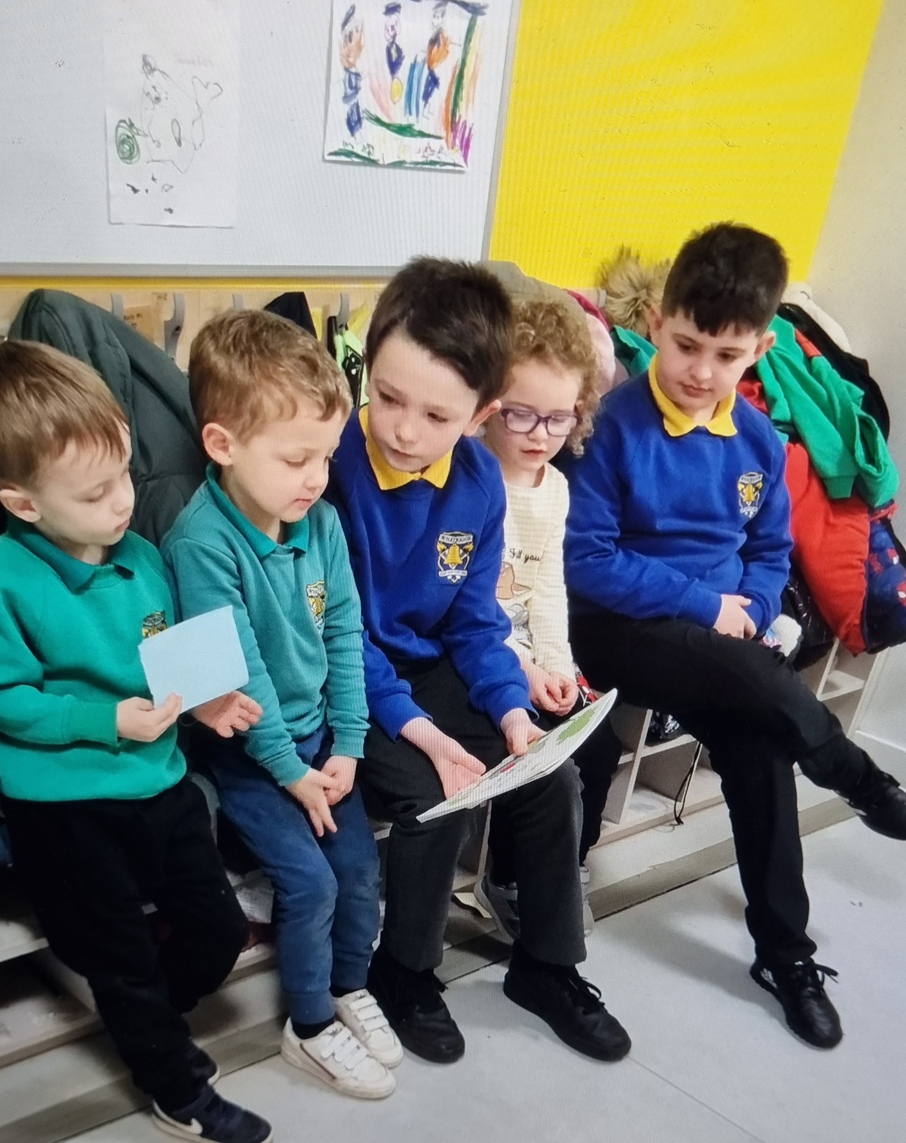
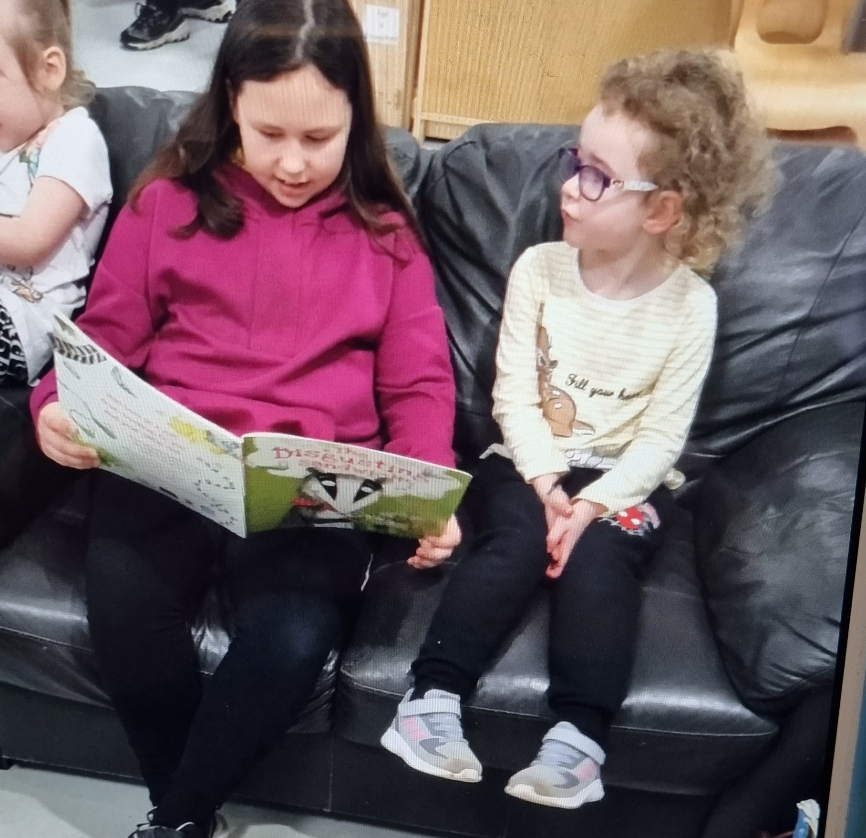
As mentioned above, throughout last week for world book day we had various planned activities with the school. We will be continuing to work with the school to increase transition activities for the pre-school children prior to the planned induction programme during May and June. The p6 pupils are also being trained as part of the playmakers programme with Active Schools. As they will become the buddies for the children moving to P1 in August, they will be involved in carrying out a range of activities with the children. We are also hoping they will accompany us on our woodland visits next term and support us with some Eco related activities including litter picking and planting.


Community Book swap
We are in the process of organising a book swap within the local area. Books will be placed within the community for borrowing to read at home. If you find a book please take this home to read with your child and replace when finished with it. Then you can go on a search to see if you can find another book in a different area to enjoy at home.
This will begin during the two week spring break at the end of March and will continue during the month of May.

Cat sitter service

After the two week spring break we will be introducing our cat sitting home link activity. Each room will have a toy cat to look after and it will need a home for the night while the nursery is closed. Children will take it in turns to bring the cat home for a sleepover and we would like it to join in with anything you are doing as a family. Our cat friends will come with their own overnight bag with everything they will need. There will also be a notebook included and we would love it if you could write about the adventures during their time with you. We would also love to see any photos you have taken during the cats visit. These could then be emailed to us at either elaine.kirk@eastayrshire.org.uk or michelle.murphy@eastayrshire.org.uk
Parent committees

Thank you to the parents who completed our online questionnaires prior to the Christmas holidays and thank you to those of you who indicated that you would be willing to join our fundraising and or gardening committee. Unfortunately, as we only had three parents wanting to join the fundraising committee and two for the gardening committee, we have decided not to continue with this for the duration of this year. We will gather family feedback again at the start of the new term in August and will hopefully be able to set up a parent committees at this time.

Parent and Child Questionnaires

After the two-week Spring break holiday, you will have access to an online questionnaire to enable you to express your views about the ECC in general, we would really appreciate it if you could take a few moments to complete this form, as we welcome any feedback that you can offer. The questionnaire will be anonymous but if there is anything specific you want to raise with us, please do not hesitate to speak to a member of staff.
As we also value contributions from the children, we will give you a short questionnaire for you to complete with your child. This will enable them to give feedback about their thoughts and feelings of the ECC. It is always valuable to gather the children’s views so that we can be responsive to likes and dislikes.

Staff team


← Katie, one of our Senior ELCPs returned to the Centre this week following her maternity leave. She will be working on a temporary part time basis and will be in the Centre on Mondays, Tuesdays and some Wednesdays.
Amy, → who has been covering Katie’s post will continue in her position as temporary Senior ELCP, but this will now be on a part time basis to job share with Katie. Amy will now only be in the Centre on Wednesdays, Thursdays and Fridays. Sheree will continue in her post as full time Senior ELCP Monday-Friday.

Students
Our two students Lauren (Birch room) and Jett (Chestnut room) are due to finish with us this week, Thursday 9th March will sadly be their last day. Both student have been great and will be missed but we wish them well for the completion of their course and their future employment within early learning and childcare. Carys will be returning for her second block of placement practice on Monday 13th March and we are looking forward to welcoming her back. She will be with us until Friday 4th May and will be working within the Birch room for the rest of her placement.
Katie Nelson (BA student) re-joined us last week for her second 3 week block of placement and she is currently working within the chestnut room until her last day on Friday 17th March.


Photographer
Scott Walker from Photostudio in the Sandgate Ayr will be visiting us on Tuesday 14th March. The children will be photographed during their usual session and staff in the ECC will coordinate this. If your child does not attend on this date and you would like them to be photographed, please contact the Centre to arrange a suitable time. If you wish to purchase photographs, the company will provide information relating to payment at the time. If you do not wish to purchase the photographs, these should be returned to the ECC. Scott hopes to be able to provide everyone with the proofs before the two-week spring break at the start of April, so that orders can be returned to the Centre after the holidays. Scott also did the photographs for the ECC last year and we received lots of positive feedback from families, so we are sure you will be happy with the results.

Spring activities


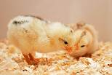



Planting
Throughout March, the children will be participating in various planting activities. We will be learning about growth and how to care for our newly planted seeds. We are looking forward to watching our flowers, fruit and vegetables grow. If you have a garden or outdoor area, you could maybe include your child in any planting activities you do and we would love to see any photos of them getting involved!

Easter Bonnet home link

We invite your child to take part in our Easter Bonnet home link activity, we ask that you create a bonnet with your child and bring this into the ECC week beginning 27th March. This will provide an opportunity for your child to think about design and make their own choices about materials, the more child led the better! These will be displayed within the Centre and there will be a small prize for everyone who takes part. We look forward to seeing the finished products.

Community Links/Delivering Easter gifts
Week beginning 27th March, the children will be spending some time in the community delivering Easter gifts and cards to the residents from the local sheltered housing at Princess Court. During this time the children will also sing some songs for the residents.


Easter Egg Hunt
Week beginning Monday 27th March, we are hoping that the Easter Bunny will pay us a visit to hide some items around the ECC and school grounds. Providing this activity over a few days will ensure that all children are able to participate. We will be taking the children outside for an egg hunt at the end of both the morning and afternoon sessions to see if our furry friend has left any Easter treats!

Holiday
Reminder that the ECC will be closed for two weeks for term time children for the Spring break. The last day of term will be Friday 31st March, the holiday dates will be from Monday 3rd – Friday 14th April inclusive. Term time children return Monday 17th April.
The Centre will also be closed for all children on Friday 7th and Monday 10th April for the Easter long weekend. We will re-open on Tuesday 11th April.
For the children who attend on a 48-week basis, please let us know if your child will be attending during the two-week holiday period or any times that they will not be attending for their usual session. This will enable us to provide accurate meal number requirements to the central kitchen.

We hope that everyone has an enjoyable break when the time comes.


