Whatriggs Early Childhood Centre
November 2022 Newsletter

Curriculum and learning topics
The most recent learning experiences from all playrooms is displayed on our Blog for you to view.
The children participated with excitement during the Halloween parties. Lots of fantastic costumes were on display, thank you for your efforts and involvement in this and thank you to those of you who donated items for our costume swap, providing further dressing up opportunities. The various spooky activities on the lead up to Halloween were also very popular. The children used their imaginations to engage in appropriate related role-play. Our focus was to encourage children to manage and control their emotions related to Halloween and the darker nights, the majority of children enjoyed the spooky aspect and focused on the fun rather than feeling scared.
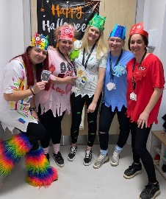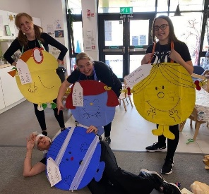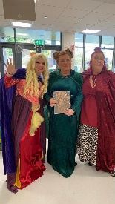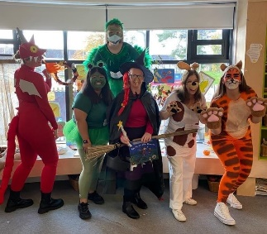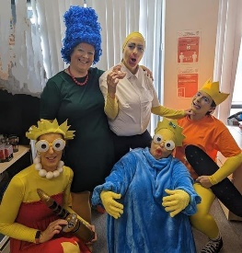
As you can see, it wasn’t just the children who were keen to join in with the Halloween dressing up fun. The staff were also desperate to get involved! There was aslo some healthy competition between the staff in all playrooms, all keeping their theme a secret until the big day. The winners were our team ‘Hocus Pocus’ from the birch room. This was judged by Sandra from the school office, who choose the well deserving winners. WELL DONE BIRCH ROOM!
Thank you for the votes we also received on our Facebook page, there’s still time to give a like to your favourite team.
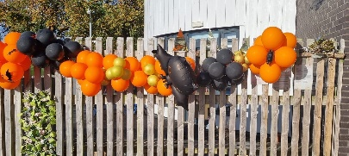
Thanks also to Bell and Balloons for the very kind donations to decorate our indoor and outdoor area for our Halloween parties on Friday. It was great to have such lovely balloon displays to get everyone in the Halloween spirit.

Pumpkin trail
The pumpkin trail also proved very popular with both the children from the ECC and the wider community who visited to look at the various pumpins on display and also add their own. Sadly, after placing our decorated pumpkins at the entrance to the estate on Thursday, we were notified on Friday morning that they had all been destroyed. Thank you so much for the kind donations of extra pupkins on the Friday morning which enabled the children to redecorate and add to the trail.

Leading up to Bonfire night at the weekend, we are now discussing fire, learning how to keep safe around fire/fireworks, as well as safety in the dark. We are spending time learning about colour mixing and what colours are used to create secondary colours, there is also a focus on basic shapes. Both of which are relevant to the creation of the children’s firework pictures.

Outdoor Classroom Day
Reminder that this will be taking place this week on Thursday 3rd November. You will have the opportunity to join us for an outdoor stay and play session, please see below for times for your child’s group.
- Oak am children and willow am children – 9.15-10.00am.
- Oak pm children and willow pm children – 1.15-2.00pm.
- Oak full day children – 9.15-10.00am
- Birch and Chestnut children – 2.30-3.15pm
- Willow 9am-3pm children – 2.30-3.15pm

St. Andrew’s Day
On Wednesday 30th November, we will be celebrating St. Andrew’s day within the ECC. If your child has any items of tartan clothing, we would appreciate it if they could wear this to the ECC on this day, alternatively your child could wear something blue. We will also be singing Scottish songs, listening to Scottish music and other Scottish related activities will take place.
Parental Learning Fayre
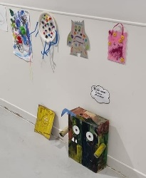
On Thursday 17th November we invite you to come along to the Centre between 3.30-4.30pm. There will be a variety of stalls available in relation to various curricular areas and staff champion roles such as literacy, numeracy, health and wellbeing and partnership working. You will have the opportunity to browse a variety of information to support your child’s learning as well as supports for your home life. Amanda Latif our link community practitioner will be in attendance to tell you about her services, provide related information and answer any questions that you may have. We are also hoping to have some other outside agencies to be able to join us to share information. It would be beneficial for you to attend this event without your child to enable you to fully engage with information. As the playrooms will be set up with stalls, there will be limited resources available for the children. However, if you do require to bring your child, please speak to a member of staff before the day of the event.

Colour Monsters
Well done to everyone who contributed to our home link activity. We received lots of fabulous colour monsters which are now displayed in our corridor for all to see. Thank you for participating in this.

Staff
Following interviews, Helen Anderson will be joining us as a clerical assistant. Janet will continue as senior clerical and will be in the office from 8.00am-1.00pm. Helen will be working in the afternoon from 1.00-6.00pm. We are looking forward to her joining the team in the near future. As Katie will be returning on a temporary part time basis in February, we will also be interviewing later this month for a temporary part time senior early learning and childcare practitioner to cover the other side of Katie’s post. We will also soon be advertising for a temporary part time practitioner to job share with Sharelle when she returns from maternity leave in February. We will notify you of the successful candidates when these positions have been filled. Three of our students have also now started with us for their first placement block and are settling in well. They will attend 4 days a week until Thursday 1st December. After this time, different students will be joining us to begin their placement allocation on Monday 5 December.

Parent meetings/Care Plan reviews
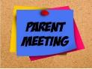
During November, you will have the opportunity to speak with your child’s keyworker on the phone or in person to discuss your child’s progress and care plan. These meetings will take place during week beginning 21st Nov (Willow room 2-3s) 28th November (all 3-5 playroom) and will last for a maximum of 10 minutes. If you have any concerns you feel will take longer than this allocated time, please arrange a separate time with your child’s keyworker to discuss these.

These meetings will take place as follows –
Monday 21st & Tuesday 22nd – (am) Lorna (stars).
Monday 21st & Tuesday 22nd – (pm) Heather (sunshines) / Tracie (moons) / Sarah (rainbows).
Monday 28th – (pm) Rebecca (red pandas) / Beth (orange tigers) / Laura (orange orangutans) /
Dayna (red ladybirds).
Tuesday 29th – (am) Regan (grey rabbits) / Emily (blue dolphins)
Tuesday 29th – (pm) Isobel (blue peacocks) / Lee-Anne (yellow lions) / Margaret (green frogs),
Vivianne (pink pigs) / Catherine (green turtles).
Wednesday 30th – (am) Regan (grey rabbits) / Emily (blue dolphins).
Wednesday 30th – (pm) Michelle (red squirrels).
Thursday 1st – (pm) Cheryl (yellow giraffes) / Kirsty (red ladybirds).
Friday 2nd – (pm) Claire (green frogs).

Reminders – (Belongings)
Please discourage your child from bringing toys into the ECC to avoid items being misplaced or lost. We cannot be held responsible for any missing or damaged belongings/toys that are brought in and we don’t want children being upset if this were to happen. There have also been lots of occasions when children go home with the wrong items, please ensure all your child’s belongings are labelled so that they can be more easily returned to their rightful owner. If you realise your child has come home with something that doesn’t belong to them, please ensure this is returned. Please also ensure your child does not come dressed in good clothes, as there is lots of messy play and outdoor learning each day.
Infection Control
Please be aware of the spread of infection when sending your child into the ECC with contagious conditions. We are aware that it is difficult when your child becomes unwell and you have no other childcare arrangements in place. However, please ensure you think of the other children/families and staff at these times. There is a strict 48 hour exclusion policy for sickness and diarrhoea which must be adhered to at all times. Please ensure you do not send your child to the Centre if they have a high temperature or are generally unwell.
Christmas activities/Dates for your diaries
We will be beginning our Christmas activities on Thursday 1st December and this will be the start of a very busy time within the ECC. Further details will be provided in the December newsletter, on our App and Facebook page but below are some dates for your diary.

Pre-school outings
We will be taking the preschool children on a trip on the minibus with Amanda our community practitioner. We will be visiting Dobbies in Ayr to have a look at their Christmas decorations. Amanda hopes to have some more available dates in the new term to enable us to book the minibus to take the ante-pre children from the 3-5 rooms and the 2-3 room children on an outing. The dates for the Dobbies visits will be Tuesday 22nd November, Monday 5th and Tuesday 13th December. We will notify you of the date your child will be attending nearer the time.
Christmas jumper day
This will be taking place on Friday 9th December. We would love it if your child could wear an item of festive clothing on this day. If you have any children’s jumpers/t-shirts that no longer fit, we would appreciate any donations so that we can provide opportunities for a jumper swap prior to the day. These would be placed on our clothing rail outside the ECC for anyone who wants to swap or select an item if needed.

Princess Court
We will be visiting our neighbours in Princess Court Sheltered housing before Christmas to provide them with a Christmas gift. We will also participate in some outdoor singing of our favourite Christmas songs, to get the residents into the Christmas spirit. We will notify you of dates within the next newsletter.

Mince Pie and Mingle
Lets celebrate the festive season together and we hope you can join us for a Christmas sing a long in our garden area and a mince pie and hot chocolate. Bring torches, lanterns and wrap up warm and don’t forget to bring your best singing voice! This will take place on Wednesday 14th and Thursday 15th December between 3.15-4.00pm and 4.15-5.00pm. Days and times will be allocated and these will be confirmed nearer the time. We will inform you in advance of the songs that we will be singing so that you can have plenty of practice beforehand. Mince pies and hot chocolate will be provided and please wrap up warm for the outside event.
Please note, no videos or photos should be taken, as not all children have permission to be photographed.
Christmas Parties
Parties will take place during December, dates to follow in December newsletter. We are hoping that Santa will be able to take time out of his busy schedule to pop in for a visit. The Grinch may also pop by to say hello if he’s not feeling too grumpy about Christmas!

McDougalls virtual panto
This has been available the last couple of years and we are hoping we can again purchase this for all of the children to enjoy within the Centre. Alternatively, we will be providing a Christmas movie and popcorn day for all of the children during the last week of term, which will be week beginning 19th December.

Christmas closure and 48 week sessions
The last day of term for all children will be Friday 23rd December. The Centre re-opens on Wednesday 4th January for any of our 48week children who wish to attend during this holiday week from the Wednesday-Friday. Term time children will then return on Monday 9th January. If your child attends on a 48 week attendance pattern, we will be emailing you mid-November regarding your plans for your child’s attendance during the first week in January. Please respond to this email to enable us to inform the central kitchen of meal numbers for each day and to amend our daily registers accordingly.
We will provide you with further information relating to Christmas activities/events during the first week of December.

