Oak Class W/C 8th March 2021
All sheets to complete the task set below can be found in your child’s home learning pack

Literacy | Numeracy  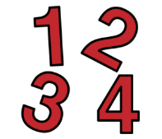 | Health and Wellbeing  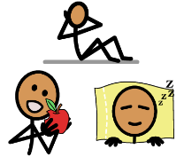
Reading  Oxford Owl Tree –  (You will have to create an account before you can access the ebooks).  Read the following books;  -Big Feet  -Spots  Writing –  -Can you make a Mother’s Day card, inside write how down what you love about your mum.  Spelling  - Sound focus is ‘th’. Use the words in the pack. Can you cut out the picture, mix them all up. Can you match the word and picture. Can an adult say and word and you can spell them.  Listening Comprehension  - Complete week 5 & 6 of the listening tasks. Ask an adult to read the question out loud for you.  Listening & Memory  -Recap the light blue and green sentences  -Get an adult to read out the purple sentences. Can you listen and repeat it back to an adult. | Time  -Using ground chalk outside,  Ask an adult to draw a clock with different times, O’clock and half past. An adult will call out a time and you have to jump onto the correct time.  Money  -Can you walk to the shop and buy a something and use the correct money to pay for your item.  -Use the Money matching card for a variety of different amounts. | Cooking – Try and make chocolate brownies an Fantastic Fudge for a Mother’s Day treat.  Life Skills – Can you prepare your own breakfast and make a sandwich for lunch.  Yoga – Cosmic Yoga (Minecraft)  Physical Education – Remember to keep completing your daily fitness diary.  Complete the Stretching worksheet and the green pulse raising worksheet. Do each exercise for 30 seconds. Use Youtube for a countdown timer with music.  Dance- Follow the leader and Banana Banana Meatballs  Relaxation – Get pillows and lie on the floor, ask an adult to play relaxation music on YouTube, lights out and enjoy.  My Body – Can you cut out the brushing teeth symbols and put them in the correct order.

