Oak Class W/C 1st March 2021
All sheets to complete the task set below can be found in your child’s home learning pack

Literacy | Numeracy  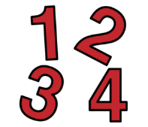 | Health and Wellbeing  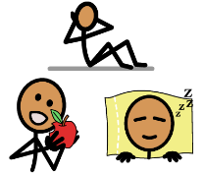
Reading  Oxford Owl Tree –  (You will have to create an account before you can access the ebooks).  Read the following books;  -Can You See Me?  -The Haircut (Now this book has no words, so can you talk about what you see in the pictures.  Writing – The Haircut  -Can you write 1 sentence for each picture in the book, ‘The Haircut’.  Spelling  - Sound focus is ‘ch’. Use the words in the pack. Can you cut out the picture, mix them all up. Can you match the word and picture. Can an adult say and word and you can spell them.  Listening Comprehension  - Complete week 3 & 4 of the listening tasks. Ask an adult to read the question out loud for you.  Listening & Memory  -Get an adult to read out the green sentences. Can you listen and repeat it back to an adult. | Time  -Play time bingo using the cards in your home learning pack.  -Play time bingo again, an adult will write the digital time on the laminated display clock and look and see if you have that time.  Money  -Complete the match the coins worksheet.  -Can you do some coin rubbings on a blank piece of paper.  -Can you order the coins from the smallest value to the biggest. | Cooking – Fairtrade Chocolate Rice crispy cakes / Can you use the internet and find a banana loaf recipe. Can your bananas be Fairtrade.  Life Skills – Can you look out what you need for your shower and try and wash your own hair and body.  Yoga – Cosmic Yoga (Banana Bread)  Physical Education – Remember to keep completing your daily fitness diary.  Complete the mobilising joints worksheet and the red stretching worksheet. Do each exercise for 30 seconds. Use Youtube for a countdown timer with music.  Dance- Do you remember the Olly Murs dance, ‘Dance with me Tonight’? If so grab a partner and get them dancing with you. You will need to use your big loud voice to lead them through the dance.  Relaxation – Get pillows and lie on the floor, ask an adult to play relaxation music on YouTube, lights out and enjoy.  My Body – Can you cut out the acceptable / unacceptable behaviour and stick the into the correct categories.

