Oak Class W/C 22nd February 2021
All sheets to complete the task set below can be found in your child’s home learning pack – If you do not have this at home, please contact the school and this can be made available at the reception for you to collect.
Visual symbols have been for each of these activities, if you would like them emailed to you please let me know.
Please feel free to email or phone me at the school if you should need anything that may help with home learning.
You can create a visual timetable at home which may help to give your child structure into their day.
Literacy | Numeracy  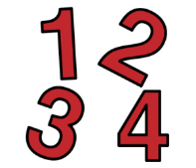 | Health and Wellbeing  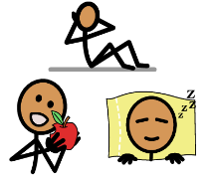
Reading  On Youtube listen to the ‘ The Lion Inside’ and ‘Conker the Chameleon’.  Writing – My circle of people of trust  -Can you draw a big circle, in this circle can you write the names of the people who are in your family. Can you colour this circle in red for love.  - Around this can you draw another big circle, can you now write the names of the people who are your friends or adults who help you and your family. Can you colour this in yellow for caring.  -Then draw a third circle around the first two, write the names of the adults in the Oak class. Can you colour this green for safety.  -Start a daily diary, include the day, date, month and year. Write how you are feeling today and what activities are you looking forward to / not looking forward to. At the end of the day, write how you felt your day was and what was the favourite part of your day.  Spelling  - Sound focus is ‘sh’. Use the words in the pack. Can you cut out the picture, mix them all up. Can you match the word and picture. Can an adult say and word and you can spell them.  Listening Comprehension  - Complete week 1 & 2 of the listening tasks. Ask an adult to read the question out loud for you.  Listening & Memory  -Get an adult to read out the light blue sentences. Can you listen and repeat it back to an adult. | Time  -Match analogue and Digital clock (o’clock and half past)  - Analogue and Digital Time with clock faces. With an adult look at one line at a time, the adult will call out a time and can you point to the correct one.  Money  -Set up a snack shop in your house, each item has prize tag. Use real money to pay for your snack, drink or lunch.  -Play a family game of Coin Bingo. | Cooking – Pink Pancakes or Purple Pancakes  Life Skills – Look out clean clothes and clean underwear for the next day.  Yoga – Cosmic Yoga (The Masked Singer)  Physical Education – Start and record a daily fitness diary from now until Easter.  Complete the stretches worksheet and pulse raising worksheet. Do each exercise for 30 seconds. Use Youtube for a countdown timer with music.  Dance- Continue to learn the new Oak dance Best Day of my Life.  Relaxation – Get pillows and lie on the floor, ask an adult to play relaxation music on YouTube, lights out and enjoy.  My Body – Use the shower symbols, cut them out and put in the correct order. Discuss what you see in each picture with an adult.

