Literacy  ‘Th’  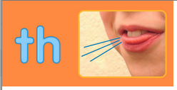 | Numeracy  Nature’s numbers  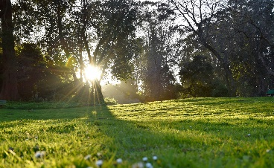 | Health and wellbeing  Germ experiment | Outdoor learning  Sign of Spring activity  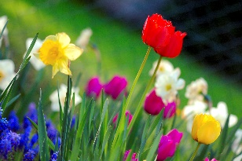
This week we are going to be working on some phonics. We are going to be looking at the soft sound /th/  First, I would like you to watch this video-  https://youtu.be/TlX5jSEN5sQ  Can you think of any words that have the /th/ sound in them?  Here are a few to get you started.  Th u m b thumb  T oo th tooth  Th u r s d ay Thursday  As an extra challenge you could read a book with someone at home and make the /th/ sound whenever you see it.  Or  You could draw a picture with different /th/ words. | 1.Gather some sticks and make different numbers with them.  2. Collect items for outside and make a nature number line. For example: 1=1 stick, 2=2 stones and so on.  3. How many of the following can you spot outside?  -birds  -trees  -flowers  -clouds  -animals | In our class we understand how important it is to wash our hands. By washing our hands we are keeping ourselves and others safe.  At home you could try this simple magic pepper and soap experiement.  All you will need is-  - Plate  - Water  - Dish Soap  - Black pepper  Before you start, make some predictions.  What you think is going to happen>  Watch this short video-  https://youtu.be/rMGW4Sp33xw  What were the results?  Why did this happen? | This week I would like you to look out for the signs of Spring.  You could take a note pad and pen and tick these items off as you find them.  Let me know hom many of these you can find!  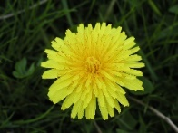  Dandellion  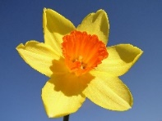  Daffodil  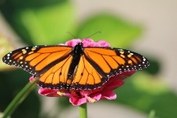  butterfly  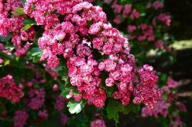  Blossom

